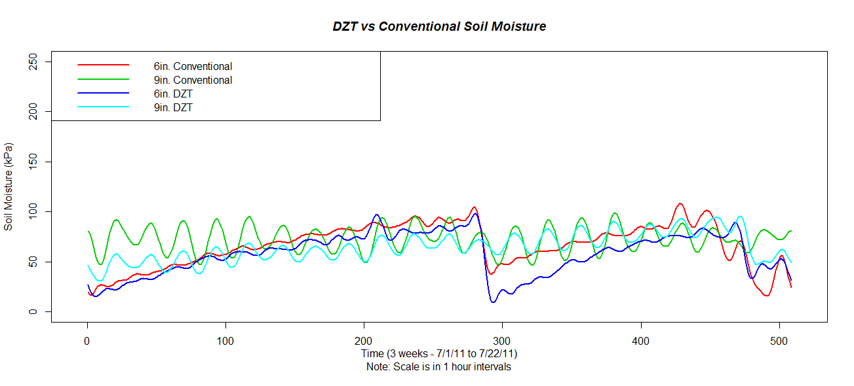
Figure 7: Soil moisture readings at 6” and 9” depth for DZT and Conventional plots. The smaller amplitudes on the 9” depth DZT (light blue line), as compared with the 9” conventional (green line), shows less fluctuation in water (more stable). The DZT plots (light and dark blue) retain higher moisture levels as compared to the conventional.

