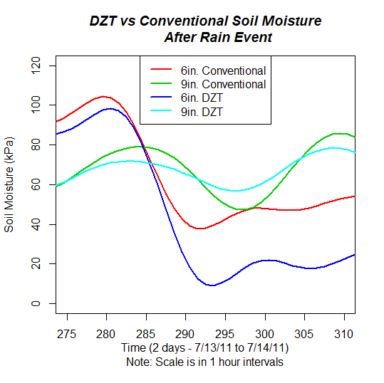

Figure 8: Soil Moisture sensors at 6 inch and 9 inch depths for conventional and DZT plots. The lower kPa (closer to 0 on Y-axis) represents higher moisture levels.

