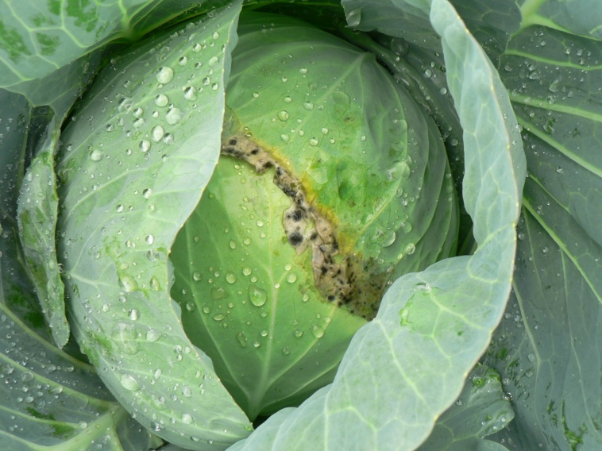
Figure 9: Example of white mold on cabbage head.

