“New” Leaf Cutter and Vacuum
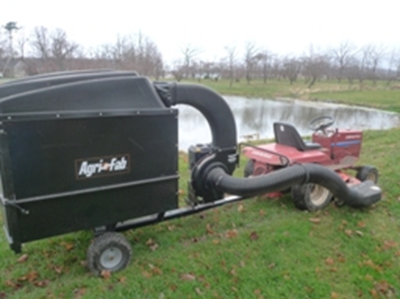 it took us to thoroughly

