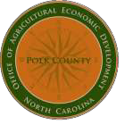
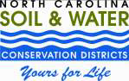

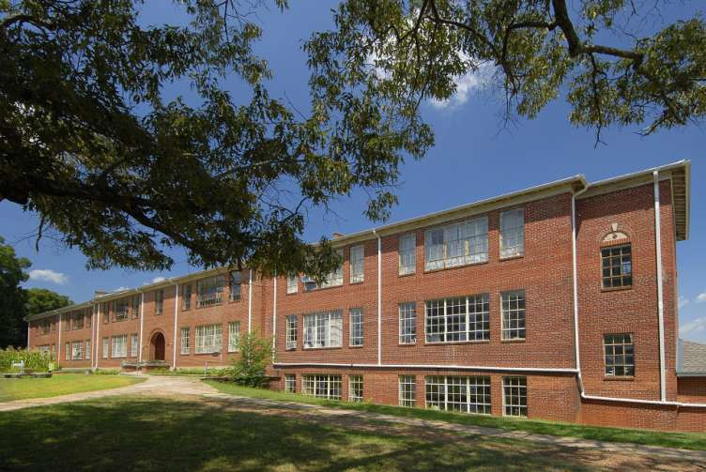

Polk County Agricultural Economic Development and Polk County

Soil & Water Conservation District Annual Report

2010-11

Mission
Polk County Agricultural Economic Development & Mill Spring Agricultural Economic Development Center
The Mission of the Mill Spring Agricultural Development Center (MSAC) is to enhance commu-
nity spirit and promote sustainable economic growth in Polk County through collaborative pro- jects and innovation in the fields of agriculture, natural resources, education, tourism, health
and wellness, art and music. We will work with farmers, businesses, and individuals as well as
state and federal agencies to preserve our rural heritage and improve our quality of life.
Polk County Soil & Water Conservation District
The Polk County Soil & Water Conservation District is a government entity dedicated to
the protection, preservation, and enhancement of Polk County’s natural resources. In the past
five years the Polk Soil and Water Conservation District has managed several
miles of Stream Bank Restoration on the Pacolet River and acquired and managed millions of dollars of federal and state project funds including; livestock exclusion and watering facilities, livestock stream crossings and plantings as part of these projects. Through work involving
the NC Agricultural Cost Share Program and Federal NRCS conservation programs the Polk
Soil and Water Conservation District has converted highly erodible crop land to permanent grasslands and installed hundreds of conservation practices. Recently the Polk Soil and
Water Conservation District acquired the abandoned Mill Spring School as a donation. The
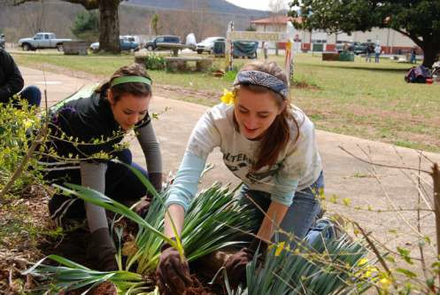school will be used as the Mill Spring Agricultural Development Center along with community activities.

The Agricultural Economic Development office was created in a County that supports its farmers and supports agriculture. First and foremost, the suc- cesses of this office are owed to the community and its focus on a local
and sustainable economy. Agriculture is key to our community, the state, and our nation and a focus on agriculture means a focus on job creation, tourism, and the environment.

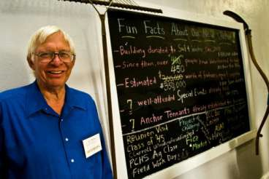We have four core programs which we will highlight in our report and in- clude our successes and the
hopes and dreams we have for our County but most importantly we wish to remember from
where we have come and the
community that supports the missions of our departments. Thank you Polk County.

Lynn Sprague, Director

Polk Soil & Water Conserva- tion District Board

Richard Smith, Chairman

Dave Slater Frank Smith Albert McEntyre
Charles Edwards
MSAC Advisory Committee

Dave Slater, Chairman

Dot Moyer William Arledge Steve Mauldin Chauncey Barber
Betsy Burdett
Farmland Preservation Board

Doug Harmon, Chairman

Dave Slater Evangelina Barber Bruce Edwards
Bill Davis

Willis “Bill” Holbert

Jeff Searcy

Employees, Americorps, & Contract Workers
Lynn Sprague, Director Sandra Reid, District Administrator
Vaughn Loeffler, Farmers’ Mkt Manager Brent Sheehan, Carpenter Carol Lynn Jackson, PolkFresh & Special Events Mike Blackwell, Electrician Kirk Wilson, PolkFresh Distribution Ctr Kacy Spooner, Americorps Patrick McLendon, Americorps

Economic Development

The most important thing we do is make connections…farmer to farmer, buyer to farmer, and consumer to farmer. All of our programs are dedicated to making those connections happen
consistently.

Success Stories

• Assisted farmers in securing over $150,000 in grants to sup- port agriculture.

• Established Green Creek Community Center as a certified kitchen and arranged for local value-added producer to create pastries and breads.

• Consulted with 20 entrepreneurial farmers interested in grow- ing in Polk County.

• Facilitated Eight New or Re-activated Commercial Greenhouse
Operations.

• $600,000 in Annual Direct Sales at Polk Farmers’ Markets with
over 100 Participating Vendors placements per Week.

• Ag Economic Development Office has worked personally with over 100 different farmers and vendors to consult about their business and make it better.

• As a regional resource we have worked with over 12 Counties throughout WNC and many region and state wide agencies.

• Created partnerships with over 30 organizations and agencies throughout the region.

Friends of Agriculture

The Ag Office has increased membership in our Friends of Ag mailing list from 160 to 227. In an effort to reduce operating cost from postage fees and manpower we launched a program to switch those that could from regular mail to email an- nouncements. Over 50 people switched from the mailing list to email and still increased both mailing lists. Another cost saving move initiated was to utilize postcard mailing versus letters— this move saved massive amounts of paper,
time, and postage money. This past year has
also seen the utilization of social media via Face- book and Twitter. From zero to over 160 follow- ers in a short amount of time means we are
moving forward fast.

116 53 193
FOLLOWERS
227

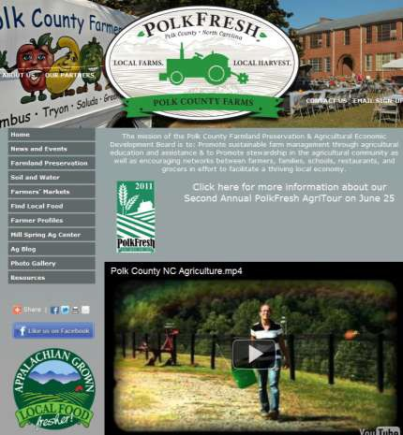New Website

Launched

The Polk Ag team created and launched a new website this year which includes many resources dedicated to helping consumers find farmers, farmers’ markets, and information about a multitude of things related to Agriculture. The website features Google maps of farms, farm stands, local food grocers & restaurants, and more. It also features a calendar of events.

Visit us at www.polkcountyfarms.org

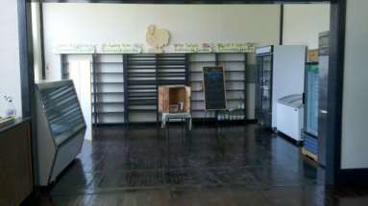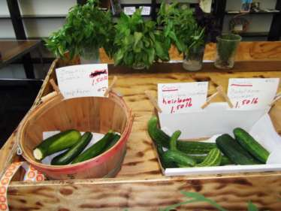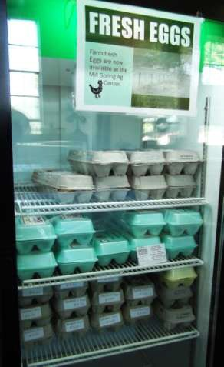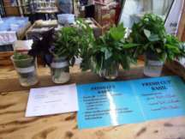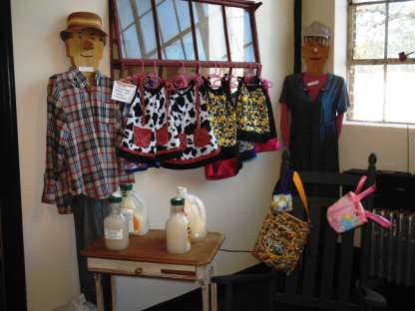

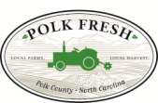Economic Development

PolkFresh TradePost

In 2011 the MSAC launched a cooperative store inside the building so that farmers could sell their products throughout the year and at times outside of the usual Farm- ers’ Markets. The store has been a great success for many of the farmers and as word grows that a country store with the freshest local produce is right around the corner we expect sales to go through the roof.

PolkFresh Radio

Tuesday 745 to 8 am– WJFJ 1160 AM

Starting this year the Polk Ag team has been part of a radio program every week to showcase all things Agriculture. Tune in
to hear the latest news.

Friends of Agriculture Breakfasts

Our monthly breakfast event has been a hallmark of this office since its inception. Each one has been successful with the average number of attendees reaching 65, with one fantastic morning having 89 farmers and friends. Speakers have ranged from local farming experts to statewide stakeholders in Agriculture and Business. This year has also brought about a
green change to our Breakfasts - plastic tablecloths, plates, silverware, and cups have all

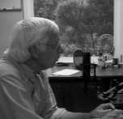
Past Speakers

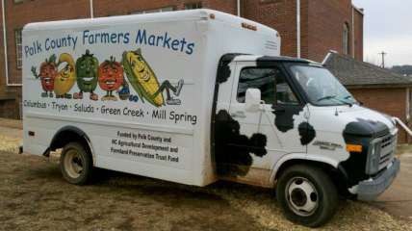Steve Troxler, NC Commis- sioner of Agriculture

Caroline Edwards, NCSU CES John Vining, NCSU CES
Sue Colucci, NCSU CES

Chris Reedy, Blue Ridge Food
Ventures

Meredith McKissick, Farmer & Organic Growers School

Chester Lowder, Farm Bureau
been replaced by their washable counterparts.

Economic Development Events

Farm to Fork Supper 2010

This year marked the First Annual Farm to Fork Supper. It included two live music per- formances, live dove release, bonfires, farm information stations, and of course the main thing—fresh, local food. Food was donated from many local farms as well as many items from local business for a silent auction. The event was sold out with plenty that still
came to enjoy the building and the event.

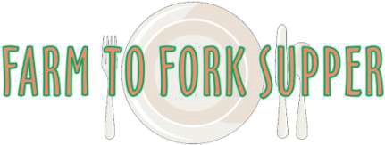

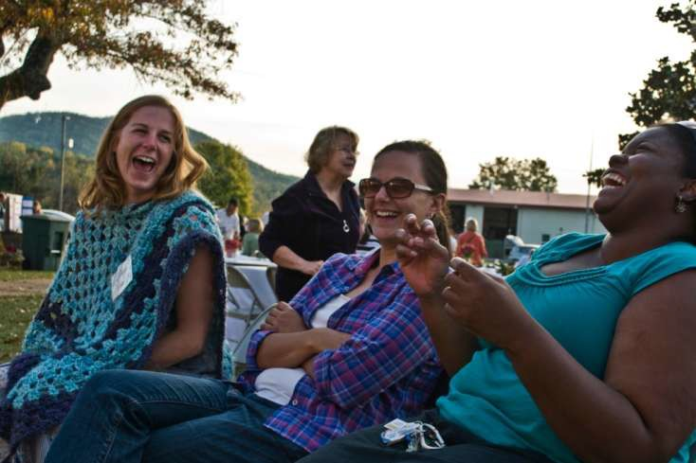

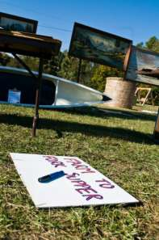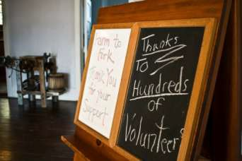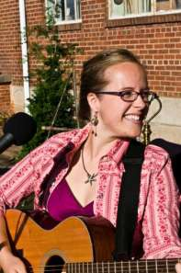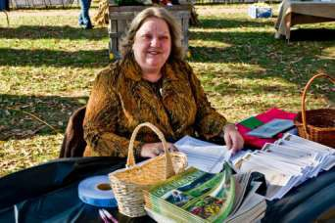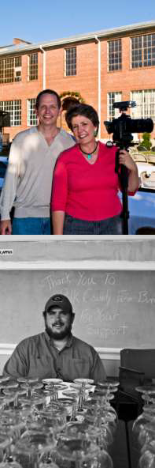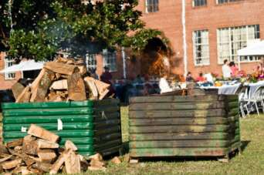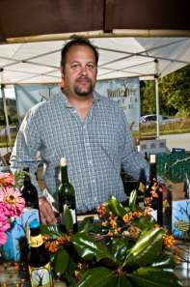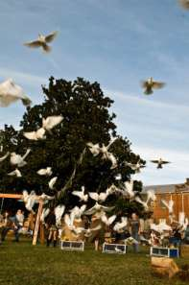

Economic Development Events

Columbus Farm Festival

The Columbus Farm Festival is going into its third year. Each year it has been a focus on Agri- culture and local farmers and producers. The last two years have gone extremely well for this free community event. Next year plans to be even better! The festival features all local mer-
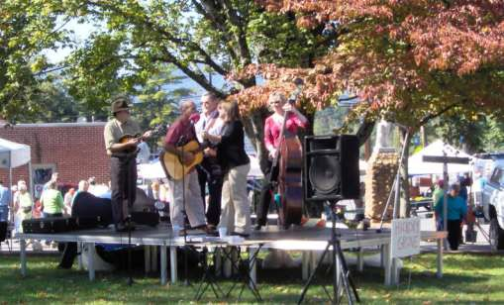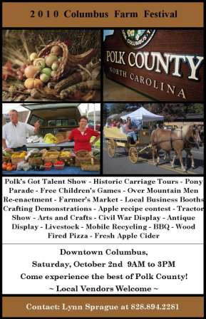chants, kids zoo and games, vendors with food and drinks, music, Civil War & Overmountain Men re- enactors, as well as many local artisans and crafters.

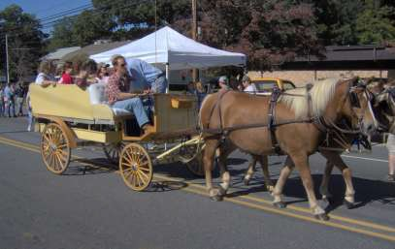

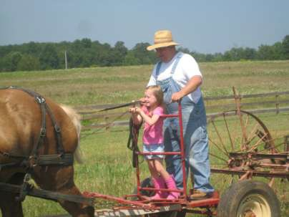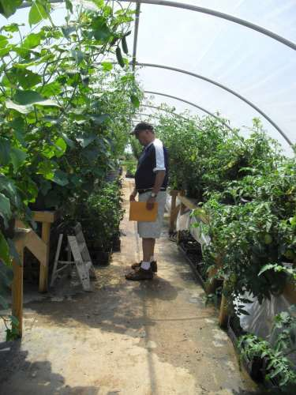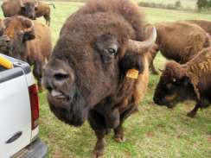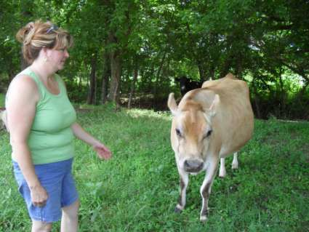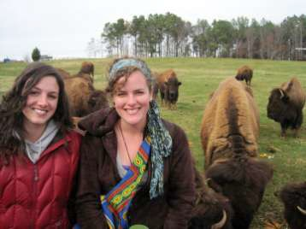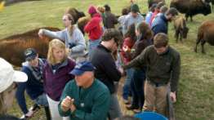Polk Fresh AgriTour

The Polk Ag Economic Development office has facilitated two AgriTours and they were both a great success. Farms reported brisk sales and hundreds of participants coming through their gates. Over ten farms participated on the Second Annual tour as well as a few local businesses.

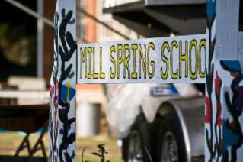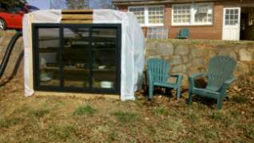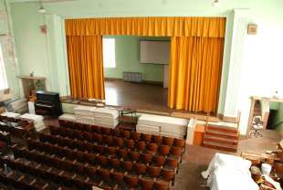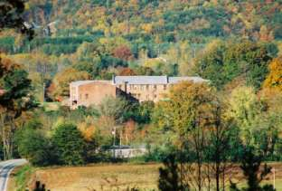

Humble beginnings were the hallmark of this building. Built in 1928 the building served the community until 1992 as a school. Its doors were shuttered in that year and the building sat vacant with minimal use until December 2009. In that year it was donated by an invest- ment group to the Polk Soil & Water Conservation District to be used as a community center. Kudzu was the only occupant then and now there are only a few rooms left available for rent in this
40,000 square foot building. The building has come a long way and only by the hard work of the committed community has it flourished into a beacon for the county. Many projects await the Ag Cen- ter and it’s all for us—the citizens of Polk County. It is what we as citizens have made it and what it can become will be because of us.

Chris Carroll Woodworks

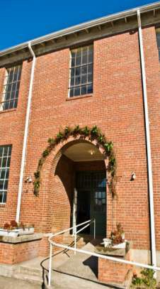June Ellen Bradley Art & Herbal Medicine

Tim Thomas Real Estate

Sheehan Carpentry

Turner HD Media

Natural Light Photography

NC Forest Service—Polk Ranger

Altamont Engineering

Janet Orselli Art KelliC Photography The Play Company
Cynthia Cole Photography

Dot’s Stained Glass

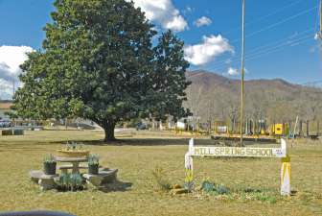Agribusiness Development

Retail Farm Store
Studio and Gallery Space

Utilize Auditorium
Regional Distribution Center for Produce

Farm to Fork Café Green Power Projects Ag Center Gardens

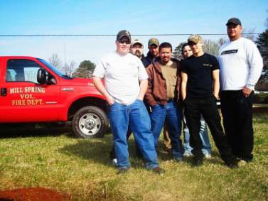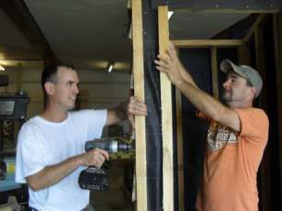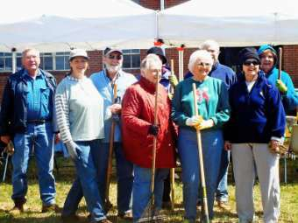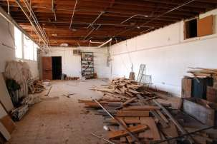

Volunteers & Renovations

Since the MSAC was donated over six hundred volunteers have come through its doors to turn this old school into a community Agricultural Center. Some volunteers have been school children or college students and some have been the farmers themselves lending their time and equipment. MSAC would not be what it is today without the support of its volunteers and those willing to give their time and money.

In 2011, the MSAC was lucky enough to have a group of 50 college students work three days in and around the building. These students from Illinois brought about massive change to the building and chose to do so using their Spring Break. These students transformed several rooms and the entire second floor from old to new.

Renovations have occurred non-stop since the beginning and will continue for years but we can say now that the building is fully operational. All of the rooms of the building are being utilized or rented with the exception of two and there are plans in place for those. Renovations are always done on a shoestring budget and often with materials donated by citizens. From time to time, citizens will have extra wood or supplies laying around and we put each scrap to use at our center.

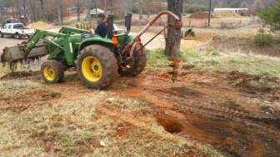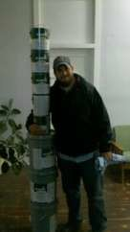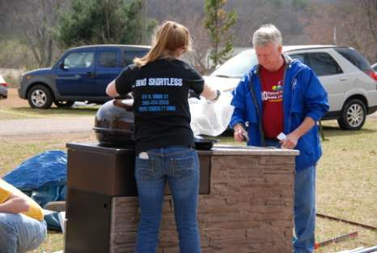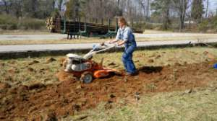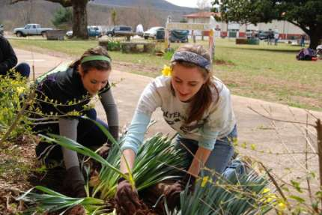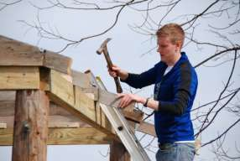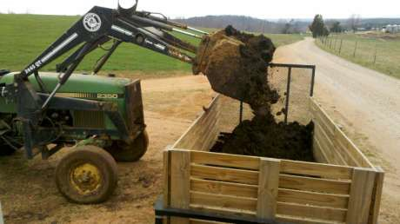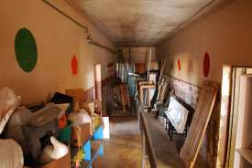

Farmland Preservation

Purpose

Each year thousands of acres of Farmland in North Carolina are lost to development pressure or the inability of the farmer or their family to
keep property from generation to generation.
Farmland Preservation is focused on educating

Agriculture/agribusiness comprises
20.3% of the state’s income and is the
number one industry in the state at
$70 billion.

farmers of their options regarding saving farms. The Polk Agricultural Economic Develop- ment Office and Polk Soil and Water Conservation District support the North Carolina state programs termed Voluntary Agricultural Districts and Enhanced Voluntary Agricultural Dis- tricts. Polk Soil and Water also holds permanent easements on Farms and support the work of Land Conservancies that work in Polk.

Farms in Polk

Program # of Farms Acres
VAD 48 5,606
EVAD 19 1,582
Total 67 7,188

Benefits of VAD & EVAD

• Recognition & public education about agriculture
• Increased protection from nuisance suits
• Waiver of water and sewer assessments
• Public hearings required for proposed condem- nation
• Eligibility for Farmland Preservation funding
• Official role in county government
• All VAD Benefits
• May receive up to 25% of its gross sales from

The Best Way to Preserve Farms is to Keep them Economically Sound

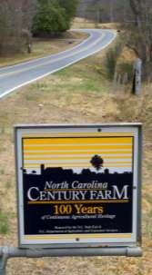nonfarm products and still qualify as a bona fide farm
• Eligible to receive a higher percentage of cost share funds

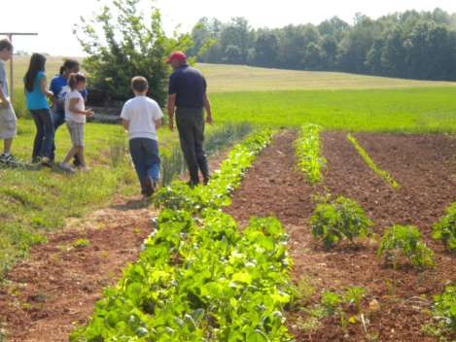ECONOMIC BENEFIT

An American Farmland Trust study showed that for every dollar in taxes received from working land only 34 cents in services is paid by the government. However, services paid to residential development are an average of $1.15 per dollar of taxes received. Therefore, it is a net gain of revenue for the tax base and thus an economic benefit for any county to preserve working lands.

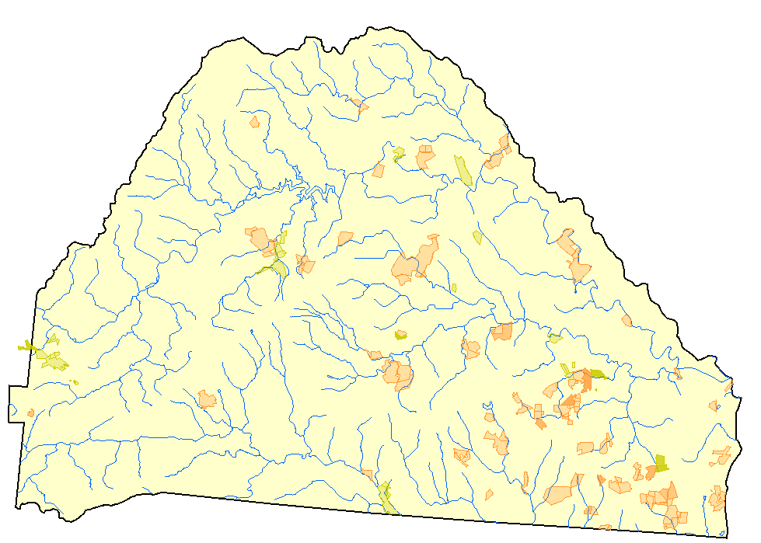
Polk Farms in Farmland Preservation

(shaded in orange)

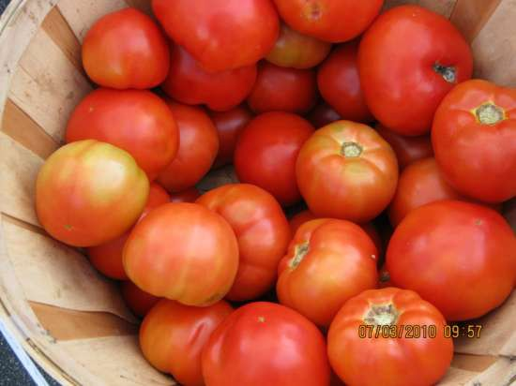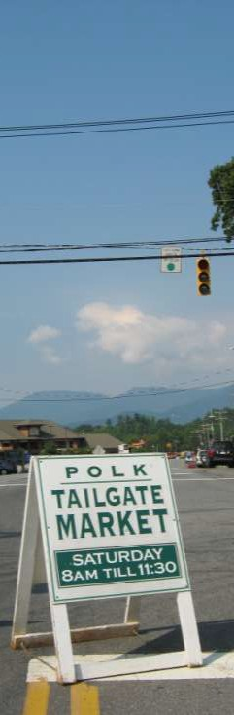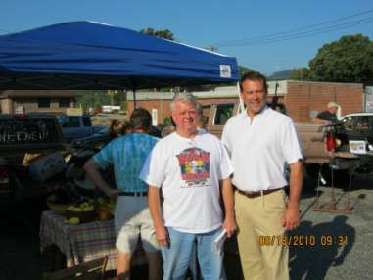Farmers’ Markets
Bringing Local Home

The Polk County Office of Agricultural Economic Develop- ment helps facilitate four farmers’ markets in Polk County. They are an opportunity for citizens to purchase the fresh- est possible ingredients and produce from the farmer right down the road.

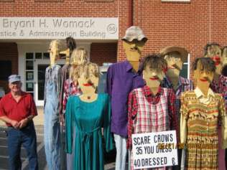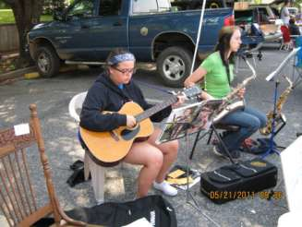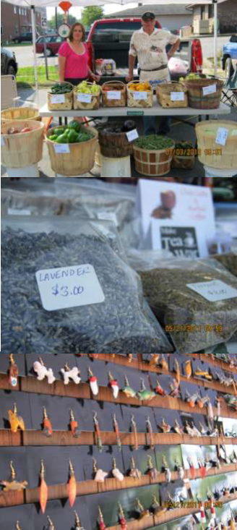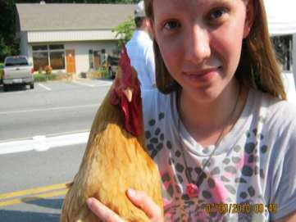

FARMERS’ MARKET LOCATIONS

Green Creek—Tuesdays

Tryon—Thursdays Saluda—Fridays Columbus—Saturdays Heritage Days, Farm Festival,
July 4th Festival, April Fools
Festival, & other Special Events.

Visit www.polkcountyfarms.org for hours and directions.

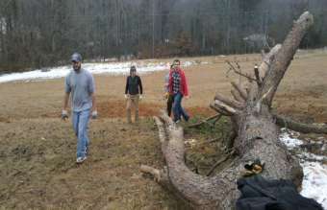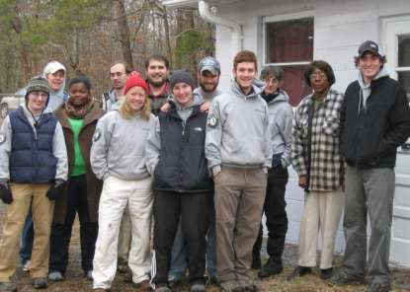Community Outreach

Stony Knoll Community Center

Stony Knoll Community Center is an area that Polk Ag has been working with since its inception. The historically African American community was created in the 19th Century and has stood the test of time. Volunteers from Americorps have been twice to help renovate the Center’s buildings and grounds. A Community Garden stands at the Center as well.

Thermal Belt Outreach Ministries

Thermal Belt Outreach and Polk Ag have been working together on many projects. TBOM being the local food bank it is only natural that a strong partnership will benefit both groups. Below is a picture of raised bed community gardens installed by Polk Ag at the Outreach.
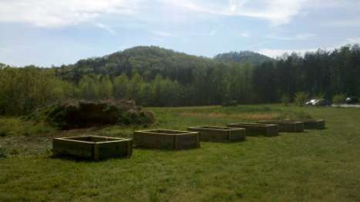

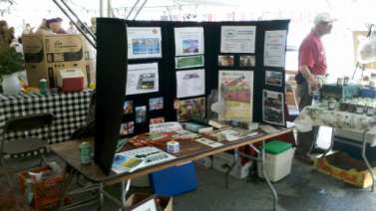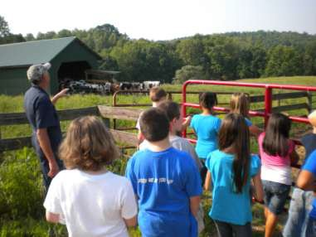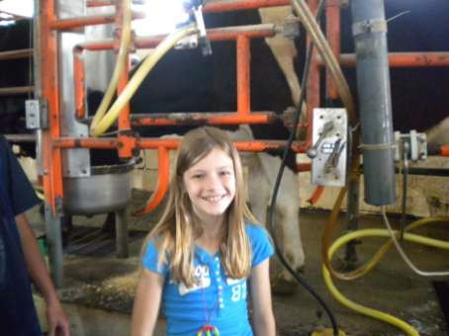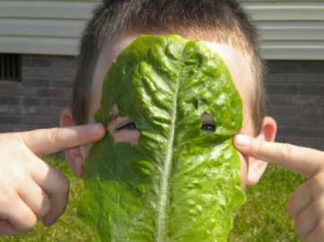Educational & Outreach Activities

In schools in Polk, Buncombe, and Henderson County, students have heard the message about farming, conservation, and that careers in farming are prosperous and needed. Five educational outings went to Polk elementary schools to teach students about soil and water, one to a Henderson County High School for a primer on farming as a career, one to Polk High for career day to explain farming in Polk County, and twice to colleges for career days as well.

In 2011, a lucky group of Fourth Graders also got to go on a special field trip sponsored by ASAP to a local dairy farm in which they learned about the milking process and got to make their own homemade ice cream.

Help Still Needed

We are working on a limited budget with tremendous amounts of volunteer help. Every project we complete needs funding. Monetary and material donations are welcomed and can be used for designated projects are general funds. There are many opportunities for
larger dedicated donations and naming opportunities.

•Tractor
◦ The Ag Center is in great need of a working tractor. Many projects are on hold or not started because of the need for a tractor. We have been helped many times by our farm neighbors but we need so much more.

•Always Needed:
◦ Lumber
◦ Nails
◦ Screws
◦ Paint
◦ Mirrors
◦ Paint
◦ Artwork
◦ Silverware and Dishes
•PolkFresh Distribution Center
◦ Fluorescent Lights
◦ Building Materials
◦ Forklift
◦ AC/Heat Units
•PolkFresh TradePost
◦ Donated Tables
◦ Volunteer Clerks
◦ Agricultural Products to Sell
•Auditorium
◦ Industrial Size Fabrics for Curtains
◦ Stage Lighting
◦ AV Equipment
◦ Seat Repair Services
•Business Center
◦ Office Supplies
◦ Office Equipment
•Agricultural Library
◦ Books about Agriculture, Cooking, Gardening, etc.
◦ Mother Earth News Magazines or the like
◦ Bookcases
◦ Labor - Sorting and Organizing the New Library
•Professional Services
◦ Lawyers
◦ Accountants
◦ Landscape Designer and Installers
◦ Architects
◦ Performers
◦ Artists
◦ Carpenters
◦ Masons
◦ Graphic Designers
◦ Event Coordinators
◦ •Ag Center Maintenance Shop
◦ Tools - Hand and Power
◦ Landscaping Tools - Hand and Power
◦ Riding Mower
◦ Pickup Truck
•Pole Barn (Wood Storage & Outside Equipment Stor-
age)
◦ Use of tractor with auger to set poles
◦ Sheet metal for roof
◦ Screws and Nails
◦ Building Materials
◦ Steel Shelving
•Mushroom Cultivation Field Lab
◦ Use of Tractor with Bucket to Dig Out Underground portion
◦ Cement
•Greenhouse
◦ Sheeting
◦ Old Windows
◦ Fans
◦ Building Materials
◦ Shelving & Tables
◦ Labor
•Community Fruit Tree Orchard
◦ Fruit Trees
◦ Use of Tractor to dig holes for trees
◦ Staking and Picking Equipment
•Well Revitalization Project (for Irrigation of gardens
and fruit trees)
◦ New Well Pump
◦ No Freeze Farm Faucet
•Banquet Hall and Ballroom Renovations
◦ Dining Room Tables and Chairs
◦ Labor - Walls and Floors
◦ Lighting Fixtures

Granting Organizations

Overall since its inception, the MSAC has received over $250,000 in grants and funding. These awards have leveraged nearly $450,000 in non-granted projects, donations, and volunteer time matches.

Some Ag Development Initiatives that have been supported by grants this year:

Southern SARE, Sustainable Community Innovation Grant - PolkFresh TradePost Project: A Strategy to Implement Polk County’s 20/20 Vision plan for Sustainable Com- munity Development: $10,000

ASAP, Appalachian Grown Matching Funds - PolkFresh marketing and promotional materials using the Appalachian Grown label. $5,000

WNC Ag Options Community Grant - Improve Polk County’s local agricultural system by enhancing existing farm ventures, particularly by addressing processing, packaging, marketing, and other distribution needs. $19,400

Blue Ridge Natural Heritage Area - Implementing a Program Base for the Mill Spring
Ag Center Project. $24,000

Foothills Chamber of Commerce - Community Business Center: $1,000

Polk Economic Development Commission - Community Business Center: $5,000

Polk County Community Foundation - Exterior Roof Repairs: $19,500

County, Polk - Water Line: $17,800 & Exterior Roof Repairs: $9,500

Turner Tennant Foundation - Business Center: $X,XXX Pangea Cable Internet - Business Center: $X,XXX Costco - Business Center: $X,XXX
North Carolina Agricultural Development & Farmland Preservation Trust Fund -
The first grant received by MSAC: $34,000

Acknowledgements

Farm Bureau of Polk County has been a grand supporter of MSAC and Polk Ag Economic Development. They fund the Friends of Ag Breakfasts and have given generously to pro- jects at the Ag Center such as our grading and gravelling.

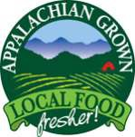ASAP has been a special partner to our organization. Helping with grants as well as making connections that benefit both of our Missions.

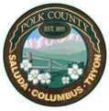Polk County has given greatly to the MSAC and has worked with the Center to help it achieve its operational status. Without the County’s support this building would not be where it is today.

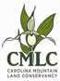As the administrator of the Americorps Project Conserve pro- gram, Polk County has benefited greatly from the efforts of CMLC. As well, CMLC was the driving force in scheduling the mass of college volunteers we had this Spring.

The Polk County Community Foundation has been a leading grantor and supporter of the Ag Center. When help is needed they have always been available to assist.

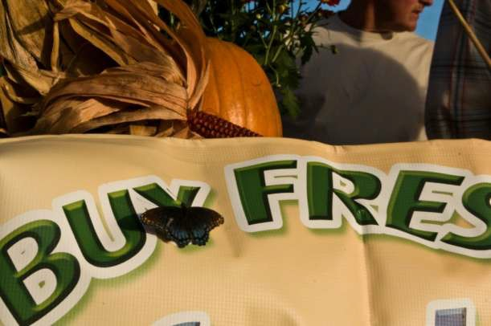

PLEASE SUPPORT YOUR LOCAL FARMERS BY VISITING FARMERS’ MARKETS, FARM STANDS, RESTAURANTS THAT USE LOCAL FOOD, AND GROCERS THAT FEATURE LOCAL FOOD. IT MAKES OUR COMMUNITY ECONOMICALLY
STRONGER AND HEALTHIER.

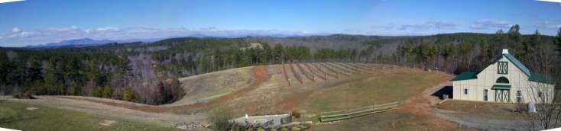

Acknowledgements

Design & Creation: Patrick McLendon

Photograph Credits: Bill Wilmhof, Travis Williams, Kacy Spooner, Patrick McLendon, Turner HD Media

Cover Photo Credits: Chris Bartol & Turner HD Media

Editing Assistance: Lynn Sprague, Sandra Reid

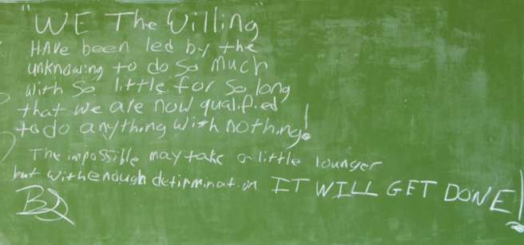

Polk County Office of Agricultural Economic Development

PO Box 156

156 School Road

Mill Spring NC 287

