Parthenocarpic Cucumbers are a Successful Double Crop for High Tunnels
Lewis W. Jett
Commercial Vegetable Crops Specialist, West Virginia University, 2102 Agriculture Building, Morgantown, WV 26506
Introduction:
Cucumbers (Cucumis sativus) are a popular warm season vegetable grown throughout West Virginia. Cucumbers are very sensitive to frost, so early- and late-season production can be a challenge. In previous studies, cucumbers have been shown to be a high-yielding, early-season cash crop for high tunnels. Another cropping system scenario is for an early warm season crop such as tomatoes to be grown in the high tunnel followed by a late-season crop of cucumbers. High tunnels facilitate trellising of cucumbers which maximizes yield and quality (Figure 1). Parthenocarpic varieties, in particular, may be well-suited for high tunnel production. This evaluation examined 10 predominantly parthenocarpic cultivars of cucumbers for late-season high tunnel production in West Virginia (Table 1).
Materials and Methods:
Seeds from 10 cucumber cultivars were seeded in mid-August in 50-cell pro trays. Two-week-old transplants were transplanted within a high tunnel in central West Virginia on September 3, 2011. Each cultivar was spaced 12 inches between plants and 42 inches between rows for a total of three replications containing 5 plants per replication. The plants were established on black plastic mulch with drip irrigation. Fertilizer was applied at planting and thoroughly incorporated into the soil. Approximately 25 lbs. of 10-10-10/1000 ft² was applied prior to laying plastic and transplanting the cucumbers. Each plant was pruned to one stem and trellised on a string trellis (Figure 1). Irrigation was applied to deliver a minimum of 1.5 inches of water per acre equivalent per week On October 10, 2011 harvest began with approximately 1-2 harvests per week until the harvest season ended on November 10 due to a freeze event. Each cucumber was weighed and graded for marketability. Length and width of random samples were also measured.
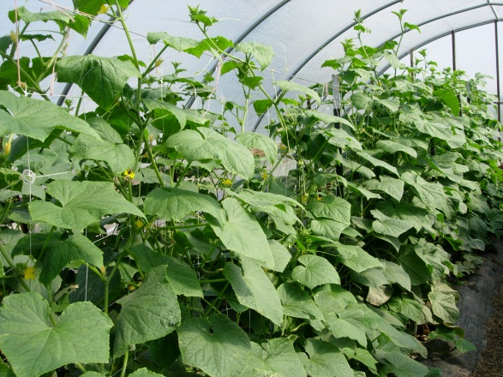
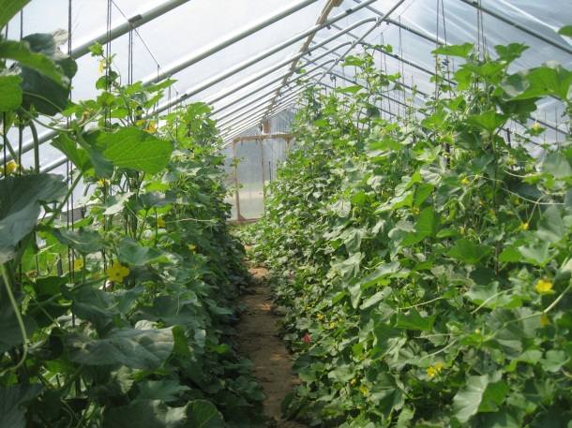
Figure 1. Cucurbits can be trellised on a mesh trellis or a string trellis for maximum production within a high tunnel.
Table 1. Cucumber cultivars evaluated within a high tunnel-2011.
Cultivar | Seed Source^{z} | Days to harvest | Comments^{y}
EXP 2856 | SW; BE | 56 | Dark green; Excellent size and shape; Parthenocarpic
Dasher II | JS | 58 | Standard hybrid slicing variety. Gynoecious
Diva | JS | 58 | AAS Winner PM and DM tolerance; Parthenocarpic
P08040 | SY | 56 | Dark green; Excellent size and shape; Parthenocarpic
P08051 | SY | 56 | Dark green; Excellent size and shape; Parthenoarpic
Rocky | JS | 46 | Good for baby cucumbers PM tolerance; Parthenocarpic
Socrates | JS | 52 | Parthnocarpic beit alpha type. PM tolerance
Sultan | JS | 56 | Beit alpha type. PM tolerance
Tasty Green | SW | 62 | European/Dutch type; Monoecious; Seed coats in fruit.
Tyria | SW | 58 | European/Dutch type; Parthenocarpic; No seeds
^{z} JS=Johnny’s Seed; SW=Seedway; BE=Bejo Seed; SY= Syngenta Seeds
^{y}PM= Powdery mildew; DM= Downy Mildew

Results and Discussion:
Cucumbers were harvested over a limited, 4-week period. An infection of downy mildew moved into the high tunnel later in the season. Had the crop been established in late July, marketable yields would undoubtedly have been much greater. Nevertheless, there were significant differences between cultivars.
The cultivars ‘P08040’, ‘EXP 2856’ and ‘Socrates’ produced the largest number of marketable cucumbers per plant or per linear foot of row (Table 1). The cultivars ‘P08040’, ‘P08051’ and ‘EXP 2856’ all had excellent quality including dark green color and a low percentage of culls per plant (Table 1; Figure 3). Although parthenocarpic varieties do not require bees for cross pollination, bees were present in the high tunnel. When parthencarpic cucumbers are cross pollinated, seeds can form and the cucumbers become misshapen. Both ‘Tasty Green’ and ‘Tyria’ had more misshapen fruit as a percentage of total marketable yield. ‘Socrates’ was the highest yielding beit alpha cucumber evaluated. ‘Rocky’ is a high-yielding, small cucumber with market potential as a baby cucumber (Figure 2; Figure 3). ‘Tyria’ was seedless with excellent quality, but yield was not significantly high.
Table 2. Yield of high tunnel cucumber: October-November 2011.
Cultivar | Marketable cukes/plant  (no.) | Avg. wt (lbs.) | Unmarketable cukes/plant  (no.)
EXP 2856 | 5.9 | 0.5 | 0.7
Dasher II | 2.5 | 0.4 | 0.7
Diva | 2.0 | 0.4 | 0.4
P08040 | 6.3 | 0.7 | 0.7
P08051 | 4.9 | 0.6 | 0.7
Rocky | 6.9 | 0.2 | 1.5
Socrates | 5.2 | 0.5 | 1.3
Sultan | 2 | 0.5 | 0
Tasty Green | 2.8 | 0.8 | 0.8
Tyria | 1.6 | 0.6 | 0.7
SE (Mean) | 0.4 | 0.2 | 0.7
‘P08040’ and ‘P08051’ had uniform length greater than 8 inches (Figure 2). Although total yields are a fraction of the potential marketable yield if the cucumbers are allowed to have a longer growing season, cucumbers are a profitable double crop for high tunnels. Occupying 65 days within a high tunnel and yielding 0.75-2.5 lbs/ft² is a realistic yield level for high tunnel cucumbers.

inches

Figure 2. Length and diameter of select high tunnel cucumber cultivars.

EXP 2856
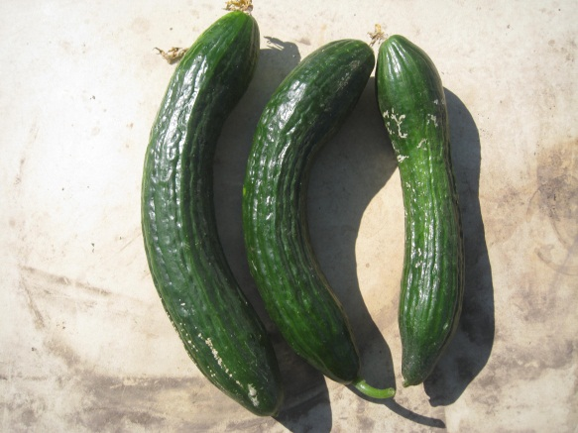
Tyria
Diva
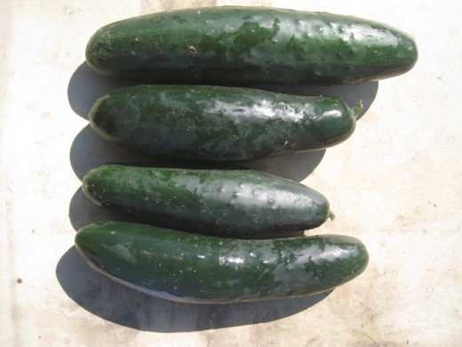
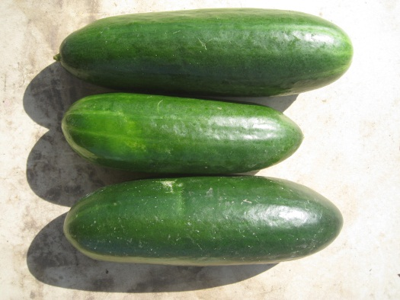
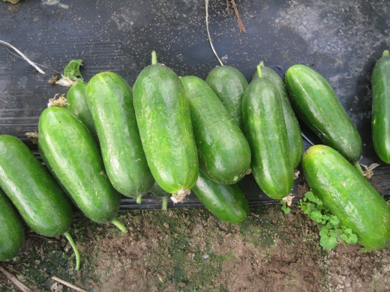
Rocky
Socrates
P08040
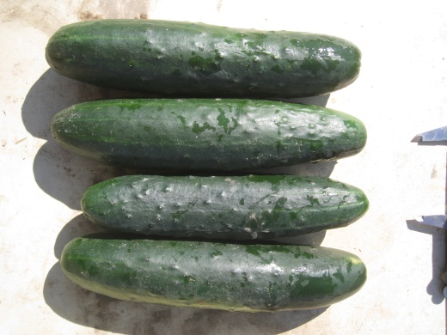
Tasty Green
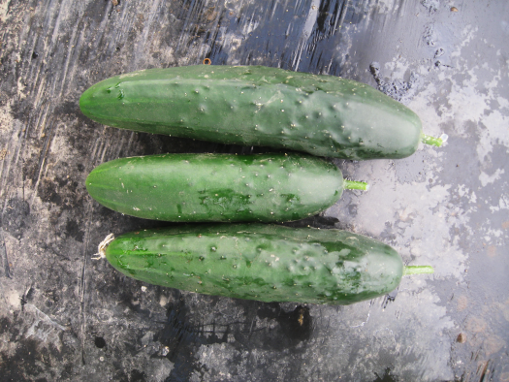
P08051
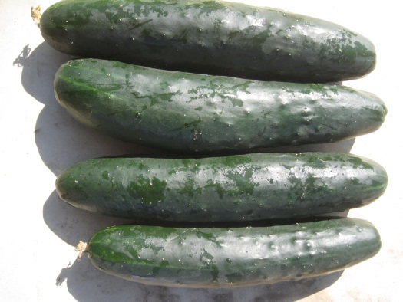
Dasher II

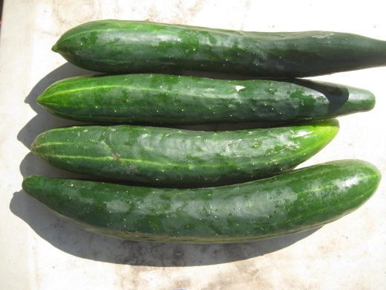

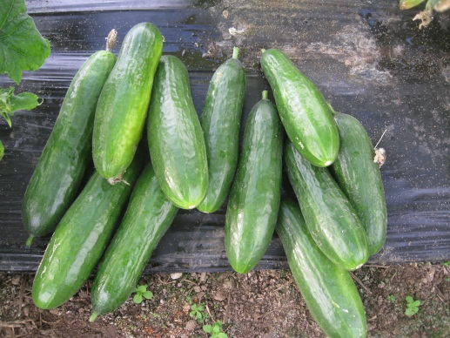

Figure 3. Appearance of select high tunnel cucumber cultivars.

*Thanks to Seedway Vegetable Seed and Syngenta Seeds for providing seed for this trial.

