Growing Chinese Cabbages in West Virginia
Lewis W. Jett
West Virginia University Commercial Horticulture Extension
Chinese cabbage (Brassica rapa) includes a diverse group of vegetables including Bok-choy (Pakchoi), Michihli and Napa cabbage (Figures 1 and 2). Bok-choy is often not classified as a Chinese cabbage, but it is closely related to these groups of cabbages. Bok-choy has an open rosette of leaves with white stems. Michihli cabbage is tall with outward spreading leaves. Napa cabbage has a barrel shape with leaves folding inward. Relative to traditional green cabbage varieties, most Chinese cabbage varieties mature in a shorter period of time. Chinese cabbages has a mild flavor and can be used for dishes such as stir fry and kimchee. Chinese cabbage is very nutrient dense with high concentration of Vitamin C and fiber.
Cultivar Selection:
Table 1. Description of Chinese cabbage cultivars recommended for West Virginia.
Cultivar | Days to maturity¹ | Description
Bilko | 54 | Napa type; Slow bolting; Resistant to club root
Blues | 57 | Napa type; Slow bolting; Good for spring or fall production.
Jade Pagoda | 75 | Michihli type
Joi Choi | 45 | Pakchoi type
Mei Qing Choi | 42 | Pakchoi type
Optiko | 60 | Napa type; Slow bolting
Red Choi | 45 | Pakchoi type with maroon color
Rubicon | 52 | Napa type; Slow bolting; Large heads
Yuki | 67 | Napa type; Uniform heads
¹From transplanting.
When choosing a Chinese cabbage cultivar for spring/summer production, a bolt resistant variety is recommended. Chinese cabbage will produce a seed stalk (called bolting) in hot weather or if young plants are exposed to low temperatures (<50ºF) for approximately one week.
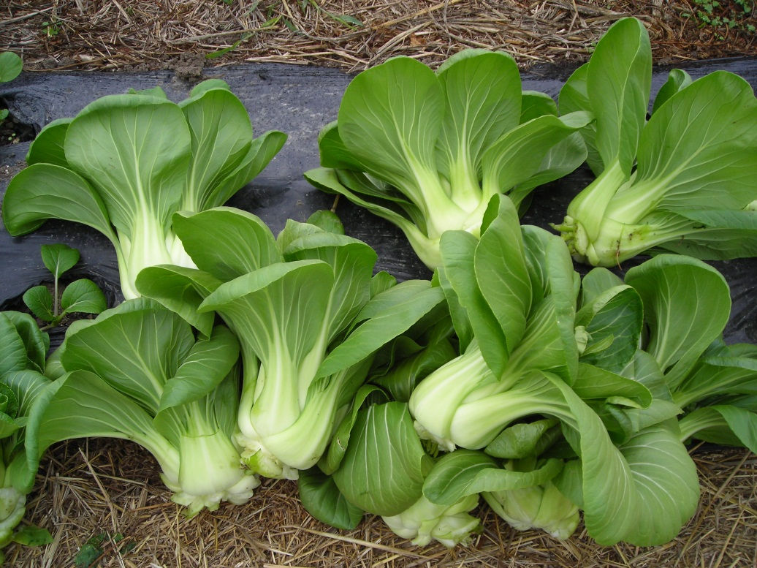
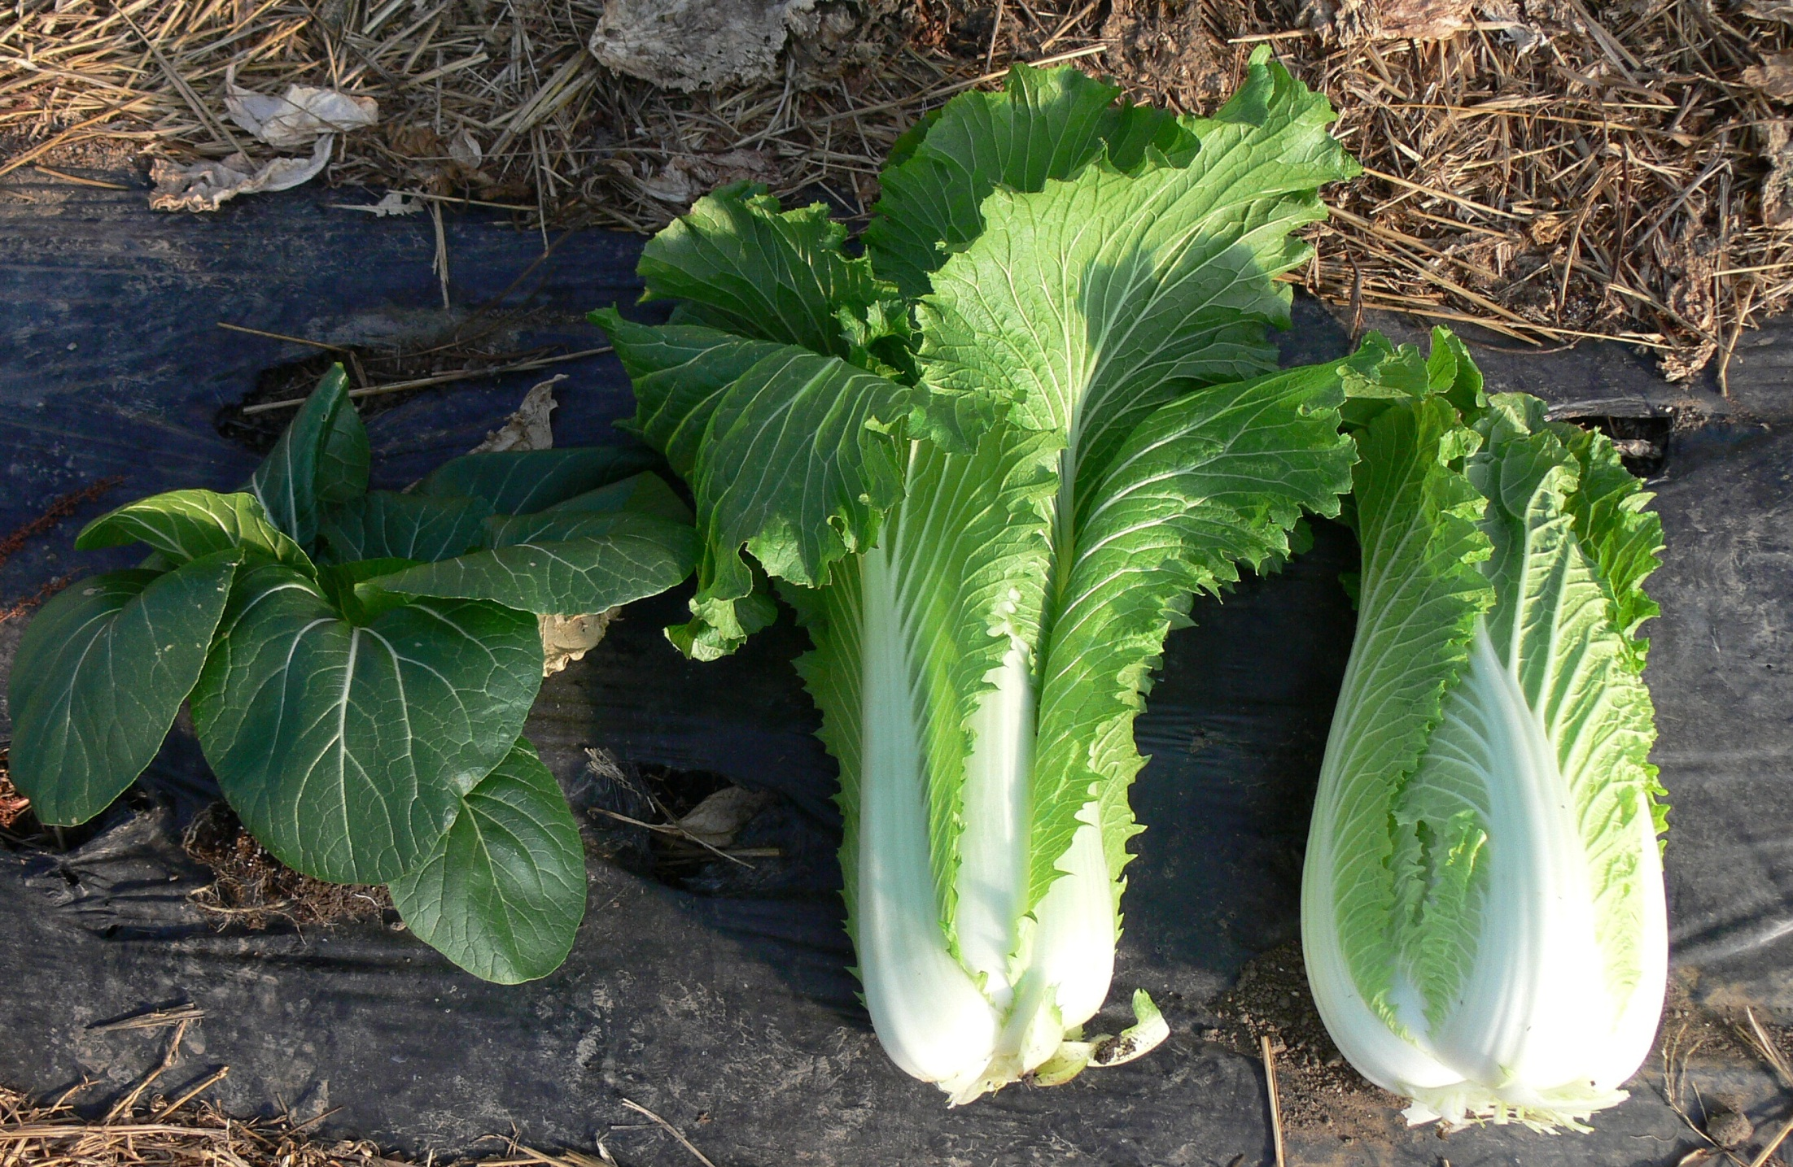

Napa
Michihli
Pakchoi

Figure 1. Chinese cabbages have a diversity of sizes and shapes.
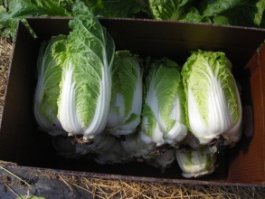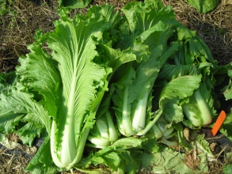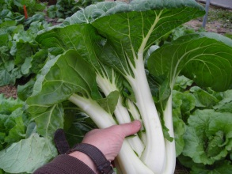
Blues
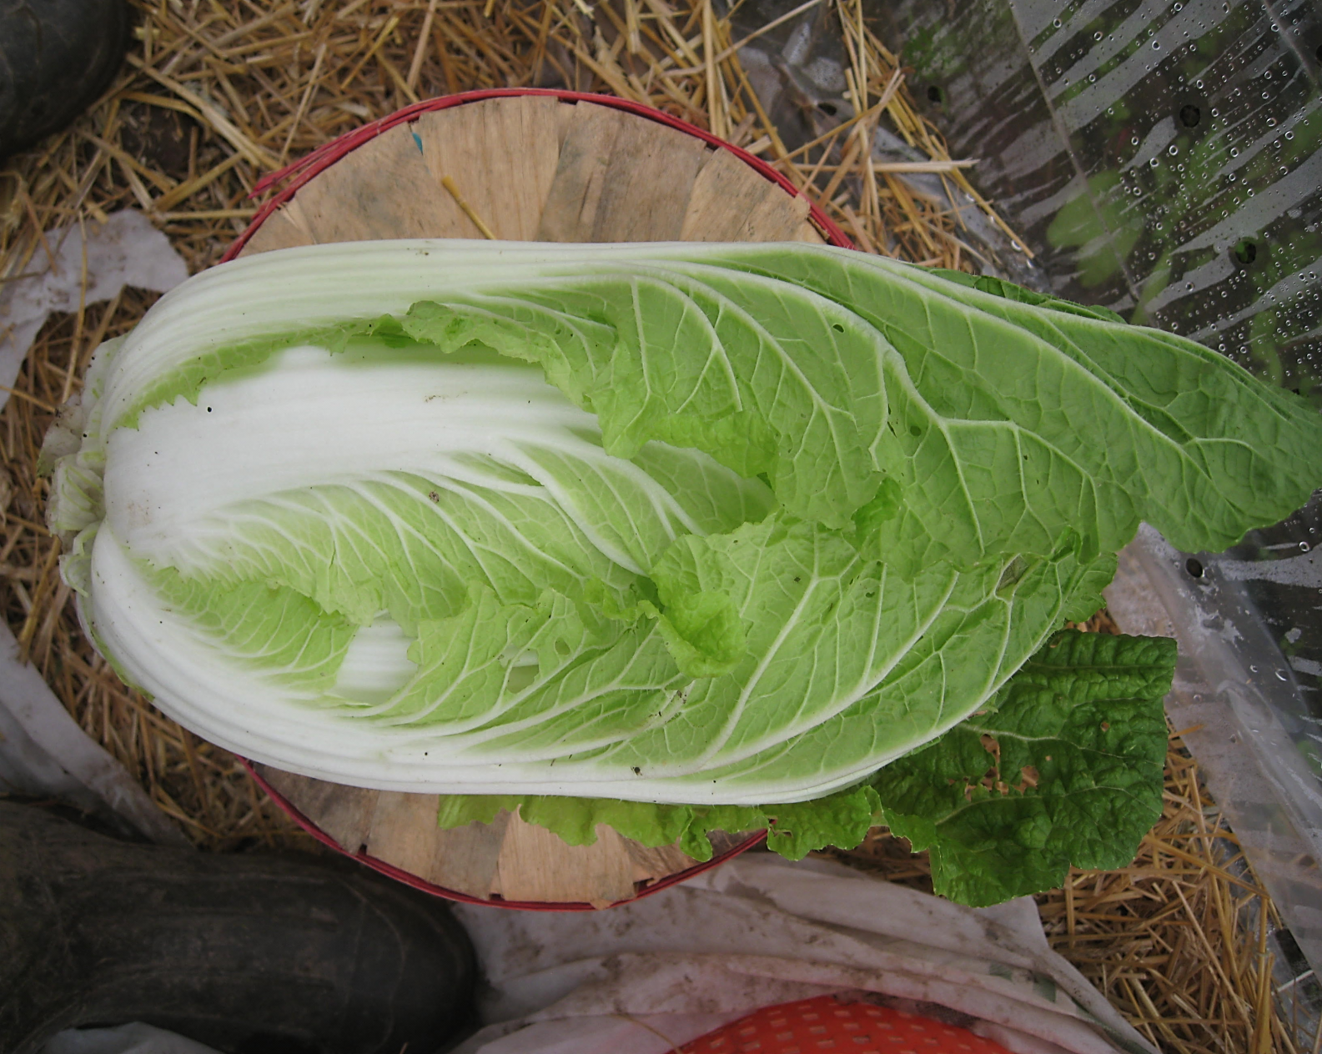
Nikko
Joi Choi
Jade Pagoda
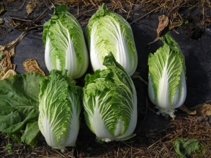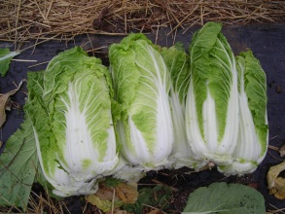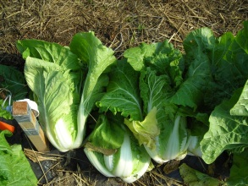
Rubicon
Optiko
Mirako
China Express
Figure 2. Cultivar selection is the most important decision for optimal Chinese cabbage yield and quality
Stand Establishment:
Chinese cabbage can be direct seeded or transplanted. If direct seeded, each seed can be placed approximately ¼ inch deep and seedlings thinned 2 weeks after emergence to one plant every 12-18 inches within the row. Rows are spaced 24-36 inches apart. Most Chinese cabbages grow well when planted as a twin (double) row on a raised bed (12 inches x 12 inches) (Figure 3). Baby Pac choi which is harvested as a salad green can be seeded in a 2 inch wide band with approximately 60 seeds per foot. No thinning is required.
Transplants can be started in 50, 72 or 128 cell trays and transplanted 3-4 weeks after emergence. Chinese cabbage varieties can be seeded or transplanted in late April to early May in most areas of West Virginia and in August for fall production. Progressively cooler weather from planting to harvest is favorable for growth of Chinese cabbage. Low tunnels with row cover fabric can protect the Chinese cabbage plants from low temperature and accelerate growth. Chinese cabbages are well-suited for high tunnel production since the high tunnel protects the crop from insects and diseases. High tunnels also enable Chinese cabbages to be overwintered for harvest in early spring.
Mulching:
Chinese cabbage can be planted on black or white plastic mulch depending on the season of the year. White (on black) plastic mulch cools the soil and is well suited for full-season production. Organic mulches such as straw or grass clippings also keep the soil cool and favor growth of Chinese cabbages. Black plastic mulch is effective in warming the soil for early spring production. Mulches reduce soil moisture loss and suppress emergence of weeds.

Fertilization and Irrigation:
The optimal soil pH for Chinese cabbage is 6.0-6.5. Nitrogen in the form of organic matter (e.g., compost) and fertilizer can be applied prior to planting. Approximately 10 lbs. of actual nitrogen per 1000 ft² is recommended. This is equivalent to 100 lbs. of 10-10-10 fertilizer per 1000 ft². The fertilizer or compost should be tilled into the soil prior to planting. Additional nutrients such as phosphorus and potassium should be applied based on a soil analysis.
Drip irrigation is the preferred method of watering for Chinese cabbage. The rosette of leaves can hold water from rainfall or overhead irrigation resulting in soft rots. Drip irrigation can be

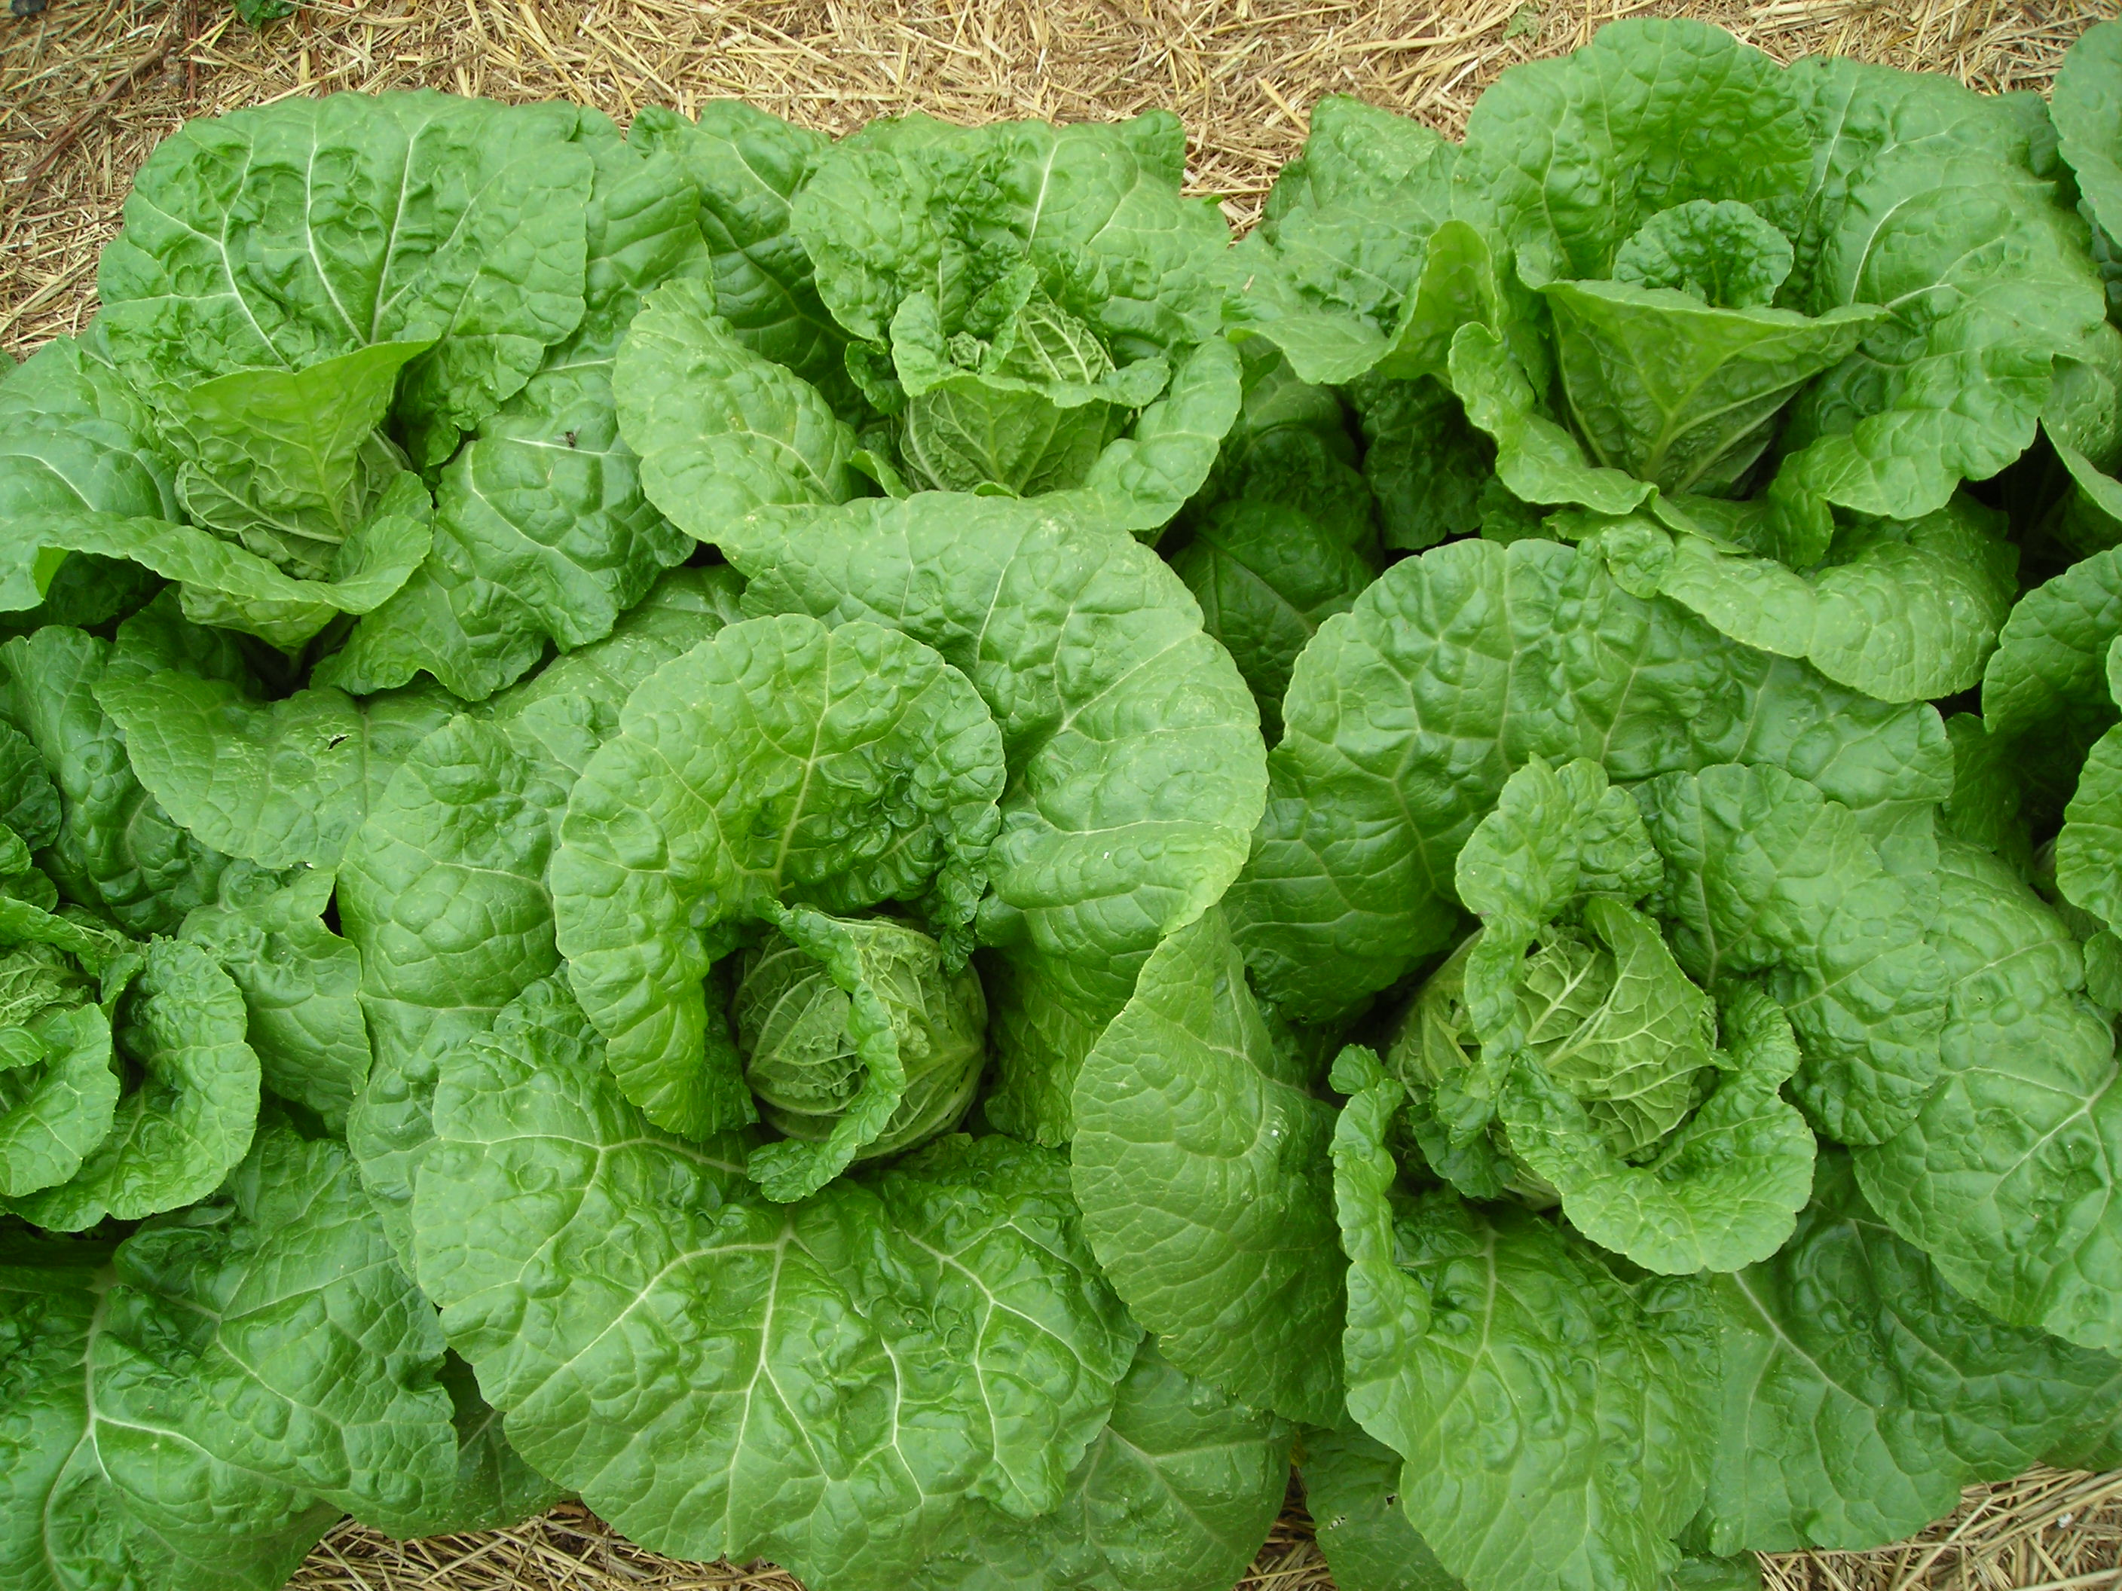
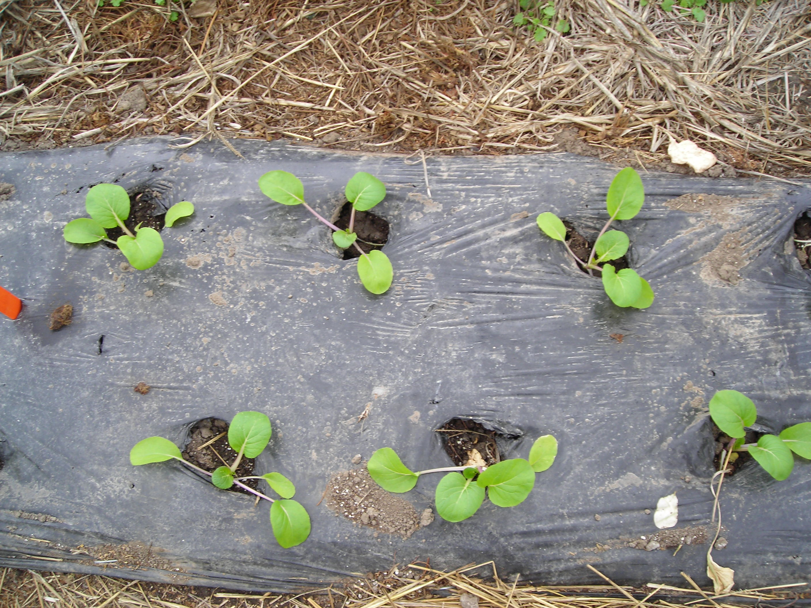

Figure 3. Napa Chinese cabbage can be established on plastic mulch with a twin row planting arrangement.
used to supply a uniform rate of water to the growing plants. Bottom watering also lowers the root zone temperature during hot weather.
Pest Management:
Chinese cabbage has a relatively fast growth rate, so it is possible to avoid many insect pests which develop later in the season. Some varieties of Chinese cabbages have a compact, vertical leaf arrangement, resulting in relatively less insect pest problems (Figure 6). Earlier plantings will also have less insect infestations. Some common pests to scout for include: slugs, aphids, cabbage worms (cabbage looper, Imported cabbageworm). flea beetles and cabbage maggots. In addition, leaf damage can be done by grasshoppers particularly during the fall. Biological or microbial pesticides such as Bt (Dipel) can be used to control worms which may damage Chinese cabbage. In addition, row covers protect the Chinese cabbage from egg-laying cabbage worm moths and cabbage maggot flies. For further information on pest control options, consult the Mid-Atlantic Commercial Vegetable Guide.
Harvest:
Chinese cabbage is harvested at various growth stages depending on the desired market. Pakchoi types can be harvested as small plants or the individual leaves cut as a salad greens. Napa and Michihli Chinese cabbages are harvested when the heads are firm. The outer wrapper leaves are trimmed off, and the heads can be placed in a cooler (35-40F) for 3-4 weeks (Figure 4). Individual heads weigh approximately 2-4 pounds.
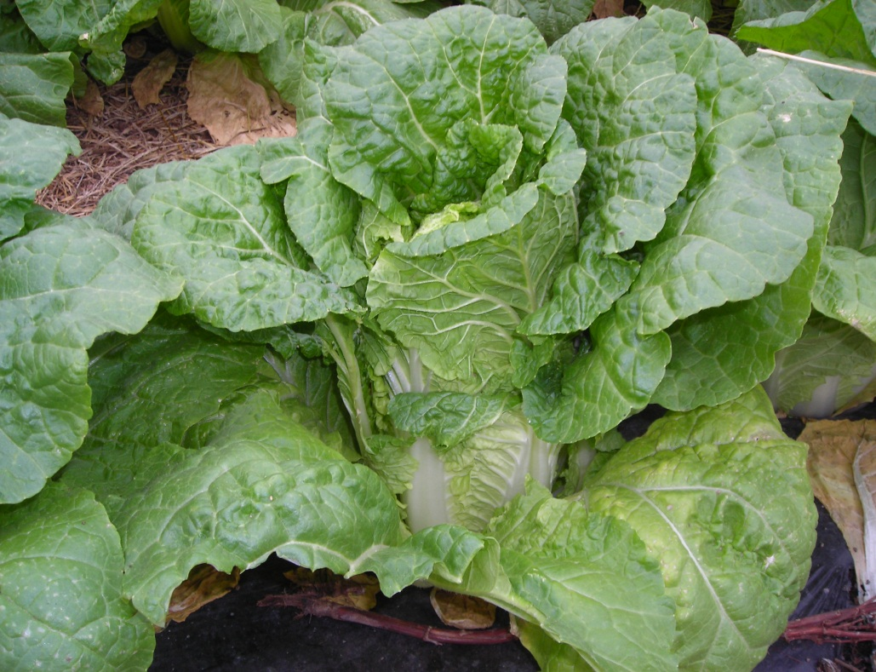
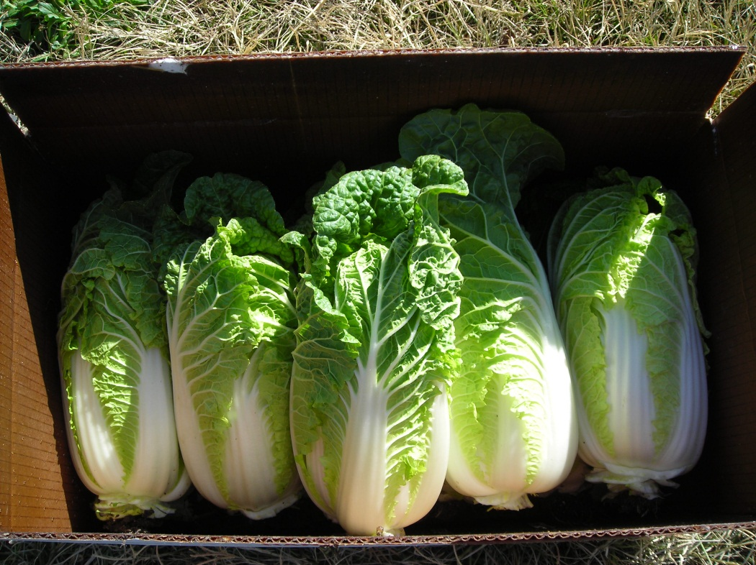

Figure 6. Napa Chinese cabbages are harvested when the heads are solid and firm.

