**High Tunnel Specialty Potato Production**

**Lewis W. Jett**

**Introduction:**

High tunnels are solar greenhouse structures which have no electrical connections or heaters. Crops are grown directly within the soil under the structure. The captured solar energy warms the soil and the air resulting in earlier (or later) planting dates. In addition, the accumulated heat units within the high tunnel structure results in earlier harvest.

Irish potatoes (*Solanum tuberosum*) are a very popular vegetable crop in West Virginia. The optimal planting date for potatoes in the open field is 4 weeks before the last frost in the spring. However, wet, spring weather in West Virginia often delays potato planting until late May or beyond. Potatoes produce a higher yield under short days and cool temperatures, so early plantings are favorable. High tunnels permit early- or late-season production of potatoes. Since high tunnels shelter the crop from rainfall, planting can be done at the optimal time.

**Preparing the site for planting:**

A commercial-sized high tunnel (30 ft wide x 96 ft long; Rimol Greenhouse Systems) was constructed on a produce farm in Lewis County, West Virginia (39° N) in 2009. The soil within the high tunnel is a silt loam with a pH of 6.0. Twelve specialty potato varieties were selected for evaluation (Table 1). Certified organic seedstock was purchased for planting in early March, 2011 (*The Potato Garden*, Austin, CO). The seeds were placed within a warm (70°F), lighted room for pre-sprouting. Pre-sprouting can result in earlier emergence of potato vines and earlier harvest. Tubers greater than 2 ounces were cut in sections and allowed to heal over approximately 3 days before planting. Potatoes should be planted when the soil temperature is greater than 45°F. A 4-inch deep furrow was made, and each seed piece placed 12 inches apart within the furrow (Figure 1). Rows were spaced 40 inches apart. Fertilizer (5-4-3) was applied prior to planting and drip irrigation used for watering the crops.

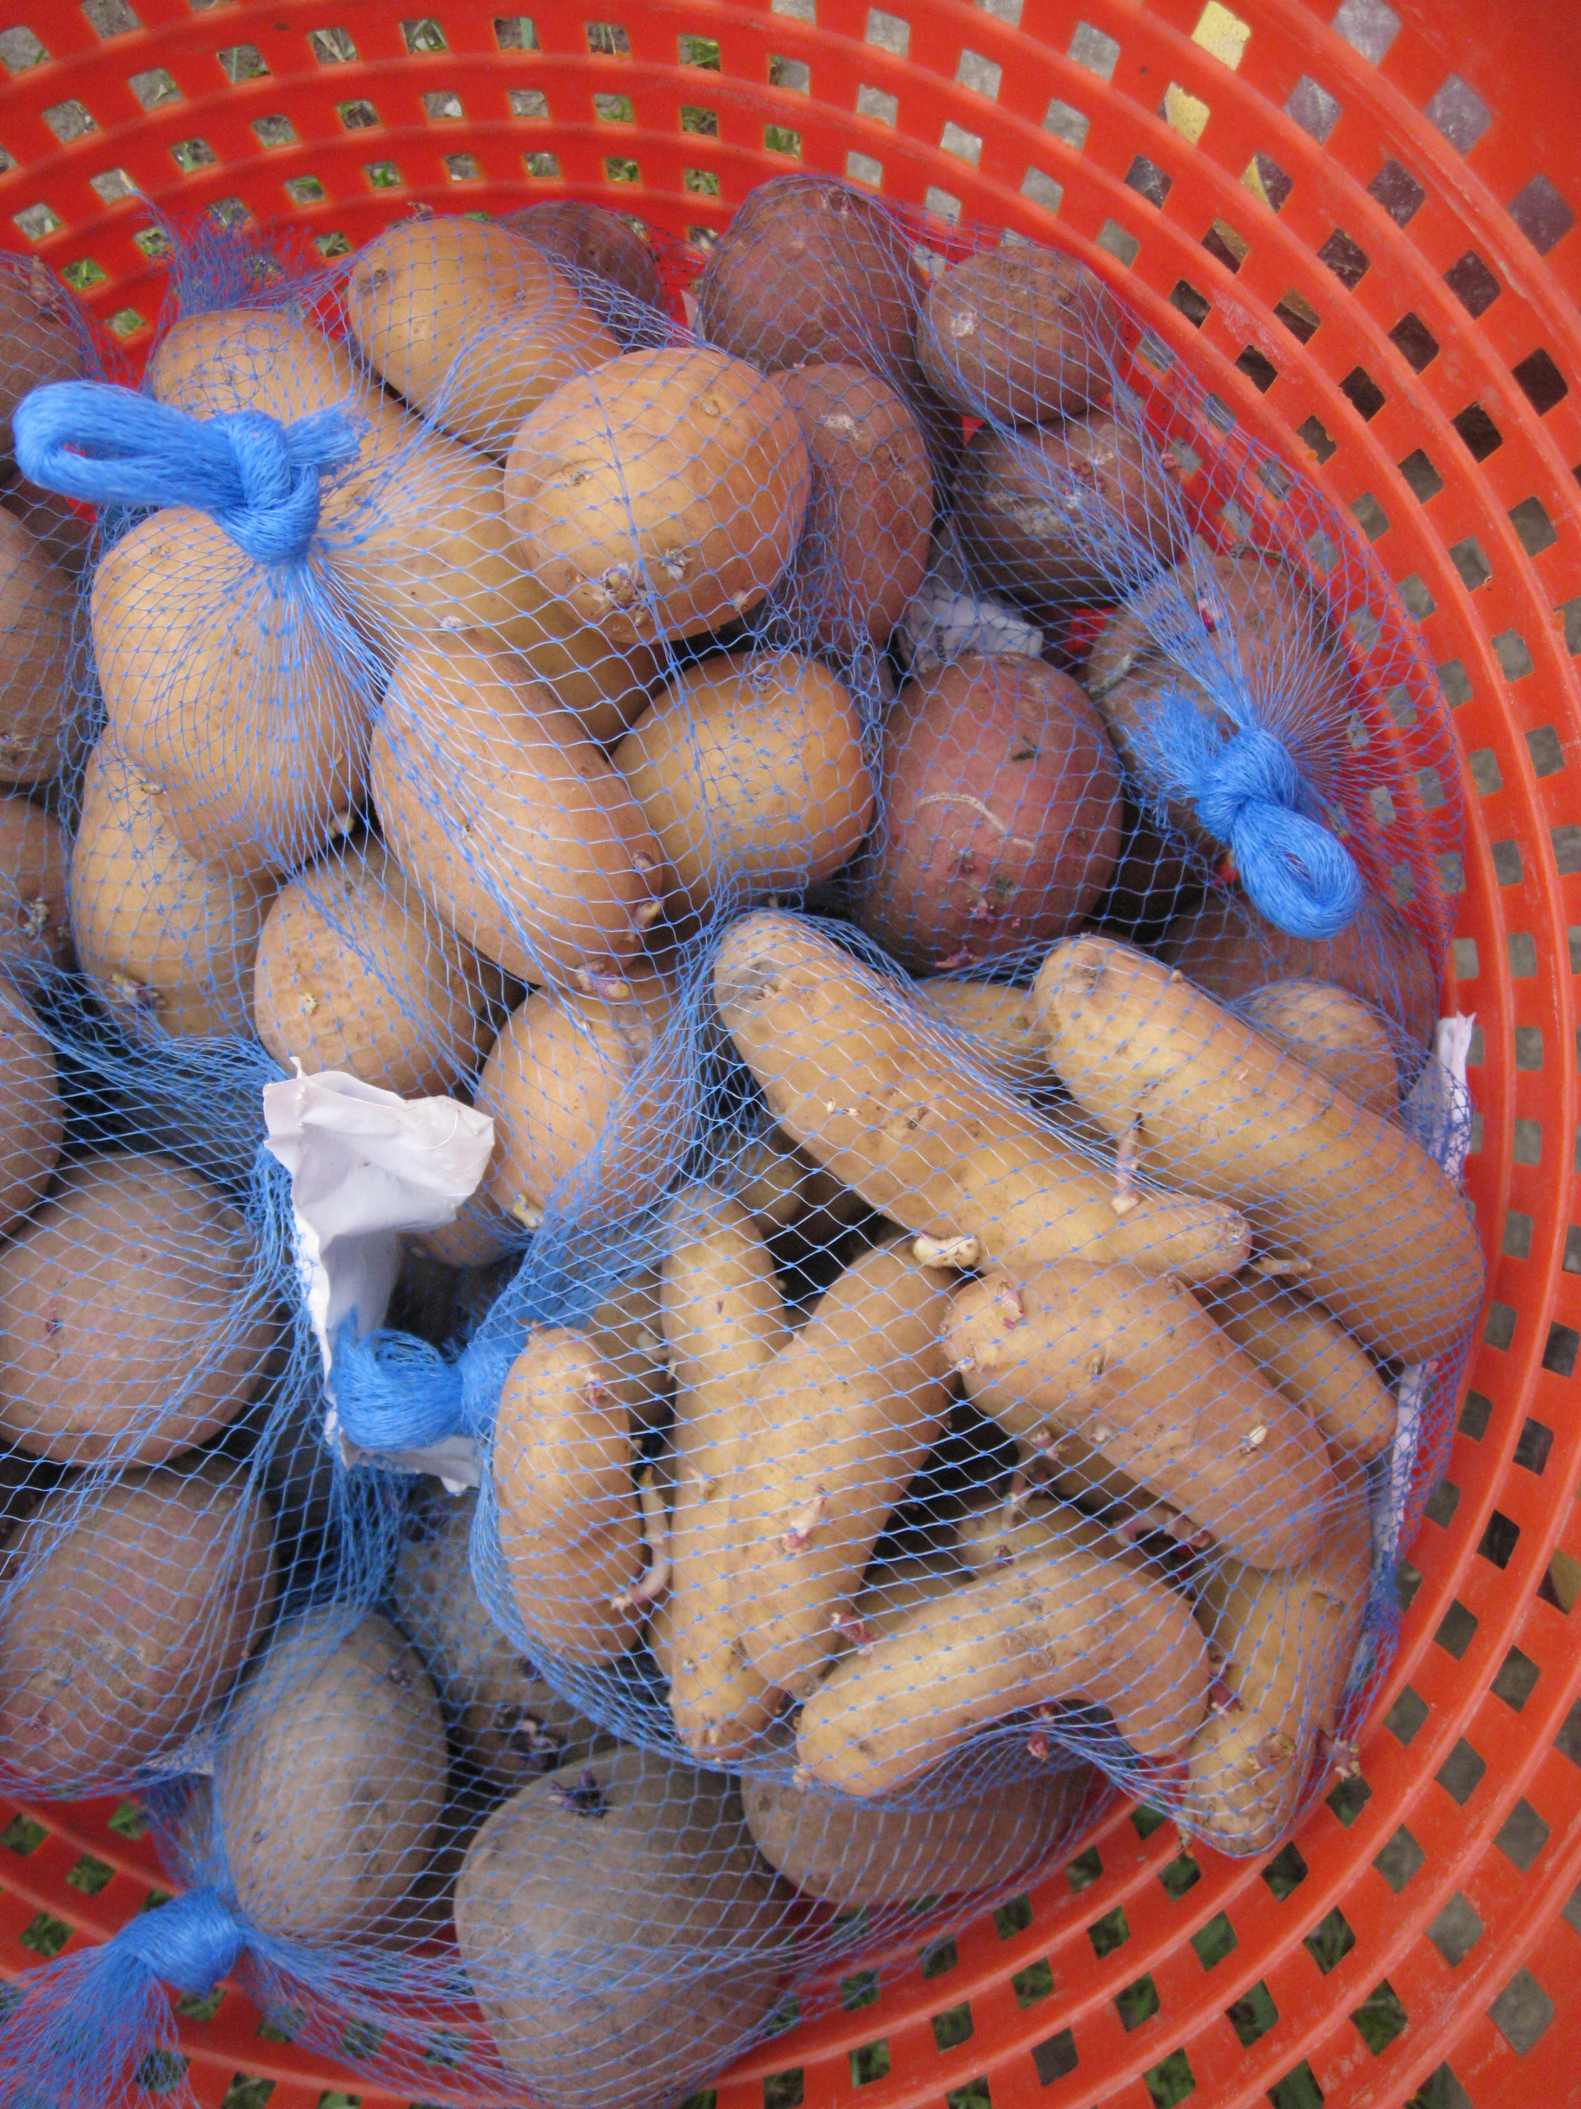

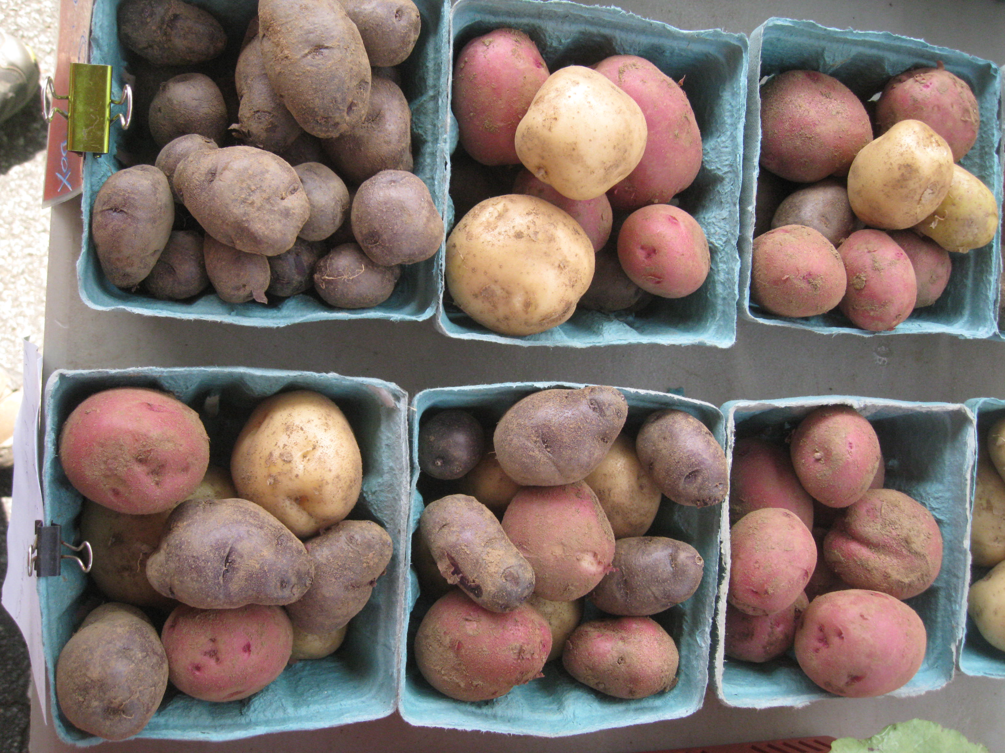

**Figure 1.** Potato seed pieces or whole tubers were planted 12 inches apart within the high tunnel in early April.

**Table 1.** Potato varieties evaluated within a high tunnel-2011.

|  |  |  |
| --- | --- | --- |
| **Variety** | **Maturityz** | **Comments** |
| **All Blue** | Late | Oblong shaped potato; blue skin and flesh |
| **Austrian Crescent** | Mid-season | Fingerling; yellow skin with light yellow flesh |
| **Carola** | Late | Oblong to round potato; good storage yellow skin and flesh |
| **Colorado Rose** | Mid-season | Smooth, red skin; white flesh; good storage |
| **Desiree** | Late | Oval shaped; Pink skin with yellow flesh |
| **German Butterball** | Late | Oval shaped; yellow flesh |
| **Kennebec** | Late | Traditional white baking potato |
| **Purple Majesty** | Mid-season | Purple skin and flesh; high anthocyanins |
| **Purple Viking** | Early | Purple skin with white flesh |
| **Red Lasoda** | Early-Mid | Smooth, red skin with deep eyes |
| **Yukon Gold** | Early | Yellow skin with yellow flesh |

zRelative days to harvest.

When the potatoes reach 6 inches in height and two weeks later, they were hilled by ridging soil against the plants. This practice promotes greater tuber formation since all the tubers which form will develop above the seed piece. On July 3, 2011, the potatoes were harvested, counted and weighed.

**Results and Discussion:**

The potatoes were harvested beginning July 2, 2011. Potatoes were separated into marketable and nonmarketable yield based on size and appearance.

**Table 2.** Marketable and unmarketable yield of specialty potato cultivars.

|  |  |  |  |  |
| --- | --- | --- | --- | --- |
| **Cultivar** | **Marketable yield/plant**  **(oz)** | **Avg. tuber wt.**  **(oz)** | **Marketable tubers/hill**  **(no.)** | **Unmarketable**  **(%)** |
| **All Blue** | 13.2 | 3.1 | 4 | 27 |
| **Austrian Crescent** | 22.1 | 1.4 | 15.7 | 19 |
| **Carola** | 20.8 | 3.2 | 6.2 | 42 |
| **Colorado Rose** | 26.4 | 4.1 | 6.5 | 3 |
| **Desiree** | 26.1 | 3.6 | 7 | 17 |
| **German Butterball** | 19.5 | 2.5 | 7.8 | 26 |
| **Kennebec** | 13.3 | 3.3 | 3.7 | 17 |
| **Purple Majesty** | 12.1 | 1.8 | 6.4 | 17 |
| **Red Lasoda** | 12.6 | 3.7 | 3.4 | 19 |
| **Yukon Gold** | 14.2 | 4.4 | 2.2 | 14 |
| SE | 1.6 | - | - | - |

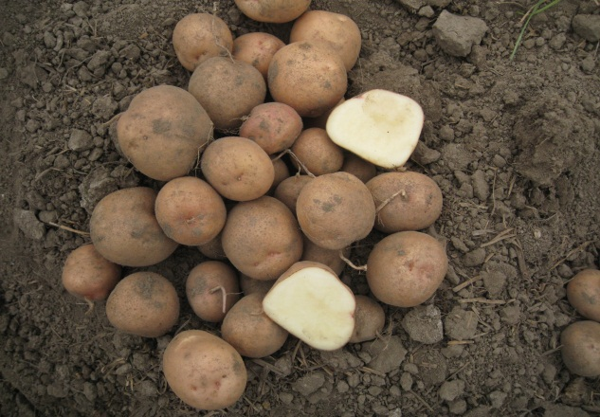

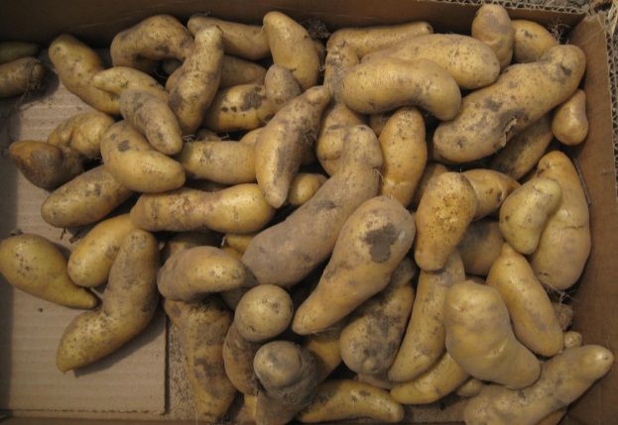

**Austrian Crescent**

**Kerr’s Pink**



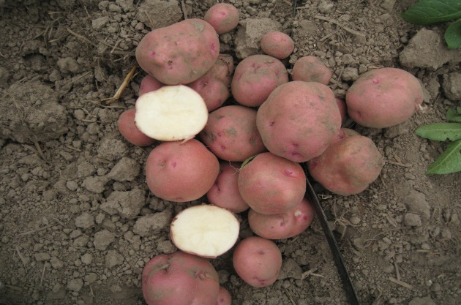

**Colorado Rose**

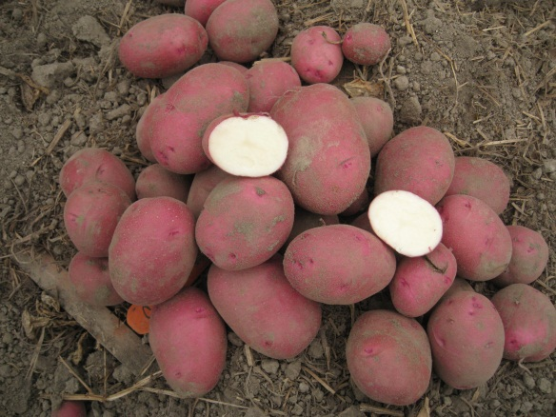

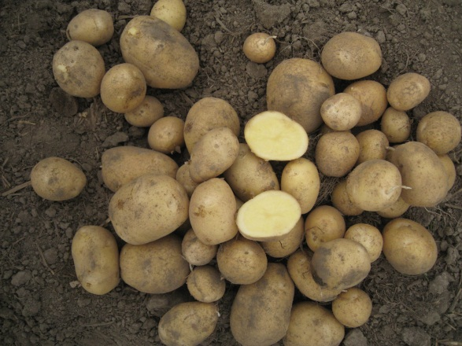

**Carola**

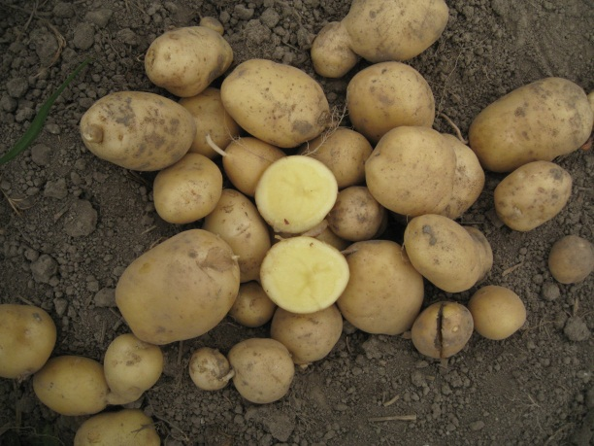

**German Butterball**

**All Blue**

**Desiree**

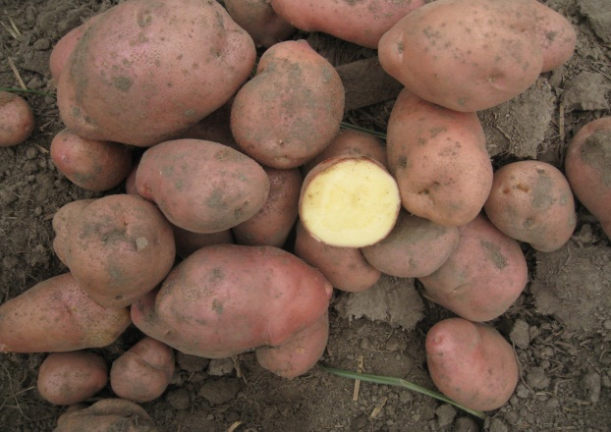

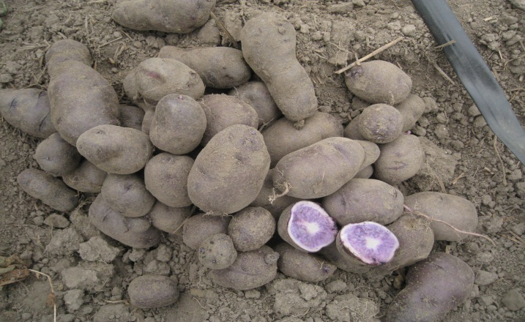

**Red Lasoda**

**Figure 2.** Specialty potato cultivars evaluated within a high tunnel-2011.