Project Number: OW10-310

Project Title: Sustainable Alternatives to the Conservation Reserve Program (CRP)

Changes since submitting original project proposal - How adaptation is part of sustainability

Initially we were to conduct the Sustainable Alternatives to Conservation Reserve Program Project on G & L Farms (Gregg Beckley). Beckley is the owner of the 6,000-acre (5,000 acres in CRP) G & L Farms that will become a century farm in 2013. Beckley was a producer collaborator in our previous alternatives to CRP project, Beefing Up the Palouse (2008-2009), and he continues to develop and implement alternative farming strategies while we document his progress. One of the decisions to be made is whether or not to plant 525 acres of certified organic wheat land into grass/legume pasture and lease it, along with an additional 500 acres already planted to improved grass/legume pasture, to a grass-fed cattle producer for $35-40/acre or to enroll the 525 acres in CRP. In addition to the lease payment, the 525 acres also qualifies for Direct and Counter Cyclical Payments (DCP) of $12-$15/acre, plus a Conservation Security Program (CSP) payment of approximately $33/acre for a total gross income of $80+/acre, which exceeds what the CRP payment would be. If Beckley plants the 525 acres to the grass/legume pasture mix, he would use the Environmental Quality Incentive Program (EQIP) to cost share fence and water development costs.

The potential to generate additional revenue from enterprise diversification and the marketing of ecosystem goods and services is also being developed. In 2009, Beckley formed the Blue Ridge Ranch Corporation (BRR) to capitalize on hunting (deer and upland birds) and recreation (trail riding, endurance riding, hunting dog field trials, etc.) opportunities. The plan is for BRR to lease the hunting and recreational rights from surrounding landowners for specific activities at specific times. So far approximately 40,000 acres have been committed to this endeavor. One of the participating ranches is in the early stages of building an RV park to accommodate visitors. BRR has formed a business alliance with Field N Marsh Outfitters called the BRR Hunt Club to manage and coordinate the hunting activities on a fee basis.

The current Sustainable Alternatives to CRP project proposed to utilize a portion of 1162 acres of contracted CRP lands expiring in September 2010. In July/August the Farm Service Agency (FSA) announced a new CRP sign-up for 2010. Beckley decided to retire and avoid the stress of managing livestock, so he pursued the CRP enrollment of his improved pasture and the 1162 acres of expiring CRP land. Cattle producer collaborator Dick Coon, who had been the cattle manager in our previous CRP grazing strategies project and was to be a collaborator on this project, decided he no longer wanted to participate due to other demands on his time. Robert and Janet Phinney, who were also listed as producer collaborators in our original project proposal, also opted out. Thus we have had to revise our plans and recruit new producer collaborators. As a result, we obtained two new producer collaborators, John Pearson (Colfax, WA) and James Wahl (Lind, WA).

John Pearson
John Pearson is a cattleman and the owner of Pearson Farm and Fence (Colfax, WA), a business that contracts fence building, as well as sells K-Line irrigation systems, fencing supplies and farm equipment.

The project team developed a demonstration study on 8 acres (Figure I) of riparian pasture owned by Pearson on the north fork of the Palouse River that had been in continuous CRP since September 1999 (contract expired September 30, 2010). The primary vegetation on the CRP site includes common tansy, reed canary grass, willows, annual grasses and patches of spotted knapweed. Pearson implemented short duration, high intensity grazing on this site in the spring of 2011 using 125 head steers. Data prior to and after grazing was collected and will continue to be collected through 2013. Vegetation and biomass changes are being monitored via 100 ft. transects (2) and 4 permanent photo points using the Land EKG monitoring system.

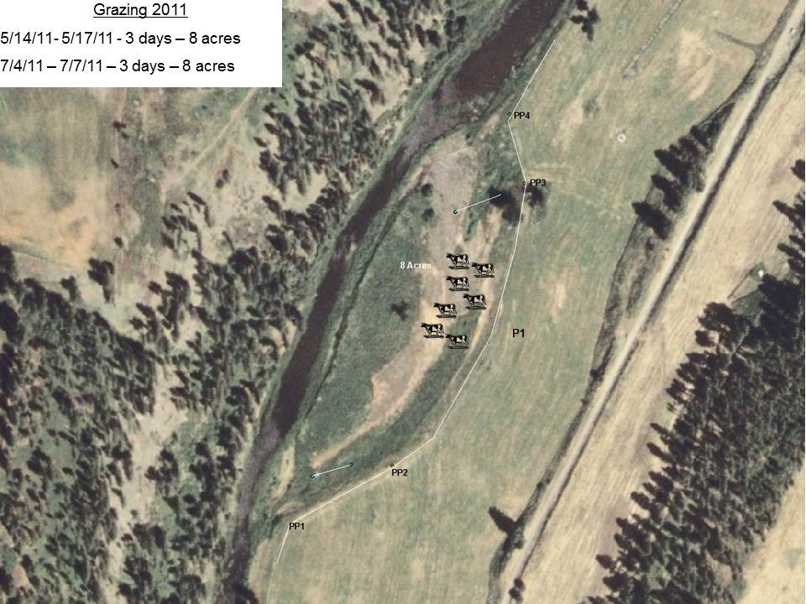

Preliminary Results - Pearson
Although the cattle grazed the area for only 2 3-day periods, forage utilization data was calculated at 30%. A large portion of the tall poison hemlock and common tansy was trodden so it became possible to move throughout the site. Grazing and data collection will continue into 2012.

James Wahl
James Wahl, a Lind, WA, farmer, is working with the J.E. Love Corp. to develop a specialty seed drill designed to provide excellent plant stands with minimal soil disturbance. The demonstration study area on Wahl’s land is approximately 25 acres within a 294.8-acre field that is currently under CRP contract. The project team applied to the FSA for a research exemption to graze the study area with cattle; however, our request was denied. We then followed up with a request to the FSA for approval to graze between July and October, 2011, which was approved although it will entail paying a 25% CRP payment penalty of about $15/acre. This study will investigate and demonstrate the agronomic, economic and environmental services provided by CRP ground with and without cattle grazing and triticale over-seeding; we will further assess triticale grain and forage varieties and seeding rates for optimum production. In the spring of 2011 (March/April), the FSA approved another re-enrollment of CRP. During this time James Wahl pursued re-enrollment of his soon-to-be expiring CRP contracts, thwarting our plans to begin grazing in the fall of 2011. Once again, we had to pursue other cooperators for grazing CRP land. As a result, we enlisted the support of Frank Garrett as a cooperator.

Frank Garrett
Upon acquiring Frank Garrett as a cooperator, we developed yet another CRP grazing project specifically designed to fit our cooperator’s situation. Frank was leasing from his daughter-in-law a 92-acre parcel of land that had expired from a CRP contract in September 2009. Frank had grazed the parcel from May 6 through October 3, 2010, with 28 pairs and 1 bull. In the spring of 2011, we set up the study area in order to graze 3 rotation pastures throughout the 2011 growing season. To monitor and evaluate the grazing impacts, we established and have been using 3 EKG transects and 3 permanent photo points within 2 exclosures. The exclosures provide data on grazing utilization and species diversity and regeneration (Figure II). We also fenced off a small area (0.38 acre) in the neighboring winter wheat crop to demonstrate the effects of grazing on crop production; 20 head grazed this area for 4 hours on May 23, 2011.

Preliminary Results – Garrett
The average daily gain of the cattle over the entire grazing period was 1.68 lbs. Considering the forage this was adequate but not as good as we had hoped. The nutritional value dropped off rapidly later in the summer and the cattle failed to perform as well on poorer vegetation (pastures 2 and 3). The grazed wheat had 51% utilization. After 1 month there was 64% less biomass in the grazed wheat compared to the ungrazed wheat. Immediately preceding harvest (August 3), there was 21% reduction in biomass from grazed to ungrazed. Grain yield was 37% less in grazed area compared with ungrazed. Vegetation monitoring and data collection will proceed into 2012.

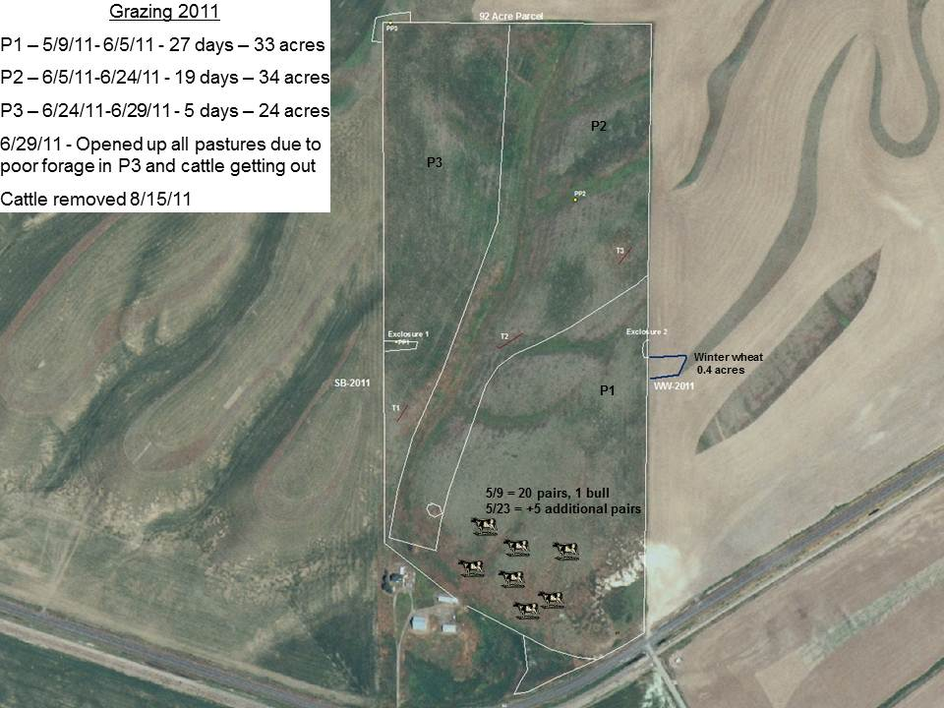

After collecting data and grazing the 92-acre block in 2011, we were advised that the landowner was signing up the 92 acres into CRP starting September 2011. We will still collect the data off the site in 2012 but cannot graze the area. We again had to scramble to locate another cooperator. During this time WSARE collaborator/investigator Steve Van Vleet was conducting a grazing study at the Dalles Mountain Ranch. As with the WSARE project, the Dalles Mountain Ranch grassland restoration project aims to restore degraded grassland and return it to healthy and productive land.

Dalles Mountain Ranch-Columbia Hills State Park
The Dalles Mountain Ranch, located near Dallesport, WA, is a historic ranch dating back to the 19th century. The project area is a 180-acre parcel of rangeland lying within the ranch that had been used for livestock production for decades. In 1992, the pasture and native range were tilled and planted to Secar bluebunch wheatgrass and Sherman big bluegrass. The property was subsequently (1994) acquired by Washington State Parks. Since then no management has occurred on this 180-acre parcel, which, as a result, has become a monoculture of Secar bluebunch wheatgrass. This exemplifies what has occurred with idle CRP land throughout Washington State. Since acquiring Dalles Mountain Ranch, the State Parks have aspired to manage the historic ranchlands by bringing livestock back to graze, so long as the land is managed in a sustainable and ecologically conscious manner. A team of research scientists was assembled to accomplish this objective.

The State Park’s objectives for operating the ranch were and remain as follows:

- Maintain the ranch as a historical site
- Showcase the ranch as a learning site (to include the training of public and state park employees on proper grazing management and to diffuse negative perceptions of livestock grazing on public lands)
- Identify, assess, monitor, protect and restore plant and animal communities associated with grasslands, oak woodland, and spring-fed riparian areas
- Publicly promote the ranch (much like central Idaho’s “Running of the Sheep”)
- Incorporate limited livestock production using state-of-the-science management
- Demonstrate techniques to hold family ranches together
- Manage the onslaught of invasive weeds entering park land

To diffuse the concerns of the environmental community about allowing livestock to graze public land, the project team conducted several on-site sessions with members of the Native Plant Society and Friends of the Columbia Gorge to jointly evaluate and document the plant ecosystems of the degraded grassland. A proposed plan to rehabilitate the idle grassland using managed rotational grazing was submitted, circulated, revised and fine-tuned over a period of nearly a year before it met with the approval of State Parks, Friends of Columbia Gorge and the Native Plant Society. A cooperative work permit between WSU and Washington State Parks was secured in 2009 and the plan was put into play.

Prior to introducing livestock onto the project site, various data-collecting tools were established. Jornada sampling transects were placed in each pasture, while EKG transects and 5 permanent photo points were established throughout the project area. All fence locations, sampling points, invasive plant populations, watering areas and native plant habitat were mapped via GPS. Biomass clippings were taken to determine amount of forage availability and to estimate stocking densities. The grazing portion of the project began in November 2009 (the dormant season) and lasted 1 month. Grazing was cut short in pasture 3 due to inclement weather.

2009 Grazing Rotations
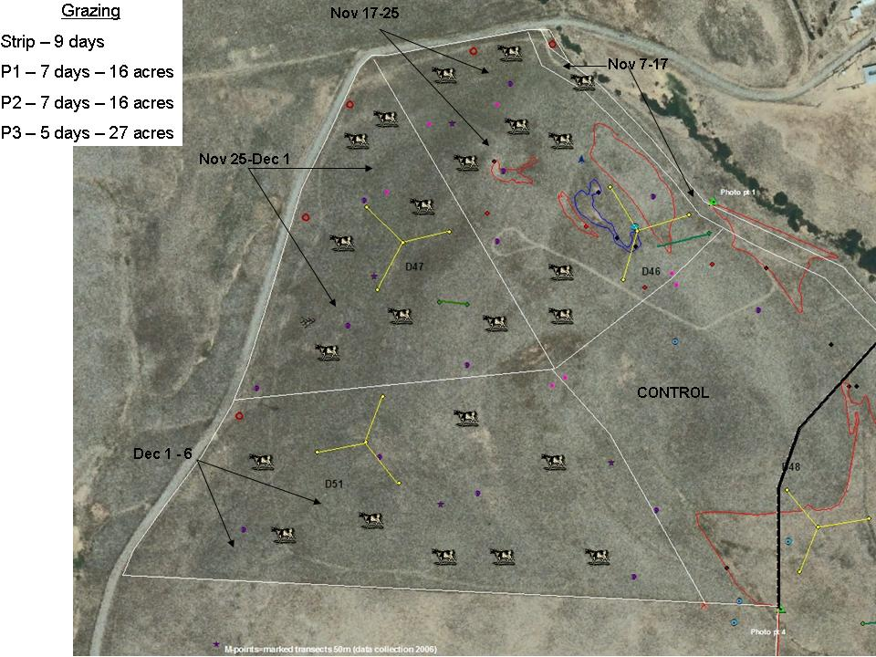

Preliminary Results - Dalles Mountain Ranch 2009/2010

Based on preliminary data collected from transects in 2010, the November 2009 grazing period resulted in an increase in forb lomatium of 95%, in lupine of 23%, and in arrowleaf balsamroot cover of 13%. Cattle had utilized the cool-season bunch grasses from a height of 24–30 inches to a healthy stubble height of 6–10 inches. Within a week of grazing, evenly distributed grazing impacts were obvious. Upon visiting the site, the director of Friends of the Columbia Gorge (a retired ecologist) was pleased by the evenly grazed paddocks and late-season green-up. The State Parks Stewardship Chief and the Parks Manager were also very satisfied with the even grazing and areas of likely wildflower emergence. Changing personal mindsets about the value of managed grazing as a restorative tool of degraded grassland has been and continues to be a significant outcome of the Dalles Mountain Ranch project.

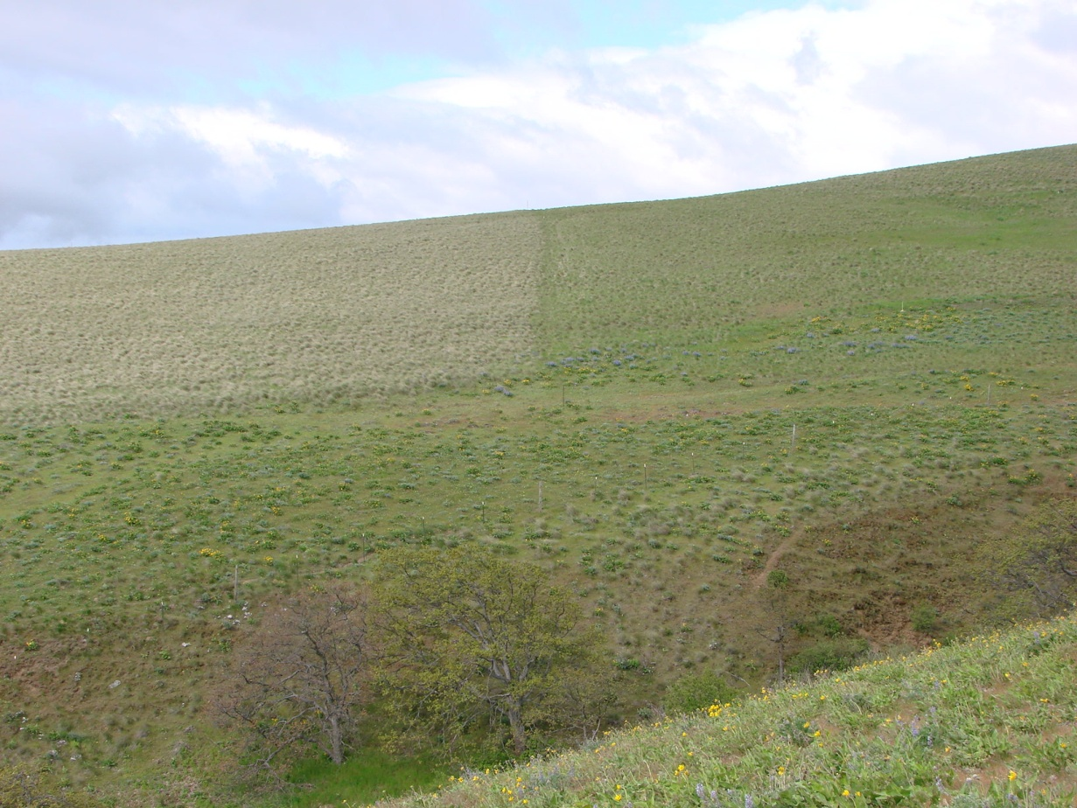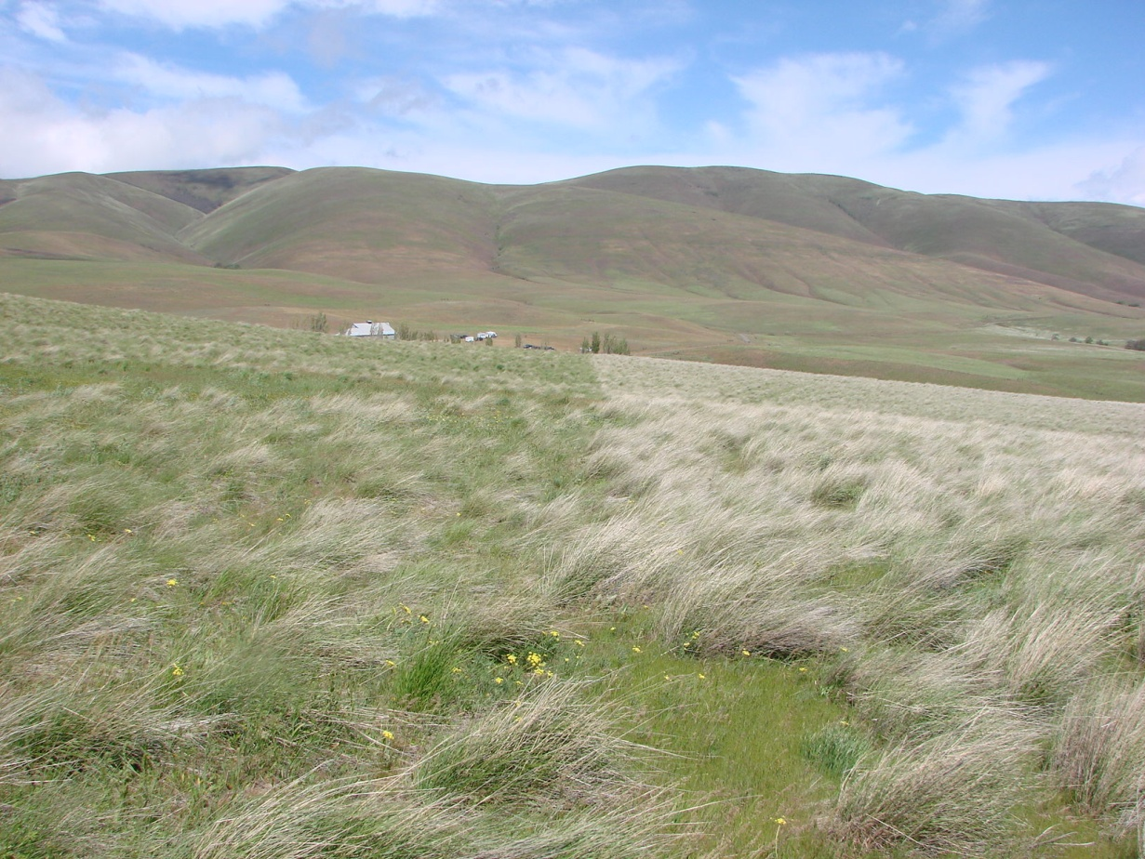

Over the summer and early fall of 2010, a watering system for the livestock was developed. In cooperation with State Parks a water line was installed from the ranch house to the pastures to be grazed (Figure VI).

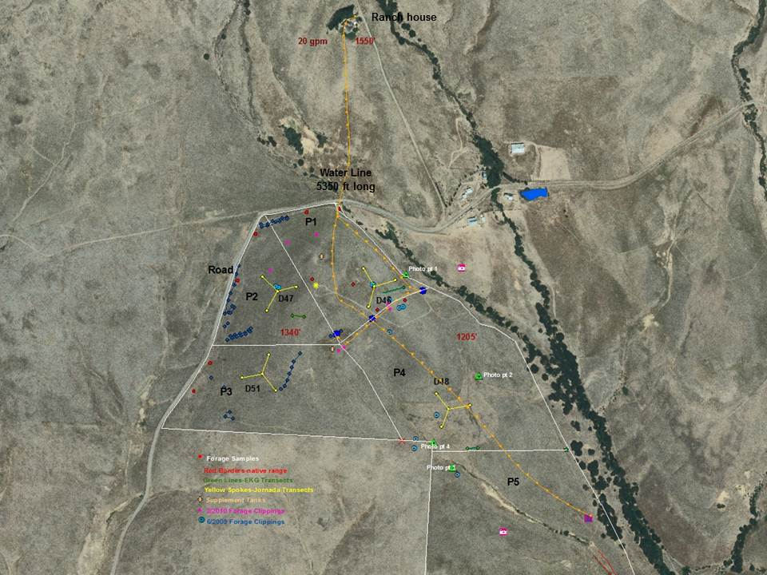

On November 14, 2010, 130 head cattle were released into pasture 5. They were later removed on November 22 due to inclement weather and were not returned due to unrelenting severe weather.
On November 6, 2011, we initiated our grazing trial by releasing 134 head of bread cows into pasture 4. The grazing schedule can be seen in Figure VII.

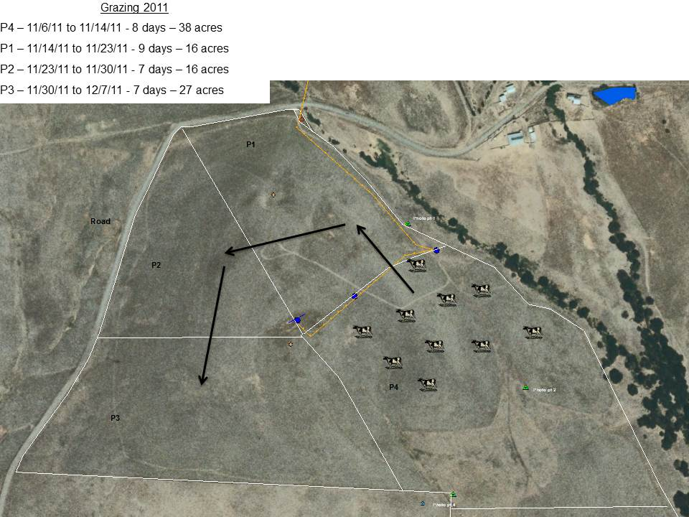

Forward-Looking Plan for WSARE Project
In 2011 we learned that the limited Renewable Resources Extension Act (RREA) funds (funds providing guidance in rangeland stewardship and health) for the Dalles Mountain Ranch Project were being reduced due to budget cuts. Ironically, this funding shortage occurred at the same time that we collaborators on the WSARE project were experiencing difficulty securing the lasting cooperation of livestock producers with expiring CRP lands. A compatible and satisfying solution to this dilemma would be to incorporate into the WSARE project the ongoing Dalles Mountain Ranch research and combined efforts of investigator/collaborator Steve Van Vleet and native plant specialists to rehabilitate the CRP-like range. Van Vleet’s familiarity with both projects will enable the smooth incorporation of research data.

From these longer-term projects, we have determined that it takes 3+ years to obtain reliable results. We have also encountered the impacts of simple passage of time (e.g., aging of cooperators, shifting of financial resources, and voicing of environmental concerns), all while adapting to the inputs of various stakeholders. Regardless of such obstacles, the WSARE and Dalles Mountain Ranch projects will persevere as they have successfully done in the past because that is the essence of sustainability.

