

**Reduced Tillage**

**Demonstration Projects - 2011**

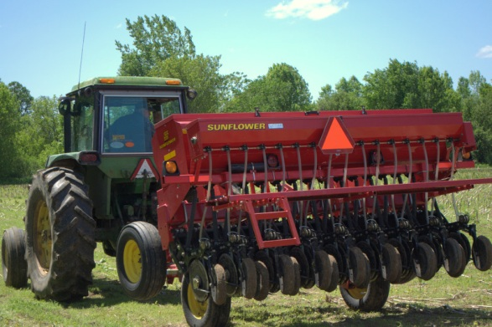

Dr. Heather Darby, UVM Extension Agronomist

Brian Trudell and Amanda Gervais, UVM Extension Agronomic Outreach

(802) 524-6501

Visit us on the web. <http://ww.uvm.edu/extension/cropsoil>

© November 2011, University of Vermont Extension

**Reduced Tillage Demonstration Projects - 2011**

Reduced tillage practices have tremendous potential to reduce farmer expenses, maintain yields, and reduce potential negative environmental effects caused by cropping operations. Conventional tillage practices require heavy machinery to plow and groom the soil surface in preparation for the planter. The immediate advantage of reduced tillage is less fuel expense, less equipment and labor required. It’s also clear that intensive tillage increases nutrient and soil losses to our surface waterways. By turning the soil and burying surface residue, more soil particles are likely to detach from the soil surface and run off from agricultural fields. Reducing the amount and intensity of tillage can help build soil structure and reduce soil erosion.

This project proposes to build upon efforts by UVM Extension to increase farm acreage in reduced tillage annual cropping systems by: 1) providing cost share funds to retrofit corn planters to become no-till capable, 2) providing trainings for farmers to help them retrofit their own machinery and to operate it successfully, 3) documenting the ability of reduced tillage systems to improve soil and water quality as well as farm viability, and 4) produce videos and published materials for distribution to educate more farmers on implementing reduced tillage systems on their farms.

The UVM Extension reduced tillage program includes four pieces of equipment that are being used to implement demonstration projects on farms in the Lake Champlain Basin- the White 8106 no-till/ zone-till planter, the Blu-Jet strip tiller, the Sunflower no-till drill, and multiple planter retrofits. Based on research conducted in other crop areas, no-till and zone-till can compete with conventional tillage yields. However, many farms experience reduced yields during the initial two to three years of transition from conventional to reduced tillage. In 2010 and 2011 UVM Extension research has shown that transitioning a continuous corn field directly into no-till will reduce yield. Therefore providing costshare, equipment, and technical assistance are all keys to assisting farmers with long term adoption of reduced tillage. Below is a summary of the UVM Extension Reduced Tillage Demonstration Projects.

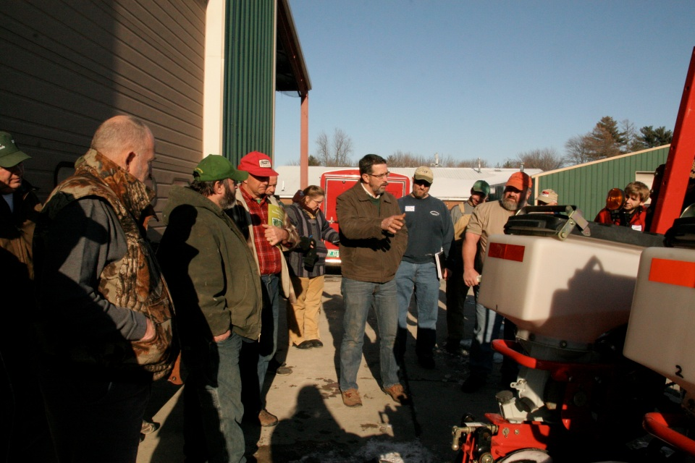

**Above: Mark Anderson (NY farmer) at No-till workshop (center) talking with farmers about no-till equipment and techniques with White 8106 Planter (right)**

In 2011, four reduced tillage projects were implemented in the northern Lake Champlain watershed. Our no-till corn planter had another great year, surpassing 500 acres of planting for the second year in a row. We were able to collect some no-till/strip-till comparison data this season by utilizing GPS navigation technology in cooperation with the Palardy Farm. Our no-till drill completed its first season with over 250 acres of spring plant and fall cover crop planting. Our first year of no-till retrofits covered over 600 acres.

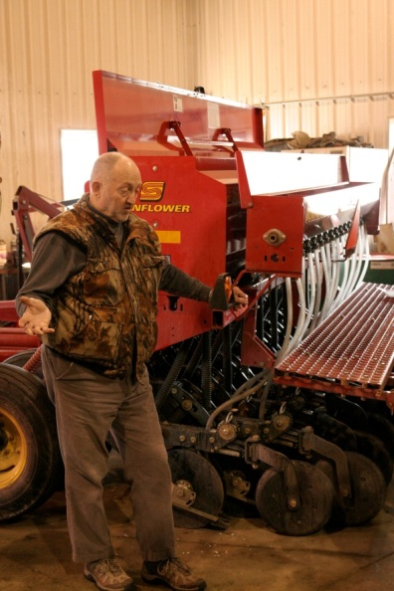Outreach during the winter of 2011 helped farmers learn how to retro-fit corn planters to operate as no-till, strategies to transition to no-till, how to operate a no-till drill, and how to have success with no-till planters. This information was covered by Mark Anderson a dairy farmer from New York that farms over a thousand acres of reduced tillage crops. He implements a variety of reduced tillage implements including Aerways, zone-till, no-till, and strip tillage. His practical and applicable knowledge encouraged many farmers to sign-up to use the no-till planter. In addition, Joel Meyer from PA No-Till Association was a guest speaker at the meeting. Joel talked about soil quality and how that will influence your no-till success. In addition, he talked about how to retro-fit a planter and how to operate the no-till drill. There were 52 attendees at the workshop.

Two videos were developed to help farmers set up their planters for no-till planting. These videos can be found at <http://www.youtube.com/user/cropsoilsvteam#p/u/36/rhTHvgp5kfg> and <http://www.youtube.com/user/cropsoilsvteam#p/u/19/kTAT9dB1qZM>. So far there have been over 2000 views of the video on YouTube.

**Above: Joel Meyers at workshop with drill in background**

**WHITE 8106 NO-TILL/ZONE-TILL PLANTER**

The White 8106 row planter was purchased though a NRCS CIG grant in 2010. The planter has the ability to plant both no-till and zone-till corn and soybeans. In the first season individual farmers were allowed to sign-up to use the planter. Unfortunately, this sharing arrangement proved to be ineffective. The 8106 is much more complicated than conventional planters. The seed depth is very important to seed emergence and the zone-till attachment also has a relatively steep learning curve. Since farmers had no experience with the planter, many corn stands were not at optimal populations. It was clear that another system was needed to help farmers overcome this steep learning curve with no-till planters.

In 2011 UVM Extension teamed up with Scott Magnan’s Custom Service with the intent of improving no-till planting success. Instead of having the planter change hands at every farm, it was decided that one operator would be able to fully learn the mechanics of operating no-till planters and at the same time potentially cover more acres. Scott kept the planter on his tractor for the spring planting season. Our goal was to cover at least 500 acres on at least 5 farms. The cost of planting for 2011 was $12 per acre- $7 to be paid by the farmer and the remaining $5 to be paid by cost share through UVM Extension grants. Scott agreed to report client and field information so that we could monitor the progression of fields. Just as farmers experienced last year, Magnan’s team had initial difficulty operating the planter. As they were able to build knowledge and experience with the equipment, corn stands improved. By the end of season Scott Magnan’s Custom Service planted 500.5 acres of corn and soybeans including 203.5 acres of no-till, 157 acres of zone-till, and 115 acres of conventional planting for comparison purposes.

**Summary of reduced tillage demonstration farms - 2011**

|  |  |  |  |  |  |
| --- | --- | --- | --- | --- | --- |
| **Location** | **Date** | **Crop** | **Acres** | **Practice** | **Prev Crop** |
| Gore Rd | 25-May | Soybeans | 25 | Zone-till | Corn |
| Gore Rd | 25-May | Soybeans | 10 | Conventional | Corn |
| Skunk Hill | 27-May | Corn | 25 | Zone-till into winter rye | Corn |
| Borderview | 31-May | Corn | 1 | Zone till | Various |
| West Enosburg | 1-Jun | Corn | 4 | Zone-till | Corn |
| West Enosburg | 1-Jun | Corn | 7 | No-till | Hay |
| West Enosburg | 1-Jun | Corn | 3.5 | No-till | Pasture |
| East Highgate | 2-Jun | Corn | 25 | No-till | Hay |
| East Highgate | 3-Jun | Corn | 35 | Conventional | Corn |
| Hanna Rd | 5-Jun | Corn | 90 | No-till | Hay |
| Alburgh | 8-Jun | Corn | 40 | No-till | Corn |
| St. Albans | 11-Jun | Soybeans | 10 | Conventional | Corn |
| St. Albans | 11-Jun | Soybeans | 13 | Zone Till | Oats |
| St. Albans | 11-Jun | Soybeans | 28 | Conventional | Corn |
| St. Albans | 11-Jun | Soybeans | 7 | Conventional | Rye |
| Sheldon | 15-Jun | Corn | 30 | Zone till | Corn |
| St. Albans | 15-Jun | Corn | 25 | Zone till | Corn |
| Stonehouse Rd | 17-Jun | Corn | 15 | No-till | Hay |
| State Park Rd | 18-Jun | Corn | 25 | Conv.- Harrowed | Corn |
| State Park Rd | 20-Jun | Corn | 23 | No-till | Hay |
| Milton | 27-Jun | Corn | 25 | Conventional | Corn |
| Machia Rd | 9-Jul | Corn | 9 | Zone till | Corn |
| Fairfield | 14-Jul | Corn | 25 | Zone till | Corn |
|  |  |  | **500.5** |  |  |

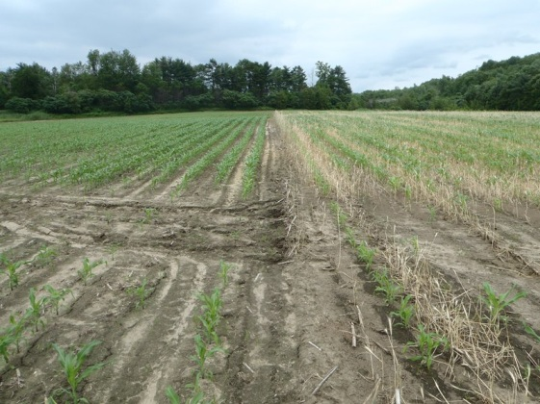Below is a documentation of success and learning opportunities during the 2011 season. Early season corn planting at two farms resulted in poor stands. These poor stands were a result of planter operator error including improper seed depth and/or over-application of liquid fertilizer during planting. These issues were quickly identified and addressed. Subsequent stands did not experience these issues. However other issues such as army worm damage were identified in fields that were no-tilled into perennial forage stands. This appeared to be a direct result of the high surface residue remaining from the previous perennial crop. In one case, army worms had done significant damage to a no-till field that was adjacent to a conventional field. The conventional field was not affected by the worms.

There were also many successful no-till production fields in the target area. Corn that was planted into herbicide terminated hay fields yielded especially well. For example, the State Park Road location was planted on June 20 after one cut of grass was taken off the field and yielded 14.8 tons/acre of corn silage in the fall.

**Above: Erosion as water flows from the no-till field on the right to the conventionally tilled field on the left.**

Plans for 2012 include a continued partnership with Scott Magnan’s Custom Service. We have already agreed to new terms for the 2012 cropping season. Changes include a cash incentive for farmers to do side-by-side comparisons.

**NO-TILL CORN PLANTER RETRO-FITS**

This spring UVM Extension retrofitted farmer owned planters so they could plant no-till corn on their operations. Conventional corn planters can be retrofitted by adding kits that manage surface residue, improve soil placement, and increase reliability of closing kits. Retrofits cost about $5,000 for a six row planter. This included six residue manager kits, six coulters, and six closing wheel units. The retro-fits covered 627 acres on four farms in Franklin and Grand Isle Counties. One farmer, who also implemented the strip-till project, has been producing no-till corn and soybeans for years. This planter was equipped with upgraded closing wheels that greatly improved his planter’s performance. Two farmers covered over 400 acres with their completely retro-fitted no-till planters. These farmers saw similar yields between their conventional and no-till fields, all while not having to pull tillage equipment through fields. When considering savings of no-till over tillage, it is important to consider cost savings as well as reductions in soil loss. Machinery custom rates for tillage range from 10 to 30 dollars per acre and average between 15 and 22 dollars per acre. In order to chisel plow and disc a field using a custom operator the cost would be expected to be $35 per acre. When considering soil loss calculations for agricultural fields we consider things like soil type, field slope, and management practices. Soil loss for a Covington silty clay loam (0 to 3 percent slopes) in a fall moldboard plow scenario can be expected to have 2 tons per acre per year of soil loss. By eliminating the moldboard plow and using a no-till system the same field can be expected to lose 0.2 tons per acre per year of soil. That’s just one tenth of the conventional system!

The fourth farmer saw the best corn yields on his farm in his no-tilled fields. The farm’s conventional corn suffered damage during Tropical Storm Irene. Wind gusts knocked down corn in conventional stands, but did not damage the no-till corn. All these farmers are planning on planting similar acreage of no-till corn again next year in combination with conventional tillage on other fields.

**BLU-JET COULTER PRO STRIP-TILLER**

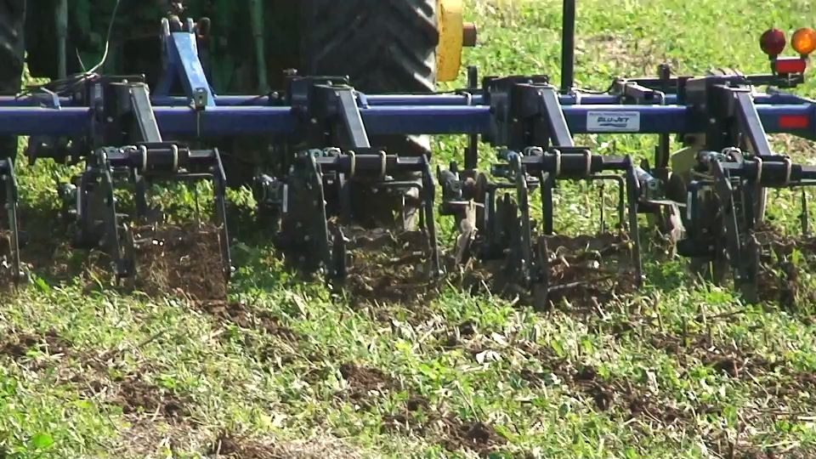

**Above: Blu-Jet Strip Tiller making tilled strips into a winter rye cover crop.**

In addition to using the Blu-Jet strip tiller for reduced tillage research on Borderview Research Farm, the strip tiller prepared 160 acres of corn ground at a farm in Alburgh, Vermont. The Blu-Jet Strip Tiller was purchased through a NRCS CIG grant in 2010. The demonstration farm uses GPS technology that allows them to plant on top of a narrow strip of ground that is prepared with the Blu-Jet strip tiller in advance of planting. The strip-tiller pulls a deep shank and coulters through an eight to ten inch strip of ground that the seed will be planted in (Image 2). The demonstration farm implemented a no-till/strip till comparison in several of fields this season. Before harvest yield data was collected from two fields.

In one field “Below Barn”, no-till and strip till techniques were used intermittently. We used this field to gather a small data set that can be seen below. Plant populations were higher in

**Table 1. Yields from demonstration plots comparing no-till and strip till.**

areas that were strip tilled but we were surprised to see that yields were not higher (than no-till) in strip till plots collected. You will also notice two plots we collected from another strip till field on the farm, “Behind House”. This field performed much better, likely a result of the better drained Benson soil. It should be noted that this was a small demonstration and management decisions should be made using replicated research with strong statistical analysis.

**SUNFLOWER NO-TILL DRILL**

UVM Extension purchased a no-till Sunflower 10 ft grain drill in the spring of 2011. The drill purchase was funded through the Agency of Natural Resources Ecosystem Restoration Program. The drill spent as much or more time in the shop than it did in the fields because we were converting the planter from a three-point-hitch to a pull-type planter. Only tractors can move implements with a three-point-hitch, making transportation of the drill slow and inconvenient. After one unsuccessful attempt, the right modifications were made to make the drill an effective pull-type planter. Our programs focus on reducing the intensity of tillage practices on annual crop fields in Franklin and Grand Isle counties and surrounding areas. As one farmer put it “the no-till drill was a critically need piece of equipment in Franklin County”.

The planter made it to two farms in the spring for re-plants. One farmer interseeded alfalfa into a stand that had suffered heavy alfalfa winter kill. The other spring plant was done by a farmer whose fields were submerged in water during the spring Lake Champlain flood levels. His mix of red clover and grasses came well in areas of the field that were no longer saturated but failed to germinate in poorly drained areas of the field. This allowed farmers to reseed these fields without having to go back into the field and plow. The planter covered 75 acres in the spring.

The drill was busy during October and into November planting winter rye cover crops into pastures, corn fields, and soybean fields. There were approximately 160 acres of winter rye seeded with the no-till drill. One farmer liked it so much that he is considering purchasing his own no-till drill for his custom service operation.

**Summary**

Having reduced tillage implements at the hands of farmers has increased availability, awareness, and evidence that reduced tillage is a viable option for farmers. There has been an increase from 500 acres to over 1200 acres of reduced tillage as a result of this demonstration project.