Manure sites
No-till sites

Figure. 1. No-till (red circles) and manure (brown circles) locations
of on-farm research experiments.

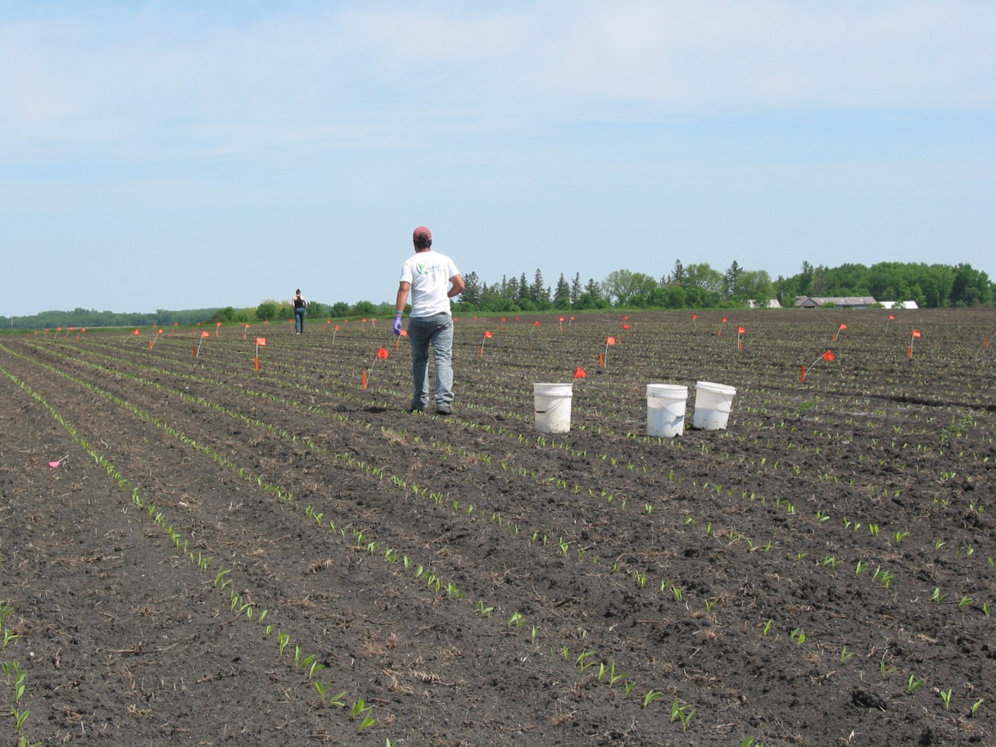
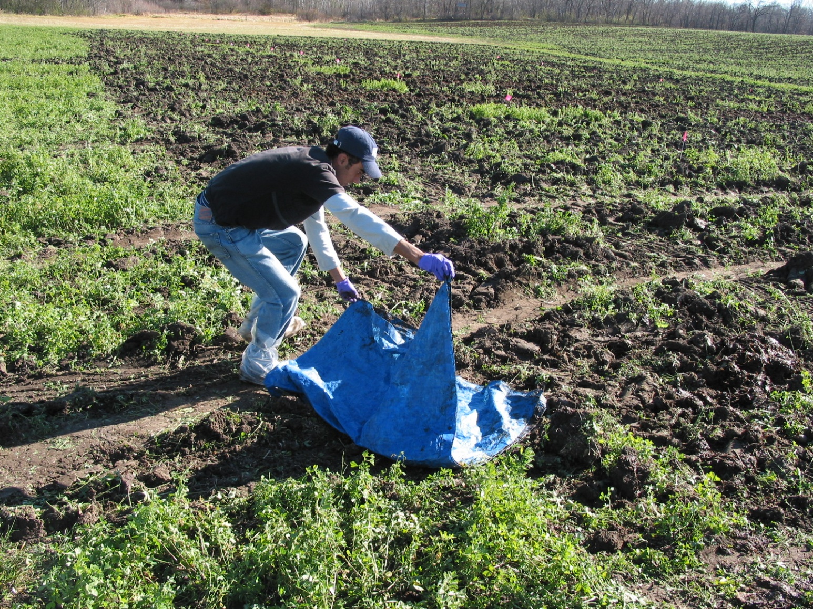

Picture 1. Measuring manure application rate at St. Rosa, MN.
Picture 2. Applying broadcast N fertilizer at Waseca, MN.
Picture 1. Measuring manure application rate at St. Rosa, MN.

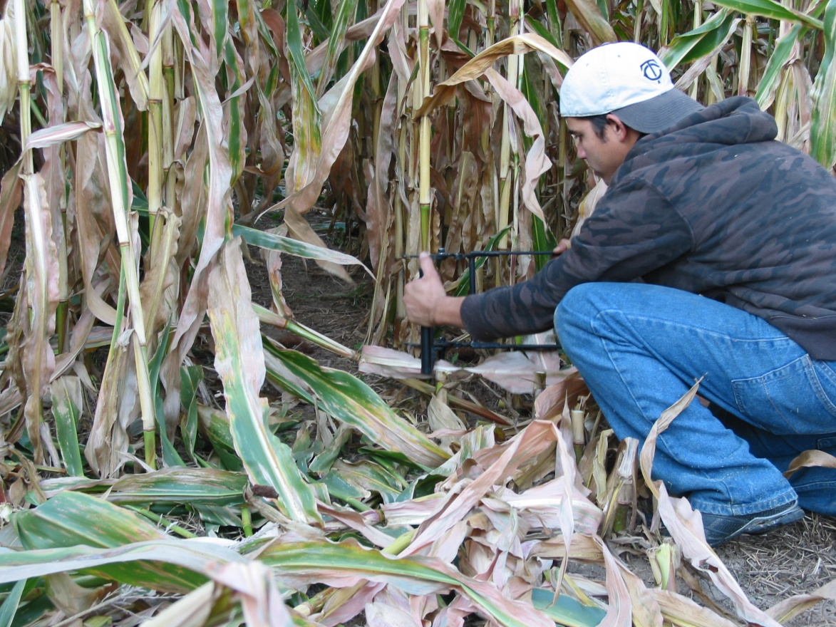
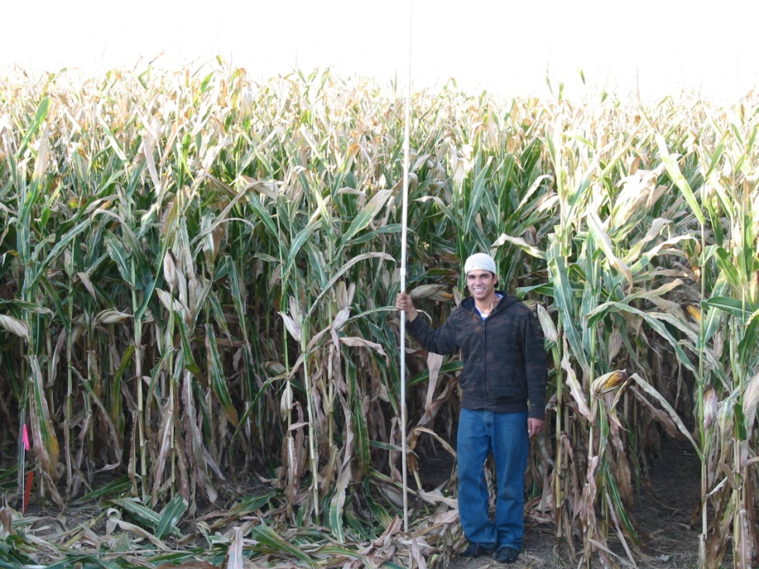

Picture 3. No-till corn harvest at Norwalk, WI.
Picture 4. Sampling basal stalks at Norwalk, WI.
Table 1. Background soil characteristics for six no-till locations in Experiment (Exp.) One and nine manure locations in Exp. Two.
 |  |  | Soil‡
Exp. | Nearest city† | Soil series/texture | P | K
 |  |  | -- ppm --
1 | Cashton | Fayette silt loam | 69 | 72
 | Goodhue | Port silt loam | 17 | 162
 | Lake City | Hersey silt loam | 19 | 120
 | Lakefield | Clarion loam | 6 | 147
 | Norwalk | Wildale silt loam | 10 | 69
 | Plainview-1 | Downs silt loam | 22 | 134
2 | Faribault | Merton silt loam | 80 | 129
 | Howard Lake | Angus loam | 15 | 126
 | Medford | Nicollet clay loam | 134 | 298
 | Plainview-2 | Tama silty clay loam | 48 | 171
 | Randolph | Cylinder loam | 89 | 277
 | Redwing | Timula silt loam | 15 | 105
 | St. Rosa | Waukon loam | 13 | 132
 | Stewartville | Maxfield silty clay loam | 59 | 236
 | Waseca | Guckeen silty clay loam | 21 | 226
† Cashton and Norwalk are Wisconsin cities and the remaining locations are in Minnesota.
‡ Bray 1-P and ammonium-acetate exchangeable K for the surface 6 inches.
Table 2. Manure application date, rate, analysis, and tillage data for nine farms in Minnesota.
 | 2010 Manure application |  |  |  |  |  |  |  |  |  |  |  |  |  | Tillage
Nearest city | Date |  | Rate |  | Type† |  | DM |  | TKN‡ |  | NH₄-N |  | C:N |  | Date | Type§
 |  |  | ton or 1,000 gal/ac |  |  |  | % |  | ----- lb/ac-----
Faribault | 14 Oct. |  | 0.7 |  | SB |  | 30 |  | 10 |  | 1 |  | 16 |  | 14 Oct. | DC
Howard Lake | 21 Oct. |  | 7.3 |  | LB |  | 2 |  | 219 |  | 139 |  | 7 |  | 21 Oct. | DC
Medford | 30 Sep. |  | 1.6 |  | LI |  | 8 |  | 66 |  | 38 |  | - |  | 15 Oct. | MP
Plainview-2 | 9 Nov. |  | 4.6 |  | SB |  | 39 |  | 78 |  | 5 |  | 23 |  | 20 Nov. | DC
Randolph | 11 Nov. |  | 3.9 |  | LB |  | 24 |  | 39 |  | 20 |  | 12 |  | 12 Nov. | DC
Red Wing | 7 Oct. |  | 5.2 |  | SB |  | 30 |  | 94 |  | 10 |  | 19 |  | 17 Nov. | MP
St. Rosa | 3 Nov. |  | 4.7 |  | SB |  | 18 |  | 56 |  | 9 |  | 12 |  | 4 Nov. | DC
Stewartville | 4 Nov. |  | 7.8 |  | LB |  | 42 |  | 55 |  | 23 |  | 21 |  | 9 Nov. | DC
Waseca | 14 Oct. |  | 4.5 |  | LI |  | 1 |  | 131 |  | 108 |  | 1 |  | 20 Oct. | DC
† LB, Broadcast liquid manure; LI, injected liquid manure; SB, Broadcast solid manure.
‡ Total Kjeldahl N.
§ DC, disc-chisel; MP, moldboard plow.

