Tables and Figures

Table 1. Biomass accumulation, C:N and N-uptake for the three harvest sample dates. Different letters within a column represent significant differences at α = 0.05.
 | 3 Dec 2010
 | Total Biomass | C:N | N-Uptake
 | (kg ha⁻¹) |  | (kg ha⁻¹)
Oat Shoots | 156.04 (±16.34)a | 7.67 (±.04)a | 8.62 (±.88)a
Oat Roots | 37.93 (±6.64)b | 14.06(±.68)b | 1.00 (±.23)b
Rye Shoots | 455.3 (±46.65)c | 8.91 (±.24)c | 22.8 (±2.52)c
Rye Roots | 130.04 (±17.2)a | 18.05 (±1.38)d | 3.09 (±.61)d
 | 28 April 2011
 | Total Biomass | C:N | N-Uptake
 | (kg ha⁻¹) |  | (kg ha⁻¹)
Oat Shoots | - | - | -
Oat Roots | - | - | -
Rye Shoots | 561.22 (±76.49)a | 15.43 (±.56)a | 11.28 (±2.18)a
Rye Roots | 142.76 (±18.22)b | 24.53(±1.08)b | 1.64 (±.15)b
 | 26 May 2011
 | Total Biomass | C:N | N-Uptake
 | (kg ha⁻¹) |  | (kg ha⁻¹)
Oat Shoots | - | - | -
Oat Roots | - | - | -
Rye Shoots | 2752.89 (±371.66)a | 27.43(±4.71)a | 31.36 (±5.14)a
Rye Roots | 473.94 (±77.71)b | 32.43(±1.33)a | 4.22 (±.45)b

Table 2. Total N₂O emissions (µg N₂O-N kg⁻¹) over the entire sample period (96 hours). Values in parentheses represent ± one standard error of the mean. Different superscripts within a column represent significant difference at α = 0.05. Because of the lognormal distribution of emissions data, averages are presented as geometric means.
Average Cumulative Emissions
(µg N₂O -N kg-soil⁻¹)
 | 7 April 2011 | 28 April 2011 | 26 May 2011 | Geometric Average
Control | 33.46 (±4.84)a | 73.74 (±7.74)a | 51.91 (±11.74)a | 50.41
Oat | 56.07 (±11.46)a | 49.20 (±11.32)a | 54.46 (±10.01)a | 59.55
Rye | 73.74 (±7.46)a | 21.38 (±1.93)b | 28.01 (±.97)a | 35.35
Geometric Average | 51.72 | 47.48 | 42.94
Table 3. Soil nitrate and active carbon levels in the top 30 cm at the three sample periods. Numbers in parenthesis are the standard errors of the mean. Statistical differences were not detected.
 | 7 April 2011
Treatment | NH₄-N |  | NO₃-N |  | Active C
 | (kg ha⁻¹) |  | (kg ha⁻¹) |  | (mg kg⁻¹)
 | 0-15 cm | 15-30 cm | 0-15 cm | 15-30 cm
Control | 7.54 (±.66) | 4.76 (±.89) | 33.06 (±3.77) | 34.74 (±4.14) | 528.59 (±25.61)
Oats | 4.16 (±.98) | 7.23 (±1.19) | 32.64 (±3.97) | 40.58 (±3.78) | 545.01 (±19.37)
Rye | 5.58 (±1.36) | 5.45 (±1.18) | 33.63 (±5.45) | 35.7 (±4.94) | 586.73 (±11.83)
 | 28 April 2011
 | NH₄-N |  | NO₃-N |  | Active C
 | (kg ha⁻¹) |  | (kg ha⁻¹) |  | (mg kg⁻¹)
 | 0-15 cm | 15-30 cm | 0-15 cm | 15-30 cm
Control | 42.36 (±7.30) | 40.13 (±7.60) | 31.76 (±2.71) | 30.6 (±5.48) | 648.9 (±8.84)
Oats | 52.48 (±8.82) | 43.53 (±9.23) | 30.61 (±4.14) | 36.44 (±4.01) | 570.47 (±47.36)
Rye | 57.63 (±9.03) | 42.74 (±9.51) | 22.3 (±2.85) | 23.91 (±2.79) | 637.95 (±52.59)
 | 26 May 2011
 | NH₄-N |  | NO₃-N |  | Active C
 | (kg ha⁻¹) |  | (kg ha⁻¹) |  | (mg kg⁻¹)
 | 0-15 cm | 15-30 cm | 0-15 cm | 15-30 cm
Control | 55.73 (±10.01) | 50.97 (±9.83) | 36.51 (±13.49) | 45.36 (±12.05) | 561.63 (±20.41)
Oats | 58.27 (±7.98) | 36.8 (±7.97) | 35.39 (±10.50) | 30.38 (±11.47) | 558.51 (±15.63)
Rye | 47.41 (±4.99) | 48.1 (±4.04) | 37.95 (±8.66) | 40.54 (±10.53) | 595.94 (±15.55)

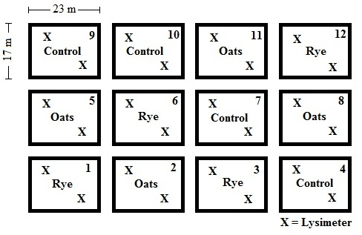
Figure 1. Spatially-balanced complete block plot layout. Plots show both cover crop treatment and the placement of two lysimeters per plot (X).

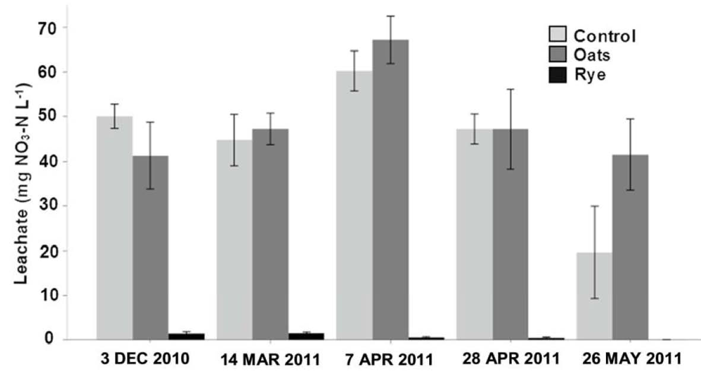
Figure 2. NO₃-N concentrations measured from lysimeters within each plot throughout the spring season. Lysimeter depth was 55 cm, which was found to be below the cover crop root zone. Due to field dryness, the rye sample during the late spring period is an average of two lysimeters.

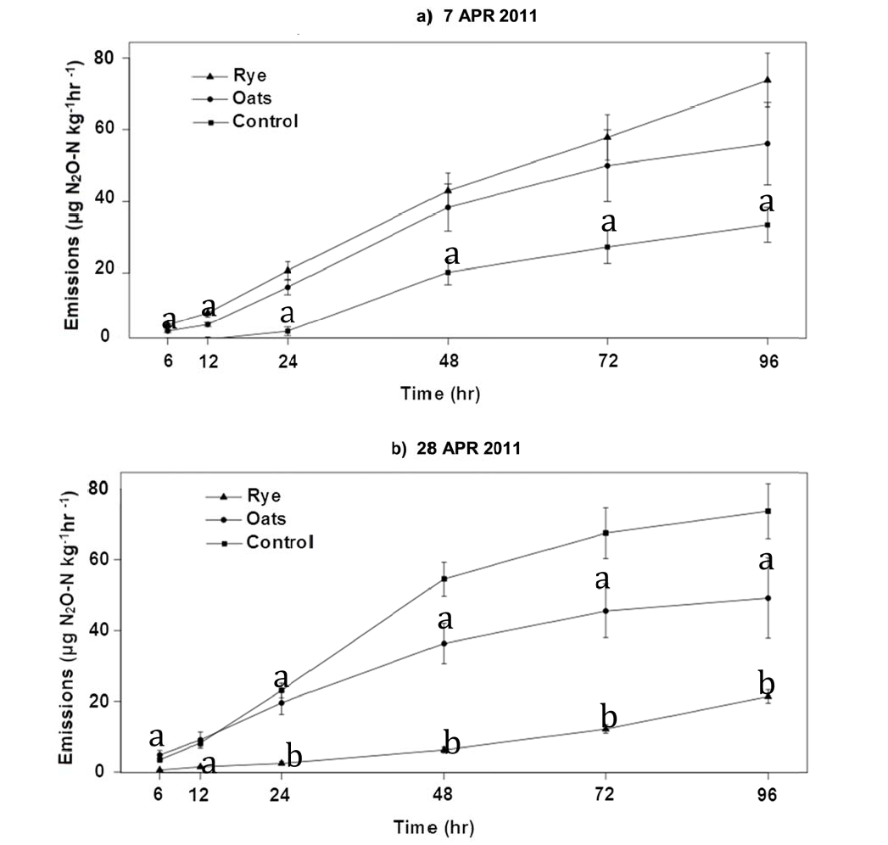
Figure 3. 96-hour cumulative N₂O emissions at different times during the early growing season. Means represents the geometric average for each treatment and error bars equal ± one SEM.
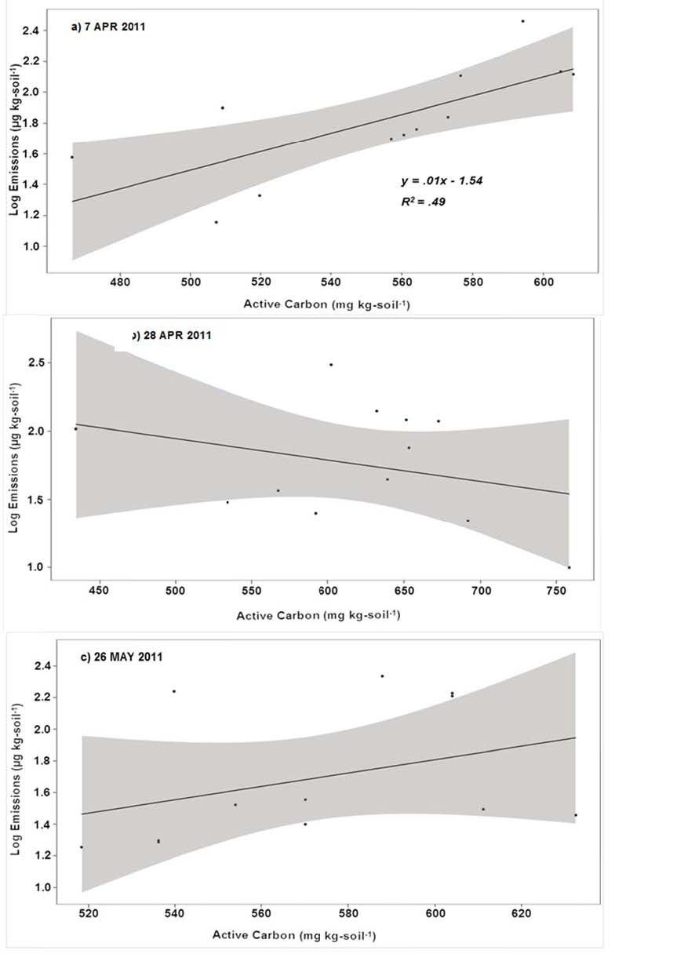
Figure 4. Linear regression of log emissions on active carbon. Active carbon was a significant predictor only during the early spring period (7 April 2011)
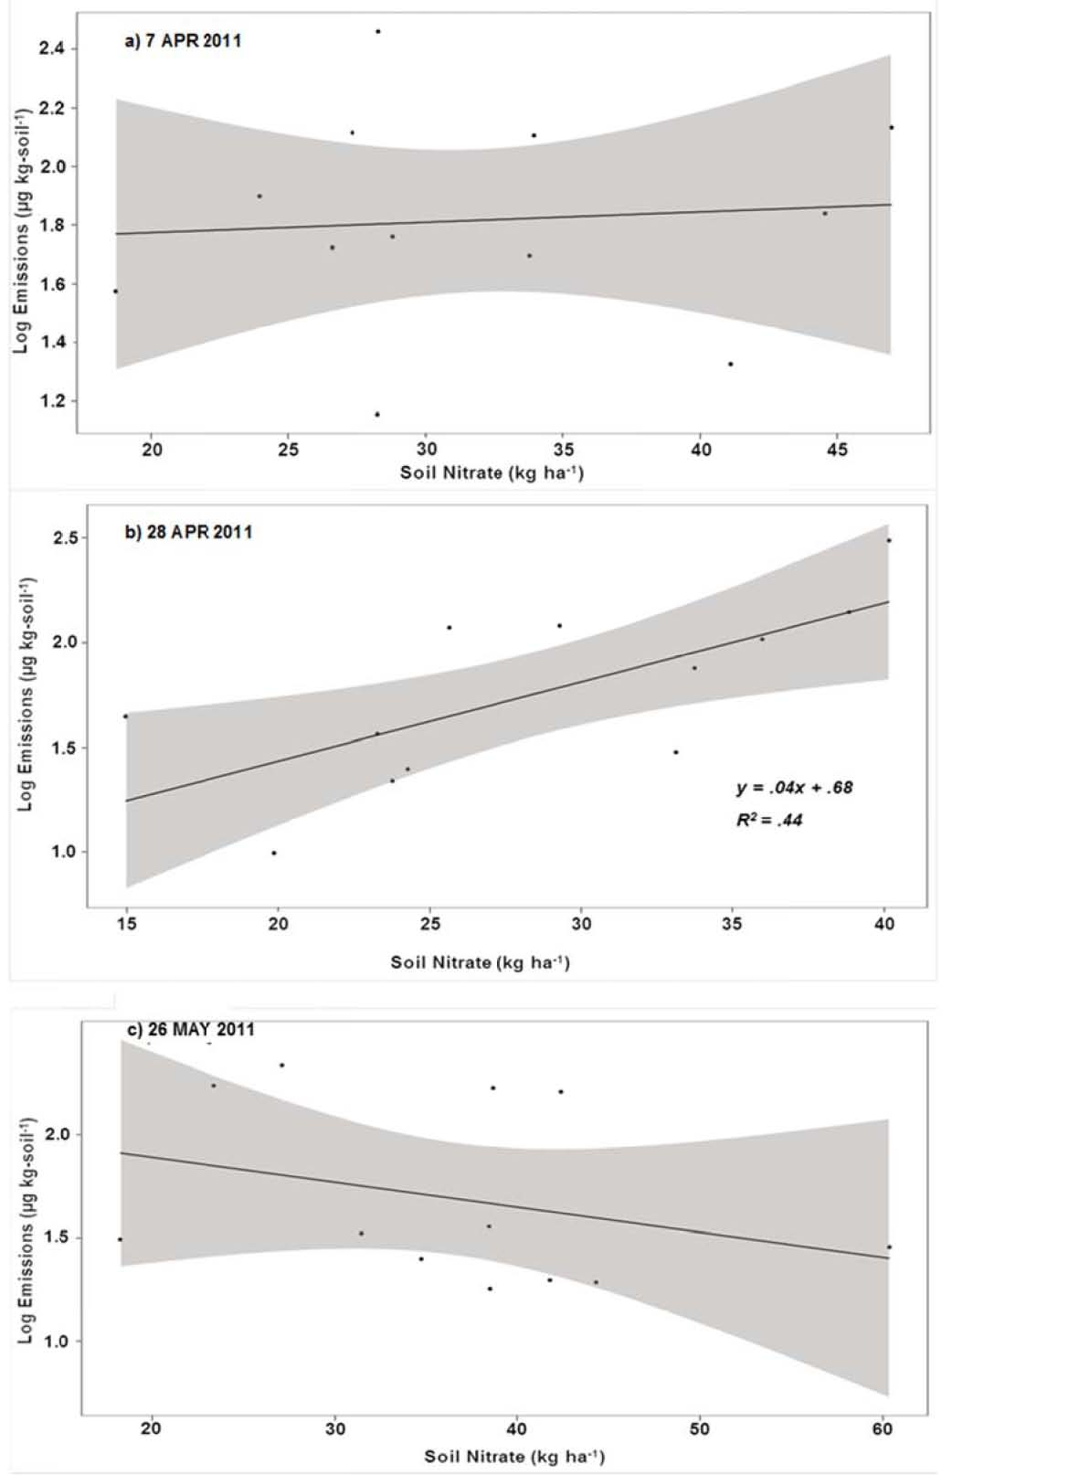

Figure 5. Linear regression of log emissions on soil nitrate levels in the top 30 cm. Nitrate was a significant predictor only during the mid spring period (4 April 2011)
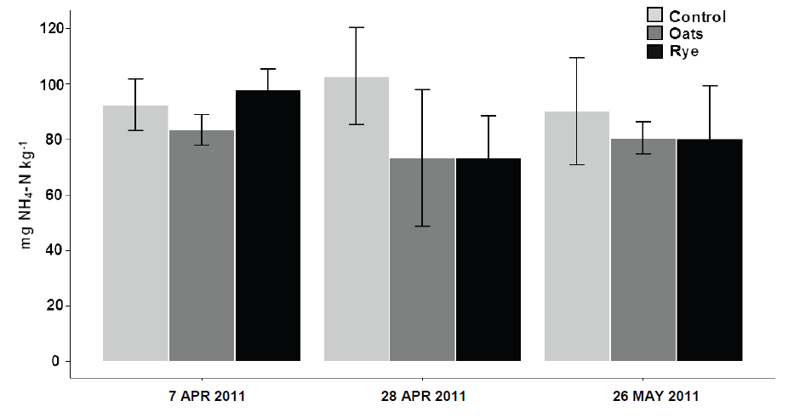
Figure 6. Potentially mineralizable nitrogen measured at the 0-15 cm depth during the spring season.

