Learn to Navigate the NRCS Certification Process!
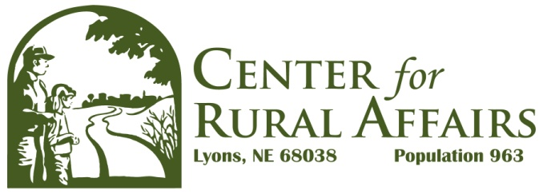Become a Technical Service Provider
for Transition to Organic Conservation Activity Plans

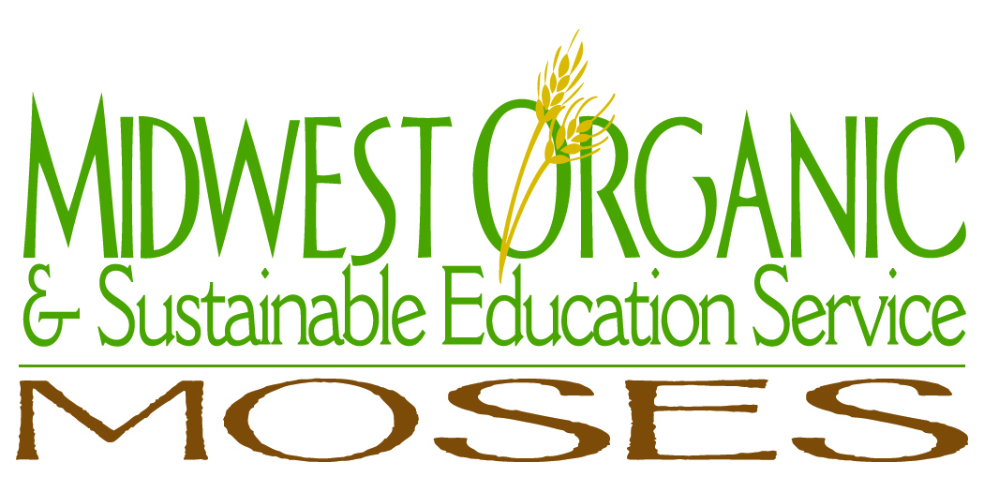This guide applies to states that approve Technical Service Providers (TSPs) to write organic Conservation Activity Plans (CAP) for transitioning land to organic farming. To be approved, a potential TSP must accomplish three tasks:

- Complete a series of online courses on the NRCS website, AgLearn. These cover NRCS history, policies, and how best to work with farmers when developing conservation plans.
- Have experience or approval from the NRCS in conservation planning. Each state may set additional education and experience criteria for conservation planning beyond the AgLearn modules.
- 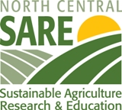Prove s/he is knowledgeable about National Organic Program regulations. A letter from an accredited organic certification agency or other NRCS-approved entity attesting to the TSP applicant’s knowledge may be sufficient.

You should contact your state NRCS TSP contact early in this process to verify the specific steps and requirements. Each state has its own standards for the national requirements (the comments below are based on Iowa and Wisconsin experience in early 2010), and since this is a new program, both national and state guidelines are in constant revision. If you want to be certified in more than one state, ask each state’s TSP contact if they have agreed to accept other states’ certification.

If you are a potential TSP with mostly organic experience, you should take some time to learn the various conservation practice standards offered in your state. The Conservation Activity Plan BOTH helps the farmer plan the transition to organic and improve conservation practices on the farm.

The organic CAP can be used as a template to help farmers apply for further NRCS funds to enhance conservation on their farms. For example, suppose a dairy farm does not graze its cattle, and it now needs to provide significant pasture for its soon-to-be organic cows. NRCS has a variety of cost-shared practices for setting up rotational grazing, as well as putting in water lines, fencing and animal lanes. The conservation needs identified in a CAP can be the basis for new applications for conservation practice cost-share funding, while at the same time implement organic farming systems.

The main steps and timeframes for this certification process are:
- set up a Level 2 e-Authentication account (30 minutes)
- activate the SCIMS account at a local NRCS office with photo identification
- link the Level 2 and SCIMS accounts at the NRCS office (2 hours for 2 & 3, plus travel)
- complete the AgLearn online modules (5 - 8 hours over 2+ days; accessible only by Windows computers)
- Review NRCS handbooks (4 - 8 hours)
- provide verification to NRCS of your knowledge and experience (collection of materials plus 2+ weeks for reply)

This guide covers the certification process and briefly describes the conservation plan and payment.

Getting Started:
Passwords and Accounts

Navigating the NRCS approval process can be somewhat difficult. Remember to be patient and to take the time to read ALL instructions on the NRCS websites. You will start on the http://techreg.usda.gov website. Look for the Certification Categories you wish to apply for; when you click on this, you will see the specific criteria you need to meet (courses, certifications etc). You can then look at View Terms and Conditions and make sure you are qualified to complete the process.

Next, you click on New User or How Do I Access TechReg? or Get a Level 2 eAuthentication Account. All these links take you to the same E-authentication site. Government contractors and the general public need to register to access these government training files. Read the What is an account page carefully, and then Apply for a USDA level 2 E-government user ID and password. Your password must be fairly long and complicated including upper and lower case letters, symbols and numbers. WRITE DOWN your password. Take the time to complete the profile as completely as you can, because your application might be delayed by NRCS if it is not complete. Don’t be shy about listing your areas of knowledge, even if they are not ‘certified’ in some way.

Once you have submitted a user name and password as a new user, you will receive a confirmation email for this request. YOU MUST REPLY WITHIN 7 DAYS, to this email. After you respond, you have a couple of weeks to appear in person, with a government issued photo ID, at a local NRCS office.

You are seeking to “activate” your Level 2 account. Call ahead and make sure when you arrive there is someone there who can activate your Service Center Information Management System (SCIMS) account AND link this to your Level 2 information (your user name and password). Make sure before you leave the office that this linking has been done or you will have difficulty doing the next steps. It will take a few hours after your activation for you to be able to use the user name and password.

Requesting Your Certification

You then go back to the TechReg website, and review the Requesting Certification page. Print this out to help you through the process. Then click on Login and request certification for the specific area you are seeking. The website can be slow, so be patient for the subsequent screens to load.

For the general TSP criteria, click on Certification Categories and find the criteria for planners who write nutrient management plans, pest management plans, etc. For the Organic CAP, click on Conservation Activity Plans and search for the organic transition plan.

Here are the Conservation Plan Supporting Organic Transition (CPSOT) education and experience criteria for the organic CAP:

Conservation Plan for organic farming: Provide two locations or customer references where technical service has been provided that verify the personnel experience and proficiency to support Organic Systems Plan (OSP) planning.

Conservation Plan Supporting Organic Transition Development: Develop a Conservation Plan Supporting Organic Transition Plan (138) that meets the criteria listed in Section III of the Field Office Technical Guide (FOTG).

[state-by-state: one or both of the above; may be done under supervision of an existing TSP]

Conservation Planning NRCS Training:
Step 1 - Complete modules 1 through 5 of NRCS Conservation Planning course.
Step 2 - Complete NRCS Environmental Compliance for Conservation Assistance (EC Level 1) course.
Step 3 - Complete Modules 1-6 of the NRCS Web-based Cultural Resources Training course. [these are the AgLearn modules]

Conservation Planning Tools: Knowledge and proficiency with the current applicable erosion prediction models for wind and water. [RUSLE2 calculations require separate certification; advising or observing erosion risk does not]

CPSOT Experience: 1 year of experience developing Organic System Plans (OSP). [verification method varies by state]

FOTG Knowledge: Knowledge of the NRCS Field Office Technical Guide as related to the specific elements for which expertise is being provided.

National Planning Procedures Handbook: Knowledge and understanding of National Planning Procedures Handbook - Part 600. [this describes what conservation plans look like: http://directives.sc.egov.usda.gov/RollupViewer.aspx?hid=17088]

Next go to the State TSP coordinators list and write down the name(s) and contact information for the state(s) in which you wish to be approved (listed at the end of this document as of May 2010). It is a good idea to make contact with this person, so s/he is aware you are in process to become a TSP. S/he can help you with problems or lead you to someone else. S/he can provide specific help should you have trouble accessing the learning modules discussed next.
2

AgLearn Online Modules

Your next step to becoming an approved TSP for organic Conservation Activity Plan is to go to the AgLearn website http://www.aglearn.usda.gov to access the learning modules. The AgLearn modules teach you about NRCS procedures for environmental planning, cultural (historic, archaeologic, etc) resources, and working with farmers. The modules are accessible only with Windows computers and Internet Explorer or Netscape browsers.

Click on Learner Login and put in your NRCS Level 2 account user name and password (this is what you activated and linked when you went in person to the NRCS office). Remember, the website is slow, so be patient as your user name and password are reviewed after you Login.

The next screen should welcome you by name and have options for learning as well as your very own Learning Plan list. If this is not present, you need to call the State TSP coordinator and get the name of the State’s AgLearn coordinator so s/he can put items in your learning plan. Tell her/him you want to be a TSP for writing organic transition plans. S/he should know what you need in your learning plan.

Once the modules you need appear in your list, click on Go to learning plan. You will then see this learning plan in a larger screen and the modules will be live links. You can then start going through the modules. At any time in your learning process, you can bookmark the page. The next time you want to continue reviewing the modules, you click on that bookmark to return to the last screen you reviewed.

The modules will need your full attention, so try to block out some time when you will not be disturbed. Going through all the modules will take from 5-8 hours, with a quiz at the end of each. Do not plan to do this all in one sitting, but try not to spread it out over too much time since there will be a comprehensive test over all the modules. It will be helpful to take notes, particularly of acronyms and lists, since they are on the tests. If you do not pass a test you can take it over, but it appears you will have to repeat the module to retake the test.

You’ll find links to a variety of NRCS policies, practice standards and worksheets. Take the time to familiarize yourself with the Field Office Technical Guide (FOTG). This has the standards for the practices approved in your state, as well as the cost-share dollars for each practice by acre, linear foot or activity.

NRCS practice standard 138 is the Transition to Organic Conservation Activity Plan. Make sure you read this one, and print it out for reference. There are specific worksheets for each practice standard, mostly for the land activities, such as what type and density of rock would be approved for a stream crossing.

Each state has an eFOTG (the electronic FOTG), which can be accessed on your state’s NRCS website. Your state TSP coordinator or AgLearn person can help you find both the eFOTG and practice worksheets on their state’s website.

When you have completed all of the modules, contact the State TSP coordinator again and verify with him or her what types of verification s/he will accept to illustrate your “experience and proficiency to support OSP (Organic System Plan) planning.” After you have done this and you are approved, your name will appear on the TechReg website as a TSP approved for organic CAP!

Writing Conservation Activity Plans

Farmers and NRCS personnel search the TechReg website to find names of approved TSPs, since ONLY approved TSPs may be paid with NRCS funds. A farmer may contact you to write his or her plan. The dollars listed for the organic CAP in the FOTG is the maximum amount a farmer can receive from the NRCS for this practice. If you feel the plan is more complicated than usual, you can charge more, but the farmer would need to agree to this extra fee.

To write the organic CAP, you will need to do an on-site visit and then write up a plan. As of this writing, the National NRCS office is developing a template for organic CAP, but it is not complete. Check with your state TSP coordinator to see if the template is done before you begin writing your organic CAP.

Your plan will include an assessment of specific crop fields and livestock and when they would be eligible for organic certification. It will also have a plan for crop rotations, pest management and nutrient management. Depending on the operation, there may also be a requirement that the farm be reviewed for soil erosion using the RUSLE2 calculations (e.g. greenhouses may not need this, but crop and livestock operations will probably need it).
3

During your farm visit, make sure you are reviewing conservation concerns as well as organic ones, since these will need to be “inventoried” and clearly described in the plan. Descriptions of issues faced by the farmer as well as his or her plans for the future are to be described for all aspects of the farm. The farmer should be able to complete an Organic System Plan with the information you are providing in your organic CAP.

You may also either recommend or fully design a variety of NRCS conservation practices that would aid the farmer in his or her transition from conventional to organic production. If you are designing practices, but are not certified for them, you and/or the farmer will need to work with other TSPs who are approved for pest management, nutrient management and/or RUSLE2, for example. Have that TSP approve what you have written in your organic CAP if the subplans are ready for implementation. However, if you are only suggesting a pest management plan be written, for example, then no other TSP would need to review your plan.

Receiving Payment for Conservation Plans

Give the plan to the farmer when your part is complete. He or she may need to get approval for the various aspects that you may not be “certified” to do (like RUSLE2), and submit the final plan to the state NRCS office. That office then reads and approves your plan. They may have questions if they find an area incomplete. In addition, the NRCS in your state may require an organic certification agency to review and approve your transition to organic CAP, and the organic certifier may charge a fee for this as well.

The farmer receives the payment from NRCS for the work you do, and s/he pays you. You will need to submit an invoice to the farmer with your TSP number on it so the NRCS can track that you are eligible to receive payments; ONLY approved TSPs certified for those practices may receive payment from cost-share funds.

Plans developed by TSPs are included among the conservation practice payments the farmer has had approved by NRCS (including your CAP). If you require another TSP to contribute to your CAP, that fee would need to be previously included in the payment plan or would come out of your fee (or from additional payment from the farmer). Some government staff may not charge for this service. NRCS personnel can suggest who could approve these aspects of your plan and if they would need payment.

How you get paid is between you and the farmer. S/he can pay some of it up front with the rest after the NRCS approves your completed plan, or any other type of arrangement. You should write a contract between you and the farmer, with clear descriptions of what you will be writing, what further approval the farmer may need to obtain on his or her own dime and how much you are to receive and when.

While this process can be time consuming, the payments for writing an organic CAP range from $1200-$1800, depending on the type of plan and each state’s limits. This is an area of growth, offering opportunities to certified crop consultants, conservation planners as well as organic inspectors, long-time organic farmers, former organic certification personnel, and others.

Current USDA guidelines state that organic certification employees cannot write organic CAP. Independent organic inspectors or organic reviewers could write these plans as long as they do not perform inspection or certification duties on that farm for at least a couple years, to prevent a conflict of interest.

How to Learn More

For persons who do not have organic knowledge or those who do not have NRCS conservation practice background, there are a wide variety of opportunities to learn, with trainings offered by both the NRCS and private organizations. Check these websites for field days and webinars being offered on organic production in the north-central states. Check with your state NRCS office and get yourself on their email list serve where they periodically announce NRCS-approved trainings in their state.

Iowa: Midwest Organic and Sustainable Education Service, www.mosesorganic.org, Harriet Behar, harriet@mosesorganic.org

Minnesota: Land Stewardship Project, www.landstewardshipproject.org, Terry VanDerPol, TLVDP@landstewardshipproject.org
4
Nebraska: Center for Rural Affairs, www.cfra.org, Kathie Starkweather, kathies@cfra.org

North Dakota: Foundation for Agricultural and Rural Resources Management and Sustainability, www.farrms.org, Karri Stroh, kstroh@farrms.org

South Dakota: Northern Plains Sustainable Ag Society, www.npsas.org, Marilyn Isaacson, minpsas@drtel.net

For additional information and assistance with the TSP certification process, contact your state TSP coordinator (http://techreg.usda.gov/RptStateContact4Admin.aspx):

Iowa
Judy Martinson, 515-323-2229, judy.martinson@ia.usda.gov

Minnesota
Jeffrey St. Ores, 651/602-7869, jeff.st.ores@mn.usda.gov

Nebraska
John Mayberger, 402/437-4129, john.mayberger@ne.usda.gov

North Dakota
Mark Anderson, 701/530-2039, mark.anderson@nd.usda.gov

Todd Schwagler, 701-252-1460, todd.schwagler@nd.usda.gov

South Dakota
Michael Kuck, 605/352-1206, michael.kuck@sd.usda.gov

Acronyms and websites:
CAP – Conservation Activity Plan
CPSOT – Conservation Plan Supporting Organic Transition
FOTG – Field Office Technical Guide
NRCS – USDA Natural Resources Conservation Service
OSP – Organic System Plan
RUSLE2 – Revised Universal Soil Loss Equation, version 2
SCIMS – Service Center Information Management System
TSP – Technical Service Provider

NRCS TSP Orientation page: http://www.nedc.nrcs.usda.gov/catalog/tsporientation.html
TechReg website: http://techreg.usda.gov
e-Authentication Account setup: http://www.eauth.egov.usda.gov/eauthCreateAccount.html.
AgLearn modules: http://www.aglearn.usda.gov
State TSP coordinators: http://techreg.usda.gov/RptStateContact4Admin.aspx
Technical Service Provider listings: http://techreg.usda.gov/CustLocateTSP.aspx

