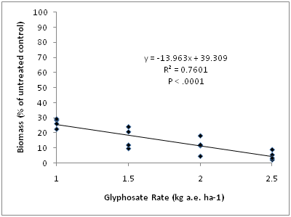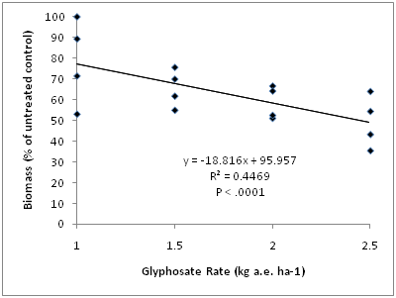

Figure 4.2. Field study: Response of white clover biomass (percent of control) to increasing rates of glyphosate eight weeks after application in spring 2010.

Figure 4.1. Field study: Response of red clover biomass (percent of control) to increasing rates of glyphosate eight weeks after application in spring 2010.

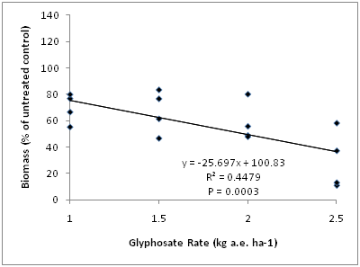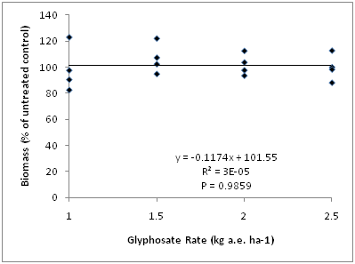

Figure 4.4. Field study: Response of white clover biomass (percent of control) to increasing rates of glyphosate sixteen weeks after application in spring 2010.

Figure 4.3. Field study: Response of red clover biomass (percent of control) to increasing rates of glyphosate sixteen weeks after application in spring 2010.

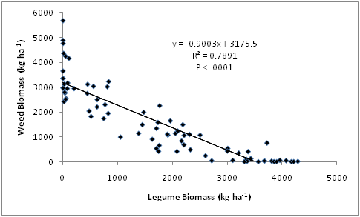

Figure 4.5. Field study: Relationship of weed biomass to legume biomass sixteen weeks after herbicide application in spring 2010.