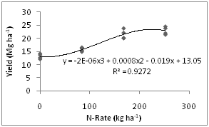 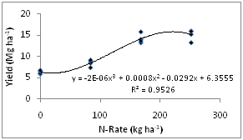

Figure 2.2. Corn grain yield nitrogen response curve for Fruita, CO in 2009.

Figure 2.1. Corn silage yield nitrogen response curve for Fruita, CO in 2009.

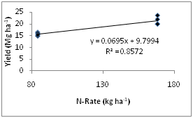 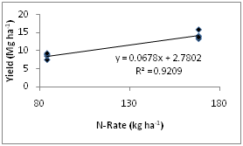

Figure 2.3. Linear regression of corn silage yield on nitrogen fertilizer rate for 84 and 168 kg/ha rates.

Figure 2.3. Linear regression of corn grain yield on nitrogen fertilizer rate for 84 and 168 kg/ha rates.