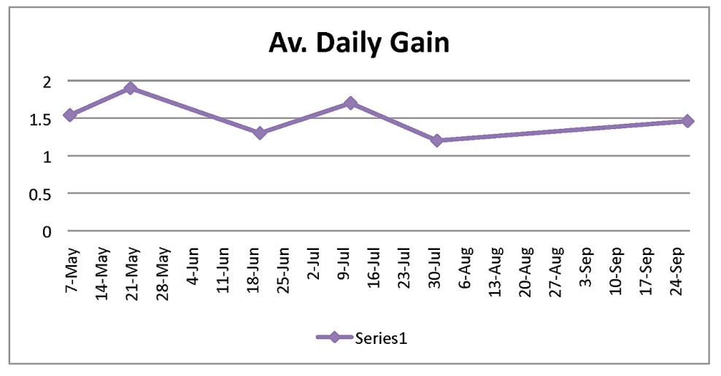

The points in the table to the left indicate the ADG for heifers fed pasture forage alone.

These results can be manipulated to reach desired goals by careful grazing management or additional grain being fed.