Photos for SARE project FNE11-718, Planning tool for succession planting of crops, particularly lettuce, broccoli, and corn. 2011 Growing season.
Below. A planting of Broccoli in seeding area. Note tag.
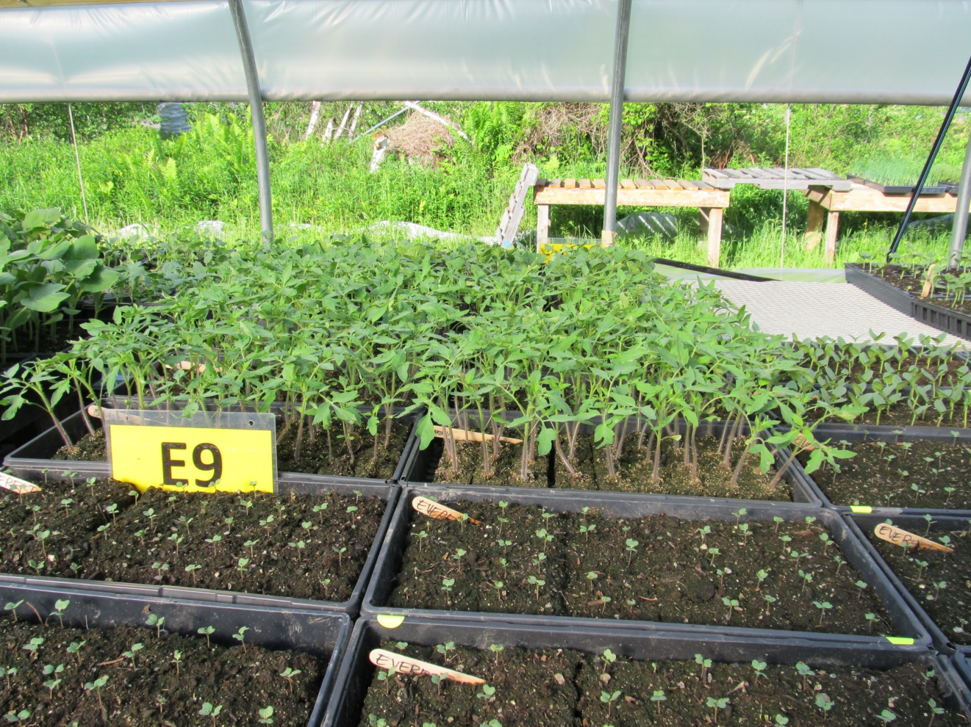
Thermal probes in Broccoli
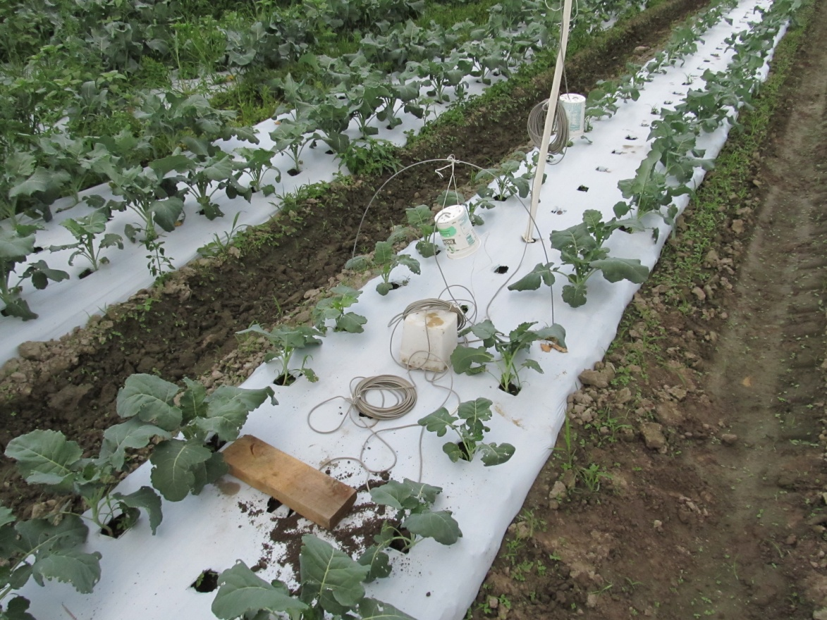
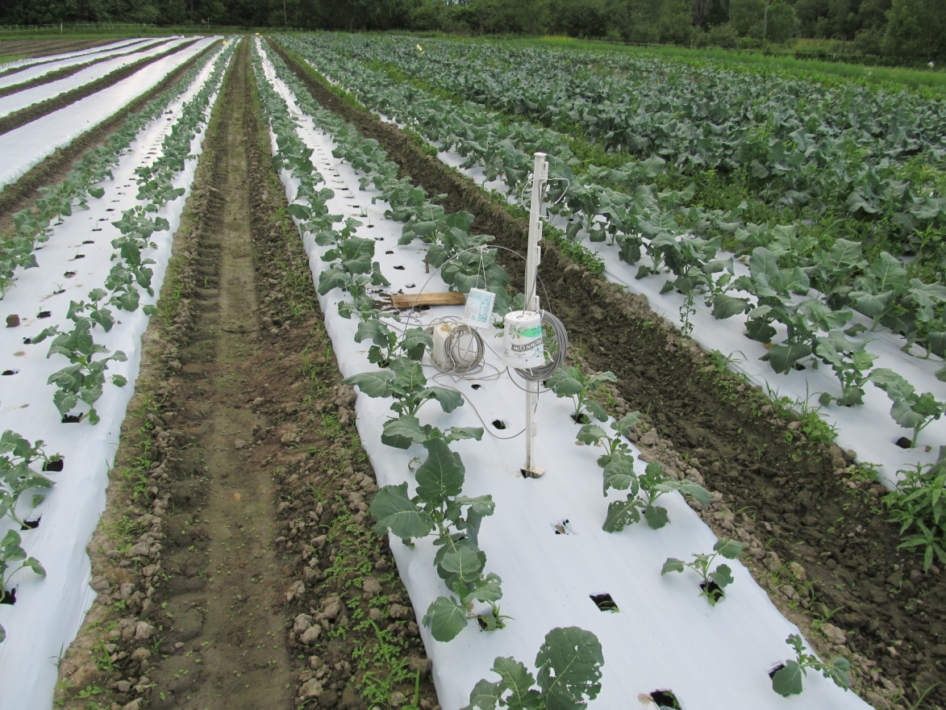
Thermal probes in Broccoli on plastic

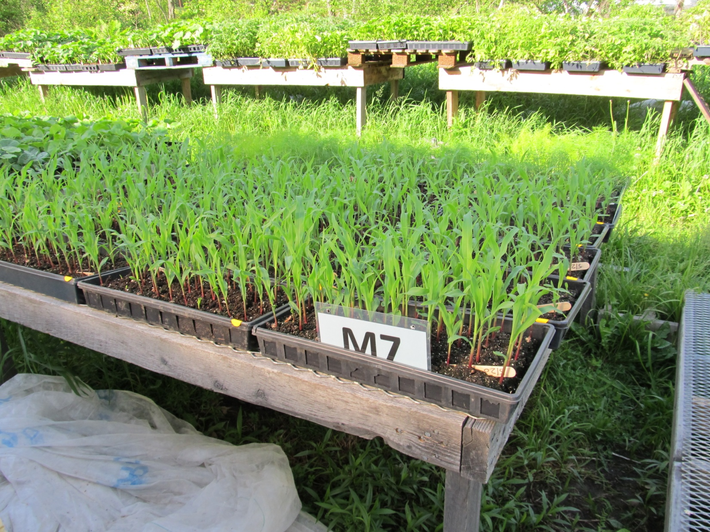
Corn just before transplanting, in seeding are. Note tags.

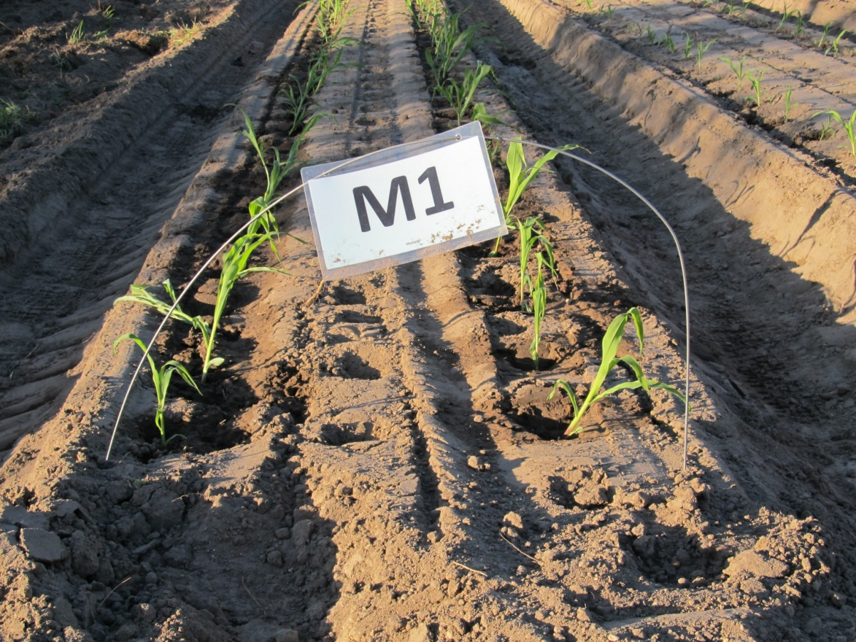
First planting of Corn
Soil temperature probe in Corn soon after transplant and initial setup.
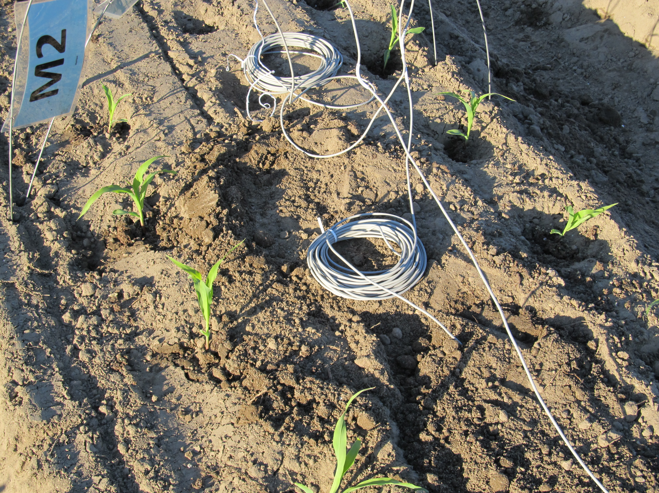
Air temperature 1 (lower) probe in Corn soon after transplant and initial setup. Note Datalogger as well.
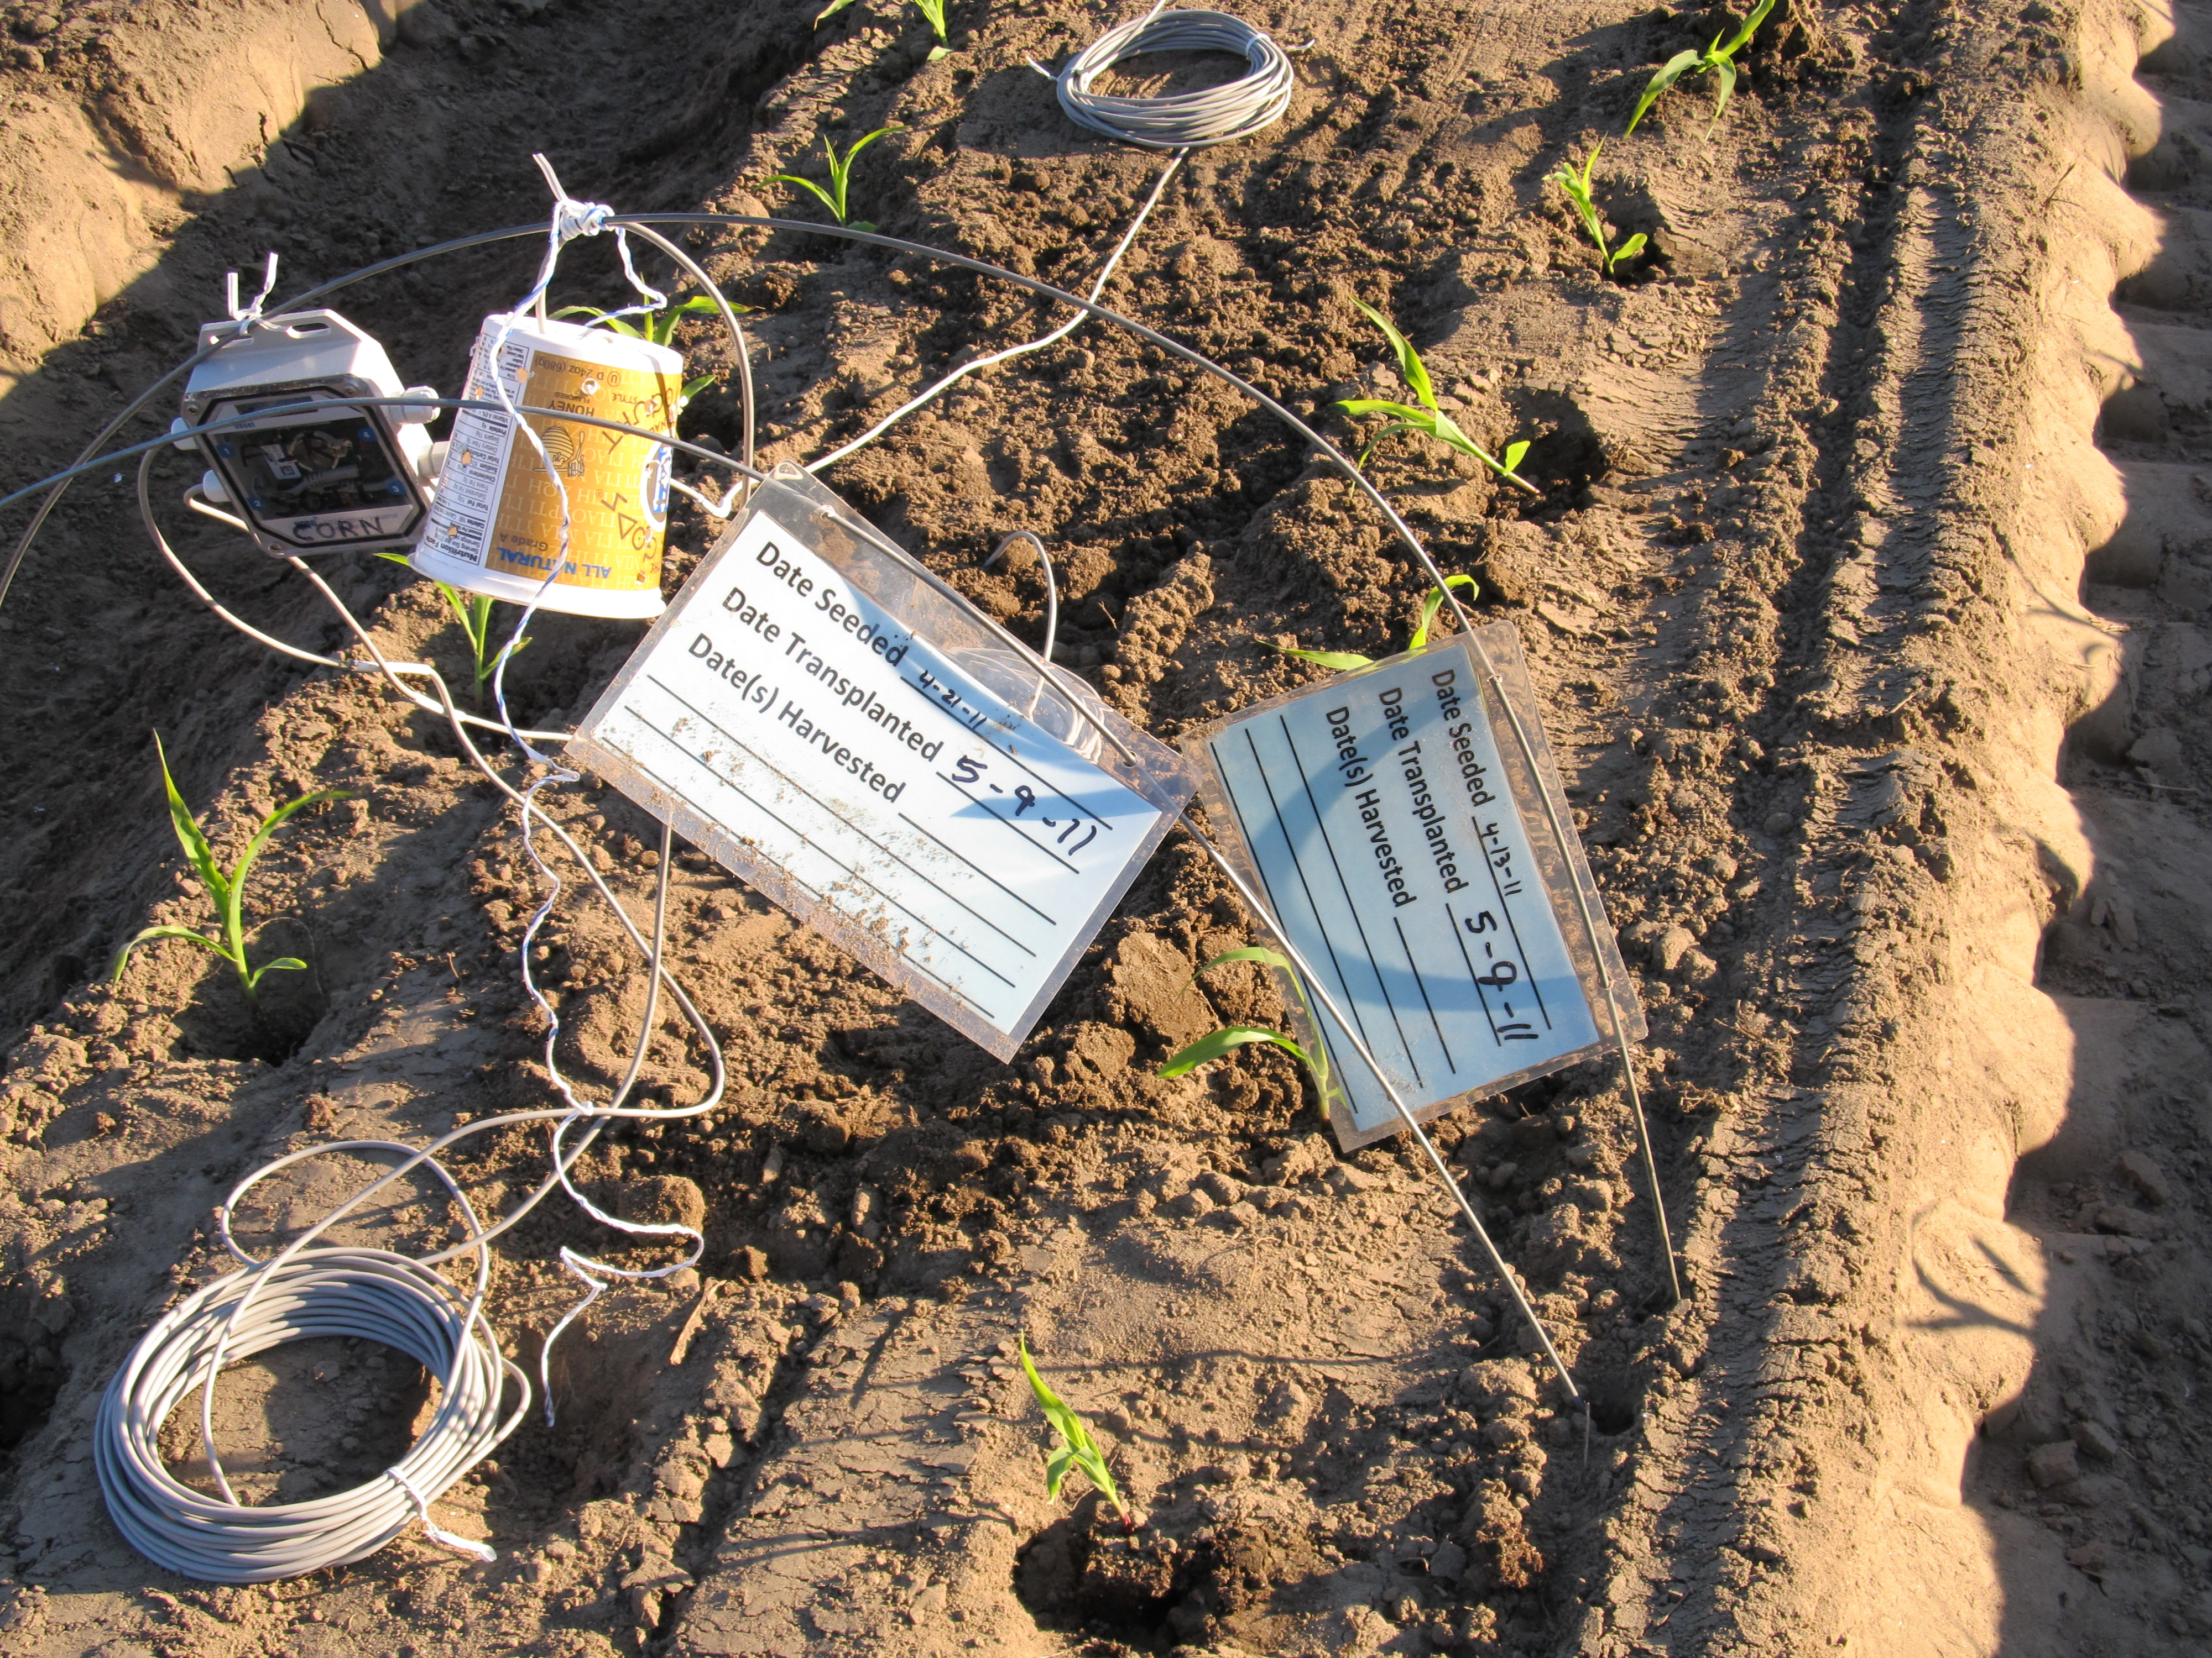
Corn, 1st three plantings and probes just after setup
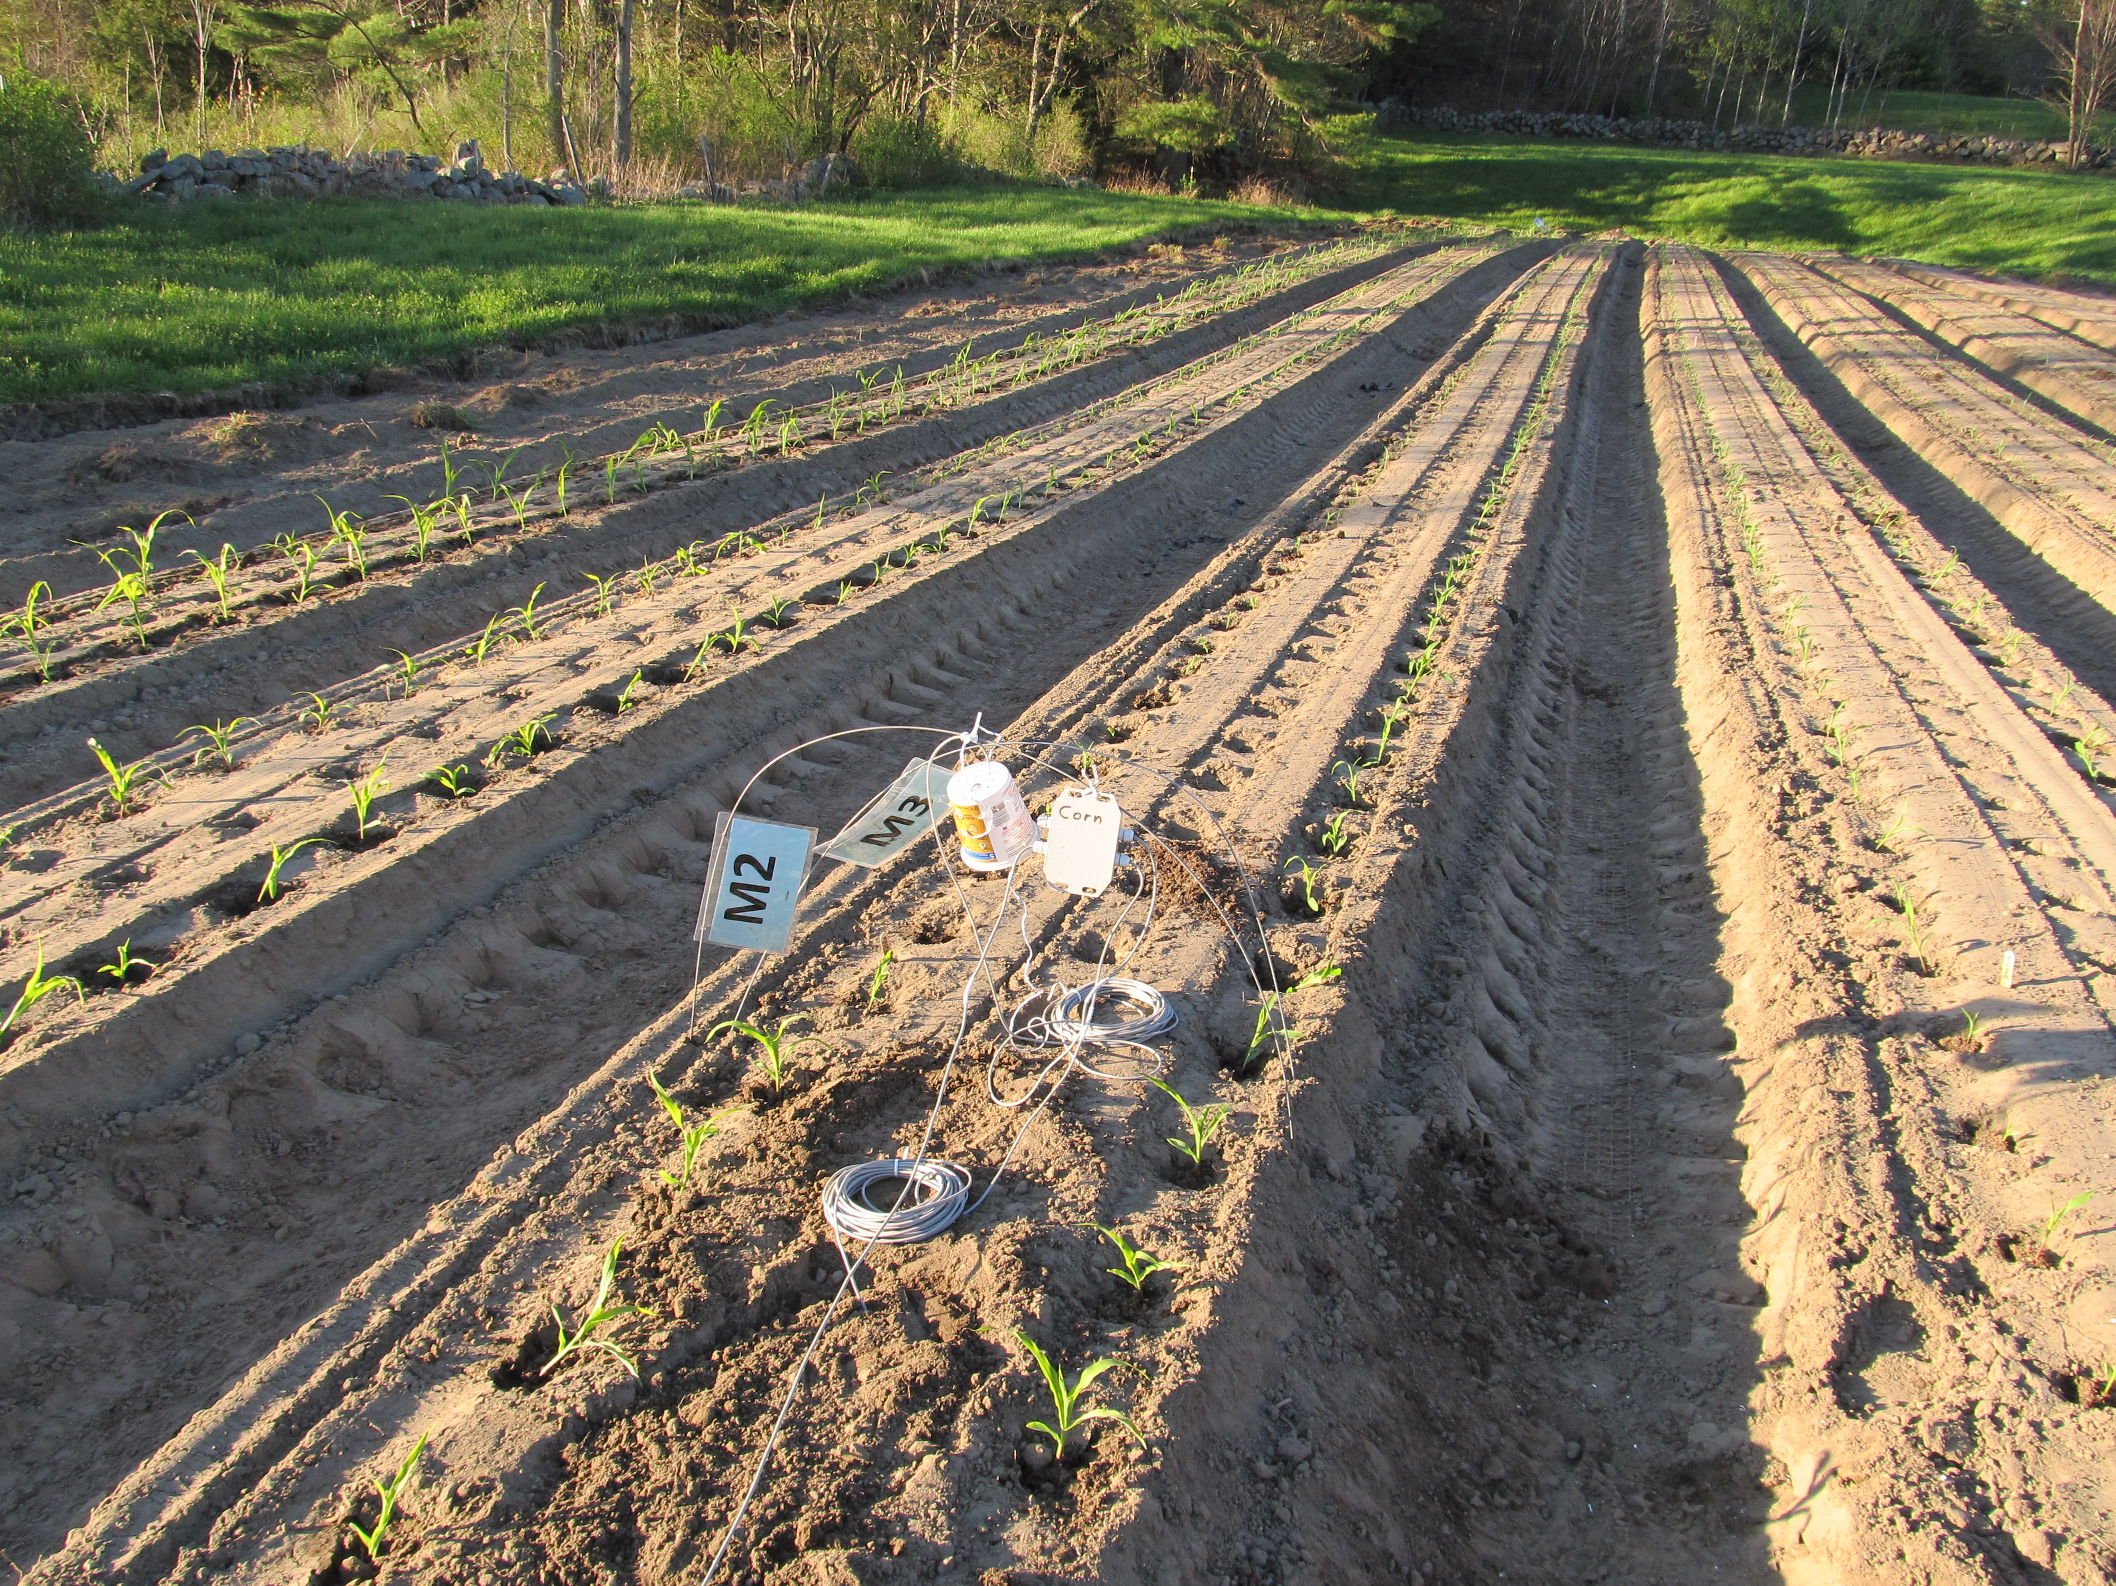
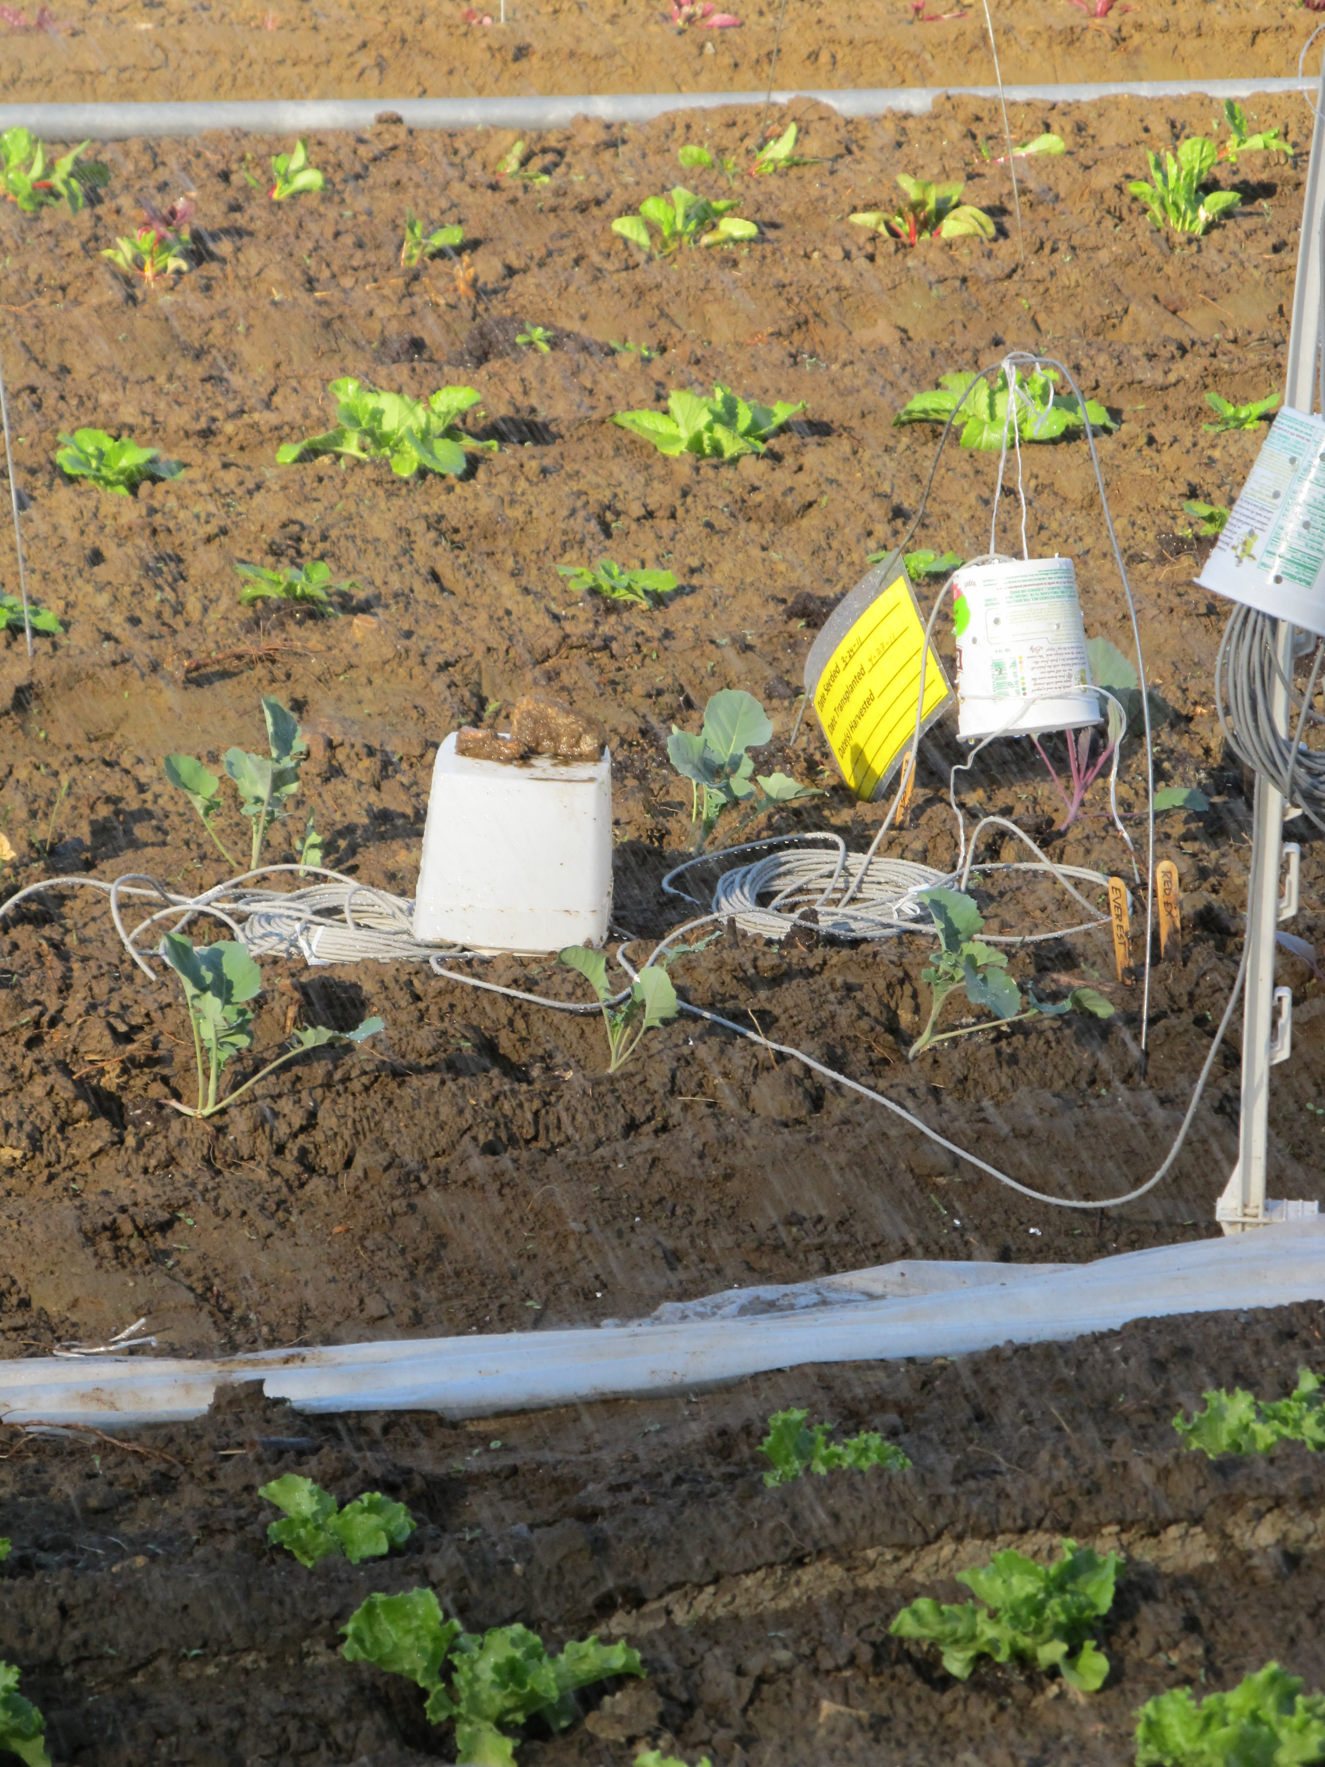
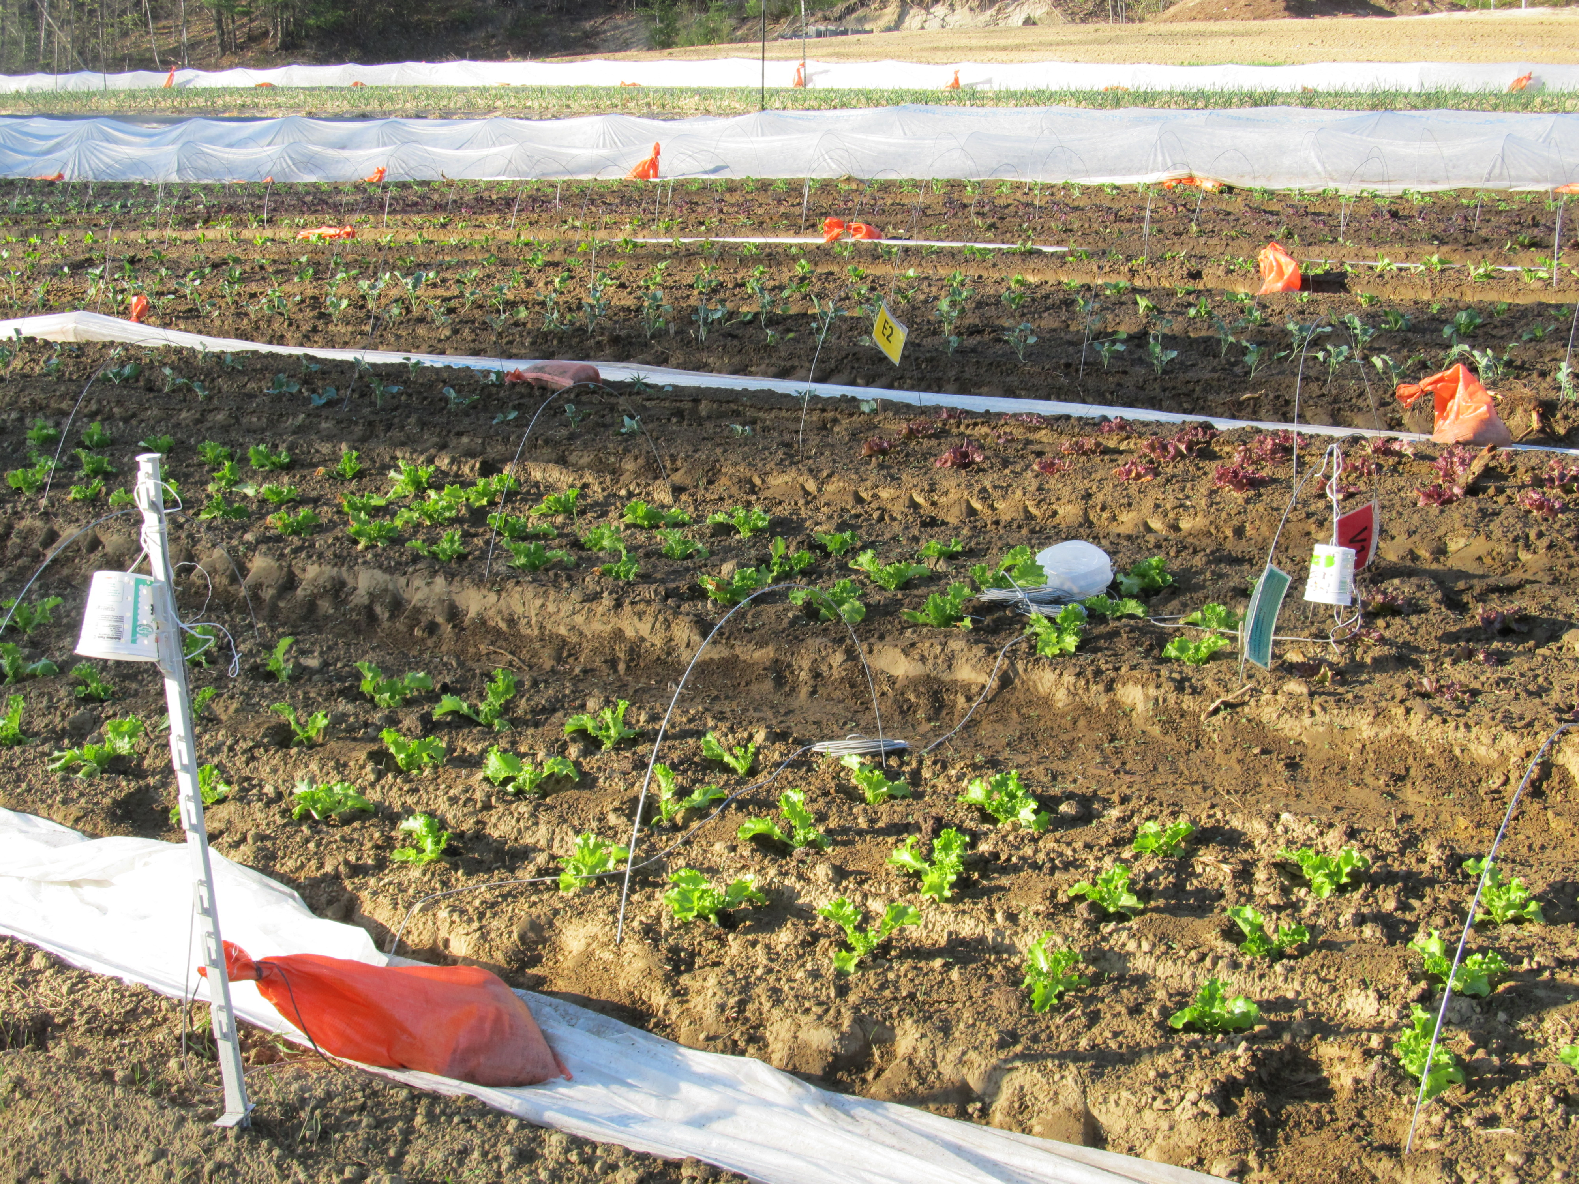
Sensors in first 3 plantings of lettuce and 2 plantings of broccoli (no plastic)
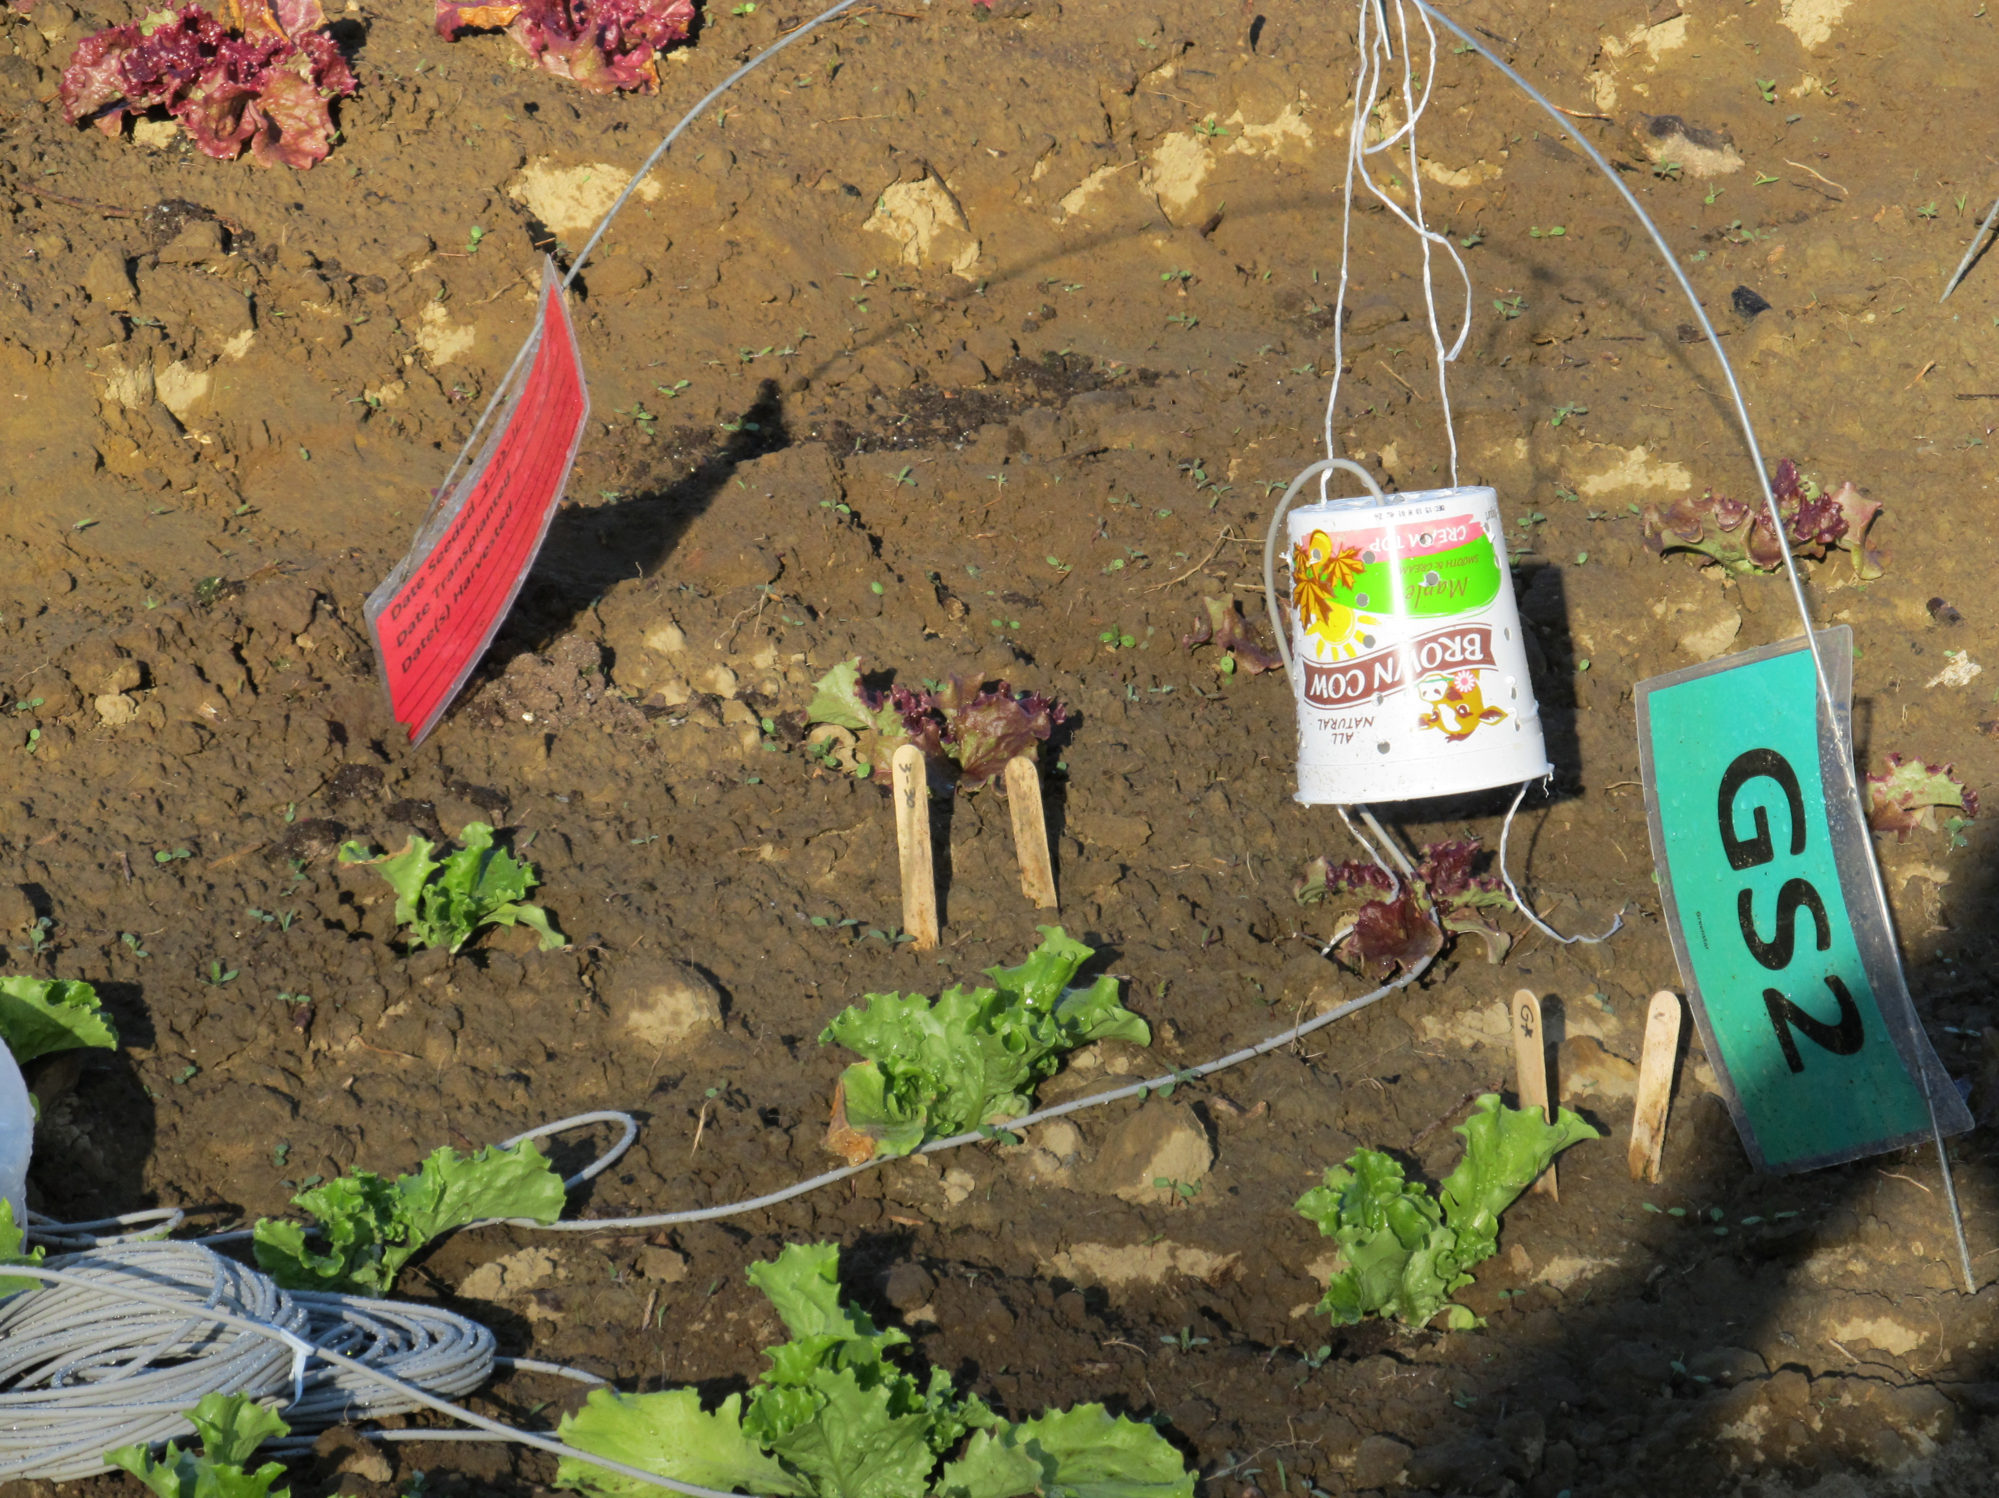

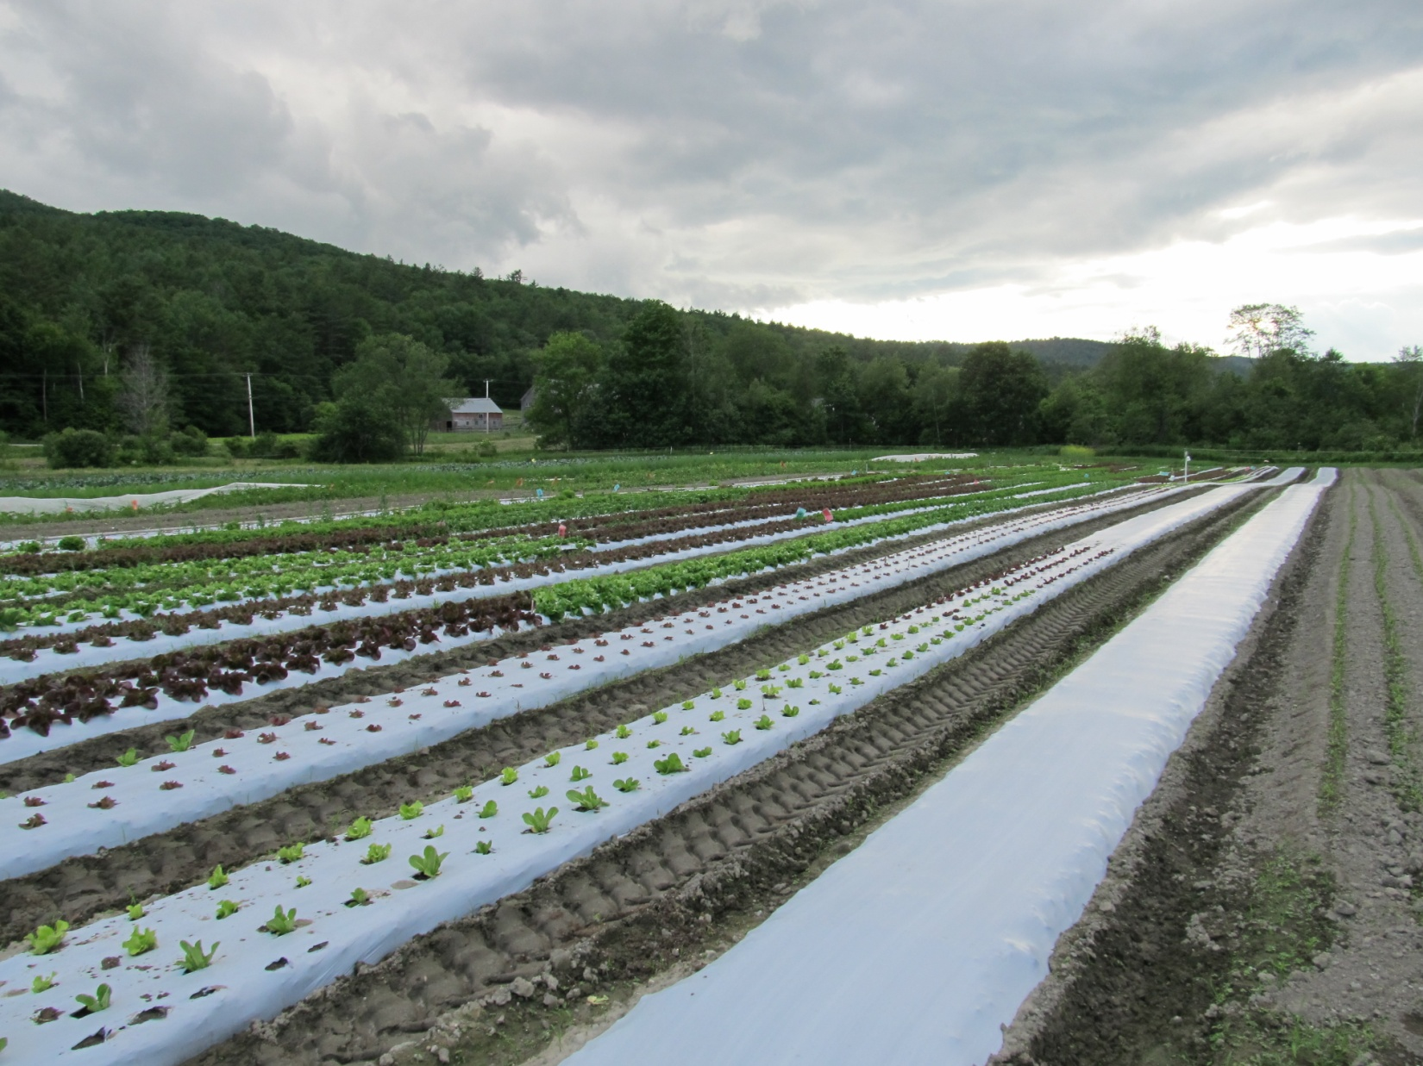
Note tags in the field for different plantings. Also Lettuce thermal probes.

Lettuce during harvest, note a few heads left to see when they bolt.
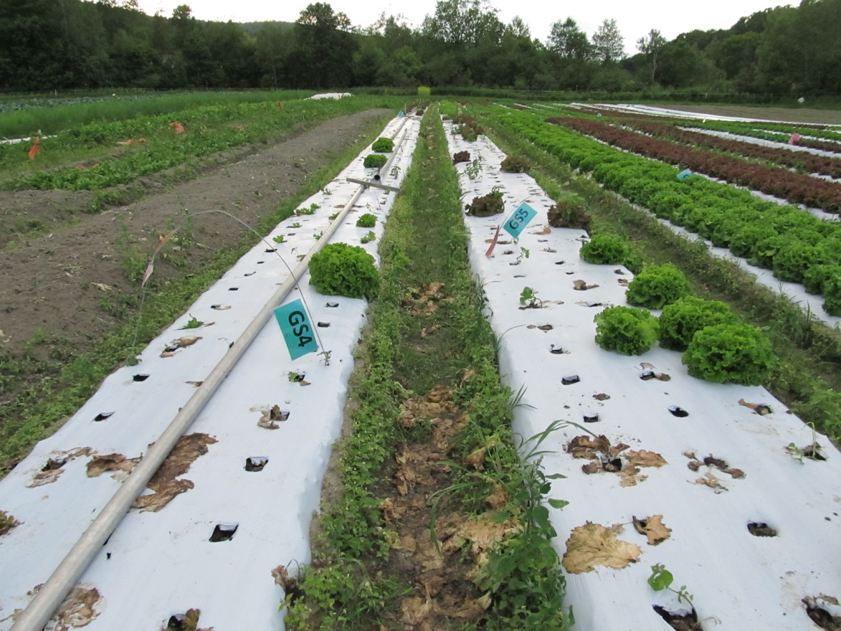

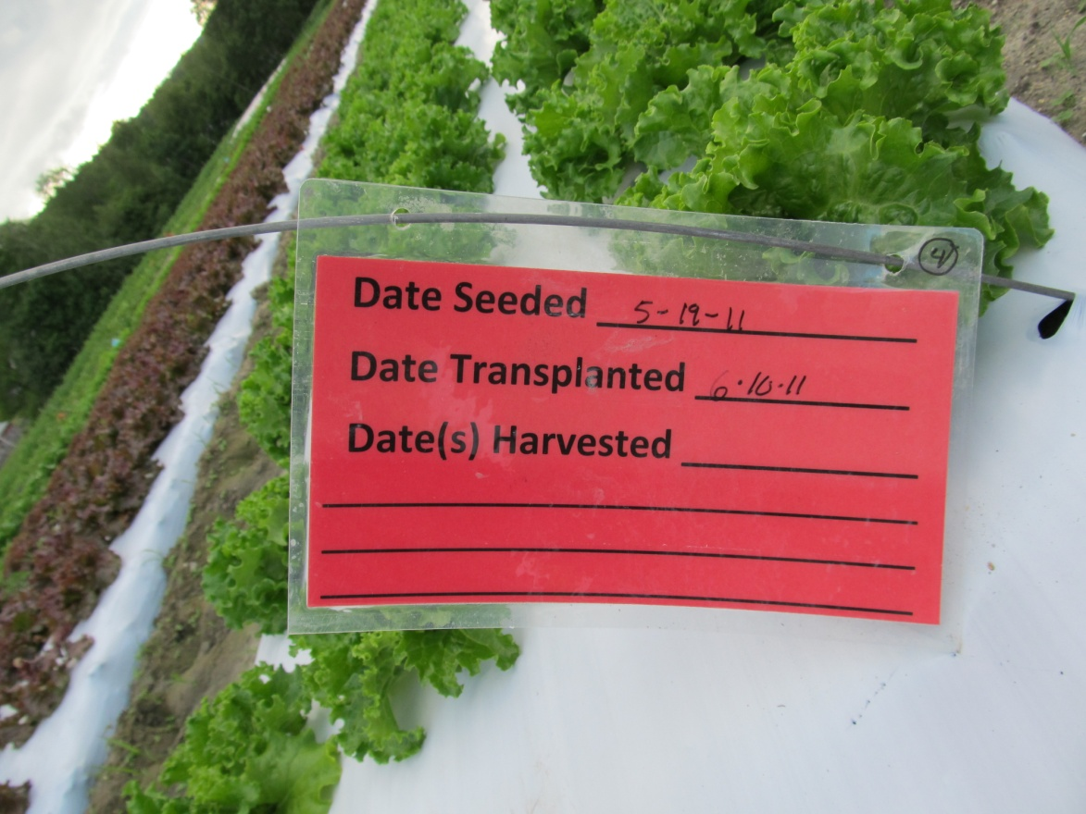
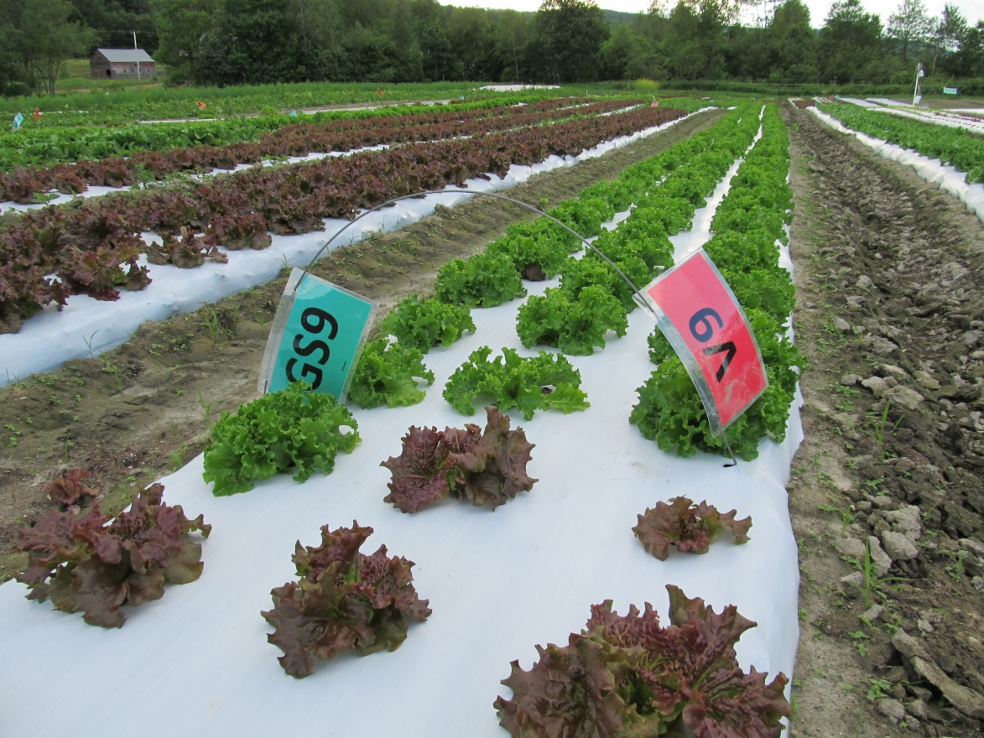
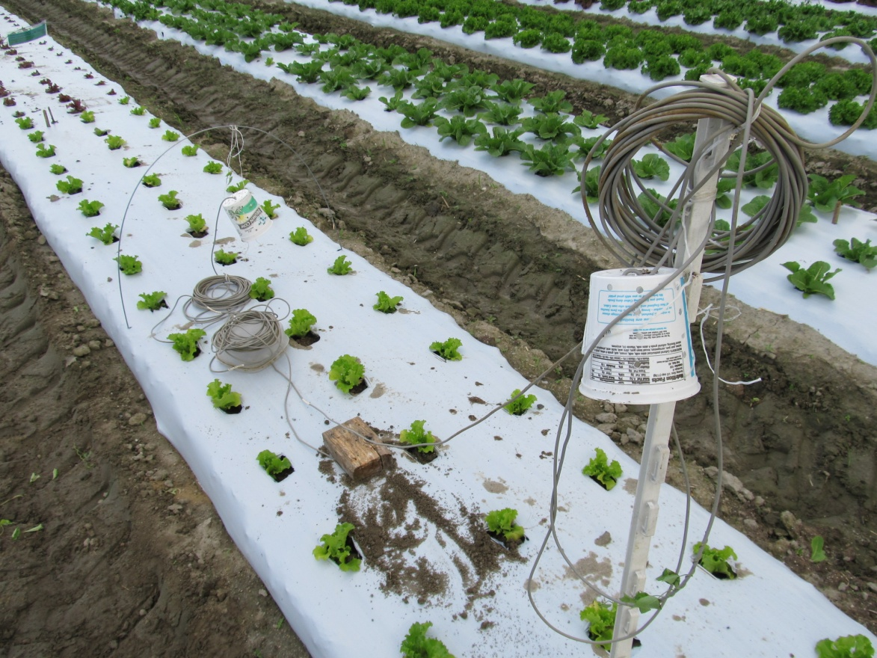
Air1
Soil Temp
Air2, (higher up)
Three sensors in lettuce

