Tank Temperature increases from 68oF to 98oF in 4 days

Solar Panel = 125oF

.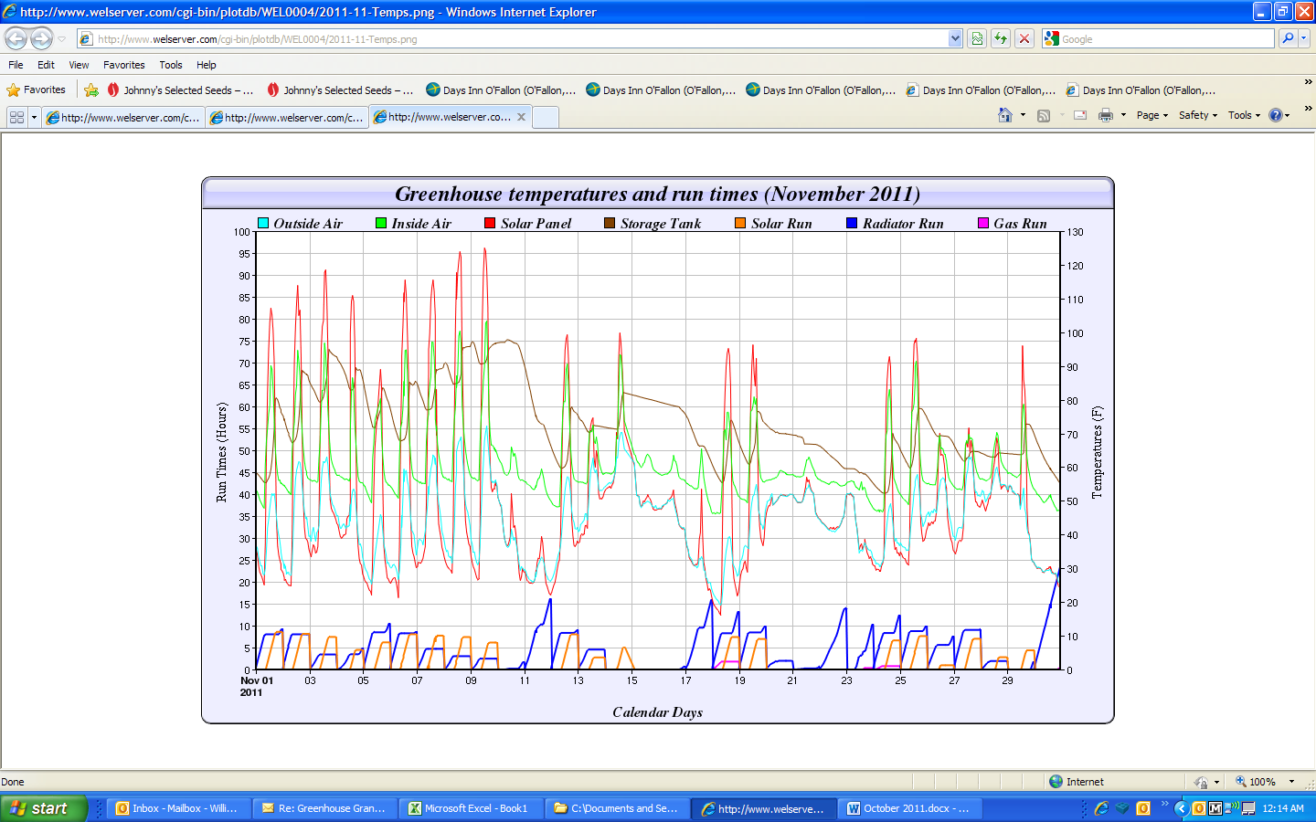

Tank Temperature drops 38oF in three days heating the greenhouse without supplemental heat and night temperatures in the 20soF. (252,000 BTU=2.8 gal propane)

Night time temperatures in 30soF. House used 106,000 BTU of heat in three nights while still increasing tank temperature.