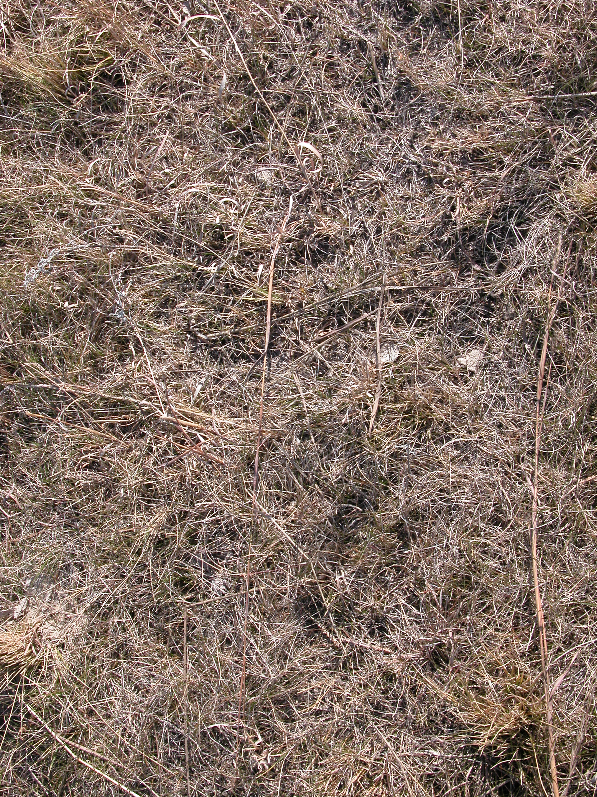

Figure 2. Representative control test plot (no mulch).

