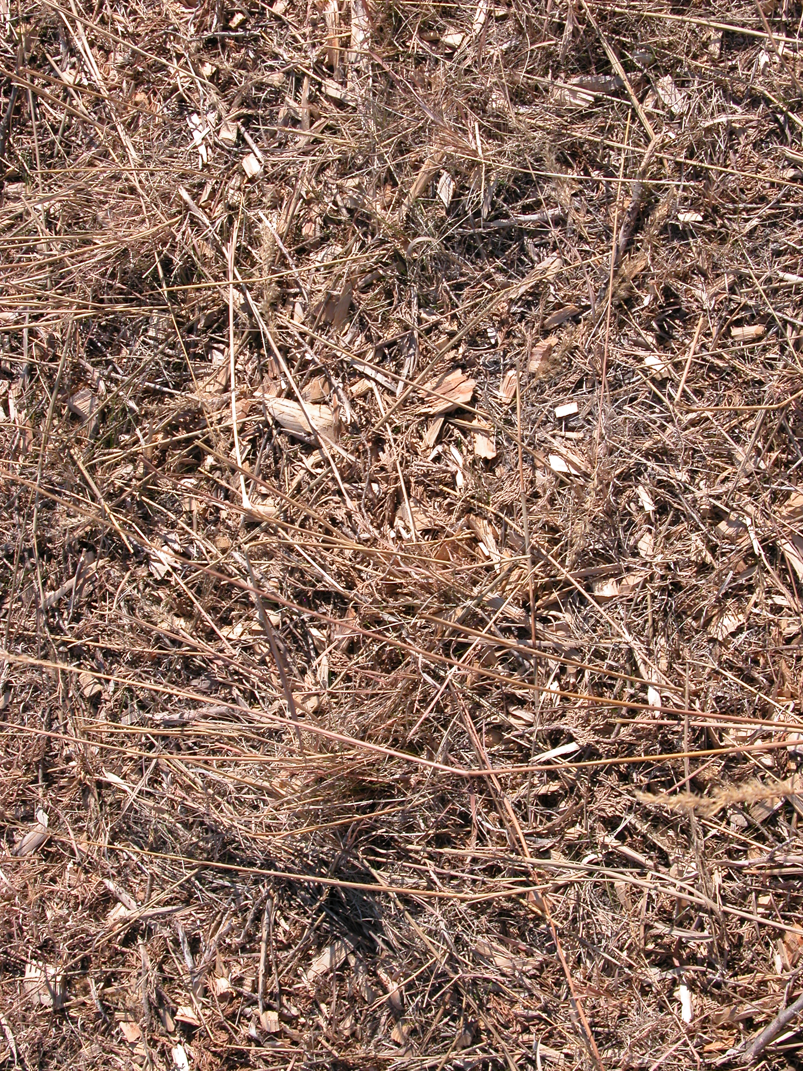

Figure 4. Test plot with a heavy application of cedar tree mulch.

