N-Release under different cover crop termination methods – FIGURE SET

Figure 1a. Nitrogen flux under flail-killed treatments of two winter annual cover crop species (AP = Austrian winter pea, HV = Hairy Vetch, N0 = bare ground, no cover crop, N150 = 150 lbs N ha⁻¹)

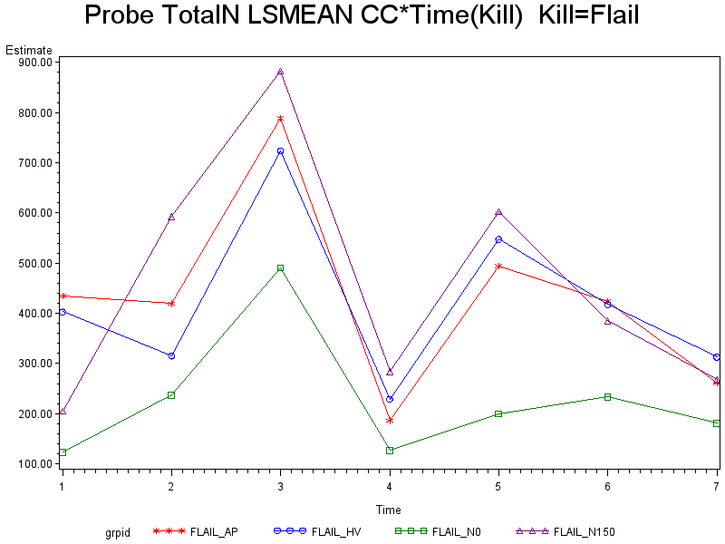

Figure 1b. Nitrogen flux under disked termination treatments of two winter annual cover crop species (AP = Austrian winter pea, HV = Hairy Vetch, N0 = bare ground, no cover crop, N150 = 150 lbs N ha⁻¹)

