Pictures from Focus Group discussions in Luverne, and Thomaston AL
LS10-237: Understanding Small Landowners’ Perspectives on Adoption of Goat-Agroforestry Land Management System

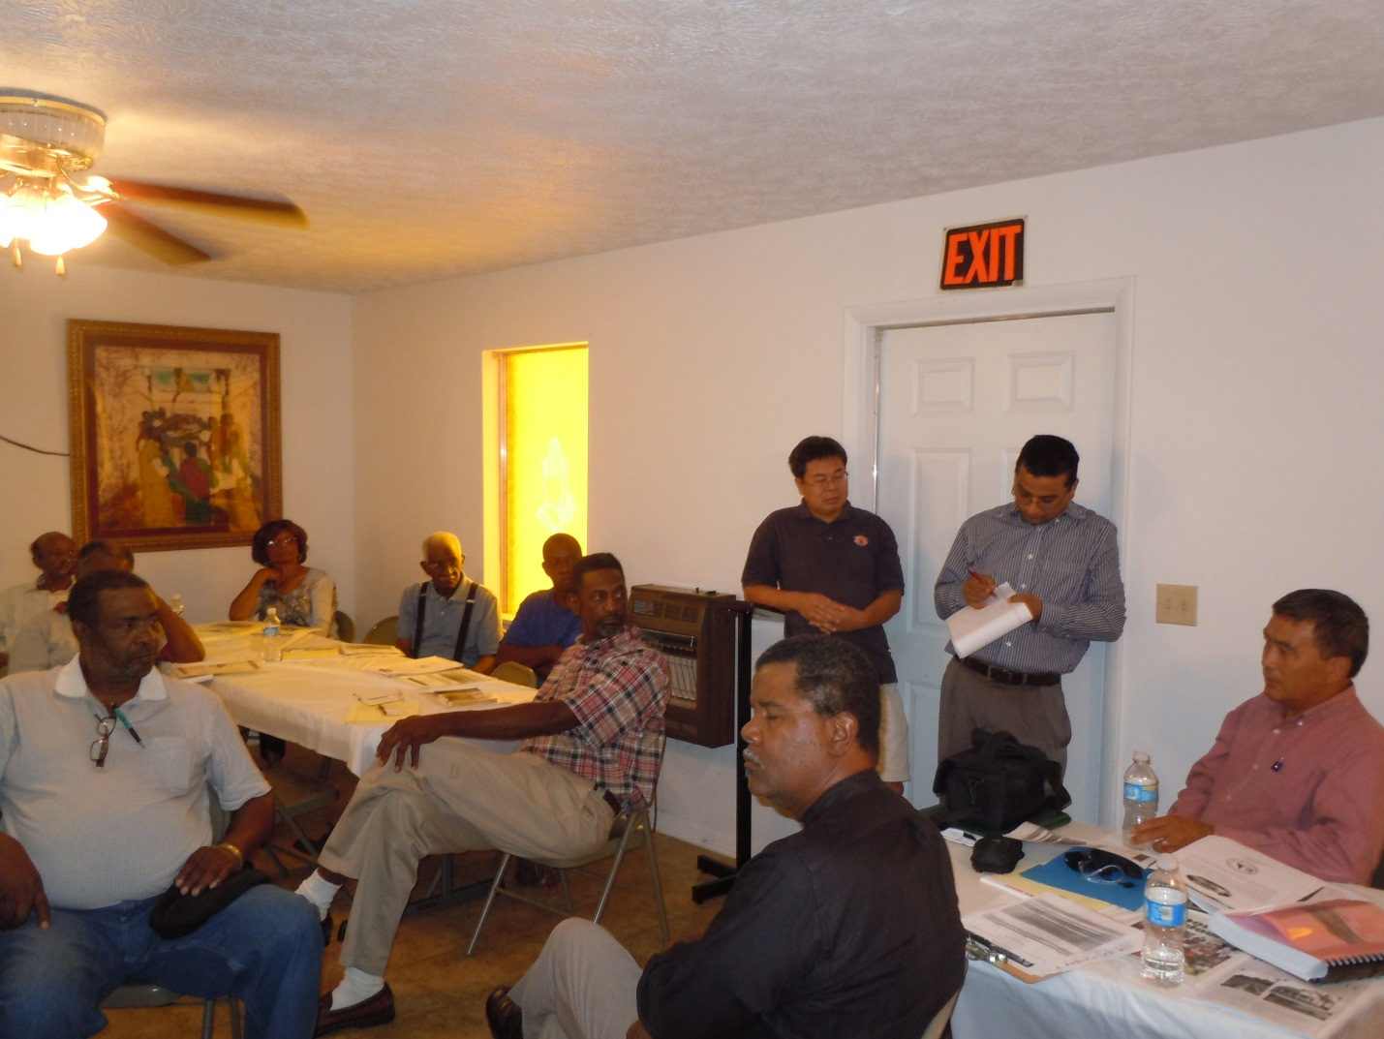

Project Director, Dr. Buddhi Gyawali is talking notes of focus group discussion in Luverne, Alabama

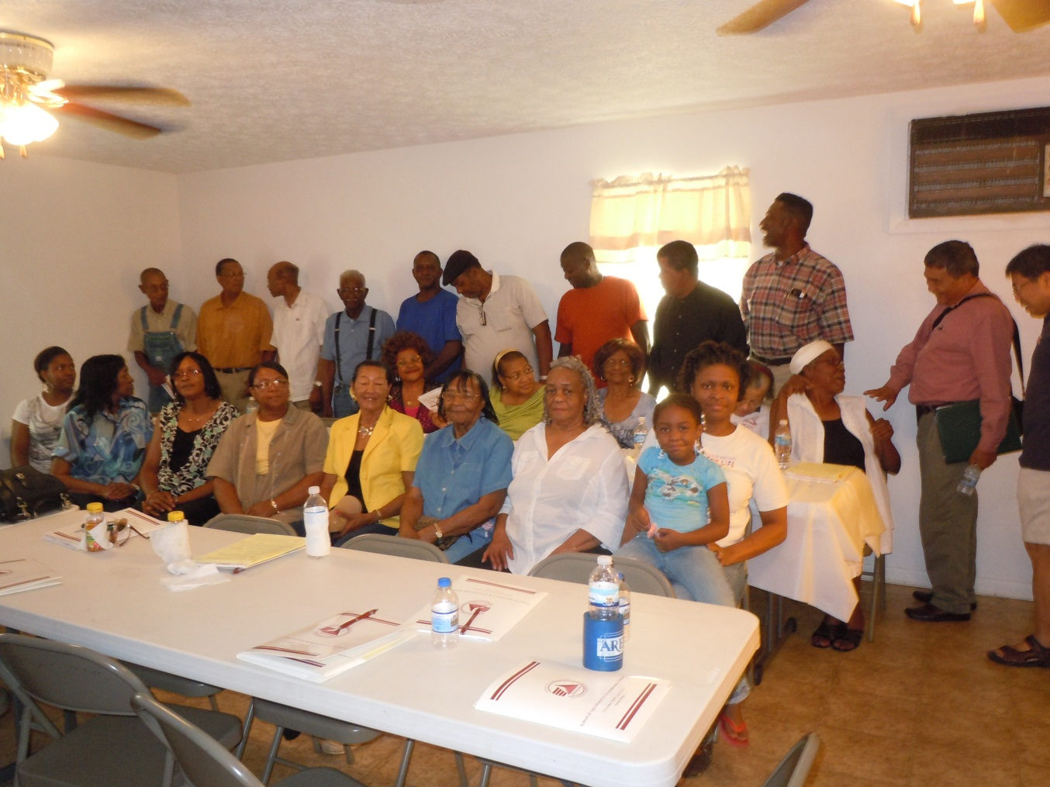
Focus group workshop participants in Luverne, Alabama, August 4, 2011

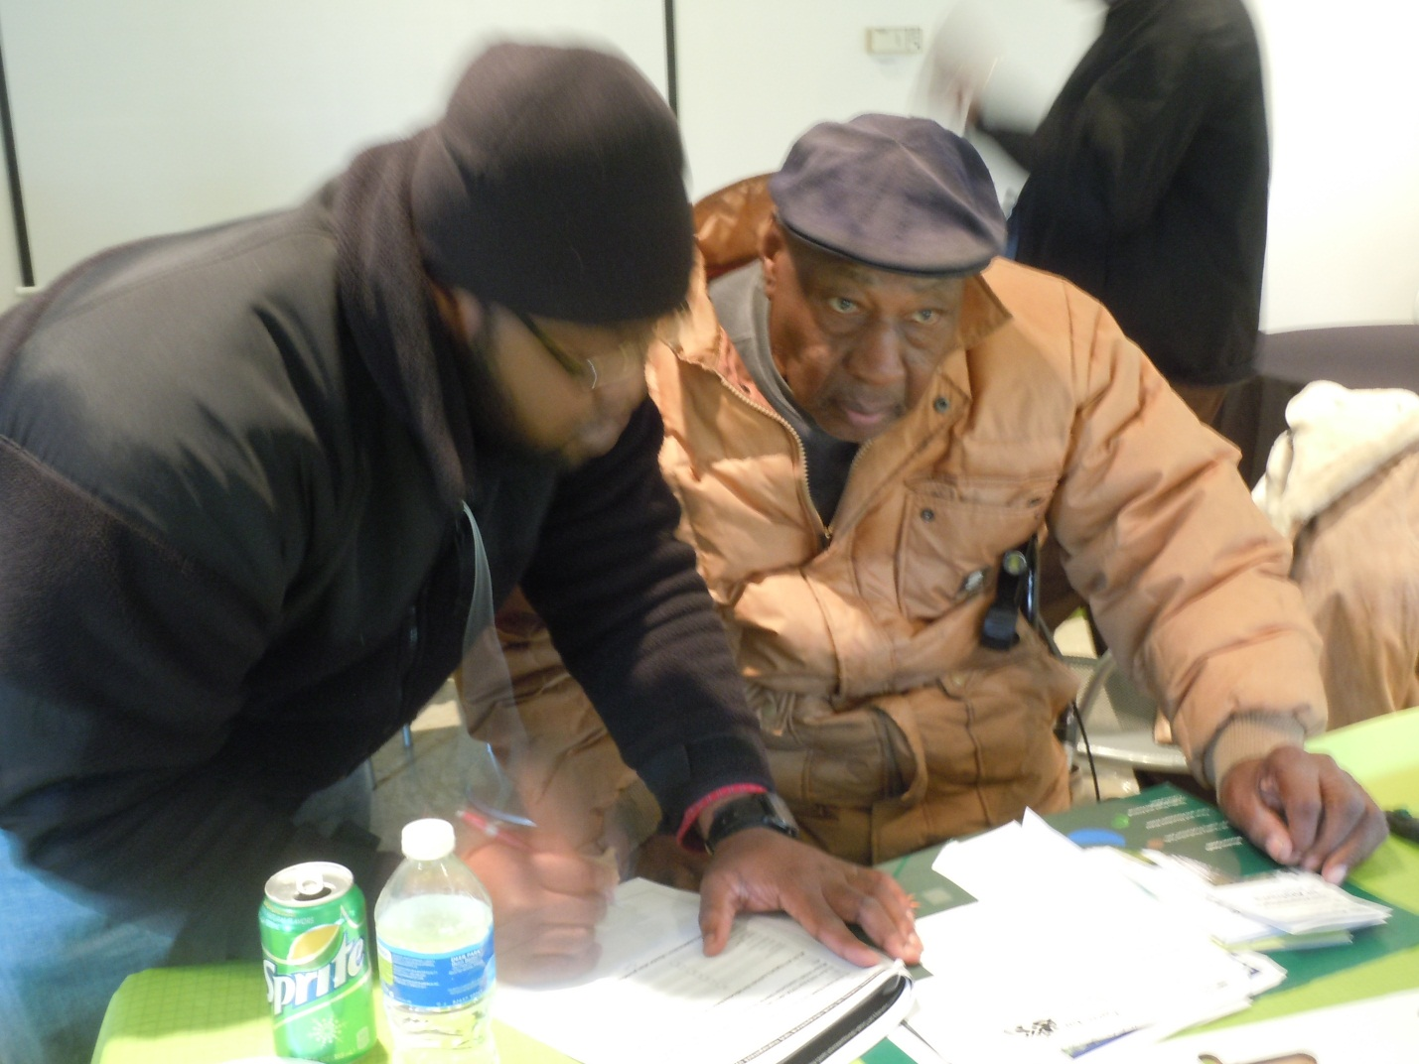
Ryan McCloud, AAMU junior, is helping Rev. Davis in filling out his survey.
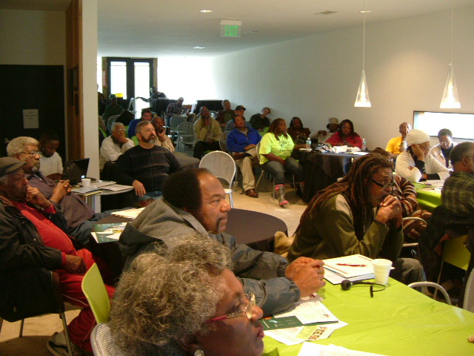
A group of participants at the Thomaston, Alabama workshop listening to the speaker from NRCS.

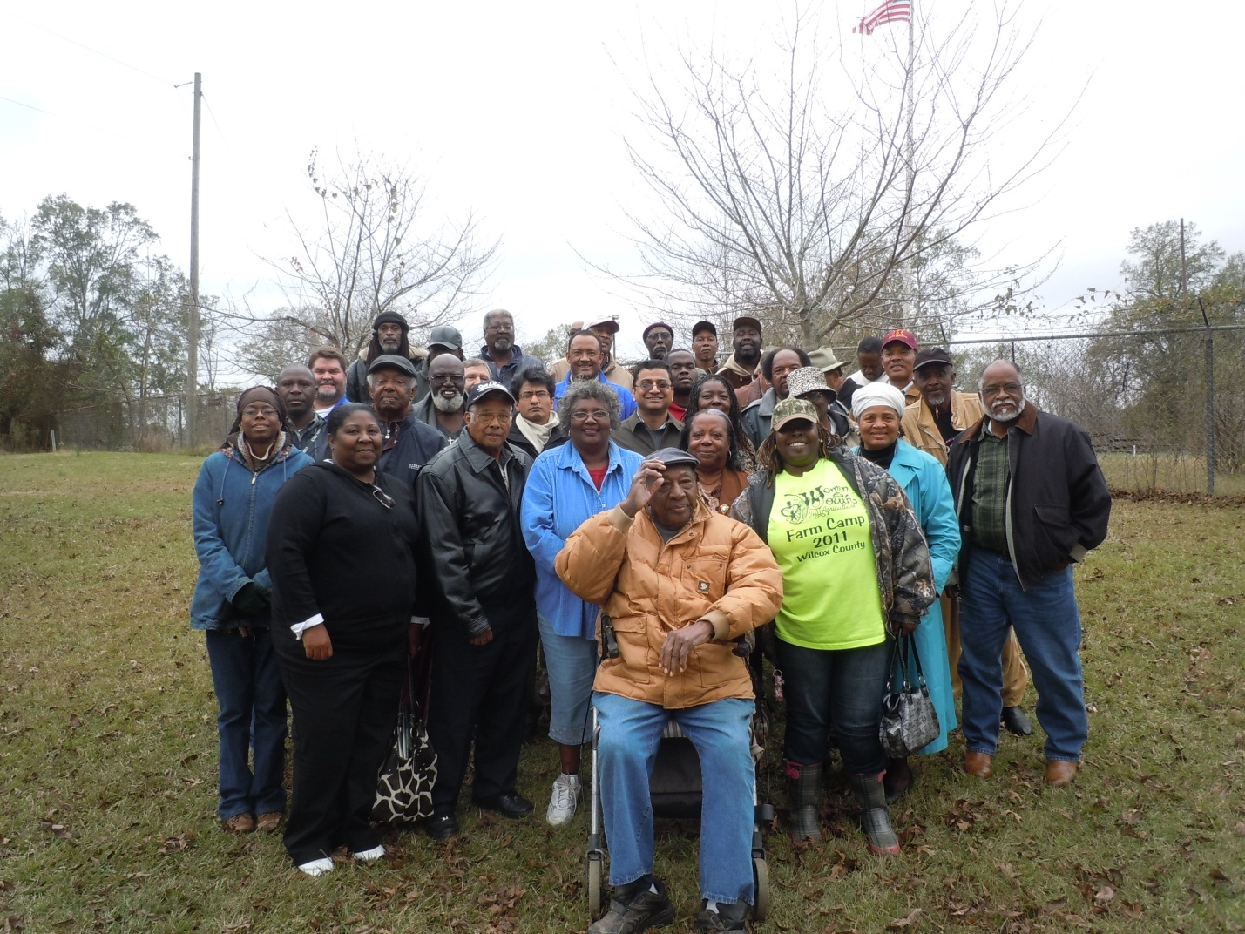

Focus group workshop participants in Thomaston, AL in front on a wheel chair, Rev. JH Davis, 96 years old but very active motivator and land owner

