Adirondack Grazers’ Cooperative

## **Adirondack Grazers’ Cooperative**

**Adirondack Grazers’ Cooperative is a group of beef producers from small to mid-size family farms in New York and Vermont who naturally raise and finish beef.**

**Our cattle are raised on the rich grasses of the Washington County Region without the use of hormones or feedlots. Our farmers care, and you can taste it in the meat.**

**Everyone Deserves Healthy Beef!**

**Quality Natural Beef**

**From Pasture to Plate**

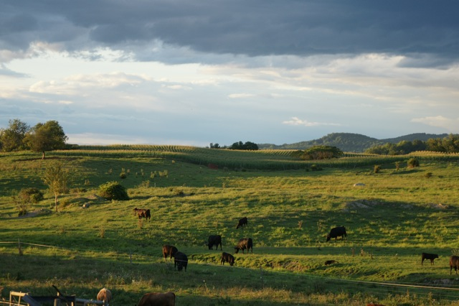

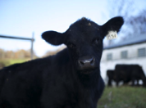

**100% grass-fed or pasture-raised, grain finished beef brought to you by a community of small family farms**

**www.adkgrazers.com**

ADK

Grazers’ Cooperative

**102 Emsig Lane**

**Granville, NY. 12832**

# **Choice**

# **Sustainable**

**For a price list and availability, please contact:**

**Meagan Blank:**

[blankme23@gmail.com](mailto:blankme23@gmail.com)

207-664-8179

**Sarah Teale:**

sarah@tealeproductionsinc.com

917-941-0481

[**www.adkgrazers.com**](http://www.adkgrazers.com)

Partial funding for the work reported here was provided by the **USDA Sustainable Agriculture Research and Education Program.**

# **Contact Us**

* A reliable supply of quality meat produced by more than 20 member farmers
* All of our cattle are pasture raised; we offer a choice of 100% grass-fed or pasture-raised grain-finished beef.
* We can deliver whole, half or quarter carcasses, or the specific cuts of your choice

* We slaughter and age our beef locally, at small-scale, USDA facilities, which our farmers have known and worked with for years.
* Each farm is able to maintain their individuality and identity. The customer can know where and how their beef was produced.
* ADK Grazers’ maintains a local New York City point of contact for our local farmers and our urban consumers.

**AGC Farms sustainable practices promise:**

* No high concentration of manure –greatly reduced air and water pollution
* No soil-depleting planting and harvesting practices
* Rich, varied legumes & grasses
* Less land used for grain production for livestock consumption
* Pasture-grazing rotation actually reduces CO2 emissions through plant absorption

**WE ARE WHAT WE EAT has become WE ARE WHAT THEY EAT**

**By purchasing our beef, you become part of a community of New York and Vermont farmers who share knowledge, equipment and resources in order to sell humanely and sustainably-raised meat.**

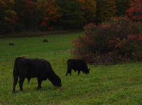

**Our customers will know exactly where their beef is from, and who raised it. We encourage customers to visit our farms in order to ensure transparency and to restore a vital link between what we eat and the communities we live in.**

**Why AGC Beef?**