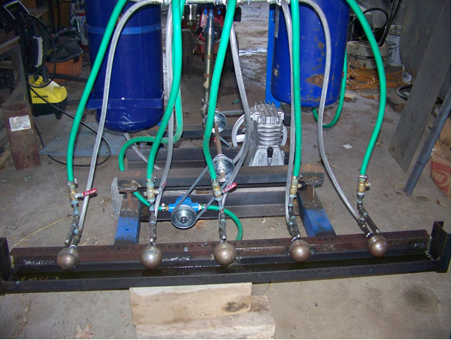
The waste vegetable oil flows over the balls and is supplied by the green hoses. Compressed air is applied to the back of the holl0w balls and comes out of three small .01 inch holes in the front . Waste oil is caught in the trough and recycled. The burner runs very well while stationary but not is motion.

