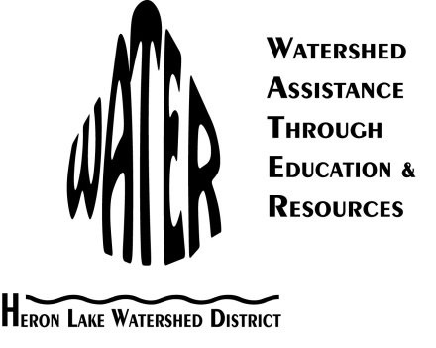
Heron Lake Watershed District Cover Crop Demonstration Project
This project would work with Jerry and Nancy Ackerman, local landowners and operators, to establish a cover crop demonstration site as a means to distribute new conservation technology to other agriculture producers and the community.
The proposed cover crop demonstration site is directly adjacent to Jackson County Judicial Ditch 3 located in Section 33 of West Heron Lake Township in Jackson County. The cover crop project will address water quality problems by increasing nutrient uptake, reducing erosion, and minimizing nutrient leaching. The cover crop will directly benefit the community and watershed by slowing water and reducing sediment and nutrient runoff before it enters the ditch.
This project location drains to South Heron Lake. The West Fork Des Moines River and Heron Lake Total Maximum Daily Load Report found South Heron Lake to be impaired for phosphorus. This project will decrease phosphorus levels by using vegetation to reduce erosion and nutrient runoff.

This demonstration project will build upon previous work done through different grant foundations including the Sustainable Agriculture Research and Education Program. Our project results will allow farmers within the HLWD and southwest Minnesota to gain knowledge and understanding of cover crops and their ability to be used locally. Data will show farmers that cover crops are a useful management tool for their own farm’s sustainability.

This project will deliver the following: soil samples, coverage data, and water quality monitoring data. Tillage transects, infiltration measurements, plant tissue tests, and soil samples will be taken at the cover crop fields and control fields for comparison in the spring of 2012 and the spring of 2013 to gauge cover crop success.

Evaluation of this project will be done by HLWD staff. Success will be defined as implementation of a cover crop, developing and distributing a newsletter and newspaper articles about the project, and hosting a field day to demonstrate the cover crop project.

