A 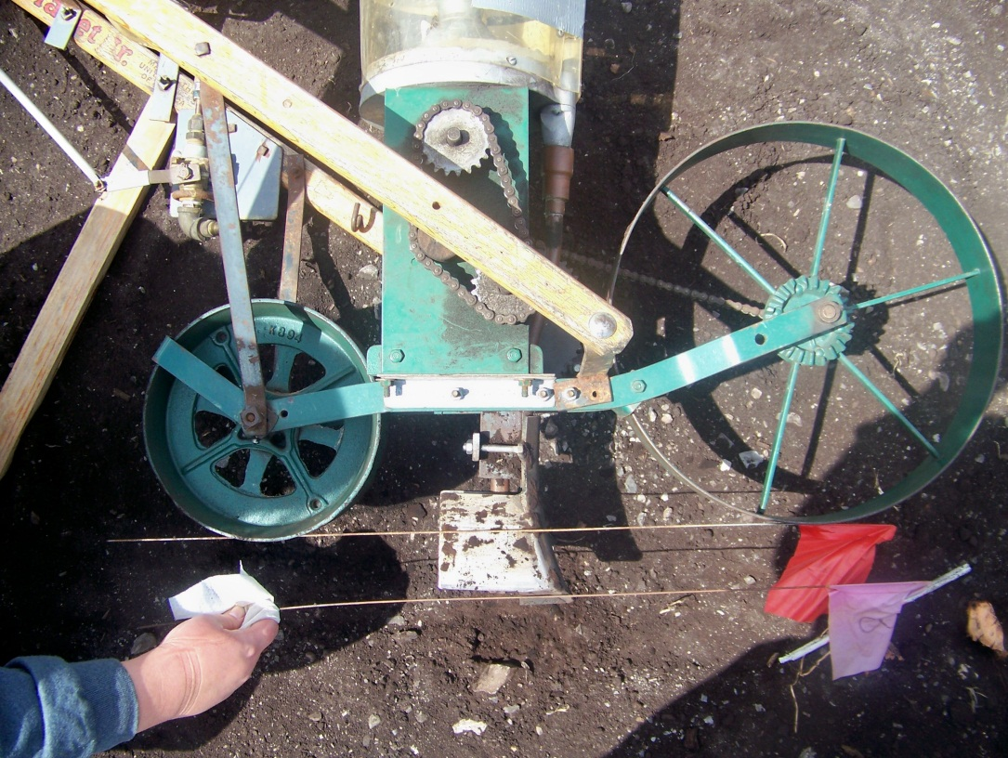

B 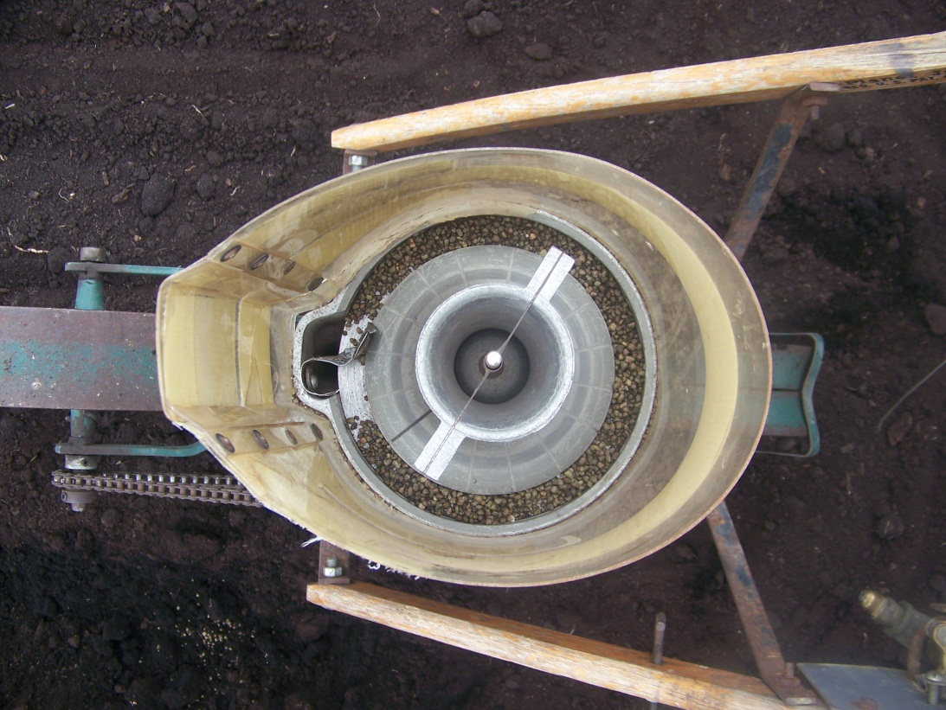

Figure 1. A) Push cone seeder with a modified shoe to place fertilizer 2-3 inches below the seed. The red flag indicates the depth of the seed and the purple flag indicates the depth of the fertilizer band.
B) Bird’s eye view of the cone seeder, holding the fertilizer to be banded.

