A 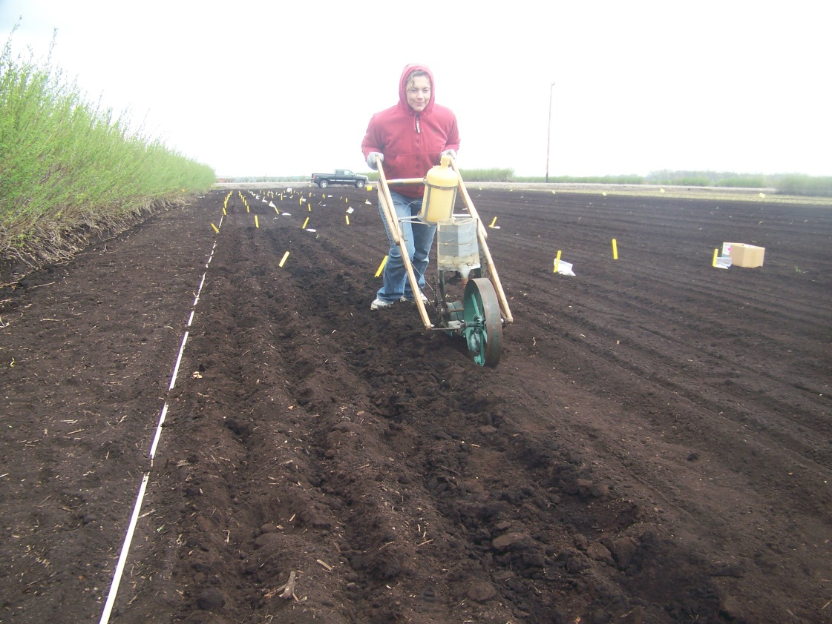
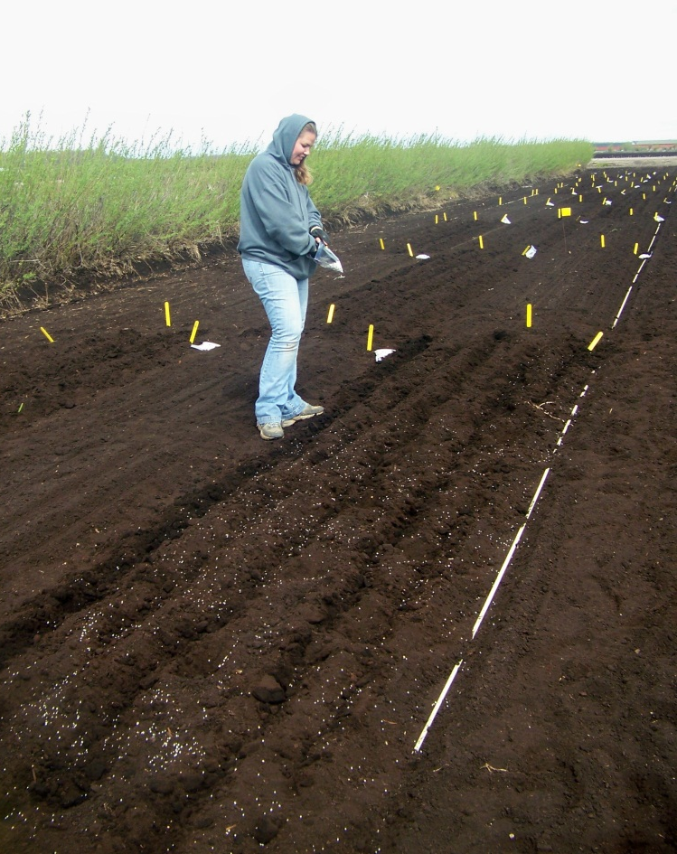
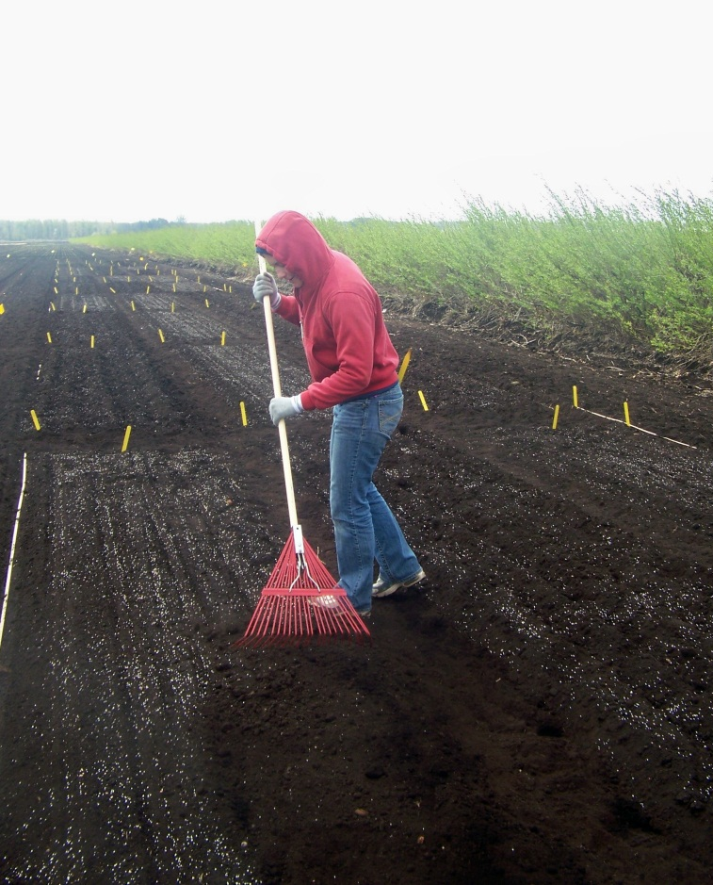
Figure 2. A) Banding the fertilizer below the seed using a push seeder. B) Broadcast fertilizer treatments were applied by hand and C) raked in. Then, the trial was planted by the using a commercial seeder.
C
B

