Grassfed Beef Case Study

Jim and Phyllis Munsch Farm

Coon Valley, Wisconsin

Jim and Phyllis Munsch bought their farm in southwestern Wisconsin near the town of Coon Valley, in 1978 while Jim was still working as an agricultural engineer.

Production Model
Jim started out grazing cattle for others but purchased his own herd of Black Angus cattle from a neighbor in the early 1980s. That herd has served his grass-based system well. It was owned by an early Angus breeder who was well-known in the 1940s, before the cattle breed associations started focusing on size. Jim bought five families of small-framed cows, perfect for a grass-based system, and he’s maintained and improved on those genetics through line-breeding.

Why?
Jim started growing crops on contour strips, but the crop enterprise was tough on the land and economically unsuccessful. “In order to make money, I just totally embraced rotational grazing,” Jim says.

Farm, Soil, and Climate
On Jim’s beef farm in the hills of Vernon County, Wisconsin, level ground is in short supply. Located in an area untouched by the glaciers, it is characterized by its rolling topography and steep hillsides. About half of the 100-acre farm is in woods and the other half is now in permanent pasture. While some farmers in the area grow annual row crops on similar slopes, since his early days on this farm, , Jim has felt that this land is best suited to perennial pastures.

Pastures/Grazing Management
Jim learned grazing management from his local grazing network. Although most of the farmers involved are dairy graziers, Jim finds that most of the information shared is applicable to his operation and that finishing steers need high quality pastures to perform just like lactating dairy cows do. Jim also keeps up with the latest research through University Extension information, the Internet, publications, and through working directly with University of Wisconsin (UW) scientists. Jim’s farm is the site of an ongoing study with UW agronomy faculty on frost-seeding legumes into perennial pastures.

The herd of 35 cows grazes on 80 acres of pasture, of which 50 is owned and 30 rented. The permanent pastures on Deer Run farm are 25 years old. Jim counts four legumes, six grasses, and four or five common broadleaved forbs as contributors to pasture productivity. His current research project involves evaluating kura clover and a new white clover called Kopu II. So far, the Kopu II is performing better, mostly because of the kura clover’s poor establishment.

Jim moves both his cow herd and his market animals every one to two days. He has a total of 38 paddocks on his farm, so each paddock gets a 30- to 37-day rest period before grazing again

He stockpiles forage in paddocks, not for winter, but for the frequent late summer droughts his area experiences.

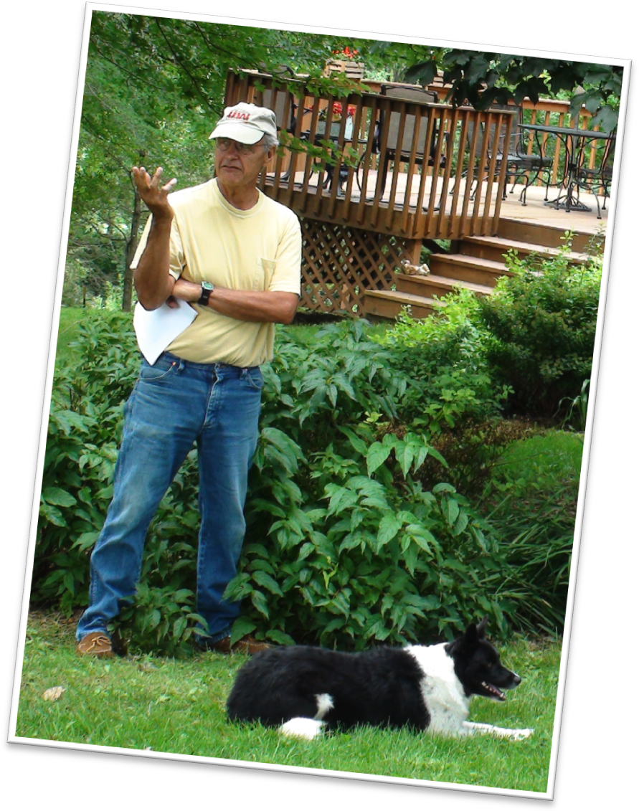
Jim rents an additional 95 acres for hay production. Hayfields are reseeded every five to seven years when the alfalfa in the stand falls below 30%. At that point, Jim plows down the stand and seeds it to oats and red clover for one year to allow the alfalfa autotoxins to break down. The next year, it goes back into an alfalfa and smooth brome mixture with a nurse crop of oats.

The first cutting of hay is made into round bales for the cow herd. Second crop is made into small square bales for the finishing animals. Jim guages growth and cutting dates to get14 to 16 percetn protein and 120 Relative Feed Value in his hay.

Winter Feeding
Jim looks at his winter system as his nutrient management plan. He outwinters cattle where he feels his soil needs nutrients. He estimates that his herd is outwintered approximately four months most winters. During this period he feeds hay: one bale intact in a bale ring and another rolled out on the ground each day. For roughly two months during the coldest part of winter, the animals are maintained on a bedded pack with access to a building. The finishing animals and weaned calves are managed on a bedded pack with access to shelter.

Marketing
Jim has focused his efforts on cattle breeding and land management. Until about 14 years ago, he sold cattle through the local sale barn. In 1995, he entered into a relationship with a nearby Community Supported Agriculture (CSA) farm that has made a big difference in his bottom line. The arrangement meant that Jim had to transition his farm to be certified organic, but that was not much of a challenge—he was mostly there with the pasture-based system he developed. The farm was certified in 1999, the year that USDA allowed meat to be labeled as organic.

The CSA farm purchases nearly all of Jim’s meat animals—about 30 per year. They buy half of them at about one year of age, to be grazed on their farm as part of their organic rotation. The other half are finished on Jim’s farm and sold as carcasses to the CSA.

Beef Herd Management

Calving time and period? Weaning time? Managmentment of weaned calves until market?
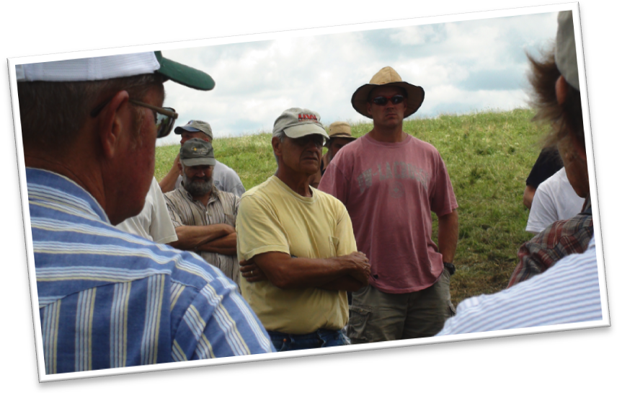
While this marketing arrangement allowed Jim to avoid getting involved in doing marketing himself (something he wasn’t interested in), he did have to learn a lot about producing high quality meat on pasture. Jim did his background research and delved into it as he does everything; monitoring, keeping records, and always focusing on improvement. He weighs market animals and grades carcasses, feeding all this information into his breeding, feeding, and pasture management programs. The meat animals are raised on a forage-based diet with small amounts of organic grain provided (2 lb./day) only when pasture quality warrants it.

Herd Health
Although transitioning his herd to be certified organic required few changes in his production practices, Jim said there is one thing he would do differently if he was not organic. “I would probably worm my yearlings. To me, there is no good organic way to do that right now and that’s troublesome to me.”

Summary – Challenges
“The only bad thing about grazing in Wisconsin is that we have winter,” Jim jokes.

To Jim, learning is a continual process and he still attends and hosts pasture walks to pick up new information. Jim is always looking for opportunities to improve his grazing operation, especially through nutrient management. The cost and sustainability of the farm is on the line when nutrients are managed poorly or ignored, Jim says.

Keys to the Operation
Jim does some consulting work for farmers that are having trouble and said cost of production is often overlooked.

“It always surprises me how little is known about their cost of production, not of the end product so much, but the intermediate products.”

Questions such as, “How much does it cost me to raise hay?” or “How much does it cost me to keep an acre of pasture and how much do I get off that acre?” are easier for farmers to answer because the university has worksheets and models available. But recordkeeping to track of all of the costs along the way opens up significant opportunity for improvement, he says.

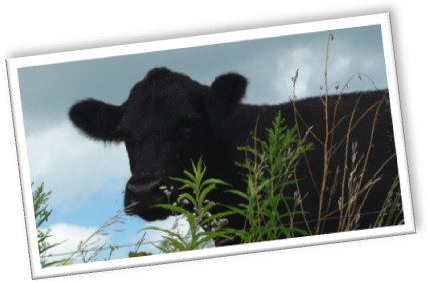
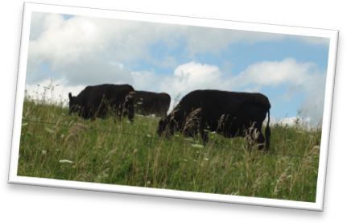
“I’m an ag. engineer by training and I have a master’s in business and it was heavily on the financial and management side, so I’ve approached this farm that way.”

That means the farm ends each year with a profit. Not a huge profit, Jim says, but only because it’s not a huge farm.

Written by Kelliann Blazek and Laura Paine, WI DATCP. Photos by Kelliann Blazek. September 2010.

