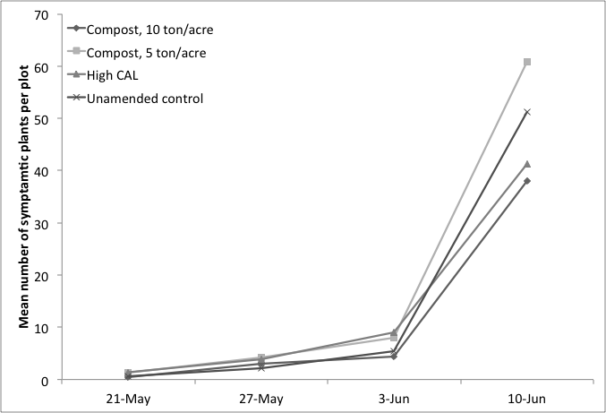
Figure 1. Incidence of fusarium wilt in commercial tomato where compost and lime treatments were applied to sandy soils prior to bedding in Florida during the spring 2010 growing season.

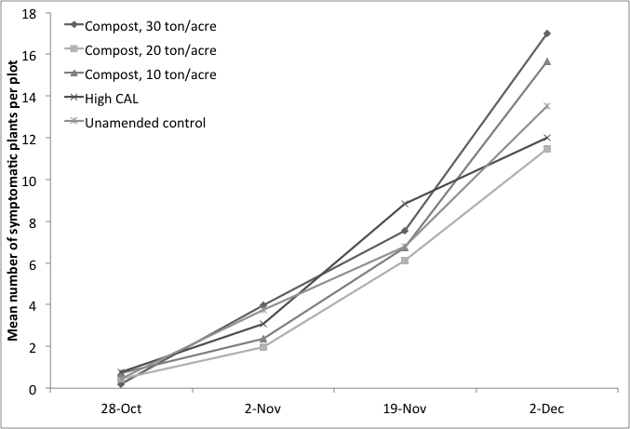

Figure 2. Incidence of fusarium wilt in commercial tomato where compost and lime treatments were applied to sandy soils prior to bedding during the fall 2010 growing season.

