 | <--- 1 m --->
<1m> | Ginseng GI) | 1/2 meter | BC | 1/2 meter | FU | 1/2 meter | VS | 1/2 meter | GO | 1/2 meter | GI
1/2 meter
 | Goldenseal (GO) |  | GI |  | BC |  | FU |  | VS |  | GO
1/2 meter
 | VA Snakeroot (VS) |  | GO |  | GI |  | BC |  | FU |  | VS
1/2 meter
 | F. Unicorn (FU) |  | VS |  | GO |  | GI |  | BC |  | FU
1/2 meter
 | Black Cohosh (BC) |  | FU |  | VS |  | GO |  | GI |  | BC
Figure 1. planting design for FFN private landowner trials
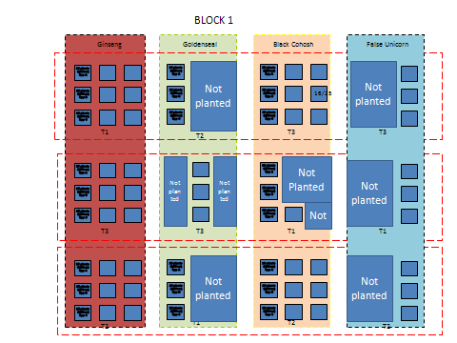
Figure 2. Block 1 of large planting scheme
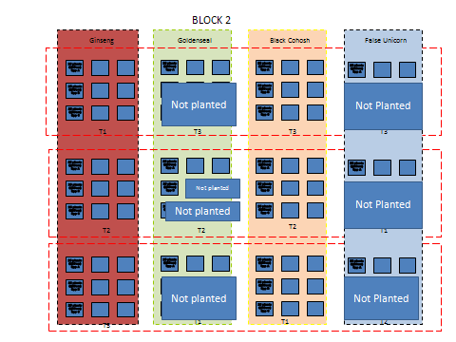
Figure 3. Block 2 of large planting scheme
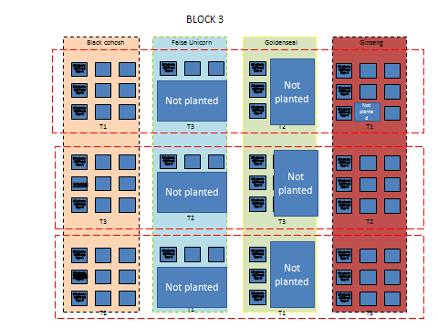
Figure 4. Block 3 of large planting scheme

Figure 5. Relationship between ginseng root weight and vegetation weights of plants harvested from the UGA experimental forest in 2011.

Figure 6. Relationship between false unicorn root weight and vegetation weights of plants harvested from the UGA experimental forest in 2011.

Figure 7. Relationship between goldenseal root weights and vegetation weights of plants harvested from the UGA experimental forest planting in 2011.

Figure 8. Relationship between ginseng root and vegetation weights of plants harvested from Catawba Sustainability Center in 2012

Figure 9. Relationship between green root weight and number of leaflets for ginseng plants harvested from the Catawba Sustainability Center in 2012.

Figure 10. Relationship between goldenseal green root weights and green leaf weights for plants harvested from the Catawba Sustainability Center plantings in 2012.

Figure 11. Relationship between goldenseal green leaf diameter (cm) and green root weights (grams) for plants harvested from the Catawba Sustainability Center plantings in 2012

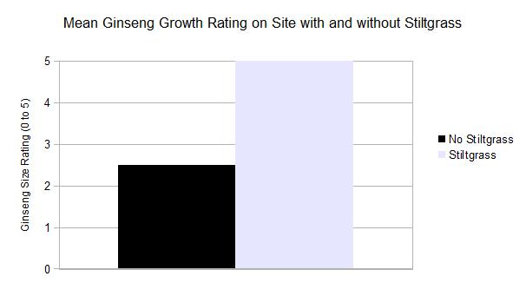
Figure 12. Ginseng growth in sites with and without Japanese stilt grass suggests that the invasive plant may improve ginseng production.
Table 1. Soil and other ecological factors of planting sites for FFN participants, including the McCormick Farm.
Location | P (lb/ac) |  | K (lb/ac) | Ca (lb/ac) | Mg (lb/ac) | Zn (ppm) | Mn (ppm) | Cu (ppm) | Fe (ppm) | B (ppm) | pH
AR | 4 | 161 |  | 2879 | 374 | 1.2 | 12.5 | 0.4 | 6.3 | 0.8 | 6.8
BH | 6 | 96 |  | 1745 | 116 | 1 | 11.8 | 0.2 | 3.8 | 0.6 | 6.71
BK | 5 | 78 |  | 1404 | 189 | 2.5 | 18.9 | 0.2 | 8.1 | 0.3 | 5.9
BW | 4 | 42 |  | 141 | 54 | 1.2 | 5.2 | 0.5 | 16.7 | 0.2 | 5
CSC | 4 | 144 |  | 703 | 131 | 1.7 | 9.7 | 0.3 | 17.1 | 0.2 | 5.4
DF | 4 | 135 |  | 296 | 113 | 2.7 | 17 | 0.2 | 43 | 0.2 | 5.1
DM | 4 | 136 |  | 549 | 119 | 1 | 10.2 | 0.3 | 8.9 | 0.2 | 5.3
DR | 6 | 383 |  | 1119 | 493 | 1.5 | 10.5 | 0.5 | 33 | 0.5 | 5.5
GS | 4 | 101 |  | 283 | 76 | 1.6 | 13.5 | 0.3 | 27.5 | 0.2 | 4.9
JB | 9 | 182 |  | 7377 | 344 | 5.1 | 32.8 | 0.2 | 10.7 | 1.4 | 6.8
JL | 4 | 202 |  | 2094 | 367 | 2.7 | 8.6 | 0.2 | 3.8 | 0.5 | 6.5
JW | 5 | 153 |  | 558 | 179 | 2.2 | 11.2 | 0.5 | 24.5 | 0.2 | 5.1
LG | 11 | 125 |  | 1110 | 164 | 1.4 | 13.2 | 0.2 | 13.3 | 0.3 | 5.6
MF-B1-T1 | 9 | 72 |  | 570 | 86 | 1.6 | 13.5 | 0.2 | 7.7 | 0.2 | 5.2
MF-B2-T1 | 9 | 72 |  | 570 | 86 | 1.6 | 13.5 | 0.2 | 7.7 | 0.2 | 5.2
MF-B3-T1 | 14 | 99 |  | 789 | 117 | 1.4 | 16.7 | 0.2 | 8.8 | 0.3 | 5.3
RG | 9 | 193 |  | 1931 | 152 | 0.9 | 14.8 | 0.3 | 5 | 0.4 | 6.8
SW | 5 | 153 |  | 558 | 179 | 2.2 | 11.2 | 0.5 | 24.5 | 0.2 | 5.1
TV | 4 | 154 |  | 723 | 124 | 1.4 | 5.4 | 0.2 | 15.7 | 0.2 | 5.1
minimum | 4.0 | 42.0 |  | 141.0 | 54.0 | 0.9 | 5.2 | 0.2 | 3.8 | 0.2 | 4.9
mean | 6.3 | 141.1 |  | 1336.8 | 182.3 | 1.8 | 13.2 | 0.3 | 15.1 | 0.4 | 5.6
maximum | 14.0 | 383.0 |  | 7377.0 | 493.0 | 5.1 | 32.8 | 0.5 | 43.0 | 1.4 | 6.8
Location | Buffer Index | CEC (meq/100g) |  | % Acidity | % Base Saturation | % Cation Saturation | % Mg Saturation | % K Saturation | FSQI Value | Slope % | Aspect
AR | 6.4 | 9 |  | 0.7 | 99.3 | 79.9 | 17.1 | 2.3 | 10 | 51 | 64
BH | 6.27 | 10.7 |  | 7.2 | 92.8 | 81.5 | 8.9 | 2.3 | 9 | 50 | 305
BK | 6.14 | 5.9 |  | 26 | 74 | 59.1 | 13.1 | 1.7 | 13 | 13 | 14
BW | 5.78 | 4.3 |  | 85.4 | 14.6 | 8.2 | 5.2 | 1.3 | 12 | 25 | 38
CSC | 5.87 | 5.6 |  | 55.9 | 44.1 | 31.2 | 9.6 | 3.3 | 7 | 57 | 336
DF | 5.81 | 4.9 |  | 71.8 | 28.2 | 15.1 | 9.5 | 3.5 | 12 | 30 | 52
DM | 5.92 | 4.9 |  | 58.3 | 41.7 | 28.1 | 10 | 3.6 | 13 | 47 | 30
DR | 6.09 | 7.2 |  | 25.7 | 74.3 | 39 | 28.4 | 6.9 | 7 |  | 119
GS | 5.67 | 5.5 |  | 79 | 21 | 12.9 | 5.7 | 2.4
JB | 6.34 | 20.4 |  | 1.8 | 98.3 | 90.2 | 6.9 | 1.1 | 7 | 40 | 280
JL | 6.27 | 7.8 |  | 9.9 | 90.1 | 67.3 | 19.5 | 3.3 | 8 | 24 | 245
JW | 5.59 | 7.1 |  | 67.4 | 32.6 | 19.5 | 10.3 | 2.8 | 9 | 35 | 260
LG | 5.88 | 6.7 |  | 46.1 | 53.9 | 41.4 | 10.1 | 2.4 | 12 | 25 | 28
MF-B1-T1 | 60.1 | 4.2 |  | 55.3 | 44.7 | 34 | 8.5 | 2.2 | 12 | 9 | 2
MF-B2-T1 | 60.1 | 4.2 |  | 55.3 | 44.7 | 34 | 8.5 | 2.2 | 11 | 2 | 300
MF-B3-T1 | 5.92 | 5.4 |  | 52.5 | 47.5 | 36.3 | 8.9 | 2.3 | 12 | 3 | 352
RG | 6.37 | 5.9 |  | 3.1 | 97 | 82.1 | 10.7 | 4.2 | 12 | 23 | 31
SW | 5.59 | 7.1 |  | 67.4 | 32.6 | 19.5 | 10.3 | 2.8 | 9 | 35 | 260
TV | 5.81 | 6 |  | 58.2 | 41.8 | 30 | 8.5 | 3.3 | 7 | 34 | 270
minimum | 5.6 | 4.2 |  | 0.7 | 14.6 | 8.2 | 5.2 | 1.1 | 7.0 | 2.0
mean | 11.7 | 7.0 |  | 43.5 | 56.5 | 42.6 | 11.0 | 2.8 | 10.1 | 29.6
maximum | 60.1 | 20.4 |  | 85.4 | 99.3 | 90.2 | 28.4 | 6.9 | 13.0 | 57.0
Location | Slope Position | Oak SI (ft) |  | Elevation (ft)
AR | 2 | 70
BH | 4 | 65 |  | 1914
BK | 4 | 80 |  | 2117
BW | 1 | 75 |  | 2568
CSC | 2 | 60 |  | 2131
DF | 3 | 75 |  | 2580
DM | 5 | 80 |  | 2316
DR | 2 | 50 |  | 2111
GS |  |  |  | 2578
JB | 2 | 60 |  | 2020
JL | 3 | 60 |  | 2899
JW | 5 | 65 |  | 1819
LG | 2 | 75 |  | 2788
MF-B1-T1 | 4 | 75 |  | 1800
MF-B2-T1 | 3 | 72 |  | 1800
MF-B3-T1 | 3 | 75 |  | 1800
RG | 4 | 75 |  | 1905
SW | 5 | 65 |  | 2774
TV | 2 | 60 |  | 2751
minimum | 1.0 | 50.0 |  | 1800.0
mean | 3.1 | 68.7 |  | 2259.5
maximum | 5.0 | 80.0 |  | 2899.0

Table 2. Soil conditions of the three sites on the UGA forest that were planted.

 | Block
 | 1 | 2 | 3
pH (soil water) | 4.77_{c} | 5.07_{b} | 5.74_{a}
pH (CaCl₂) | 4.04_{c} | 4.28_{b} | 5.03_{a}
g-C/100 g-soil | 3.39_{b} | 3.29_{b} | 11.98_{a}
g-N/100 g-soil | 0.13_{b} | 0.13_{b} | 0.48_{a}
C:N | 25.93_{a} | 25.67_{a} | 24.24_{a}
meq Ortho-P/100g-soil | 1.07_{a} | 0.66_{a} | 0.75_{a}
meq Ca/100g-soil | 1.15_{b} | 0.97_{b} | 3.69_{a}
meq K/100g-soil | 0.16_{b} | 0.15_{b} | 0.24_{a}
cmol exchangeable acidity/kg-soil | 1.46_{a} | 1.04_{b} | 0.21_{c}
meq CEC/100g-soil | 3.23_{b} | 2.71_{b} | 5.42_{a}
% base saturation | 53.7_{b} | 60.7_{b} | 95.2_{a}

Table 3. Overall plant survival of species planted by private landowners of the FFN.

Species | Mean  (Std Dev)
Ginseng | 11.4 (6.5)
Goldenseal | 14.6 (6)
Virginia Snakeroot | 3.9 (4.9)
False unicorn | 0
Black cohosh | 0

Table 4. 2012 survival of species planted at the McCormick farm in 2010, reported by treatment.
 | Treatment
Species | T1 – No Disturb | T2 – Rake | T3 – Till | Mean
Black cohosh | 0 | 0 | 0 | 0
False unicorn | 10.1 (3.4) | 12.8 (4.6) | 15.0 (2.6) | 12.63 (3.53)
Ginseng | 10.6 (3.9) | 10.5 (4.8) | 6.0 (3.6) | 9.0 (4.1)
Goldenseal | 10.9 (4) | 7.9 (3.8) | 7.6 (3.5) | 8.8 (3.76)

Table 5. Overall plant survival of species planted at the UGA experimental forest in 2010, reported by treatment.
 | Treatment
Species | T1 – No Disturb | T2 – Rake | T3 – Till | Mean
Black cohosh | 0 | 0 | 1.1 | 0.4
False unicorn | 18.9 (2.9) | 17.4 (1.7) | 17.6 (3.4) | 17.9 (2.7)
Ginseng | 5.8 (2.2) | 7.4 (3.9) | 9.3 (3.5) | 7.5 (3.2)
Goldenseal | 5.6 (5.7) | 10.3 (3.4) | 10.1 (5.0) | 8.7 (4.7)

Table 6. Demographic characteristics of FFN participants, and potential forest farmers.
Characteristic | Response Category | Mean | Percent of Respondents
Primary motivations for collaborative conservation partnership membership* | Environmental |  | 79%
 | Educational |  | 79%
 | Economic |  | 46%
 | Social |  | 44%
Initial information source about collaborative conservation partnership | Word of mouth |  | 46%
 | Presentation |  | 25%
 | Other organization |  | 16%
 | Advertisement |  | 15%
Belong to multiple conservation groups |  |  | 60%
Gender | Male |  | 59%
 | Female |  | 36%
 | Both (a couple) |  | 5%
Household Annual Income |  | $55,000-$99,000
Age |  | 55-64
Race
Educational Attainment |  | Bachelor's Degree
Acres forestland owned |  | 95
Years of land tenure |  | 24
Primary residence |  |  | 75%
Primary ownership motivations | Live there
 | Appreciate the woods/aesthetics/privacy
 | Recreation
Most common harvest objectives | Improve forest health |  | 44%
 | Achieve objectives in management plan |  | 44%
 | Obtain products for personal use |  | 41%
Primary land management information sources | Virginia Department of Forestry |  | 87%
 | Conservation organizations |  | 57%
 | Extension/university personnel |  | 55%
 | Private consultant |  | 49%
Diffusion of Innovations Adopter Categories | Innovators |  | 53%
 | Majority |  | 21%
 | Laggards |  | 26%

Table 7. Descriptive statistics for ginseng root and vegetation harvested from the UGA experimental forest plantings in 2011.
 |  | Total | Root | Vegetation
Count |  | 158 | 158 | 158
mean |  | 0.386 | 0.120 | 0.265
maximum |  | 1.779 | 0.759 | 1.197
minimum |  | 0.111 | 0.001 | 0.049
skew |  | 3.078 | 2.826 | 3.036
kurtosis |  | 12.696 | 10.638 | 14.255
variance |  | 0.060 | 0.013 | 0.020
std. deviation |  | 0.246 | 0.115 | 0.143
Pearson |  | 0.820

Table 8. Descriptive statistics for false unicorn root and vegetation harvested from the UGA experimental forest plantings in 2011.
 | Total | Root | Vegetation
Count | 161 | 161 | 161
Min | 0.50 | 0.50 | 0.00
Max | 16.00 | 15.50 | 5.00
Mean | 3.52 | 2.53 | 0.99
Stdev | 2.74 | 2.35 | 0.86
Variance | 7.52 | 5.54 | 0.73
Pearsons | 0.31

Table 9. Descriptive statistics for goldenseal root and vegetation harvested from the UGA experimental forest plantings in 2011.
 | Total | Root | Vegetation
Count | 82 | 82 | 82
Min | 0.5 | 0 | 0
Max | 4 | 2 | 2
Mean | 1.43 | 0.88 | 0.55
Stdev | 0.69 | 0.44 | 0.40
Variance | 0.48 | 0.19 | 0.16
Pearsons | 0.37

