Organic practices for the production of muskmelon ISU Horticulture Farm, 2011

Jean Batzer, Assistant Scientist
Steven Johnson, Undergraduate student
Mark Gleason, Professor/Extension Plant Pathologist
Department of Plant Pathology

Introduction
Cucurbit crops, especially muskmelon and cucumber, attract cucumber beetles which vector bacterial wilt, Erwinia tracheiphila, causing significant crop losses. High beetle densities are associated with high bacterial wilt incidence, which usually occurs during the first stages of plant establishment. Growers of organic muskmelon need effective ways to manage the cucumber beetle/bacterial wilt complex.
Row covers are usually deployed from transplant until anthesis (start of flowering), then removed to allow insect pollination. Several studies at ISU and elsewhere have suggested that a 10-day delay in row cover removal can shield muskmelon crops from the first emergence of wilt-vectoring cucumber beetles, resulting in much less bacterial wilt, and correspondingly better yield, than either removing the cover at anthesis or not using row covers at all. Opening the ends of the row covers has been tried in order to allow for pollination.

This project is the second year in a three-year multi-state effort, with Kentucky and Pennsylvania, to optimize organic growing practices that effectively manage insect and diseases, and enhance pollination for cucurbit crops.

Materials and Methods
Transitioning organic land was used for the multi-factorial experimental plot at the Gilbert horticultural research station. On May 17 three-wk-old organic transplants of ‘Strike’ muskmelon were planted 2 ft apart in black plastic mulch with drip irrigation and 8 ft centers. Subplots consisted of 30 ft rows of 15 plants. Spunbond polypropylene row covers (Agribon® AG-30) were installed on wire hoops immediately after transplanting.

A Latin square experimental design using 16 subplots (4 replicates of 4 treatments) was used to examine impacts of row cover treatments:
1) No row covers (control)
2) Row covers applied at transplanting and
removed at anthesis (start of perfect flower
bloom)
3) Row covers applied at transplanting with the
ends opened at anthesis and removed 10 days
later (Fig 1)
4) Row covers applied at transplanting and
removed 10 days after anthesis.
OMRI-registered insecticides and fungicides were applied on a rescue basis only, triggered by results of weekly monitoring. Pyganic® was applied to control picnic beetle damage on ripening fruit, the evening of August 7. Champ 50WG® (copper hydroxide) was used to control anthracnose. Weed management was achieved with 6 inches of corn stalk mulch between rows and composted bark was placed around the opening in the plastic around each seedling before row cover placement.

Striped and spotted cucumber beetle adult numbers were monitored weekly from transplant through the beginning of harvest using yellow sticky cards and weekly counts from 5 randomly chosen plants. Disease incidence was monitored weekly. Melons were harvested twice weekly to optimize fruit quality for four weeks beginning Jul 29. The number and weight of marketable and cull melons harvested from each subplot was recorded.

Results and Discussion
Cucumber beetles did not enter the plot until early July, as evidenced by weekly counts on plants and sticky card captures (Table 1,Fig 2), although cucumber beetles were observed in other cucurbit fields at the farm in early June. Low frequency of bacterial wilt was detected (11 of 240 plants) fairly late in the growing season (July 21) (Table 1,Fig 3a) and did not affect yield (P>0.05). However, row cover treatments 3 and 4, which delayed removal until ten days after anthesis had lower numbers of wilt later in the season (Fig 3a).

Earliness and yield were not enhanced by row covers this season (P>0.05) (Table 1,3b). In addition to the lack of bacterial wilt, this may have been related to the absence of severe weather early in the growing season where row covers can offer protection to the young transplants. Since first harvest dates for treatment 3 were about one week earlier than for treatment 4, it is likely that pollinators were accessing the flowers under the row covers through the open ends (Fig 1).

Acknowledgements
Thanks to Nick Howell, the ISU Horticulture Farm crew, and the 312 Bessey field crew for crop planting, maintenance and harvest.

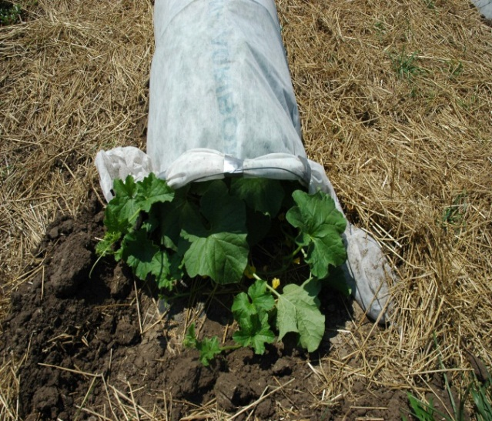
Figure 1. Row cover with open ends allowed pollinators to access flowers (Treatment 3).

Figure 2. Weekly counts of striped and spotted cucumber beetles from sticky card traps in each plot.

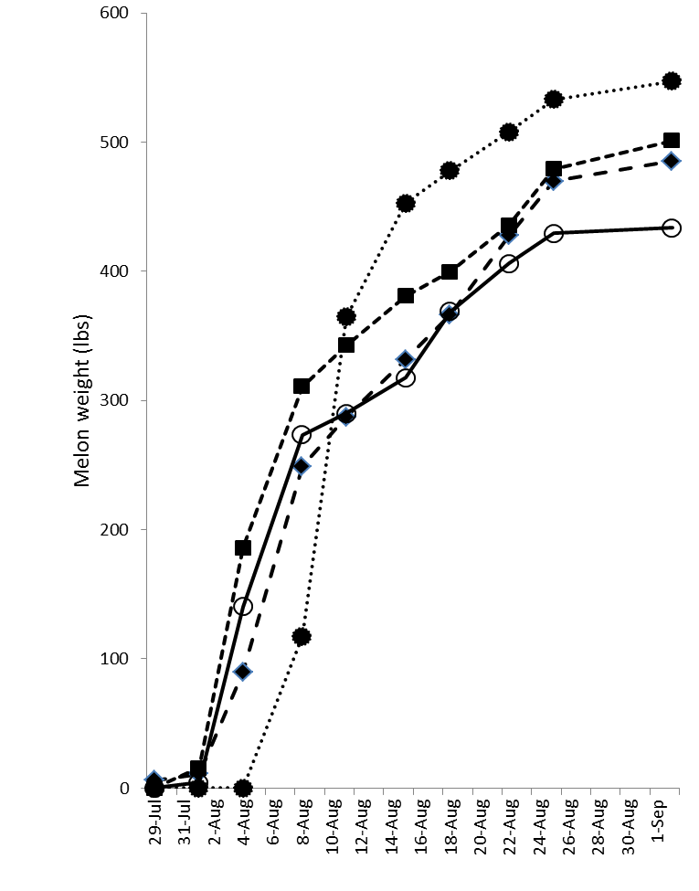Figure 3. Bacterial wilt incidence (A) and cumulative mean marketable harvest weight (B) from four row cover treatments.
3B
3A
 |  | Table 1. Summary of organic production of muskmelon using row covers 2011
Row Cover Treatment |  |  | Number of Sprays |  |  | Dates |  |  |  | Weight (lbs) per  30 ft plot
 |  |  | Pyganic | Copper |  | Row covers removed | 1st Cuke Beetles | 1st Bacterial Wilt |  | Marketable | Cull*
- 1 | - No row covers |  | 1 | 2 |  | NA | 12-Jul | 27-Jul |  | 101.2 | 20.2
2 | Row covers  removed at anthesis |  | 1 | 2 |  | 22-June | 12-Jul | 22-Jul |  | 100.9 | 24.4
3 | Open ends at  anthesis; row  covers  removed 10  days later |  | 1 | 2 |  | 1-July | 12-Jul | 3-Aug |  | 87.8 | 20.7
4 | Row  covers  removed 10  days after  anthesis |  | 1 | 2 |  | 1-July | 12-Jul | 3-Aug |  | 115.9 | 20.9
 | *Culls due to poor pollination or insect damage

