Controlling bacterial wilt in muskmelon with perimeter trap cropping

Jean Batzer, assistant scientist

Ericka Day undergraduate student

Mark Gleason, professor/extension plant pathologist

Department of Plant Pathology and Microbiology

**Introduction**

Perimeter trap cropping (PTC) involves planting one or more rows of a cucurbit crop that is highly attractive to cucumber beetles around the border of a main cucurbit cash crop that is less attractive to the beetles. Cucumber beetles attempting to migrate into the field are concentrated in the relatively more attractive border crop, where they can be controlled by insecticides.

In New England, perimeter trap cropping using 'Blue Hubbard' squash as the border crop around pumpkin, cucumber, or butternut squash controlled cucumber beetle/bacterial wilt with as few as one border spray of insecticide. This strategy reduced insecticide use on the main crop by up to 94%, nearly eliminating sprays on the main cash crop. In on-farm trials, 8 of 10 Massachusetts growers found that using perimeter trap cropping saved them money. The same tactic also effectively managed cucumber beetles on muskmelon and squash in Oklahoma.

**What are the benefits of PTC to conventional growers?**

* Curtailing insecticide use could also help growers’ profits by providing a potential advantage in direct marketing.
* Reduce insecticide use in conventional and organic production – in some cases, by 90%. These cutbacks in insecticide sprays have important environmental benefits, because reducing the insecticide load mitigates chemical contamination of honey bee hives, thereby safeguarding crop pollination.
* Cutting insecticide costs with perimeter trap cropping could raise profits, and protect pollinators and natural enemies, and reduce the risk of developing insecticide resistance in pest insects.

Successful perimeter trap cropping requires several changes in crop management practices.

1. The trap crop needs to be up and growing a week or two before the main crop emerges or is transplanted, in order to intercept cucumber beetles at the critical early-season stage. We applied an insecticide drench (Admire-Pro) to the seedling transplants.
2. The trap crop needs to be considerably more beetle-attractive than the main crop, so that beetles will not continue migrating into the main crop. *Cucurbita maxima* is highly attractive to cucumber beetles.
3. The trap crop needs to be durable. If it dies early from bacterial wilt, the cucumber beetles are likely to move into the main crop.
4. The trap crop rows and main crop will need to be scouted for cucumber beetles, and insecticide sprays would be needed when thresholds were reached.
5. The trap crop itself should be marketable in the growers’ region. We are trying buttercup because is as attractive to cucumber beetles and has a higher acceptance by consumer.
6. An insecticide application should sharply curtail cucumber beetle populations in the trap crop once scouting thresholds are reached.

This report focuses on the first-year results of a 2-year multi-state effort with the Ohio State University to optimize conventional growing practices that effectively manage insect and diseases.

**Materials and Methods**

Four replications of two subplots (PTC vs. No PTC) were isolated from each other at the central, and north, east, west of the ISU horticultural research station to avoid interplot interference. Paired sub-plots were 50 ft apart and were separated by field corn (Figure 1). Main-crop subplots (50 x 50 ft) each consisted of 360 melon plants. Three-week-old transplants of muskmelon cv. Strike were planted 2 ft apart in black plastic mulch with drip irrigation and 6-ft row centers on June 17.

Three weeks before planting the main-crop of muskmelon, semi-bush buttercup cv. ‘Space Station’ seedlings (10 days-old) were planted as the perimeter trap crop on May 26. The perimeter trap crop consisted of two border rows surrounding the perimeter trap cropping subplots as well as 2 plants at each end of the muskmelon rows (164 squash plants per subplot)(Figure 2A) . Immediately after transplanting, a 25ml drench of Admire-Pro 4.6F was applied at a rate of 0.086 ml of imidacloprid per plant. In the ‘No PTC’ subplots, 12 ft. border strips of annual rye grass (the same dimensions as the perimeter trap crop strips in the treatment plots) were seeded May 19 (Figure 2B).

Populations of cucumber beetles (Figure 2C) were monitored weekly in both border rows and main-crop rows along three transects within each plot. Synthetic pyrethroid insecticide sprays (Assana XL) were applied to the squash border rows or main crop muskmelons when a threshold number of an average of one beetle per plant was reached. Bacterial wilt incidence was also monitored

for the entire field and total numbers of plants with bacterial wilt (2D) were recorded one week before harvest. Conventional practices were followed for managing weeds and fungal diseases. Squash vine borer sprays were based on counts from pheromone trap at south edge of farm. Harvest yields (number and weight) were assessed for each subplot.

**Results and Discussion**

Total melon harvest weight averaged 2646 lbs from fields surrounded by rye grass and 2315 lbs from fields with the squash perimeter trap crop. No significant differences (P>0.05) in melon yield were detected. Perimeter plots yielded a mean of 1812 lbs of buttercup squash that weighed an average of 3.6 lbs. AssanaXL sprays to the main melon crop for cucumber beetle ranged from 3 to 5 sprays in the ‘No PTC’ treatment and a single replicate was spray once the ‘+PTC’ treatment (Table 1). The butternut PTC received 4 to 5 AssanaXL sprays from cucumber beetle control and an additional two sprays were made to the base of the plants for squash vine borer control. Bacterial wilt occurred in two of the four melon main crops in the ‘No PTC’ and in one of the ‘+PTC’ melon main crops. Although bacterial wilt incidence was relatively and occurred within a few weeks of harvest, numbers of wilted plants averaged 11.5 plants in the ‘No PTC’ plots and 1.0 plant in the ‘+PTC’ plots. One plot of buttercup developed bacterial wilt early in the growing season, but the disease did not spread to the melons.

**Conclusions**

Use of a perimeter trap crop saved 3 to 5 insecticide sprays to the main muskmelon crop, reduced the incidence of bacterial wilt, and did not affect yield. The perimeter trap crop received 6 to 7 sprays and vines required pruning four times to keep them from covering the main melon crop. However, these additional labor requirements may not be a problem for main crop melon fields of larger commercial production systems where a boom sprayer can easily apply sprays to the narrow perimeter trap crop and shading of edge of the melon fields by squash vines would not greatly affect yield.

**Acknowledgements**

Thanks to Nick Howell, the ISU Horticulture Farm crew, and the 312 Bessey field crew for crop planting, maintenance and harvest.

|  |  |  |  |  |
| --- | --- | --- | --- | --- |
| **Table 1. Summary of muskmelon production using perimeter trap cropping (PTC). Values are means of 4 replicated plots.** | | | | |
| **Treatment** | **No PTC** |  | **+PTC** | |
|  | **Muskmelon**  **main crop** |  | **Muskmelon**  **main crop** | **Buttercup perimeter** |
| **Date** |  |  |  |  |
| Plant date | June 17 |  | June 17 | May 26 |
| Imidachloprid drench |  |  |  | May 27 |
| 1. Harvest date(s) | Aug 17 to Sept 2 |  | Aug 17 to Sept 2 | Sept 16 |
| 1. **Number of sprays to control** |  |  |  |  |
| Squash vine borer | 0 |  | 0 | 2 |
| Cucumber beetlesa | 3.75 |  | 0.25 | 4.5 |
|  |  |  |  |  |
| **Percent bacterial wiltb** | 3% |  | 0 | 0 |
|  |  |  |  |  |
| 1. **Yieldc** |  |  |  |  |
| Weight (lbs) | 2695 |  | 2340 | 1812 |
| Number | 415 |  | 362 | 499 |
| a Sprays were based on threshold of one cucumber beetle per plant  b Melon bacterial wilt in the ‘No PTC’ > ‘+PTC’ (*P*=0.10)  c No differences in melon weight and number between treatments  (*P =* 0.41 and *P=*0.57, respectively)    **Figure 1**. Paired subplots of melon main crop with perimeters of squash or rye grass separated by 50 ft. of field corn. | | | | |

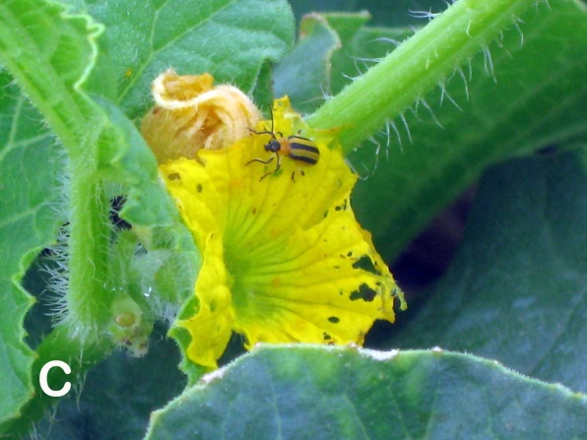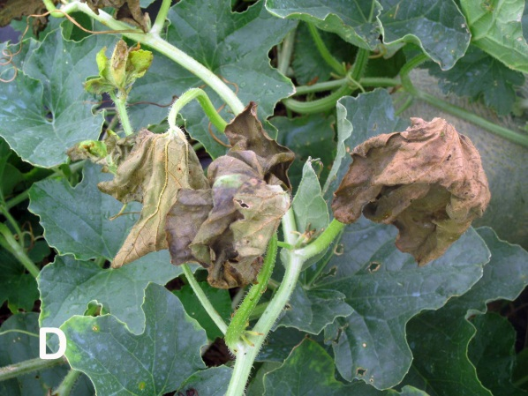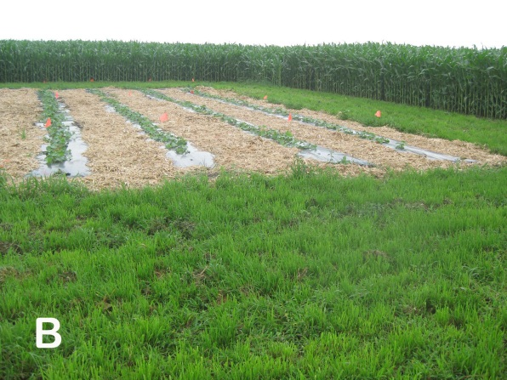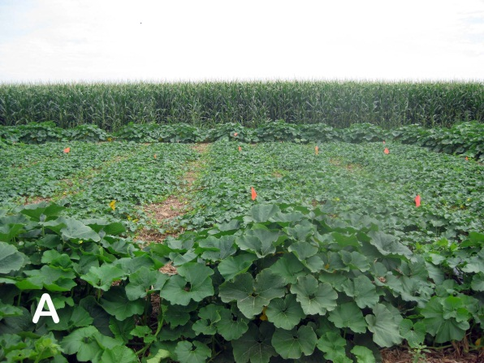

**Figure 2** A) Melon main plot with squash perimeter ‘+PTC’; B) Melon main plot with grass perimeter ‘No PTC’; C) Cucumber beetle on melon flower; D) Bacterial wilt on muskmelon.