**Photos documenting 2011 results.**

**Deborah Breth, Sr. Extension Associate**

**Lake Ontario Fruit Program, Cornell Cooperative Extension**

**Funded by NESARE Partnership grant**

**Lamont Fruit Farm Treatment plots – Photos taken 8/19**

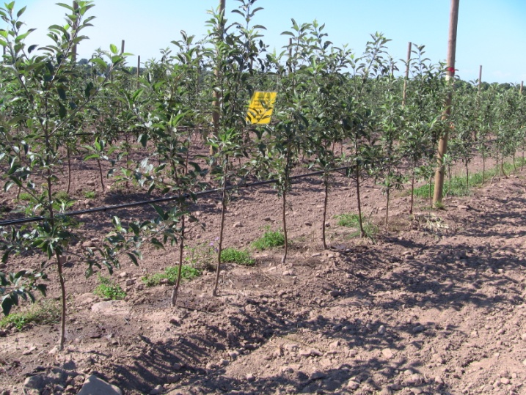 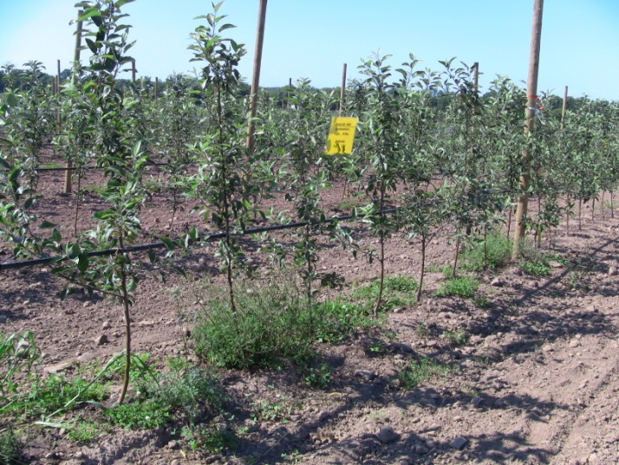

Prowl + glyphosate

Prowl +Chateau + glyphosate

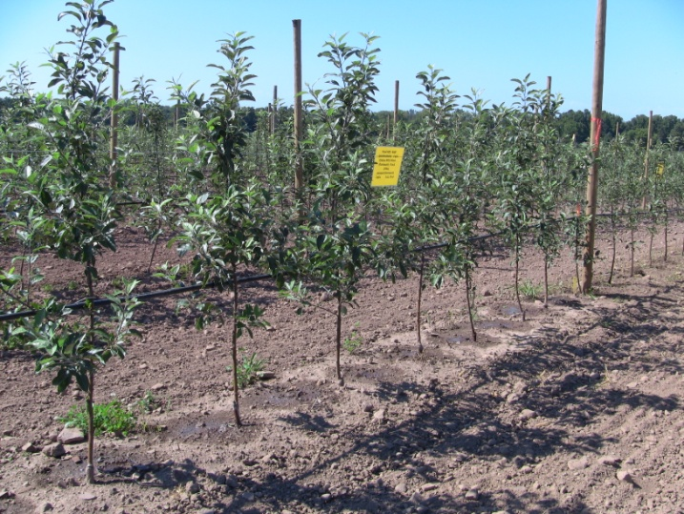 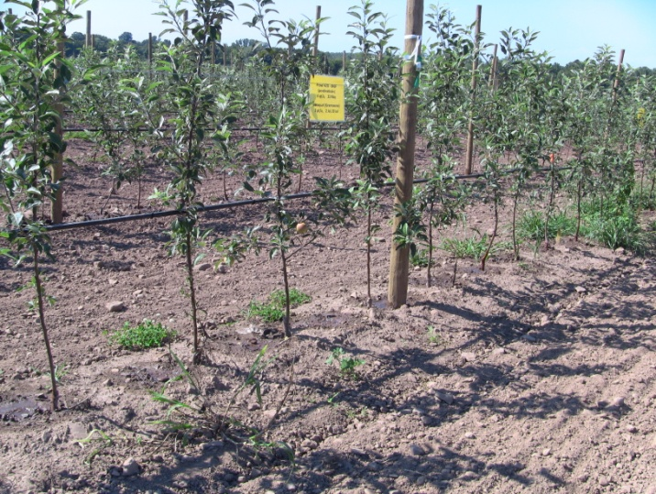

Prowl + paraquat

Prowl +Chateau + paraquat

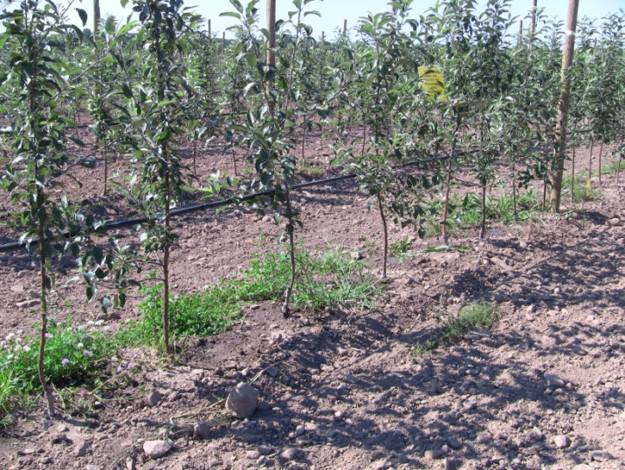 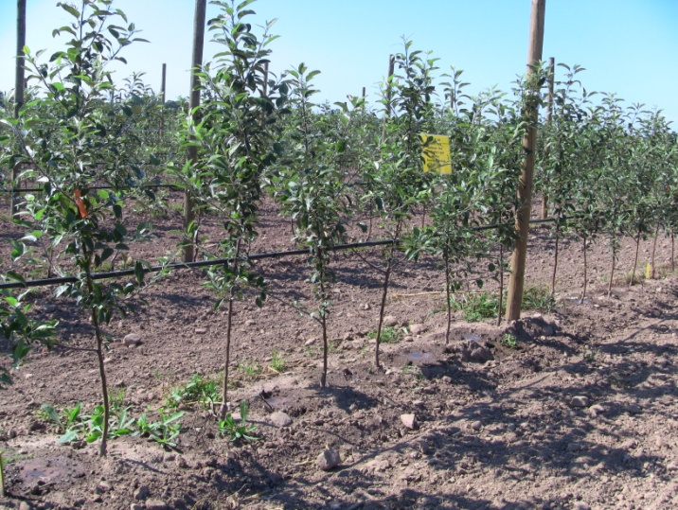

Surflan + paraquat

Surflan +Chateau + paraquat

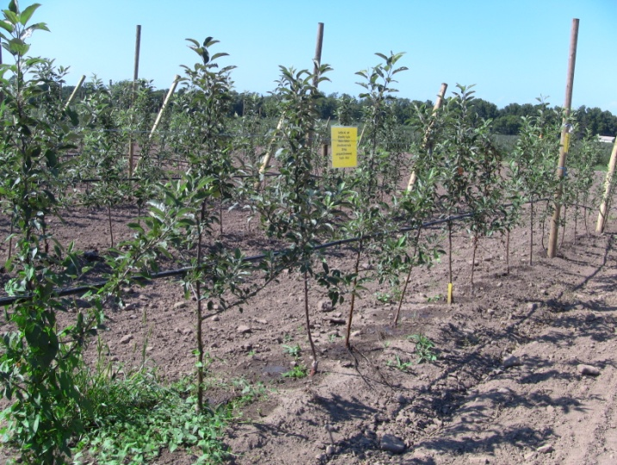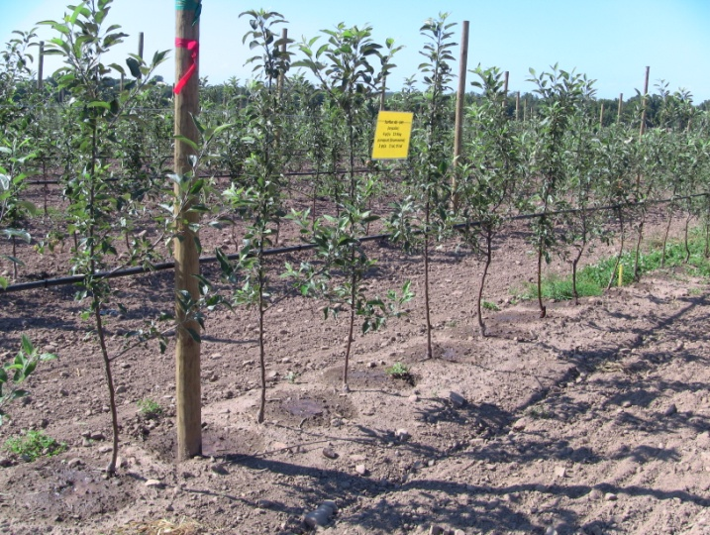

Surflan +GoalTender + paraquat

Surflan +Matrix + paraquat

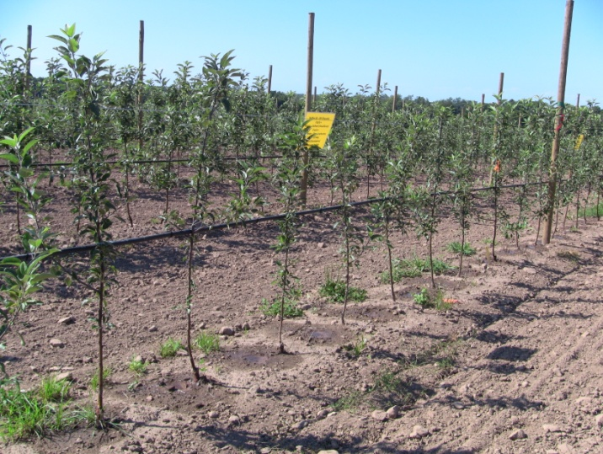 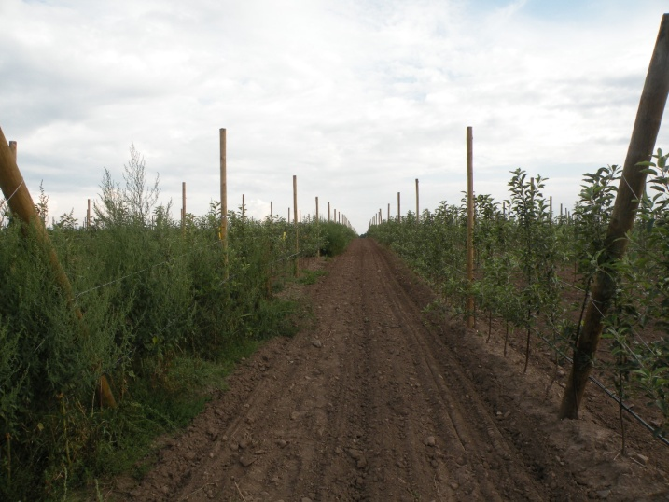

Grw STD

Untreated

Surflan +GoalTender + Matrix + paraquat

**Mason Farms Treatment Plots – Photos taken June 20.**

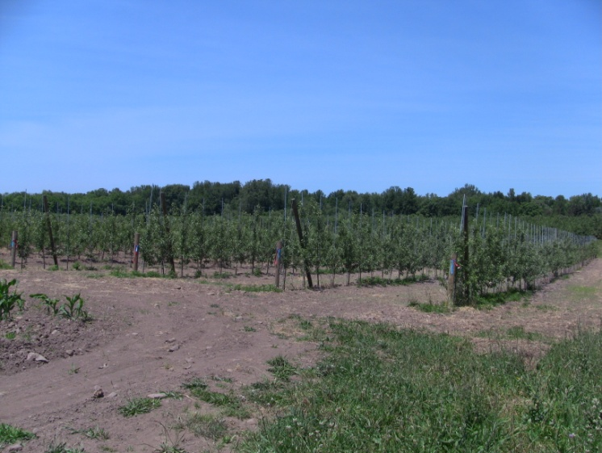 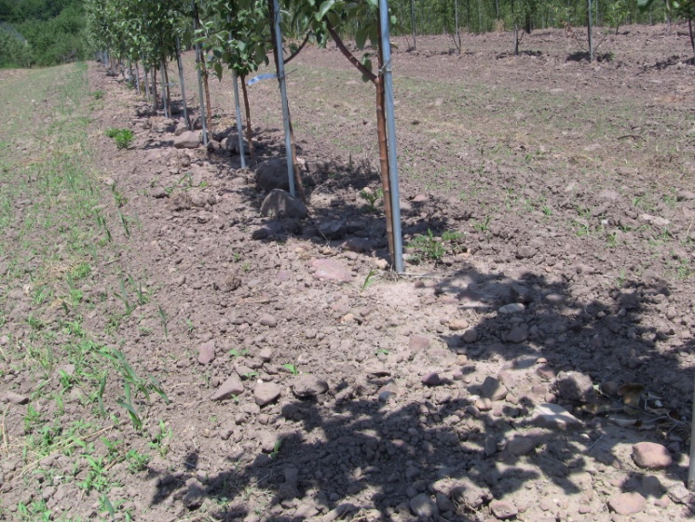

Prowl + paraquat

Mason Plots

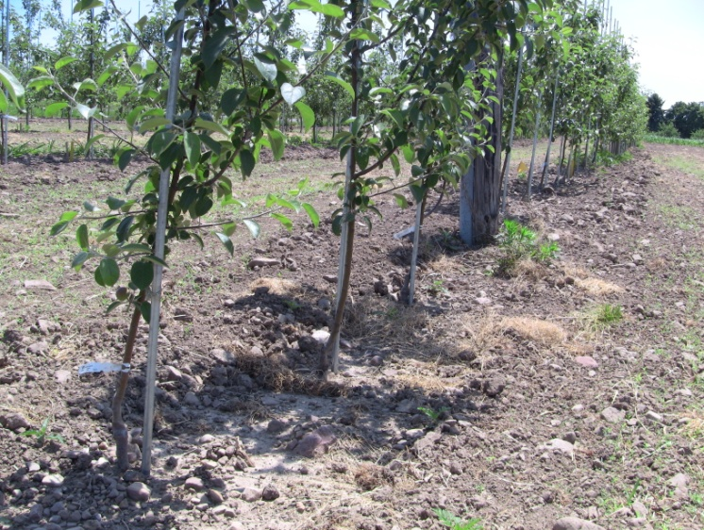 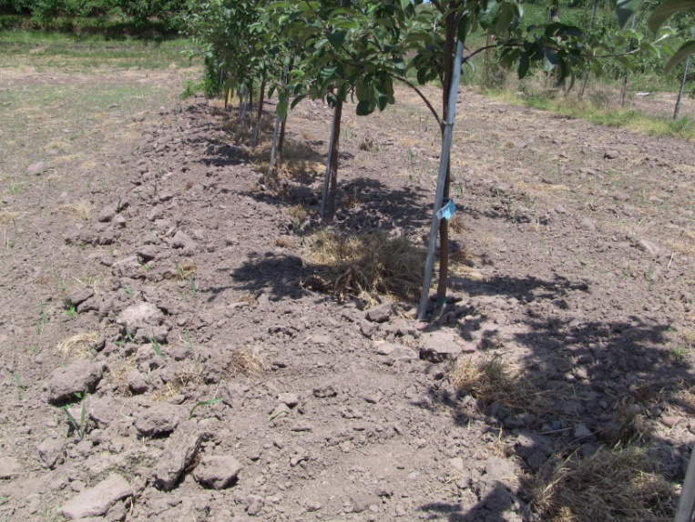

Prowl + Chateau + paraquat

Surflan + paraquat

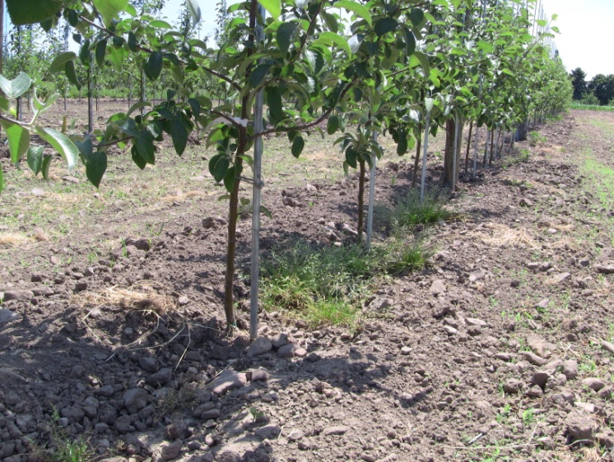 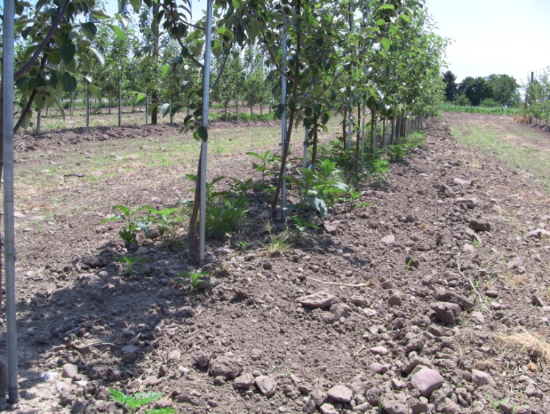

Prowl + GoalTender

Surflan + GoalTender

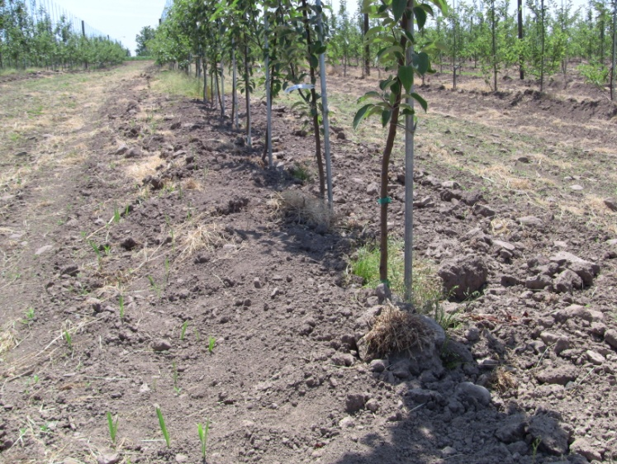 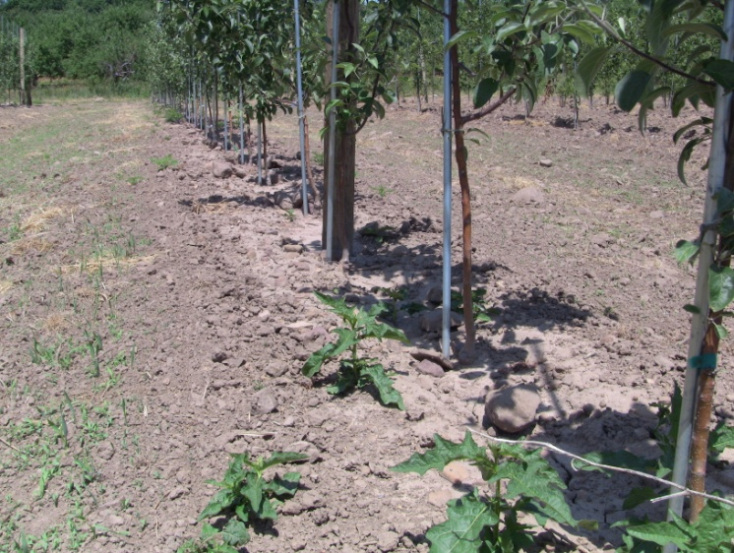

Surflan + Matrix

Matrix

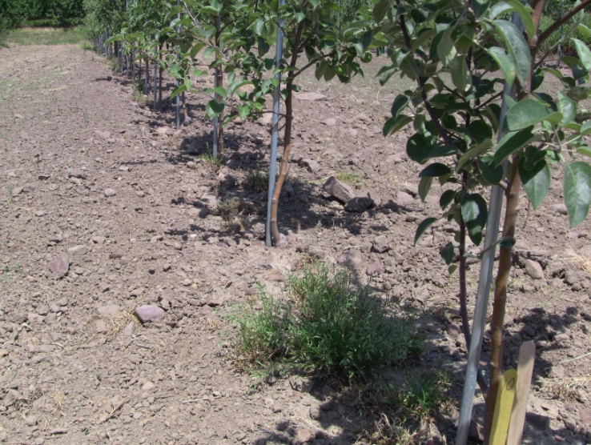 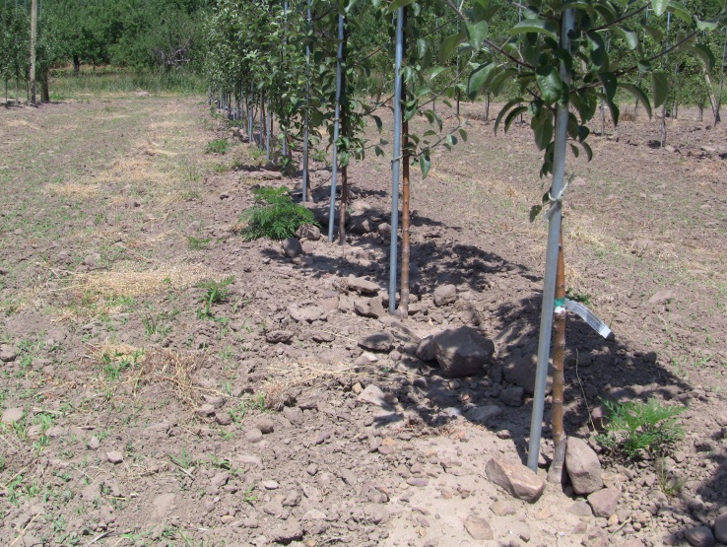

Alion provided long season control

Surflan + Matrix + GoalTender

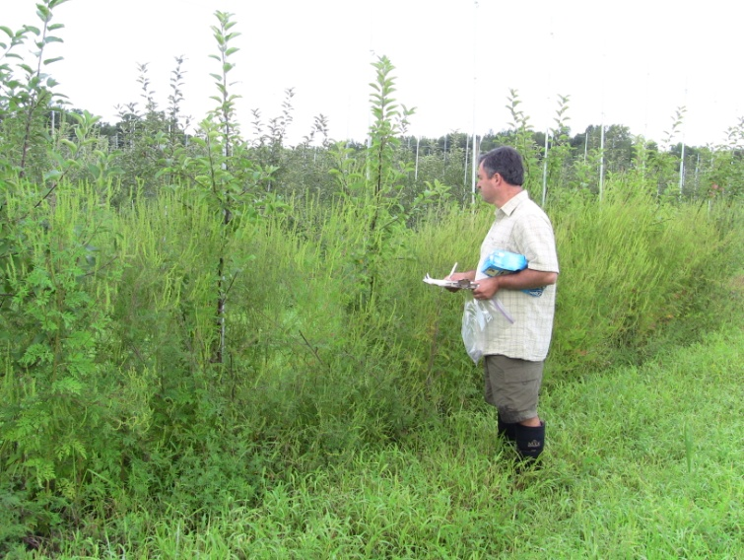 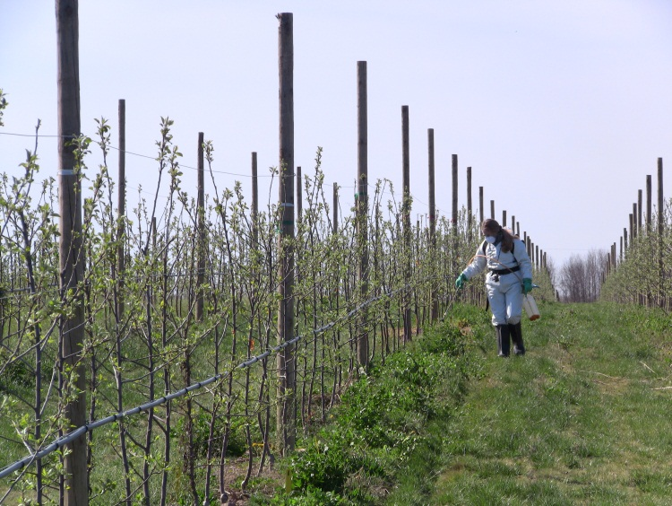

Debbie is applying Prowl H2O plus paraquat using a CO2 backpack aprayer.

Untreated herbicide strip

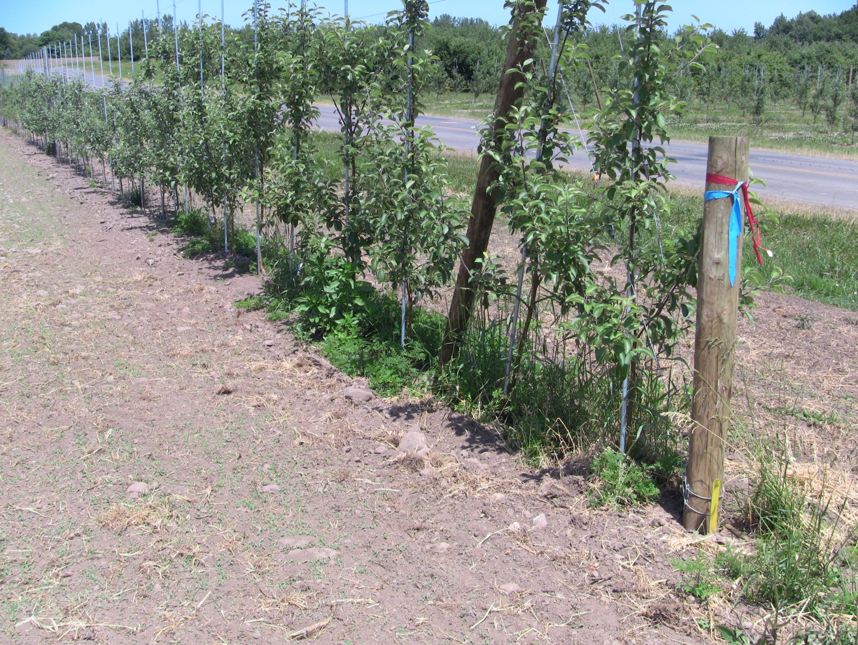

GreenMatch provided very short term burn done and most weeds outgrew any burning it did do and developed more branching of the weedy plants. GreenMatch was only effective in burning off weeds if newly emerged seedlings.