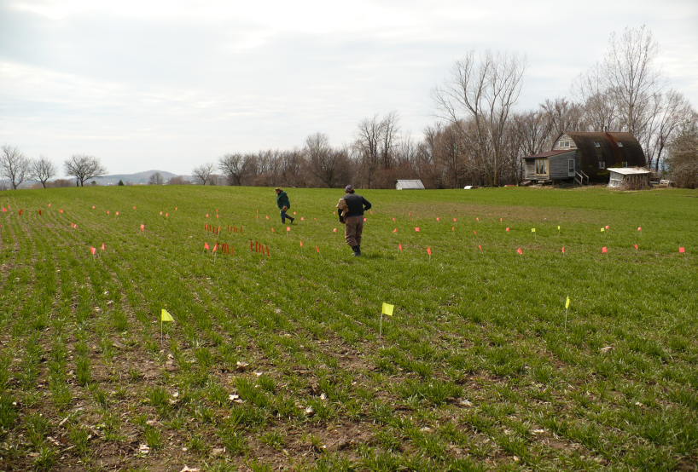

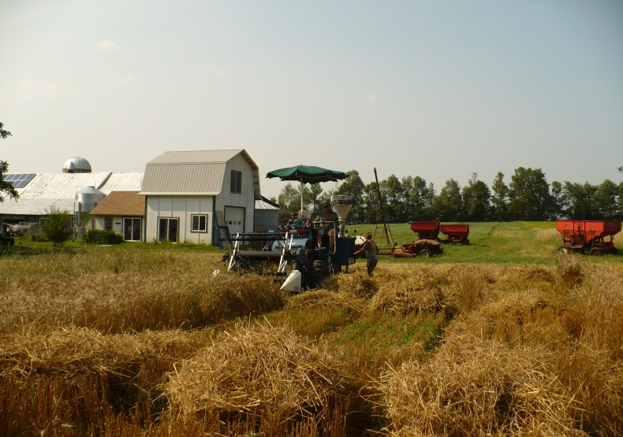

Image 1. Tillering application of organic N amendments

Image 2. Wheat topdress trial harvest –Bridport, VT