Project Title: Control of Bacterial Wilt of Ginger through an Integrated Pest Management Program

Participants: S.C. Miyasaka, M. Shintaku, B.A. Kratky (emeritus), N. Arancon, L. Cox, and S. Nelson

Table 1. Effects of four shading levels on the fresh weight of edible ginger rhizomes grown by sub-irrigation culture at The Waiakea Experiment Station.
==============================================================
Shade treatment 2010¹ 2011²
kg per 26-liter pot
None³ 4.99 d⁴ 3.66 c
30% shade screen⁵ 3.31 c 2.76 b
47% shade screen⁵ 2.42 ab 2.05 b
80% shade screen⁵ 1.63 a 1.42 a___________________
¹Three seed pieces were planted per pot on April 12, 2010. Foliage was removed on Dec.
16, 2010 and yield determination of washed and dried rhizomes was made in Feb. 2011.
²Two seed pieces were planted per pot on March 31, 2011. Foliage was removed on Dec.
7, 2011 and yield determination of washed and dried rhizomes was made in Feb. 2012.
³Rainshelter was covered with Griffolyn TX 1200 clear plastic cover.
⁴Means followed by the same letter within individual columns are not significantly different (P<.05) by Duncan’s Multiple Range Test.
⁵ Rainshelter was covered with Griffolyn TX 1200 clear plastic cover plus shade screen.

Table 2. Effect of duration of hot water treatment at 50ºC on number and percent of seed pieces found to free of viable R. solanacearum. These ginger seed pieces had been collected from three cooperating farms and tested to be infected by R. solanacearum, but appeared otherwise healthy.

Treatment Time, min. | No. of seed pieces | No. seed pieces tested negative after treatment | % Effectiveness of treatment
20 | 5 | 0 | 0
25 | 5 | 1 | 20
29 | 5 | 0 | 0
33 | 5 | 1 | 20
37 | 5 | 2 | 40
41 | 5 | 3 | 60
45 | 5 | 3 | 60
50 | 5 | 4 | 100
55* | 5 | 1 | 25*
* Anomalous result at 55 minutes of treatment. Further tests are planned to investigate whether the apparent ineffectiveness of this treatment was due to contamination by other races of R. solanacearum.

Table 3. Fresh weight yield (pounds per acre) of four rows of ginger planted at Pepeekeo farm; these plants were grown from wilt-free ginger seed pieces planted into soil tested free of ginger wilt using Enrichment-PCR method. Note: row 5 developed ginger wilt, with one obviously diseased plant removed in August 2011.

Row * | Marketable yield, pounds per acre | Unmarketable yield, pounds per acre | Unmarketable yield, % of total yield
2 | 30,770 | 4,690 | 13
3 | 23,380 | 5,580 | 19
4 | 19,520 | 7,010 | 26
5 | 7,540 | 17,010 | 69
* Yield data from rows 1 and 6 were not included in this table, because they were considered to be border rows.

Table 4. Treatments of vermicompost tea (vermitea), vermicompost, and indigenous microorganisms (Imolizer) used in a pot study to examine their effects on populations of Ralstonia solanacearum in naturally infested soil.
Treatment | Description
Vermitea, Low | 25% solution, 100 mL
Vermitea, Mid | 50% solution, 100 mL
Vermitea, High | 75% solution, 100 mL
Vermicompost, Low | 5% total volume
Vermicompost, Mid | 25% total volume
Vermicompost, High | 50% total volume
Imolizer, Low | 5% total volume
Imolizer, Mid | 25% total volume
Imolizer, High | 50% total volume

Figure 1. Growth of hydroponically-grown ginger with flowers in a shade study.
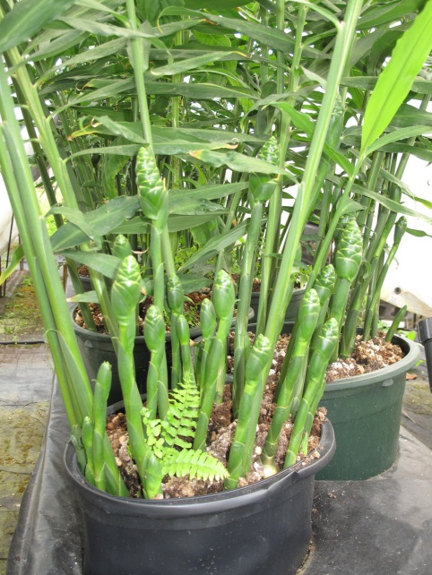

Figure 2. Can you guess which of these two ginger seed pieces is infected by Ralstonia solanacearum? These images were shown by Ms. White to ginger growers during an informational meeting to demonstrate to them that they cannot visually distinguish between diseased and disease-free ginger seed pieces.
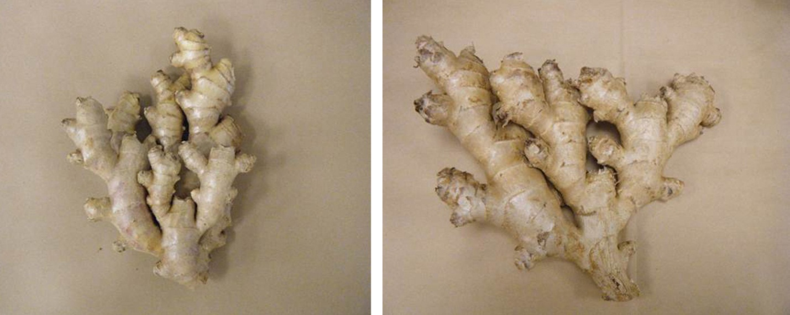

Figure 3. A poster by Dr. Kratky, Dr. Miyasaka and Ms. White on “Production of edible ginger clean seed by sub-irrigation methods in Hawaii” was displayed at the American Society of Horticultural Science, September 25-28, 2011, Waikoloa, Hawaii. In this photograph, Ms. Ferol White is in front of the poster.
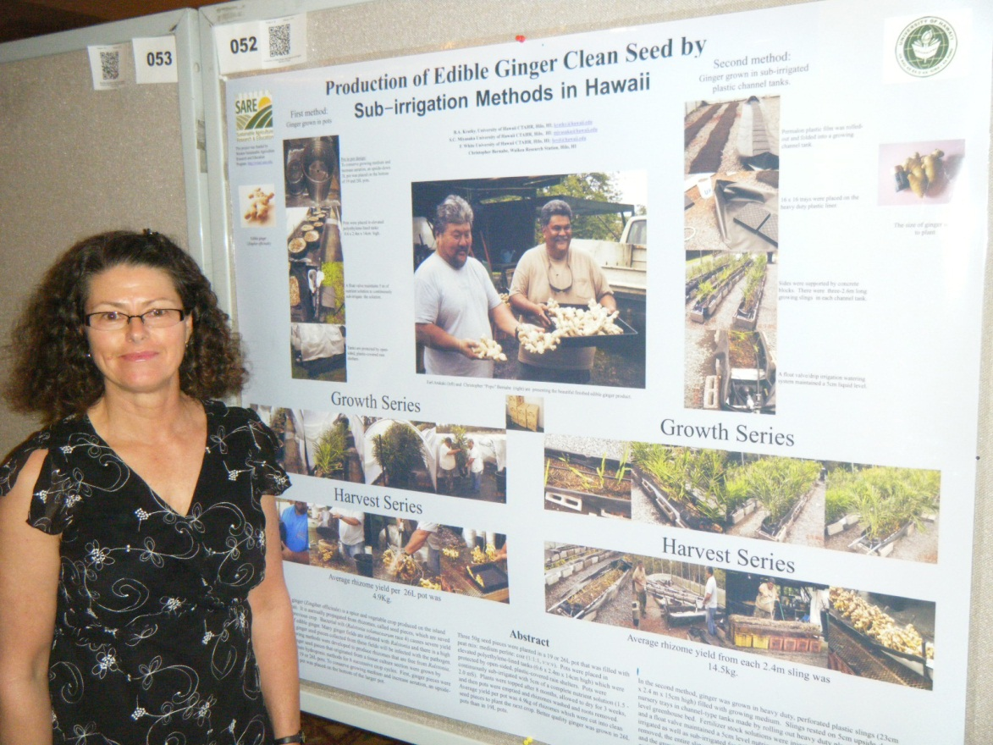

Figure 4. Tissue-cultured, wilt-free ginger plants grown in pots prior to selection for size of rhizomes.
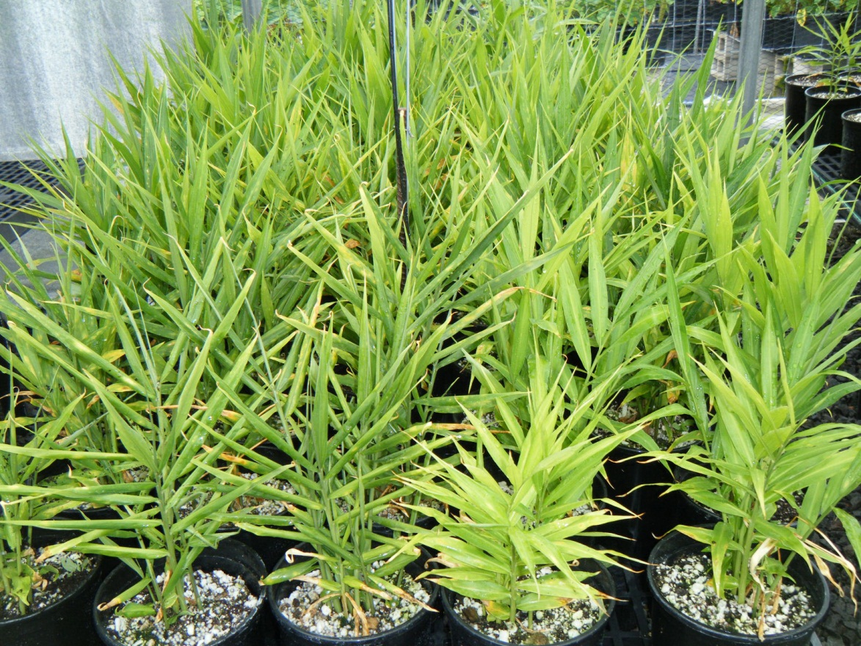

Figure 5. Wilt-infected ginger plants in a farmer’s field.

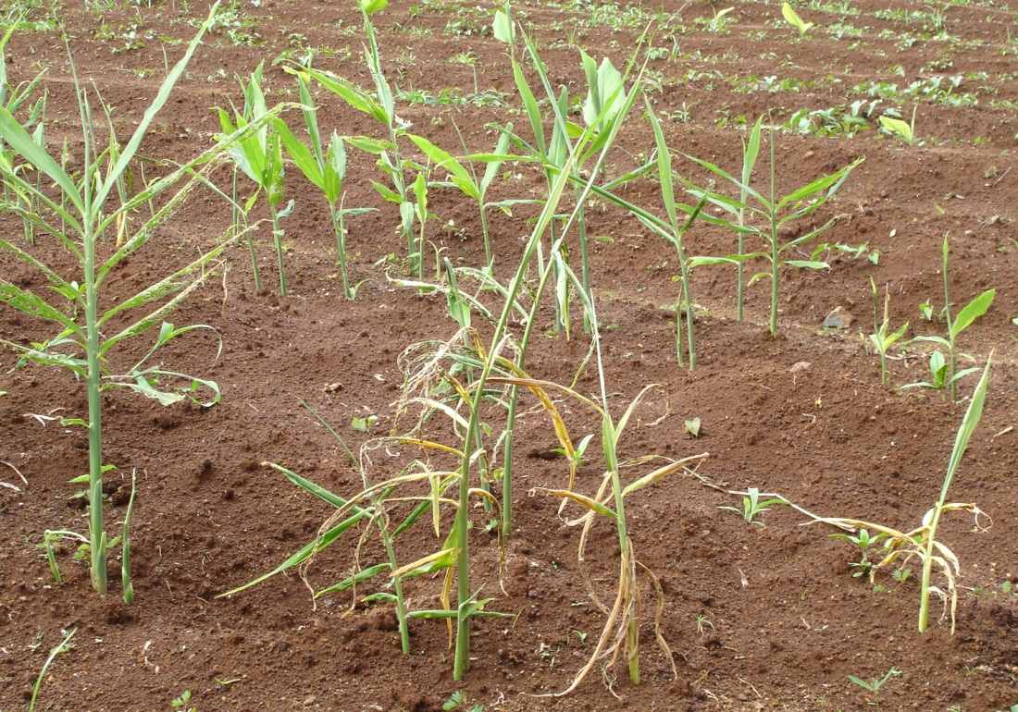

Figure 6. Wilt-free ginger planted in a field tested to be clean of ginger wilt; located at Pepeekeo, Hawaii.
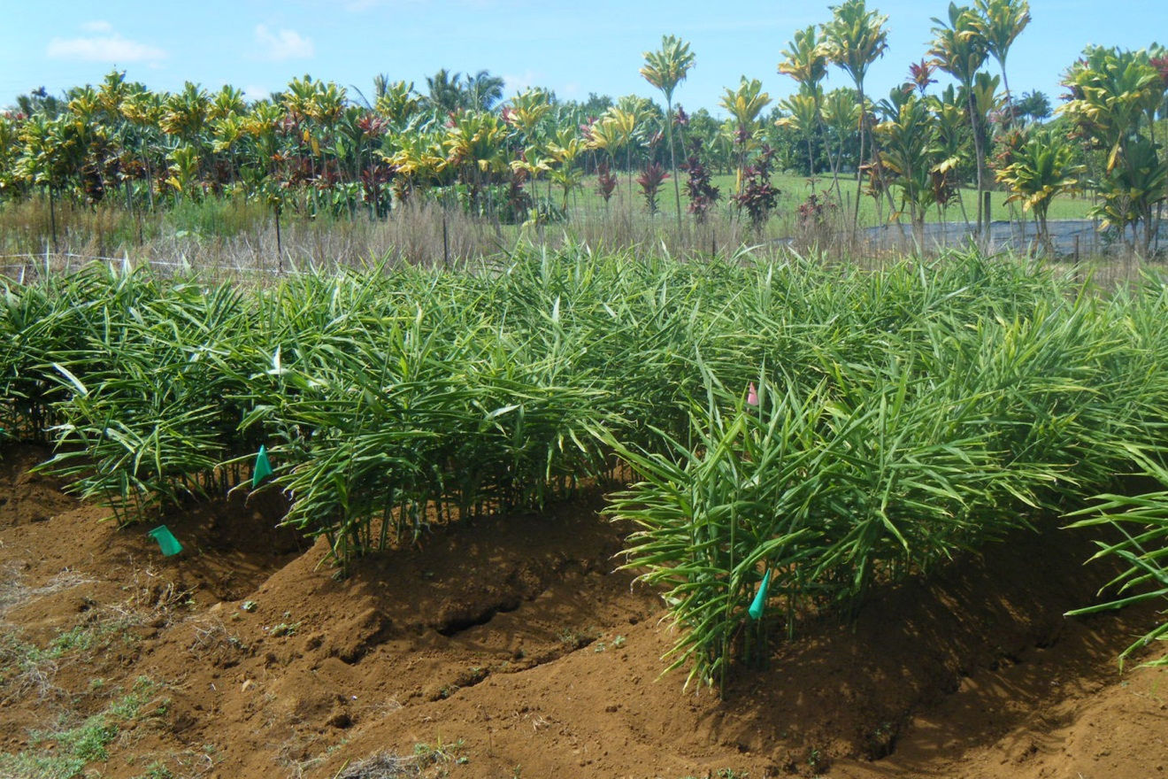

Figure 7. Ginger harvested from the on-farm trial at Pepeekeo during January 2012.
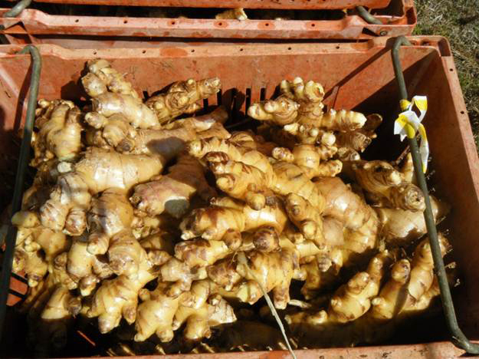

Figure 8. Chlorosis (yellowing) of ginger leaves during pot study on effect of vermicompost; thought to be caused by salt stress of vermicompost application, particularly at 80% and 100% treatments.

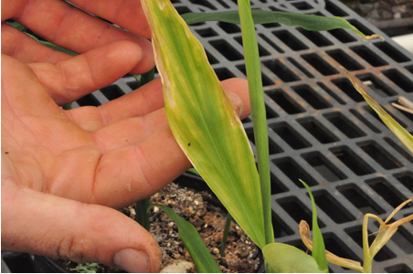

Figure 9. Effect of vermicompost treatments (0, 20, 40, 60, 80, and 100%) on ginger growth and rhizome yield.

Figure 10. Effect of 10 treatments (Vermicompost tea, vermicompost, and indigenous microorganisms or Imolizer) on populations of R. solanacearum over 12 weeks in naturally-infested soil using the Enrichment-PCR method. None of the treatments showed a consistent effect over 12 weeks in reducing viable populations of R. solanacearum.
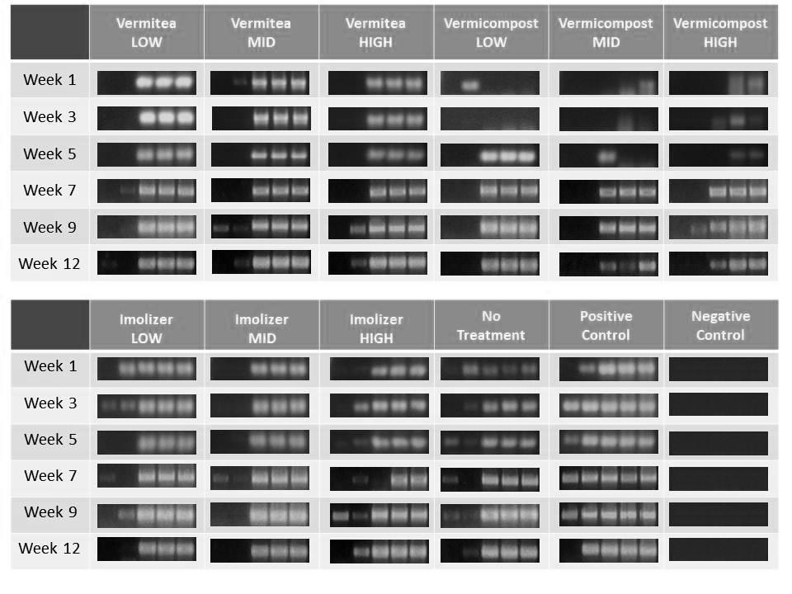

Figure 11. Display of ginger products at Mealani’s A Taste of the Hawaiian Range, held on September 30, 2011.
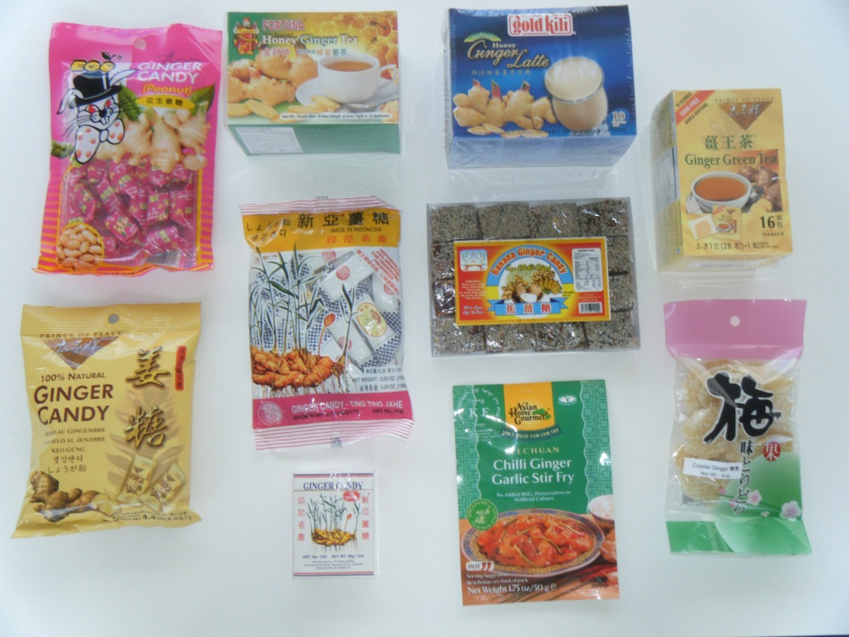

Figure 12. In addition, Cooperator William Tocantins donated bottles of Ginger Elixir for sampling by the public. In this photograph, volunteers Dr. J.B. Friday and Ms. Melissa Johnson are serving the non-alcoholic version of Ginger Elixir.
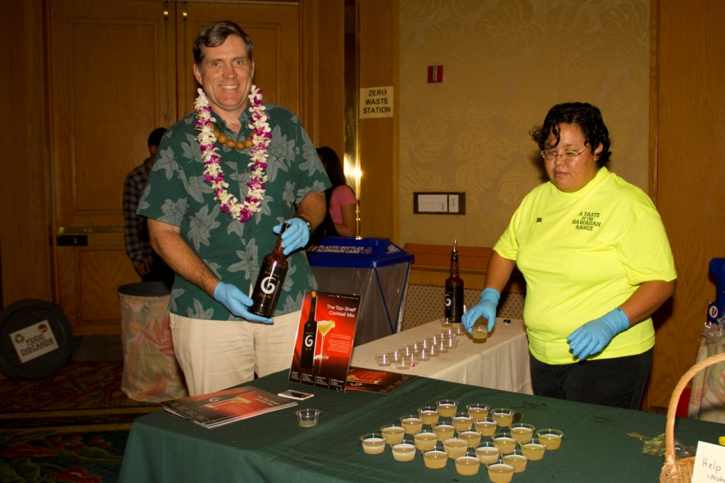

[Answer to question posed in Figure 4. The ginger rhizome on the left has ginger wilt.]

