Figure 4.1 Smidley-like pen design in the hoop barn, Farm 1.

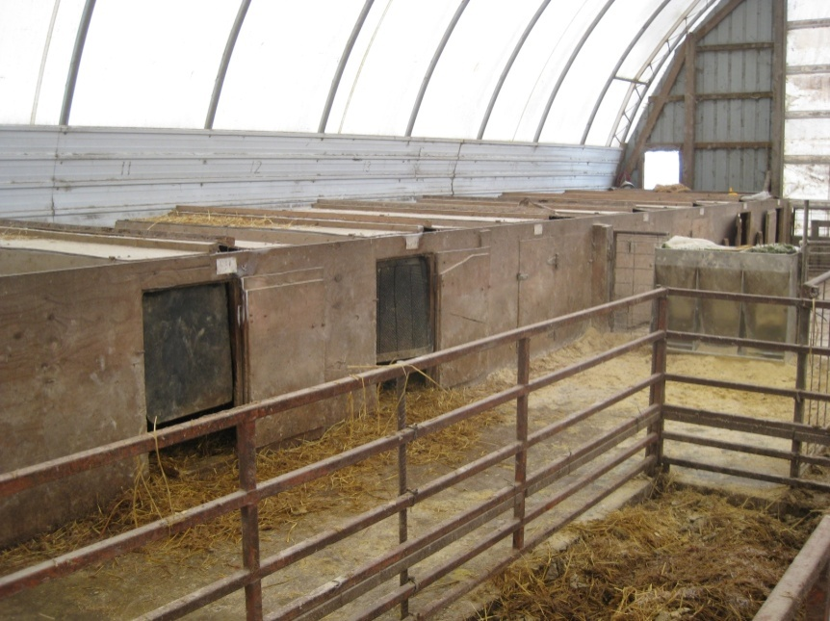

Figure 4.2 A barn with a converted farrowing crate pen design, Farm 1.

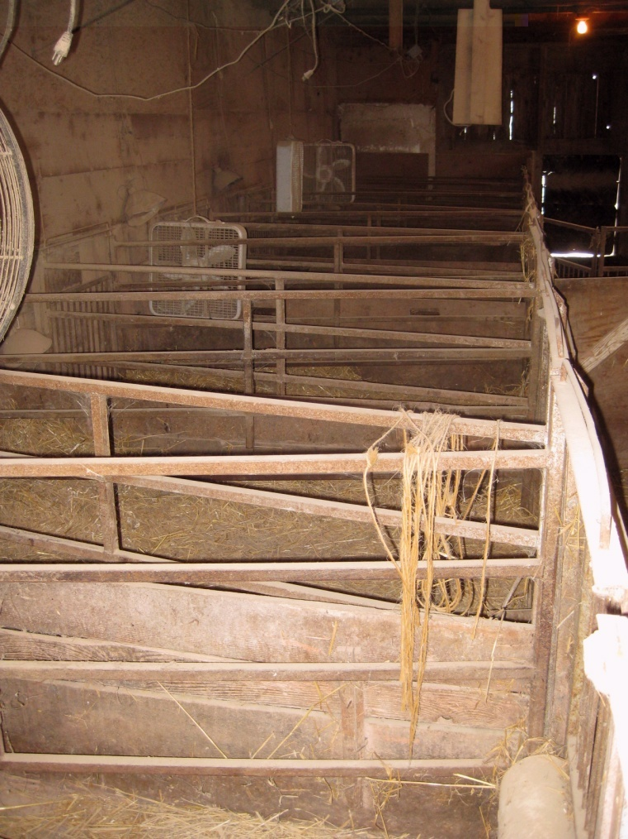

Farm 4.3 Swedish deep bedded pens inside one of the barns, Farm 2.

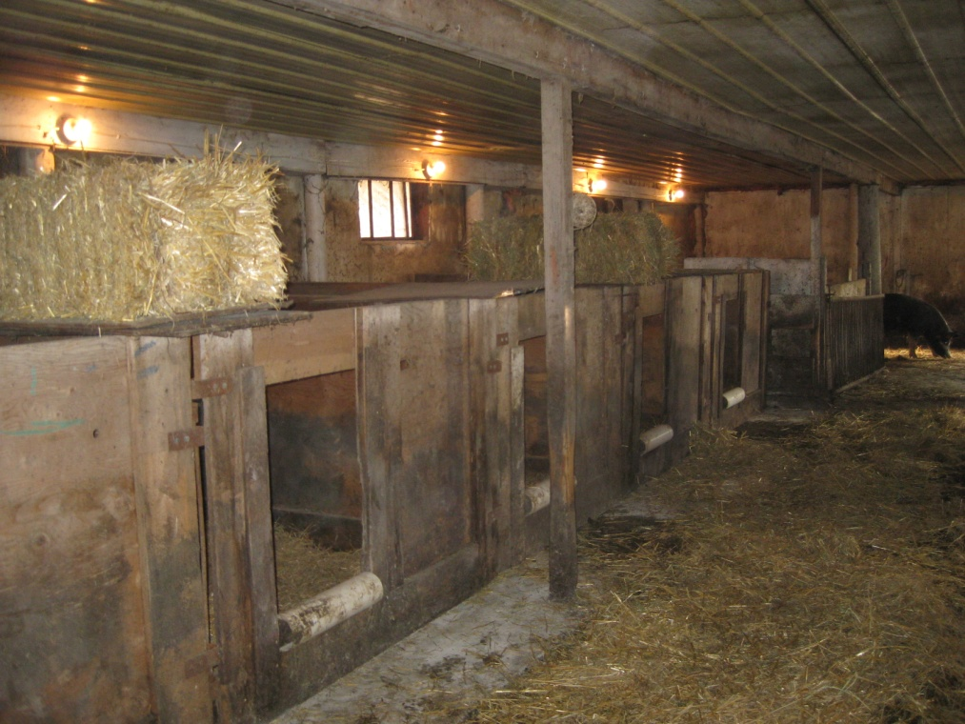

Figure 4.4 Inside the Swedish deep bedded pens, Farm 2.

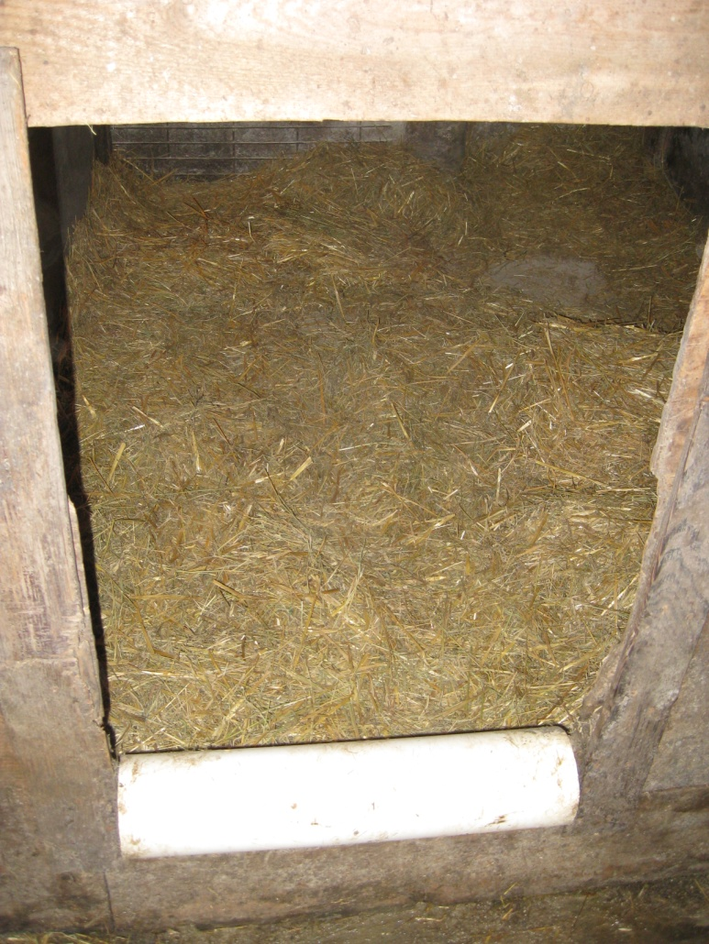

Figure 4.5 The Smidley huts and other similar huts inside a hoop barn, Farm 3.

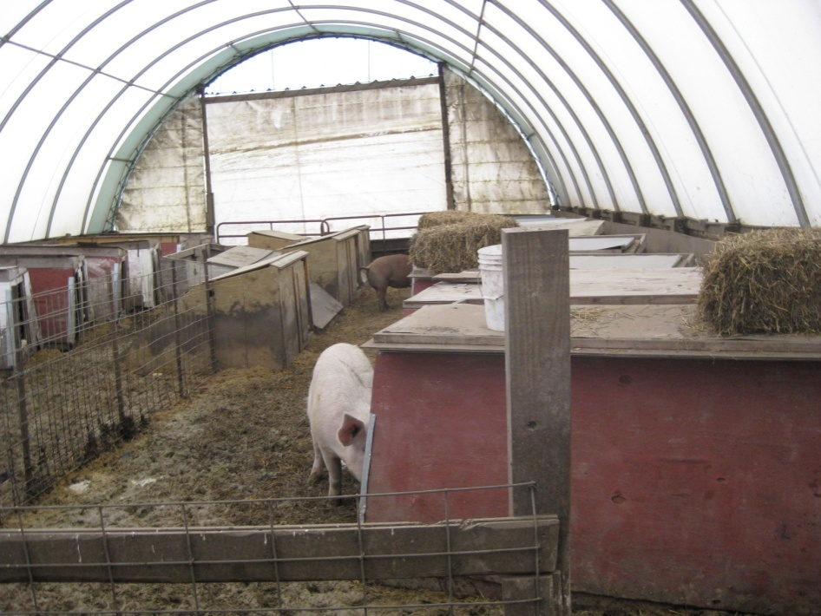

Figure 4.6 The inside of one of the Smidley huts, Farm 3.

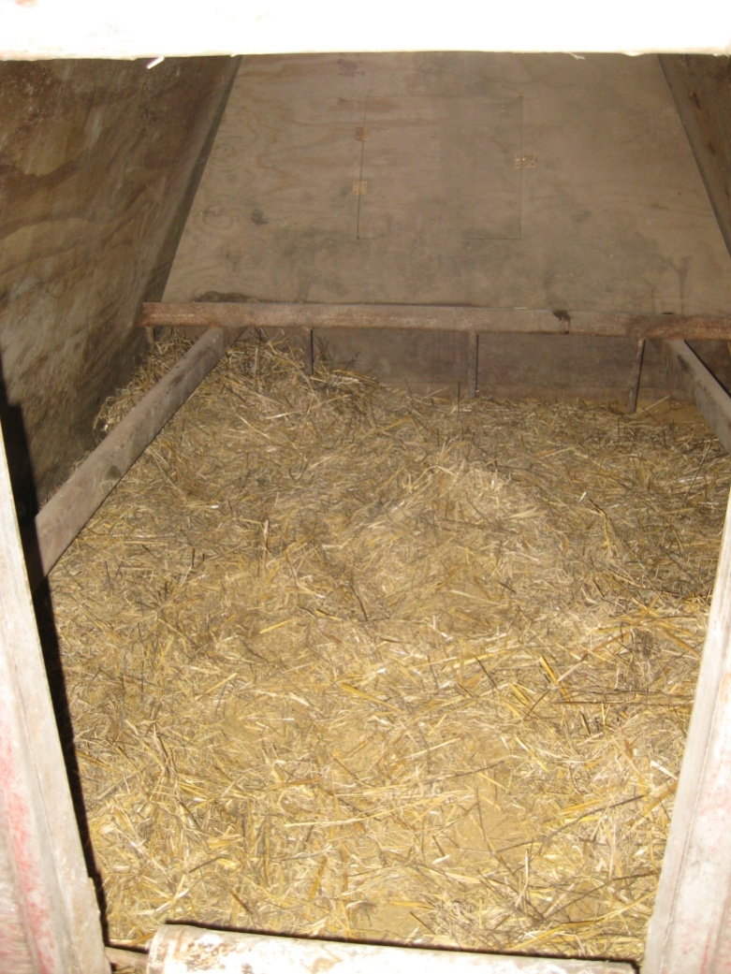

Figure 4.7 The Smidley-like huts inside a hoop barn, Farm 4

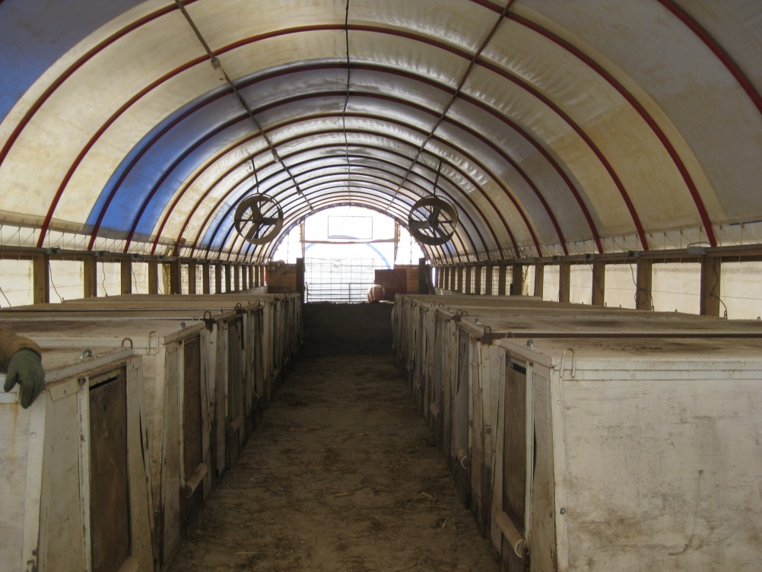

Figure 4.8 The inside of a Smidley-like hut (top view) Farm 4.

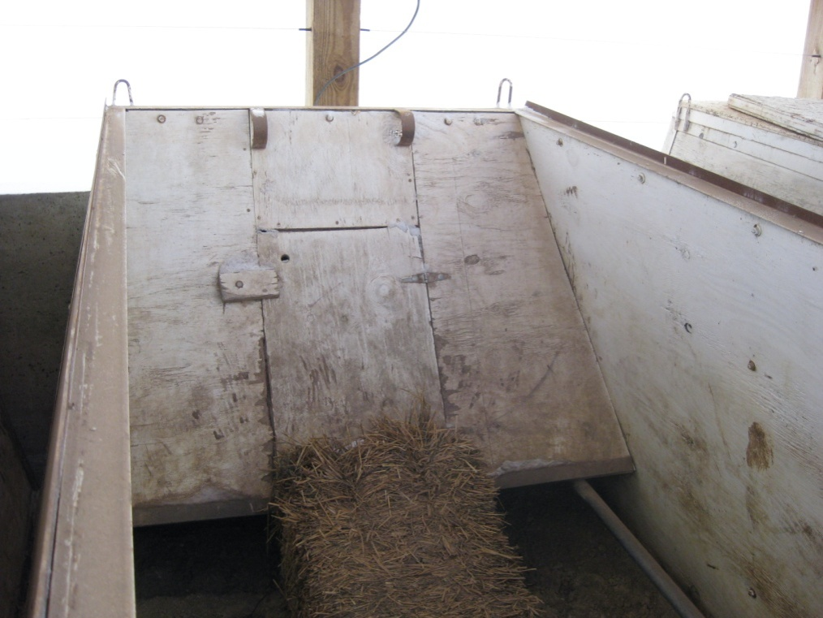

Appendix 1. Producer Survey
General Farm Information
- Name:______________________________ Phone:______________________ Email:______________________________
- Where is your farm located? City/Town________________________________ State_____________
- Size of farm (number of sows)? (circle)
<10 10-30 31-50 51-70 71-100 >100
- Is your hog operation considered (please circle):
Organic All natural Other, please specify:_____________________________________
- When do you farrow? (circle) All year Seasonal
  - If seasonal, what months? _______________________________

Housing
- Type of farrowing barn? (circle all that apply)
Indoor Outdoor Hoop Pasture Indoor with access to outside
- If indoor, is there any type of heating system for the barn? YES NO
  - If yes, please specify: _______________________________
- If indoor, is there any type of cooling system for the barn? YES NO
  - If yes, please specify: (i.e. fans) _____________________________
- Type of farrowing pen? (circle)
A-frame English style Other, please specify:________________________________
- Are there any protective rails or other structure designed to protect piglets from being crushed? YES NO
- At what day post-farrowing are piglets from different litters commingled? (circle)
<3 3-6 7-10 >10
- Do you offer supplemental heating to piglets? (circle) YES NO
  - If yes, circle all those that apply:
Lamps Pads Other, Please specify:________________________________
- Is there a creep area? (circle) YES NO
- Do you feed creep feed? (circle) YES NO
- What kind of bedding do you use? (circle)
Straw (wheat or oat) Cornstalks Woodchips Other, please specify:________________________________

Management
- How many days prior to expected farrowing do you move sows into the farrowing room? (circle) >7 7-3 >3
- How often are sows checked per day? (circle) Once Twice Three or More
- On what day post farrowing do you process litters? (circle) Day 1 Day 2 Day 3 >Day 4
- Circle all of the tasks performed on processing day:
Iron injection Tail docking Teeth clipping Castration
Ear notching Ear tagging Ear tattooing
- If you do not castrate on processing day, what day post farrowing do you castrate? (circle) 2-4 5-7 >7
- Do you crossfoster piglets? (circle) YES NO
- At how many days old are piglets weaned from the sow? (circle)
<21 days 21-28 days 29-35 days >35 days
- What types of farrowing records do you take? Circle all that apply:
  - Litter size at birth c. Litter size at weaning
  - Others, Please list: __________________________________________

Sows
- Parity of sows on your farm?
  - Average (circle) 1 2 3 3 5
  - Range (circle) 1 1-2 1-4 1-6 1-10
- Genetics
  - Of sows? _________________________________________________
  - Of boars/semen? ________________________________________________
- Litter size (number)
  - Average at birth ______________
  - Average at weaning _______________
- Number of sows culled per year? _______________
- Main reason(s) for culling sows? (circle all that apply)
Lameness Aggression Failure to rebreed Litter size at weaning Litter size at birth
Others, specify: _________________________________________________
- Do you see a seasonal difference in piglet mortality? (circle) YES NO
  - If yes, is it (circle): Higher in warmer months Higher in cooler months
- What are the main reason(s) for pre-weaning piglet mortality on your farm? (circle all that apply)
Crushing Chilled Runts/small size Disease
Others, specify: _________________________________________________
- If you believe crushing is a major contributor to pre-weaning mortality on your farm, have you taken any steps to try to reduce it? (circle) YES NO
  - If yes, briefly list what steps you have taken:

  - Have you reduced pre-weaning mortality with any of the actions you listed above? (circle) YES NO
    - If yes, please circle/mark the action(s) in your list above that you believe has contributed to reducing pre-weaning piglet losses the most.

Final Question: If asked, would you be willing to participate in a study funded by NCR-SARE that could possibly reduce the pre-weaning mortality on your farm, thereby increasing your profit? YES NO

Appendix 2. Management Protocol
Management of Environment and Housing
Bedding: Add bedding prior to farrowing and as often as necessary to keep the farrowing pen/hut dry and prevent piglets from becoming chilled. Chopped straw is suggested to be used when first bedded as piglets are less likely to get tangled, making them less susceptible to be crushed, compared with other materials.
Pen design: If the farrowing pen/hut design does not already have protective rails or another structure designed to protect piglets being crushed, install them.
Temperature: Use supplemental heating for the piglets in the form on heating lamps or heating pads for at least the first 3 d post farrowing. This will prevent piglets from huddling against the sow for heat, where they have more opportunity to be crushed.
It is important to keep the farrowing facility/hut a desirable temperature for the sow. In the summer, it is recommended that fans be used to keep the sows cool.
Management of Sows
Feeding program: Increase sow feed by 0.5 kg (feeding approximately 3 kg) 3 wks prior to farrowing. Once moved to the farrowing barn/pasture, sows should have ad libitum access to feed. This decision will depend on the producer’s current management protocol and farrowing facility/pasture design. Provide ad libitum access to water, but minimize the opportunity for water to spill into the area where the piglets are born and nursed.
Monitoring: Sow health should be monitored at least twice (morning and afternoon/evening) per day during the first 3 d after farrowing. Any sick sows should be treated promptly. Cross foster any ill sow’s litter off when needed and possible.
Management of Piglets
Cross fostering: Piglets should be cross fostered within the first 48 h after birth, after ingestion of their own dam’s colostrum, with other litters farrowed the same day if available. Sows should not be allowed more piglets than functioning teats, or no more than 12. Piglets should also be cross fostered based on their body size. When possible, piglets should be cross fostered to a litter with piglets similar to their body size. Piglets with a birth weight lighter than 1kg should not be cross fostered. The purpose of cross fostering is to increase survival rates and weaning weights.
Processing: Litters with low birth weight piglets should be processed no earlier than 3 d after farrowing. This will allow lighter piglets more susceptible to being crushed to gain strength prior to the stress of being processed.
Piglets should not be comingled until 7 to 10 d old. Effort should be made to prevent piglets from crawling out of the farrowing pen during 7 to 10 d after farrowing.
Creep Feed: If within the producer’s budget, and within the limits of the farrowing facility/pasture design, it is recommended to offer creep feed in a feeder after litters are allowed to commingle until weaning.
Monitoring: Piglet health should be monitored at least once per day. Dead piglets should be removed and recorded, and a count of piglets should be done at least once per day.

