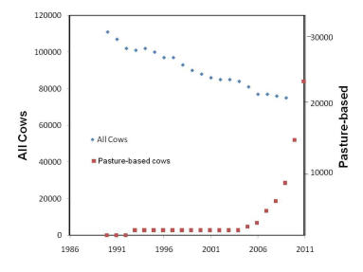

Figure 1. Population trends of dairy cows on pasture vs. total cow numbers in Georgia. **Note**: Pasture-based numbers for 2011 are based upon current permit applications for pasture-based dairy operations.