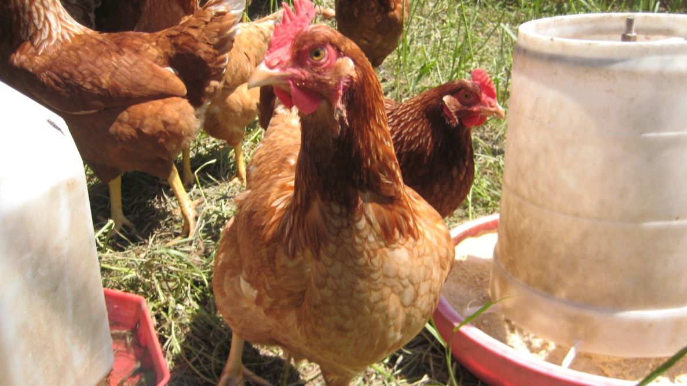
Hybrid Chickens: Group A (showing free range fresh pasture and food/water feeders)

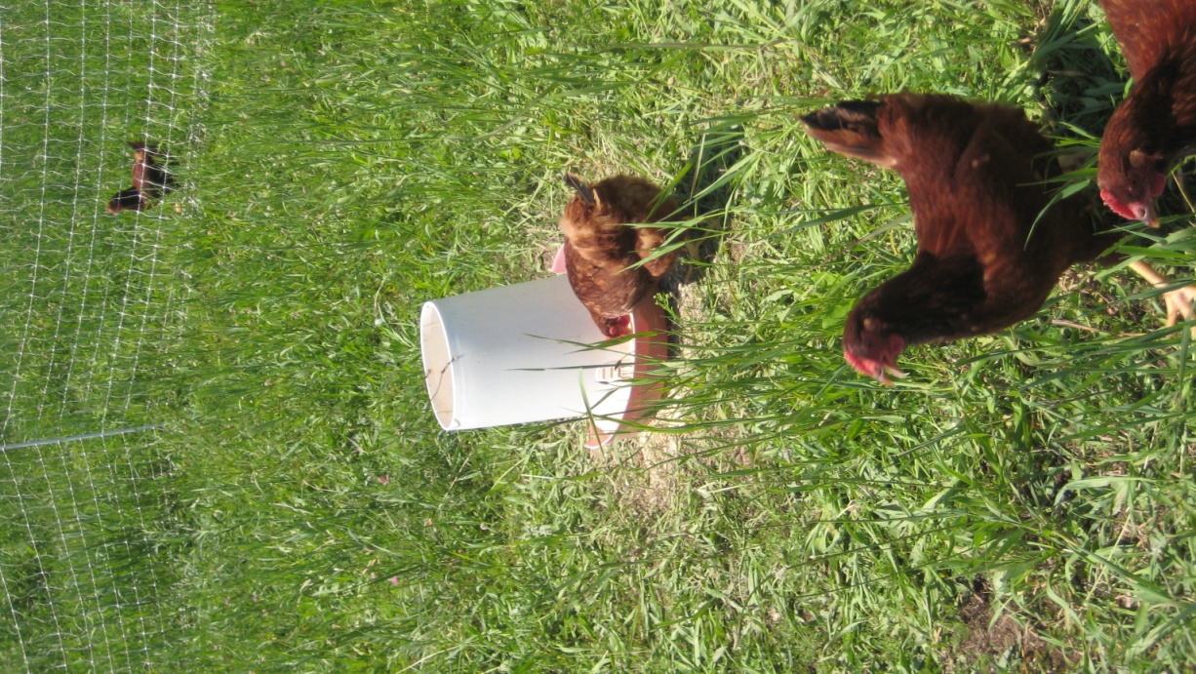
Heritage Chickens: Group C (showing fresh pasture and fencing)

