Evaluation Results

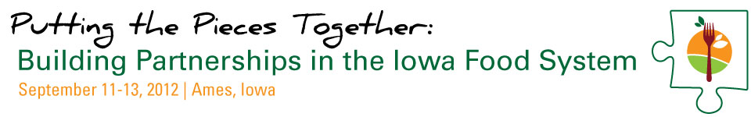

A Professional Development Conference for Iowa State University Extension and Outreach Staff September 11-13, 2012 in Ames, Iowa

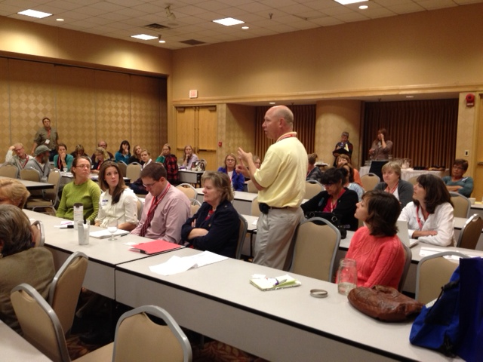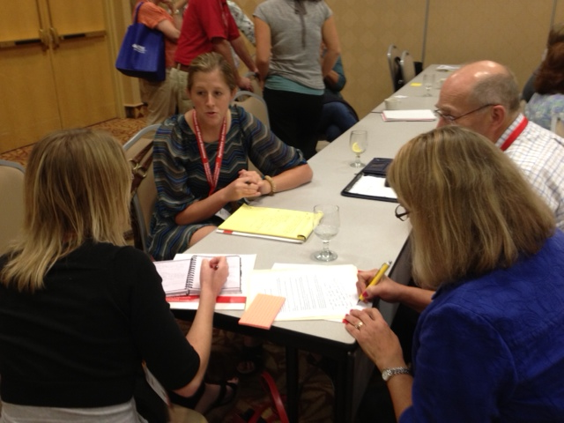

Corry Bregendahl
Leopold Center for Sustainable Agriculture

November, 2012

REPORT HIGHLIGHTS

- Iowa State University Extension and Outreach held a professional development conference for Extension staff and partners working to support local food systems in September, 2013. 70 professionals attended the event.
- Evaluation results in this report are based on usable survey responses received from 38 attendees (based on a 54% response rate).
- 67% of respondents are associated with Extension. Of those, 65% are based off campus. Nearly half have a focus on ANR although all five ISU Extension and Outreach program areas were represented at the conference.
- Extension-affiliated respondents reported working professionally (for pay) on local food systems for an average of 5.4 years, which was no different than the average number of years reported by non Extension respondents (5.6 years).
- When we asked the percent of time respondents spent either currently or in the past year working on local food systems (FTE), Extension respondents reported spending an average 27% of their time, compared to 57% FTE reported by their non Extension counterparts. This suggests opportunities for Extension, both in terms of offering more support for food systems work and for partnering with non Extension colleagues who may be more strongly connected to the work.
- 95% of respondents (35) reported they made new contacts as a result of the conference. Of those, the vast majority (86%) made new contacts with ISUEO staff. More than two in three (68%) also made new contacts with non Extension staff.
- The conference has already facilitated the development of 8 new partnerships. If plans for new collaborations are carried out, the total will be 16 new partnerships attributable to connections made at this conference.
- Of the 22 respondents attending the Regional Food Systems Working Group (RFSWG) meeting, the vast majority (17 or 77%) said they learned something new about the activities of the RFSWG in their area. For whom it applied, 14 or 70% discussed opportunities for future partnerships with RFSWG coordinators in their area.
- Compared to non Extension respondents, Extension respondents are more likely to agree that the organization they represent (Extension) has the capacity and resources it takes to organize and lead local food systems work in their geographic service area. There also is a tendency for Extension respondents versus their non Extension counterparts to be more likely to agree they understand the purpose of the newly formed Iowa Food System Working Group (IFSWG) and how it will support the work of the Regional Food Systems Working Group. These data suggest more work may be needed to help non Extension partners understand the purpose and aim of the Extension-led IFSWG, while at the same time communicating details about Extension’s capacity to provide support for local food systems work.
- Finally, the opportunity to provide open-ended comments revealed some cautious optimism about Extension’s leadership role in local food systems development. Extension should be mindful of these concerns by honoring and recognizing the impactful and important work that has already been done by Extension and other groups to move local food systems forward in Iowa, while at the same time continuing to emphasize the capacity of Extension to strengthen, support, facilitate, and coordinate future work among all partners.

INTRODUCTION

In September, 2012, Iowa State University Extension and Outreach held a professional development conference for Extension staff and partners working—or interested in working—to support local food systems. The project was funded by the North Central Sustainable Agriculture Research and Education Professional Development Program. 70 professionals attended the event.

This report documents evaluation results from the conference. Evaluation data was collected by distributing an electronic survey administered one month after the conference to “wait” for immediate post conference activities to take place and measurable outcomes to emerge. Out of 70 survey invitations mailed, we received 38 usable surveys for a response rate of 54% (several surveys were incomplete and therefore unusable). Usable surveys were defined as those where at least half of the survey was completed.

RESPONDENTS

Table 1 shows that most survey respondents were associated with Extension (67%). Of those, nearly two-thirds were based off campus as field specialists, county-based employees, or Regional Extension Education Directors (65%). Nearly half have a focus on Agriculture and Natural Resources although all five ISU Extension and Outreach program areas were represented at the conference.

In addition to asking about occupational details, we also asked respondents to tell us how many years they have worked professionally (for pay) on local food systems. Extension affiliated respondents reported an average of 5.4 years, which was not statistically different than the average number of years reported by non Extension respondents (5.6 years). However, when we asked the percent of time respondents spent either currently or in the past year working on local food systems (full-time equivalent), Extension respondents reported spending an average 27% of their time in the past year on local food systems work compared to an average 57% FTE reported by their non Extension counterparts. The same pattern held true for current time spent on local food systems work. If these statistically significant results (p=.024 and p=.038, respectively) are in any way generalizable to all conference goers and colleagues in the field, they suggest that Extension employees working in the local food systems arena are spending significantly less time (half) on local food systems work in contrast to their non Extension colleagues. This suggests opportunities for Extension in this area, both in terms of offering more support for food systems work and for partnering with non Extension colleagues who may be more connected to the work.

Table 1. Respondent characteristics
 | Results (n=36)
Extension employee or appointment | 67% (24)
Extension Position (n=24)
County-based employee | 30% (7)
Regional Extension Director | 13% (3)
Field Specialist | 22% (5)
State Specialist | 13% (3)
ISU faculty member | 9% (2)
ISU campus-based non faculty researcher/staff | 4% (1)
Other (regional program coordinator) | 9% (2)
Extension Program Area Focus (choose all that apply) (n=24)
Extension to Families | 18% (7)
Community and Economic Development | 16% (6)
Ag and Natural Resources | 47% (18)
4-H Youth Development | 13% (5)
Center for Industrial Research and Service | 5% (2)
Average total number of years Extension respondent worked professionally (for pay) on local food systems | 5.4 years
Average estimated percent of time (FTE) spent on local food systems work in the past year | 27% FTE
Average estimated percent of time (FTE) currently spent on local food systems | 29% FTE
Non Extension Partners, Occupation (choose all that apply) (n=12)
Youth educator | 3% (1)
University-based | 11% (4)
Non-profit employee not associated with ISU | 8% (3)
Farmer | 5% (2)
Consultant | 5% (2)
Volunteer | 3% (1)
Other (horticultural assistant, regional food coordinator) | 5% (2)
Average total number of years non Extension respondent worked professionally (for pay) on local food systems | 5.6 years
Average estimated percent of time (FTE) spent on local food systems work in the past year | 57% FTE
Average estimated percent of time (FTE) currently spent on local food systems | 60% FTE

RESULTS

The Overall Workshop Experience

For the first series of questions, we asked respondents to indicate the level to which they agreed with six statements about the meeting (Figure 1). The highest ranking statement regarded time spent with the Regional Food System Working Group (where the mean response was 4.5).

Respondents also overwhelmingly agreed that what they learned could be applied to their work in the future (mean score of 4.4).

Figure 1. Level of agreement with overall workshop experience

Only one in three conference goers went on a bus tour the first day, but all 12 who did reported knowledge and/or networking gains as a result. Knowledge gains included a greater understanding about the production and value of local foods, greater understanding of the groups working on local foods work in the state, how to deal with large brokers/aggregators, different kinds of marketing and distribution channels for local food, insights into the different food system sector roles and their challenges, and implicit “behind-the-scenes” information to which they may otherwise not be exposed and may never be published. Networking benefits reported were new contacts with Extension personnel and producers and a shared sense of purpose and identity with colleagues doing similar work.

One in three conference attendees also participated in the World Café activity, each reporting what they learned such as the need to: Focus on education and data, increase the number of producers and offer them support, strengthen the local foods infrastructure, coordinate and communicate information and ideas, strengthen aggregation for wholesale distribution, focus on shared identity within the movement, support the differential evolution of food systems development in varied geographic regions, educate producers selling to direct and wholesale markets, and better coordinate and integrate the local food systems work across the state.

33 (89% ) respondents visited the displays at the conference. Of those, 18 said they used display information they received at the conference. 10 contacted a representative of the display agency/organization for more information since the conference, and 15 accessed the website of the display agency/organization since then.

When respondents were asked how many times they used the flash drive nestled in their packet after the conference, 60% said they never used it once. One in three used it at least once while less than a handful (3) used it multiple times. Those who did use it said they did so simply to browse, find attendee contact information, find the Iowa Food Systems Working Group logo, locate websites mentioned during presentation, get additonal information about school gardens, and to access presentations from the workshop (which were not on the flash drive).

When asked to describe via an open-ended question the most significant thing they learned from the conference and how they will apply it to their work, respondents listed:

- Networking with groups (including Extension) to do local food systems work (17% of responses)
- Identification of potential partners (17% of responses)
- Specific content area (14% of responses) (labor management, crop management strategies, horticultural research, beginning farmer programs, Extension’s food security programs)
- A better understanding of how Extension staff (and especially administrators) are framing and supporting the food systems work (11% of responses)
- Evaluation/impact of local food system efforts/programming (Iowa Dairy Story Program, Dave Swenson’s presentation on economic benefits, need for continuing evaluation of work) (11% of responses)
- How to engage youth and schools through school gardening and Farm to School efforts (11% of responses)
- Complexity of the work, role of communities, and lack of coordination (11% of responses) and
- Understanding of all the groups involved in this work and the local foods landscape across the state (6% of responses)

Ways respondents are applying the information include consideration of grant opportunities, plans to expand local food education to counties not currently involved in local food systems work, and approaching local Extension Councils to fund to a multi-county coordinator position.

Respondents were also asked to provide feedback on information, training, networking, or skill building opportunities they would like to see in the upcoming April 2013 series of local food system meetings to be held across the state to further connect the work. Nearly 30 ideas listed include:

- Building partnerships and learning from others; networking in general (5)
- Coordinate access to funding for the work/cooperative grant opportunities (3)
- Develop and map comprehensive picture of all local food system efforts in the state, including farm to school and share it with the public so others can use it and learn from it (4)
- Focus on specific content, in some cases, from specific groups (16)
  - Learn from food service staff in schools/institutions on local food how tos (1)
  - Hear from producers and know their challenges (1)
  - Connect with county and state public health departments (1)
  - School garden education for teachers (1)
  - Farm to school efforts across the state (1)
  - Learn from food service staff in schools/institutions on local food how tos (1)
  - Hear from producers and know their challenges (1)
  - Connect with county and state public health departments (1)
  - Examples of food system partnerships (1)
  - Access to impact data (1)
  - How to connect local foods with traditional ag (1)
  - Educational ops through Extension (1)
  - Food security from terrorists and threat of contamination to water supply (1)
  - Business training/counseling for local food producers (1)
  - Aggregation and distribution efforts in the state (1)
  - Focus on profit (1)
  - Best irrigation practices (1)
  - Post harvest handling (1)
  - Youth producers and funding for youth to become producers (1)
- Connect with RFSWG to help Extension think collectively about local food systems development. Highlight regional integrated work on the ground. (1)

Networking Outcomes

An impressive 95% of respondents (35) reported they made new contacts as a result of the conference. Of those who made new contacts, the vast majority (86%) made new contacts with ISUEO staff. More than two in three (68%) also made new contacts with non Extension staff. Many respondents (47%) made contacts with both Extension staff and non Extension staff.

For those making new contacts with Extension staff, the program area of those staff were:

Figure 2. Among respondents who connected with Extension, percent who connected with someone from*:

Among those who made new connections with Extension staff, one in three (a total of 13) have communicated with their Extension contacts since the conference. The result of those contacts have already resulted in 6 new collaborations and 2 planned collaborations—from partnering on grant proposals to joint program and workshop planning.

For respondents making new contacts with non Extension staff (23), 11 (48%) have communicated with their new contacts since the conference. The result of that communication are 2 new partnerships (on grant projects and a community college Ag Entrepreneur program) and 6 new planned (but non specific) partnerships.

The conference has already facilitated 8 new partnerships. If plans for new collaborations are carried out, the total will be 16 new partnerships attributed to connections made at the conference.

Connecting with the Regional Food Systems Working Group

More than half of the respondents (60% or 22) attended the Regional Food Systems Working Group (RFSWG) meeting on the last day of the conference. Of those, the majority (68% or 15) had attended a RFSWG meeting in the past; however, 7 (32%) were new to the RFSWG meetings. Of the 22 attending the RFSWG meeting, the vast majority (17 or 77%) said they learned something new about the activities of the RFSWG in their area. For whom it applied, 14 or 70% discussed opportunities for future partnerships with RFSWG coordinators in their area (either during the RFSWG meeting or as a followup after the conference).

Attitudes

Finally, we asked respondents to rate their level of agreement with 11 statements about their local food systems work. Table 2 shows the mean for all respondents for each statement, the mean for Extension respondents, and the mean for non Extension respondents. Comparing the means between these two groups revealed one statistically significant difference: Extension staff were more likely to agree that their organization has the capacity and resources it takes to organize and lead local food systems work in their geographic service area (p = .000). There was also somewhat of a tendency for Extension respondents, in contrast with non Extension respondents, to agree they understand the purpose of the newly formed Iowa Food System Working Group and how it will support the work of the Regional Food Systems Working Group (p = .119). These data suggest more work may be needed to help non Extension partners understand the purpose and aim of the Extension led IFSWG, while at the same time communicating details about Extension’s capacity to provide support for local food systems work (for additional perspective, see Appendix 1 for respondents’ comments about Extension’s role).

Table 2. Attitudes about work in local food systems, Extension versus non Extension respondents

On a scale of 1 to 5 where 1= Strongly Disagree and 5= Strongly Agree, rate the extent to which you agree with the following statements about your local food systems work: | Total mean | Extension staff mean | Non Extension mean | t-statistic | p-value
a) Local food systems work can help my organization/agency/business achieve its mission and goals. | 4.33  (n=35) | 4.58  (n=24) | 4.73  (n=11) | .718 | .478
b) Local food systems work is a good way to connect my organization/agency/business with the people and communities we serve. | 4.56  (n=34) | 4.48  (n=23) | 4.73  (n=11) | 1.220 | .231
c) I feel like I am among friends and colleagues when I attend local food system meetings | 4.51  (n=33) | 4.48  (n=23) | 4.60  (n=10) | .476 | .637
d) If asked to do so tomorrow, I would feel comfortable participating in a stakeholder group within my geographic service area to discuss what can be done to support local food systems work. | 4.47  (n=34) | 4.54  (n=24) | 4.30  (n=10) | .619 | .548
e. If asked to do so tomorrow, I would feel comfortable convening a stakeholder group in my geographic service area to discuss what can be done to support local food systems work. | 3.94  (n=34) | 4.04  (n=24) | 3.70  (n=10) | .844 | .405
f) If asked to do so tomorrow, I would feel comfortable facilitating a stakeholder group in my geographic service area to discuss what can be done to support local food systems work. | 3.91  (n=34) | 4.04  (n=24) | 3.60  (n=10) | .945 | .352
g) I currently partner with groups within my area of expertise or program area to advance opportunities related to local food systems work. | 4.54  (n=35) | 4.5  (n=24) | 4.64  (n=11) | .564 | .576
h) I currently partner with groups outside my area of expertise or program area to advance opportunities related to local food systems work. | 4.31  (n=35) | 4.21  (n=24) | 4.55  (n=11) | 1.169 | .251
i) My organization/agency/business has the capacity and resources it takes to organize and lead local food systems work in my geographic service area. | 4.23  (n=35) | 4.58  (n=24) | 3.45  (n=11) | 3.928 | .000*
i) I know who to contact if I or my clients have questions about local food systems work. | 4.42  (n=36) | 4.42  (n=24) | 4.42  (n=12) | .000 | 1.000
k) I understand the purpose of the newly formed Iowa State University Extension and Outreach’s Iowa Food System Working Group and how it will support the work of the Regional Food Systems Working Group. | 4.11  (n=36) | 4.33  (n=24) | 3.67  (n=12) | 1.657 | .119

*Statistically significant (p<.05).

APPENDIX 1. ADDITIONAL COMMENTS FROM RESPONDENTS

- Thanks! Well-organized conference
- Thank you for putting on the conference. I look forward to more local food staff development in the future!
- The small pieces of paper with websites on them were interesting resources but a nightmare to keep track of and actually use. I would love to have a one-page resource document with an organization name, clickable web link, and very brief description so I could actually use all of this great information! Other than that, the conference was very well done, plenty of time for a good mixture of learning, discussion and reflection. Thanks for getting the conversation moving in the right direction!
- Great conference, well done, I wish more contacts from the other Regions would have attended. I tried to have my 8 people attend (one wasn't able to due to a funeral)
- There is confusion building among stakeholders across Iowa with the Iowa Food Systems Council and the Iowa Food Systems Working Group. Was the board of the IFSC consulted before ISUEO branded this new work group?
- I thought the conference was good. I continue to believe ISU Extension's move into local food work is a good thing as long as Extension moves into local food partnering work with respect and openness for what the existing body and pattern of local food work by the RFSWG has to offer. There is some concern that the Iowa Local Food System Working Group will overrun RFSWG. The conference reduced my concern on this issue some, but admit Extension has a bit of a reputation of (and resources for) "taking over". That kind of relationship would undermine much good collaboration that has taken place and surely can take place...in partnership.

