Figure 1-1. Portland Sustainable Foodshed Study Timeline
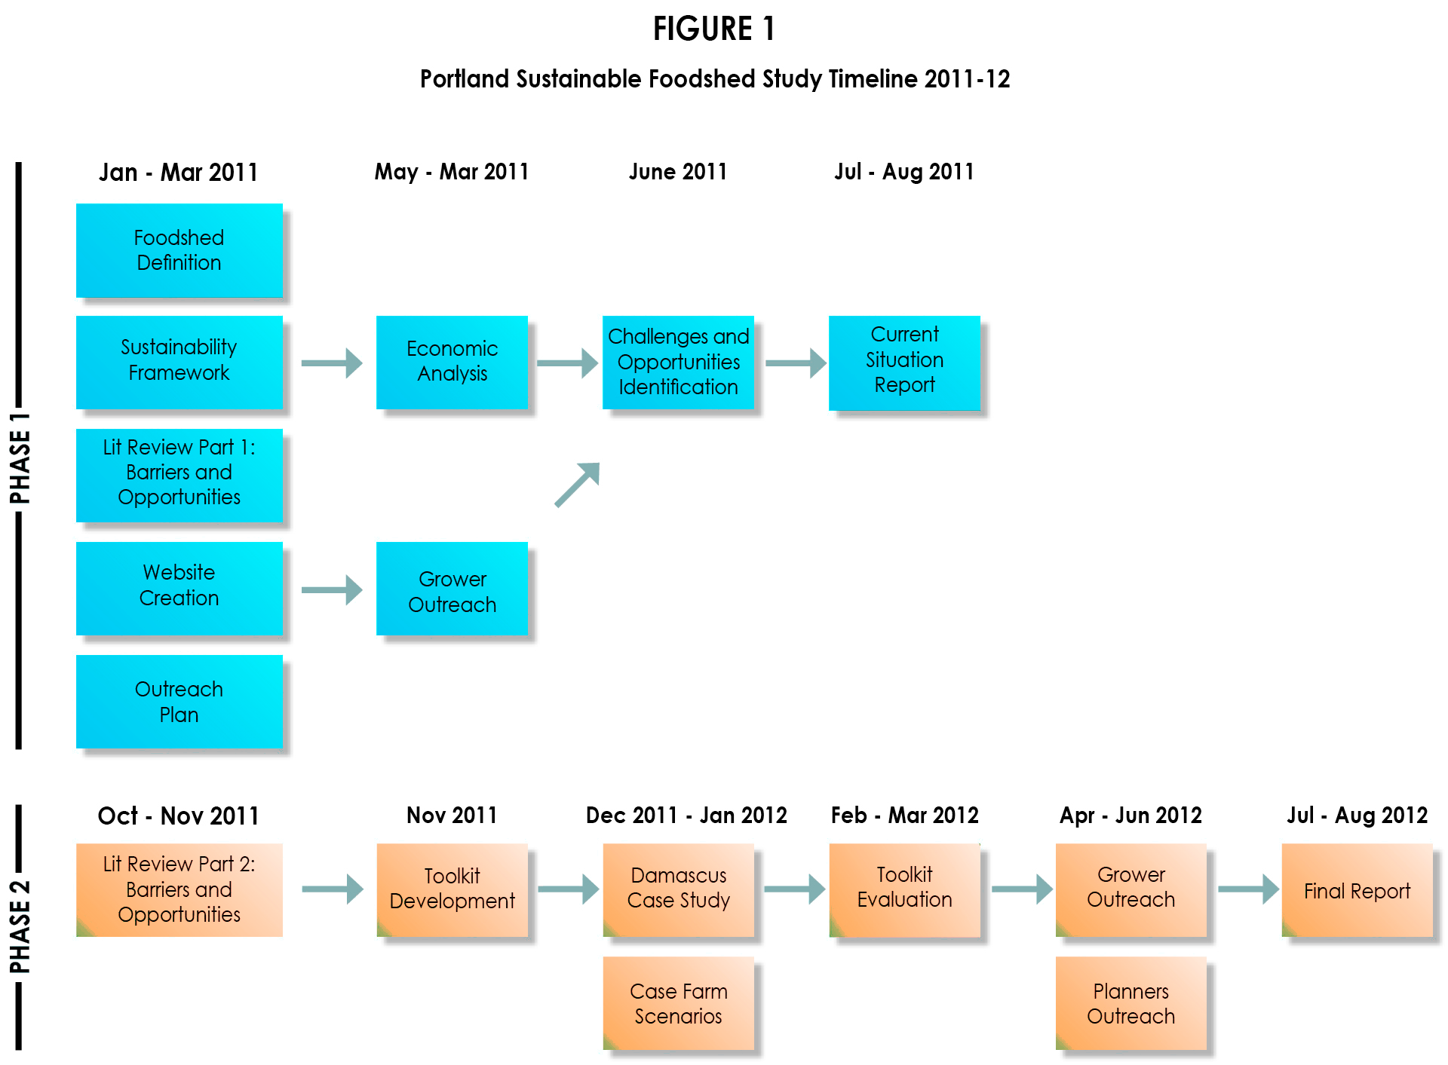
1-3

