Final Report
Northeast SARE Project 10012558
Evaluating the Use and Seed Production of Forage Radishes in Field and Forage Crop Fields to Control Compaction, Concentrate Nutrients, Suppress Weeds and provide a local seed source in Limestone Soils of the Northern Shenandoah Valley.
Craig W. Yohn, WVU Extension Agent
Principal Investigator
Summary
Three farmers and the WVU Extension Agent were evaluated the use of the Diakon radish for several purposes with several crops. A separate trial evaluated the feasibility of growing radishes for seed. Three different plots of Diakon radishes were established in the fall of 2009. These plots varied in size, previous crop and region of the county. Three different drills were used operated by the three producers. Each had a different goal for using the radish in these fall plantings. The plantings were made into the following previous crops: an established pasture that is used as a winter feeding and calving area and also used to separate calves from cows at weaning time; a killed sod that was previously in hay that needed renovation and a corn field taken off as silage. A fourth seeding of radishes was made in the spring of 2010 to evaluate the feasibility of growing radishes for seed production.
Seeding had mixed success. Seeding into the established pasture was a complete failure due several factors including: erratic emergence due to a lack of rain, competition from existing stand of forage and possibly being seeded too deep. The seeding of the killed hay field and chopped corn field was acceptable but was also hindered by lack of rainfall. This same theme can be said about the evaluation of seed production.
Radishes affect on the succeeding crop (soybeans and corn) was there was no statistical significant difference in crop yield between treatments and the control. Nutrients in all levels of the soil (3,6, and 9 inches deep) were not significantly different than levels found in the control. The affect of radishes on compaction could not be measured during the time of the trial as the fields never reach field capacity due to the extended drought.
The spring planted plot yielded only 79 pounds of seed per acre at a cost of $2.75 per acre.

Introduction
The use of cover crops in the northern Shenandoah Valley has diminished greatly over the last ten years because of issues related to timely planting, crop residue which must be killed in a timely fashion, harboring pests such as slugs and the cost burden without a perceived benefit. The lack of cover crops has increased the potential for soil and nutrient movement both across the surface and down through the soil profile.

Recent probing with a penetrometer in several crop fields by a Certified Crop Advisor found compaction to be an issue in Jefferson County. The solution for these producers was deep tillage which was expensive, buried crop residue, increased the possibility of soil erosion, destroyed natural infiltration channels and required the removal of many rocks. Yield loss is unrealized and somewhat ignored by producers in the region due to the many disincentives to reduce compaction with tillage.

The negative effect of compaction on row crops and forage fields is well documented. In forages there are many trips over the field during harvest, fertilizer, lime or manure application and animal traffic on wet soils. Compaction can limit growth and yield of forages, limit uptake of nutrients and reduce stands. Soil compaction can easily reduce crop yields by 10 percent, and can lead to water and soil quality degradation due to increased runoff and soil structure destruction. Unlike annual crops, the use of tillage equipment on permanent pastures and meadows is not practical.

In corn experiments at Purdue University, compacted plots resulted in stand reductions of 20 to 30 percent, plant height decreases of one-third to one-half, and yield reductions of about 19 percent compared to non-compacted plots. Corn yields were 160 bushels per acre for non-compacted soil compared to only 130 bushels for compacted plots.

The goal of this project is to evaluate the use of forage (Diakon) radishes as a cover crop and “bio-driller” to reduce compaction and increase nutrient infiltration in forage and field crops. These forage radishes may also provide competition for warm season weeds in fallow wheat fields after harvest reducing the use of herbicides the following spring. If these uses flourish, the need for a local and reliable supply of seed will grow.

In research conducted by Dr.Ray Weil of the University of Maryland, row crop yields responded positively to cover crops including forage radishes. Radishes can capture nitrogen which reduces leaching with a quick spring release of nitrogen. These plants also bring other nutrients from deep in the soil profile to the surface. They leave 4000 pounds of dry matter per acre with little residue in the spring as the plant dies after a few nights in the 20’s. Even so it does provide weed suppression in the fall and early spring, possibly eliminating a herbicide application. Soils also warm up quicker in the spring allowing corn planting to begin as much as seven days sooner resulting in a quicker canopy closer which preserves moisture and shades the ground which can result in less weed germination. These same radishes reduced compaction. Research has shown that radishes have a greater number of roots to a greater depth than other cover crops allowing corn roots to move deeper and reach subsoil moisture. Using the forage radish has shown a significant increase in yield of the following crop over no or other cover crops.

This project will evaluate the ability to produce seed in this region which can then be used in further plantings and for retail sale. Grower Steve Groff from Lancaster County, Pennsylvania has been a major local source for forage radish seed, but has had issues producing clean seed to sell. This project will evaluate the ability to grow clean seed in the Northern Shenandoah Valley which will diversify the source for seed and grow it closer than in the west. Grower Cam Tabb feels very confident that with our dryer summers and the correct adjustment to combining equipment, a clean seed can be achieved. Dr. Weil feels there is a local market for seed.

Objectives/ Performance Targets
Three growers will be involved in various aspects of using radishes in the Northern Shenandoah Valley. Grower 1 (Glen Hetzel) evaluated the ability of radishes to reduce compaction and improve yield in a hay field. Three seeding rates (3, 6 and 9 pounds per acre) and a control plot were replicated three times in one acre plots during early September. Plots were evaluated for compaction before and after planting with a penetrometer. Yield differences were measured through the mechanical harvest of the one acre replicated plots.
Seeding rates of the radishes were changed to six, eight and ten pounds per acre. The presence of perennial weeds in the field led to the decision to plant corn rather than reestablishing a hay crop. Compaction readings were taken, but were not valid due to the lack of reaching field capacity throughout the trial period.
Grower 2 (Bill Grantham) is interested in using the radish to reduce the compaction and improve forage yield in a winter feeding area that has been used for a calving area during February, March and April over the past 10 years. Three seeding rates (3,6 and 9 pounds per acre) and a control plot will be replicated three times in one acre plots during late August or early September. Plots were evaluated for compaction before and after planting with a penetrometer. The radishes were evaluated for their palatability to beef cattle and the affect of the radishes on the existing stand of forage.
Penetrometer and soil samples were taken prior to planting the radishes. Emergence was erratic due to a lack of rain, competition from existing stand of forage and possibly being seeded too deep. Planting would be considered a failure by most standards. Leaves on plants that did emerge were consumed by cattle in early December.
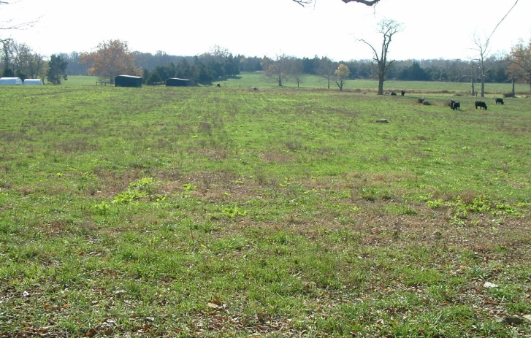 | 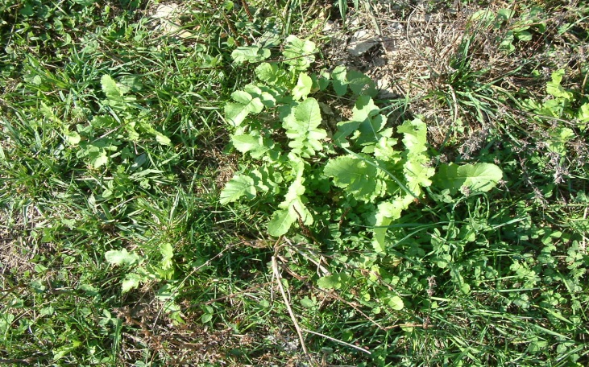
Planting in Winter Feeding Area | Close up of Competition

Grower 3(Cam Tabb) is interested in evaluating the effectiveness of radishes to improve corn yields through a reduction in compaction and the concentration of nutrients near the root zone of the corn plant. The compaction evaluation involved three seeding rates (6, 9 and 12 pounds per acre), a subsoil treatment and a control plot will be replicated three times in one acre plots during late August or early September. Plots will be evaluated for compaction before and after planting with a penetrometer and corn yields will also be evaluated. This study will also evaluate the economics of treating compaction.
Seeding rates were changed to 4, 8 and 12 pounds. A treatment of 8 pounds of seed and disking to close holes was added as Cam feared that populations would be reduced due to the holes left by the radishes in the spring. The evaluation crop was changed to soybeans as it fit in better with the desired rotation and would allow the comparison of Glen Hetzel’s corn plot to this plot with soybeans.
Cam was also interested in using the radish as a cover crop after wheat that has been harvested to reduce or eliminate warm season weeds from germinating. Using radishes as a cover crop on fallow wheat fields will involve three seeding rates (6, 9 and 12 pounds per acre), and a control plot will be replicated three times in one acre plots during early July. Plots will be evaluated for compaction before and after planting with a penetrometer, and weed counts will be taken three times.
This portion of the grant was not completed due to timing of the grant funds becoming available.
Finally, Cam was interested in evaluating the ability to grow radishes to produce a harvestable seed crop which is not being accomplished efficiently in the mid-Atlantic region. Seeding radishes for harvest will be accomplished by planting a 10 pound seeding rate across 12 acres with 3 replications of 20, 40 and 60 pounds of nitrogen and a control. Plots will be harvested and yield determined.

Materials and Methods
Seeding Dates
- Seeding after Wheat was not accomplished as the investigator and producers were overly optimistic about the release of funds to purchase seed in a timely fashion to allow the planting to occur.
- Grantham ( Winter Feeding Area) : August 13, 2009
- Hetzel ( renovation of Hay Field) : September 8, 2009
- Tabb (Cover Crop after Corn Silage): September 19, 2009
- Tabb radish seed production planting : May 21,2010
Seeding Rates (Seeding Rates were changed)
Seeding rates were changed to more closely match the ability of the no-till drills used. Grantham and Hetzel (6, 8, 10 lbs. per acre set on drill). Tabb (4, 8 and 12 set on drill). Interpretation of seed size to match with seed types with the drills was a challenge. In two of the cases, the seed was correlated with the size of sorghum. In the third case the size was correlated with the size of alfalfa. Since four different drills were used, it is difficult to say which setting could consistently be used across all drills. No drill was used for the seed production trial as the plot was disked, the seed broadcast at 32 pounds per acre and then rolled to ensure seed to soil contact.
Stand Evaluation/ Weed problems
- Grantham
    - Emergence was erratic due to a lack of rain, competition from existing stand of forage and possibly being seeded too deep.
    - Planting would be considered a failure by most standards.
    - Leaves on plants that did emerge were consumed by cattle in early December.
- Hetzel
  - Emergence was less erratic than Grantham, but emergence did not begin until three weeks after planting.
  - Planting depth (too deep) may have affected overall stand.
  - Large leaves with radishes of an overall length of 6 inches with 3 to 4 inches in the ground were observed in early December.
  - Winter annuals (henbit, shepherds purse) were most abundant weeds. Radish seeding rate did not appear to affect weed pressure.
- Tabb ( Fall trial)
  - The trial at the Tabb’s was expanded to include three seeding rates, a sub-soiled replication and a seeding rate that will be disked in the spring. There is concern by the producer that plant population of the corn planted in the spring could be compromised due to the holes from the decaying radishes. Stand counts will be taken and reported across all replications.
  - Emergence was more uniform, but lack of rainfall and later planting affected the growth rate of the radish.
  - Small plants with little radishes were observed in early December.
  - Weed pressure was nonexistent.
- Tabb ( Spring Seed Production trial)
  - Despite the higher than usual seeding rate to combat weeds there was a breakthrough of lambs quarter which greatly affected the harvest and cleaning of the seed.

Producers’ investment in this project is summarized as follows:
- Lyle C. (Cam) Tabb: Eighteen plots were developed with 3 replications of six treatments. One of those treatments was the Sub-soiled plots totaling .8 acres. Cam Tabb used his tractor and sub-soiler to do these three plots. Cam also used his tractor and no-till drill to plant three different radish seed rates in twelve replicated plots which totaled 3.25 acres. This took 4.5 hours of his time to adjust the equipment, calibrate the drill and plant or till the plots. An additional hour was required to disk plots that had eight pounds of seed and plots that had been sub-soiled the previous fall. An Additional three hours, Tabb’s combine and a weigh wagon from a local seed dealer was utilized to harvest and weigh the resulting yields from each plot.
- Cam Tabb and son Lyle used their own equipment to work the ground, broadcast the seed and roll the seed. This took approximately two hours. Their combine was used to harvest the seed and a relict was brought out of the past to clean the seed. The Tabb’s invested an additional 20 hours in the process of harvesting the seed.
- Bill W. Grantham: planted two acres in 9 replicated plots with his own drill. This took 4.5 hours to calibrate the drill, plant and clean out the drill. There was no further input as the planting was a failure.

- Glen Hetzel: Planted 4.8 acres in 9 replicated plots with a rented drill. This took 5.5 hours to first, try his own drill, rent a second drill that worked more satisfactorily, plant and clean out the drill. An Additional three hours, Glen’s combine and a weigh wagon from a local seed dealer was utilized to harvest and weigh the resulting yields from each plot.

A field day was planned for two of the three locations on December 22nd. A mailing announcing the field day was sent to over 1300 land owners in the tri-county region. The field day was cancel after the largest snowfall ever recorded in December fell on December 19th.

Results and Discussion
Glen Hetzel – Radish Planting to Renovate Hay Field followed by Corn
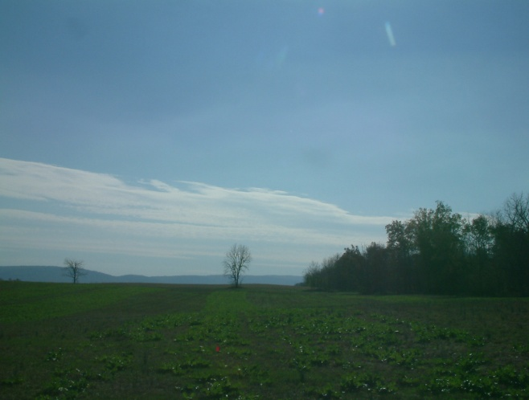 | 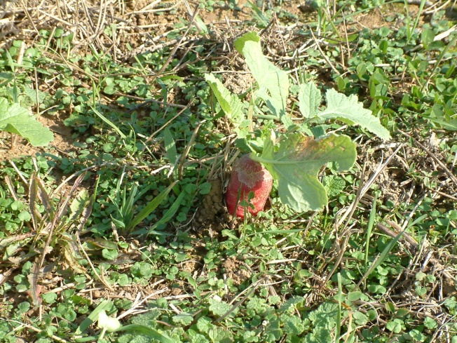
Planting Replications | Radish Before Cold Weather
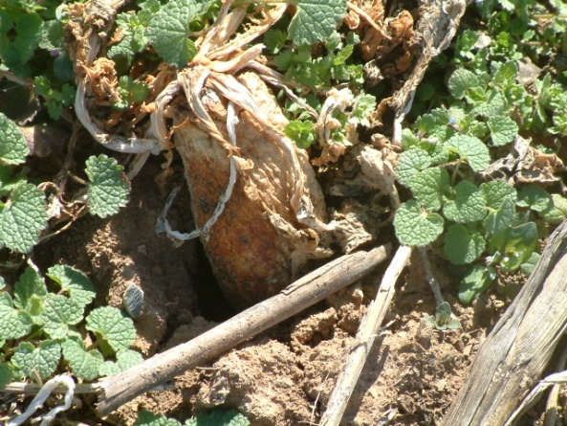
Withering Radish

No significant difference was found in soil nutrient levels between samples taken before and after the radishes were planted.
Table 1—Soil Sample Average Nutrient Levels
 | 3 Inch |  |  | 6 Inch |  |  | 9 Inch
 | Ph | P | K | Ph | P | K | Ph | P | K
Fall | 5.68 | 34 | 79 | 5.7 | 34 | 46 | 6.0 | 37 | 39
Spring | 5.88 | 30 | 63 | 5.88 | 30 | 63 | 6.0 | 37 | 44
Difference | +.2 | -4 | -16 | +.18 | -4 | +17 | 0 | 0 | +5
There was no statistical difference in plant population or corn yield between treatments and in fact yield was highest in the control plot.
Table 2—Corn Plant Populations
Pounds of Radish Seed Plants | Average Plant Population
Six Pounds | 28,000
8 Pounds | 27,667
Ten Pounds | 27,333
Control | 27,889
Average | 27,722
Table 3—Corn Yield
Pounds of Radish Seed Plants | Average Yield
Six Pounds | 90.5 bushels per acre
8 Pounds | 91.3 bushels per acre
Ten Pounds | 92.8 bushels per acre
Control | 94.4 bushels per acre
Average | 92.25 bushels per acre

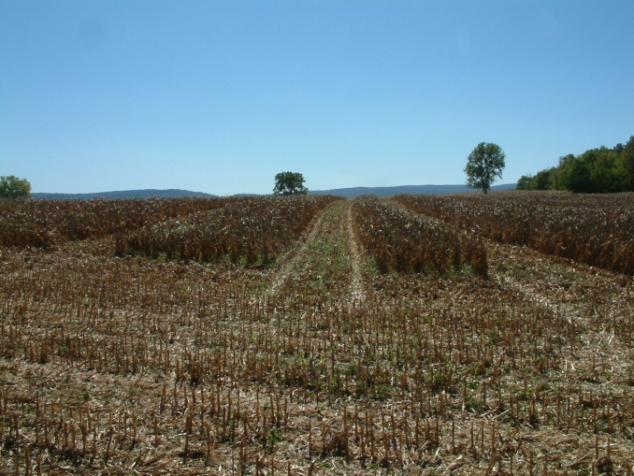 | 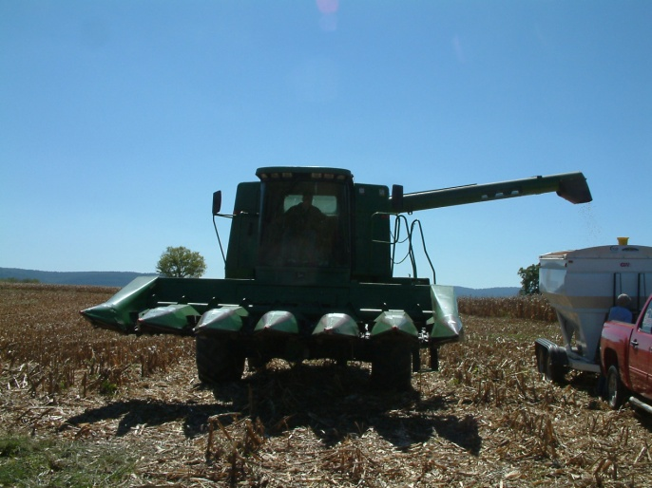
Replicated Harvested Corn Plots | Emptying Replication Into Weigh Wagon

Cam and Lyle Tabb - Compaction, nutrient sequestration and yield response to different treatments and seeding rates of radishes on soybean production
Table 5—Soil Sample Average Nutrient Levels
 | 3 Inch |  |  | 6 Inch |  |  | 9 Inch
 | Ph | P | K | Ph | P | K | Ph | P | K
Fall | 6.34 | 46 | 180 | 6.1 | 39 | 136 | 6.1 | 48 | 128
Spring | 6.08 | 39 | 121 | 6.0 | 35 | 101 | 6.2 | 46 | 94
Difference | - .26 | -7 | -59 | - .1 | -4 | -35 | .1 | -2 | -34

There was no significant difference in nutrient levels when samples were taken before and after the radishes were planted.
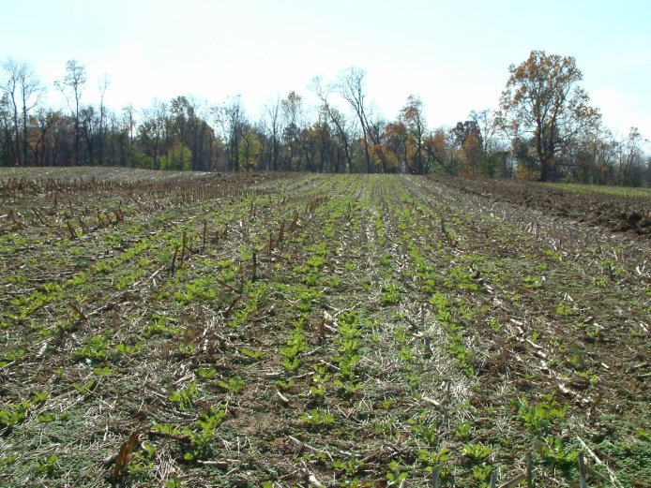 | 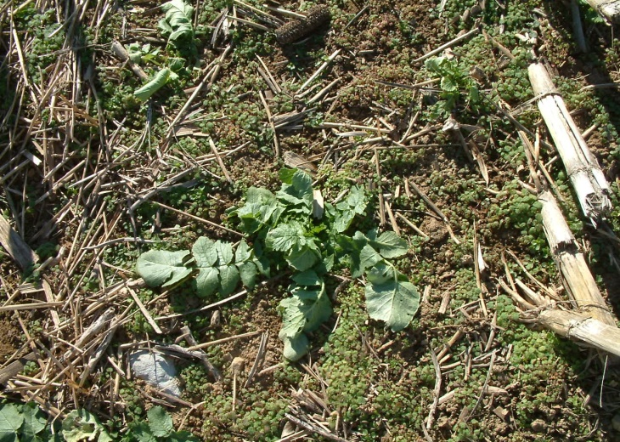
Tabb Radish Seeding Replications | Young Radish Plant

There was also no significant difference in soybean plant populations between treatments. This was a concern when this trial was begun.

Table 6—Soybean Plant Populations
Treatment | Average Plant Population
Four Pounds | 158,724
Eight Pounds | 186,328
Eight Pounds and Disked | 147,440
Twelve Pounds | 194,215
Sub Soiled and Disked | 166,611
Control | 193,230
Average | 174,498

The middle fifteen feet of the replicated trials were harvested in early November. There was no significant difference in yield across all treatments.
Table 7—Soybean Yield
Treatment | Average Yield
Four Pounds | 28.3 bushels per acre
Eight Pounds | 28.5 bushels per acre
Eight Pounds and Disked | 27.9 bushels per acre
Twelve Pounds | 27.3 bushels per acre
Sub Soiled and Disked | 28.3 bushels per acre
Control | 26.0 bushels per acre
Average | 27.7 bushels per acre
When looking at the average yield and costs, the combination of seed and/or tillage costs versus the additional yield demonstrates in this one year trial that by using the radish as a cover crop there was an increase in profit over the control or bare ground. There was only $.20 difference between 12 pounds of radish seed and 8 pounds and disking, but there is an additional use of energy and additional time to disk.

Cam and Lyle Tabb - Diakon Radish Seed Production
The planting method did control most weeds except lamb quarters which affected the harvest of the seed. Cleaning the seed was a labor intensive experience that was unexpected by the producers as they were planning that the combine would do a satisfactory job of cleaning the seed. The high seeding rate also rdued the side of the radish which improved the ride over the field. Large radishes sticking out of the ground had the potential to make harvesting a rough ride and the small radishes were not an issue.
The planting produced 79 pounds of seed per acre. This seems low, but it occurred during a period when the region was affected by a prolonged drought that had a deficit of over 6 inches of rainfall.
The radishes were seeded on May 21, 2010 and harvested on September 9, 2010 (111 days).
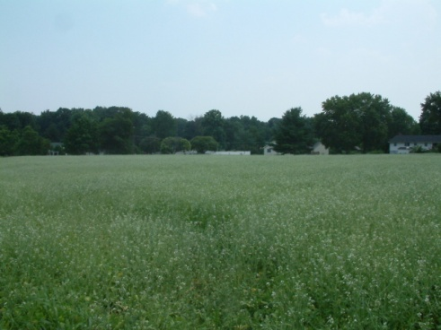 | 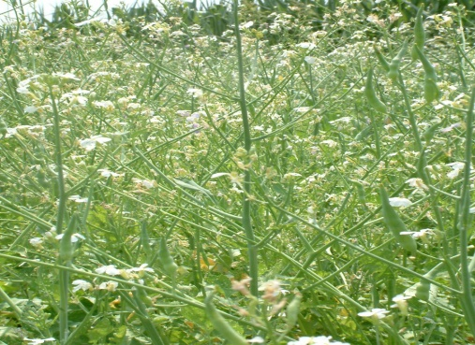 | 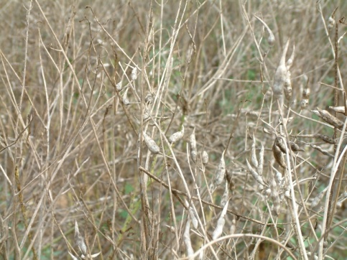
Radish Field in Bloom | Blooms and Pods | Mature Pods
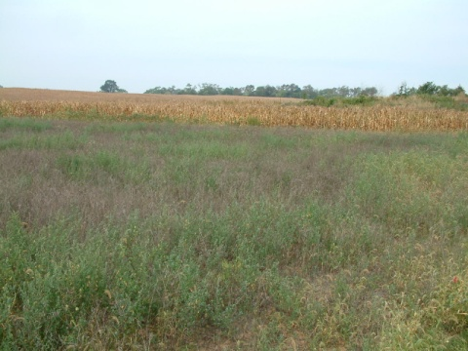 | 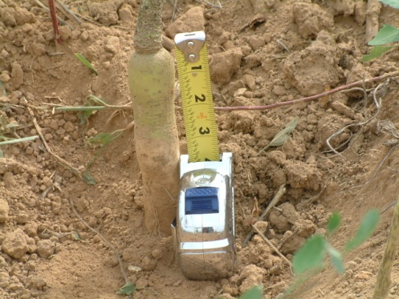 | 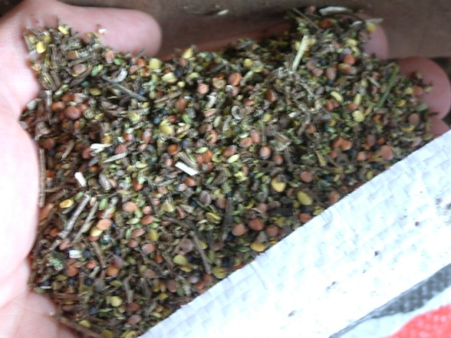
Weed Issues at Harvest | Small Radish Due to High Population | Seed Cleaned Once
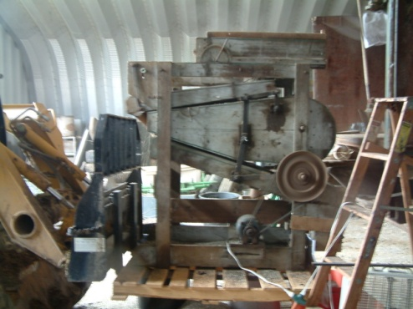 | 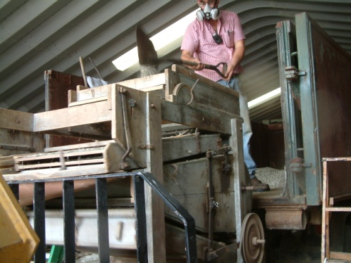 | 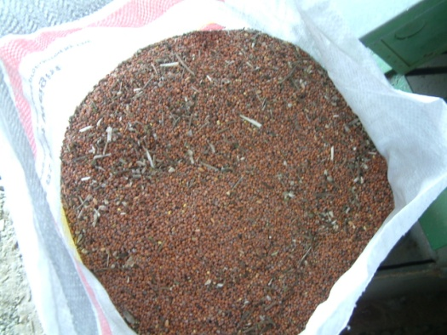
Vintage Seed Cleaner | Lyle Tabb Cleaning Seed | Cleaned Seed

Impact of Results
As a result of these studies the producers learned that tillage does not necessarily mean higher yields and that the Diakon radish can in fact be a substitute. While dry weather played a major role in the ability of these trials to express differences that may have been occurring, the cooperating producers did learn that seed can be produced and harvested here in the Shenandoah Valley. The seed harvested had a 90% germination rate and was planted in the fall of 2011 as a cover crop.
The attempt at a field day was futile due to a early snow storm, but growers in this region will learn more from the three fat sheets produced than the field day as they are poor attendees of meetings.
Economic Analysis
Each trial was individually analyzed for their economic impact. Below are the summaries of those analysis.
An evaluation of the economic impact of this practice on the yield response is summarized in Table 4. Figures are all on a per acre basis.
Table 4—Economic Summary of Radish Planting before Corn
Pounds of Radish Seed Plants | Cover Crop  Planting Cost | Income from Corn @ $4.00 per Bushel | Net After Cost of Radish Seeding | Difference from Control
Six Pounds | $36.00 | $362.00 | $326.00 | -$51.20
Eight Pounds | $42.00 | $365.20 | $323.20 | -$54.00
Ten Pounds | $48.00 | $371.20 | $323.20 | -$54.00
Control | $0.00 | $377.20 | $377.20 | $0.00

An evaluation of the economic impact of this practice on the yield response is summarized in Table 4. Figures are all on a per acre basis.

Table 8—Economic Summary of Radish Planting before Soybeans
Pounds of Radish Seed Plants | Cover Crop  Planting Cost  (Tillage, Drill and Seed) | Income from Soybeans @ $11.00 per Bushel | Net After Cost of  Radish Seeding | Difference from Control
Four Pounds | $30.00 | $311.30 | $281.30 | $4.70
Eight Pounds | $42.00 | $313.50 | $271.5 | $14.50
Eight Pounds and Disked | $60.00 | $306.50 | $246.50 | $39.50
Twelve Pounds | $54.00 | $300.30 | $246.30 | $39.70
Sub Soiled and Disked | $58.00 | $311.30 | $253.30 | $32.70
Control | $0.00 | $286.00 | $286.00 | $0.00

Table 9—Economic Summary of Radish Planting for Seed Production
 | Acres | Pounds | lbs./acre
 | 3.1 | 245.0 | 79.0
Cost per pound | $0.50
Nitrogen Cost | $20.00
Tillage | $18.00
Broadcast | $11.00
Seed (Pounds) | 32.30
Seed Cost | $3.50
Seed | $113.05
Harvest | $30.00
Cleaning | $25.00
Total Cost | $217.05
Income
Pounds | 79.0
Price | $3.00
Gross Income | $237.10
Net | $20.05
Cost per Pound | $2.75

Publications/Outreach
Three fact sheets were developed and posted on the WVU Jefferson County website:
http://www.jefferson.ext.wvu.edu/agriculture/agronomy_links
The publications were also sent to over 300 farmers.
Farmer Adoption
Farmer adoption is limited at this time due to the costs of the seed and limited sources for seed at a reasonable price. Additional demonstrations and long term research could increase adoption.
Areas Needing Additional Study
This study may have had greater impact if a prolonged drought had not affected the plantings and subsequent cash crops. A longer study on the same field would be useful to look at the long term affect on yield and compaction within a typical rotation of corn, soybeans and small grain.
A second area is seed production. Areas for further study include:
- Planting date (Could the seed be frost seeded in March or earlier)
- Seeding rate (Could the lbs. per acre be cut and still provide weed control and not allow the radishes to get too big?)
- Compatible Herbicides
- Nitrogen Rates

