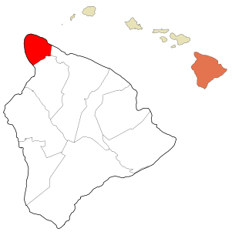
Figure 1: Hawaii and North Kohala
From Wikipedia: http://en.wikipedia.org/wiki/Kohala,_Hawaii

