Figure 1 from OS09-050 Louws, Frank – SARE Final Report

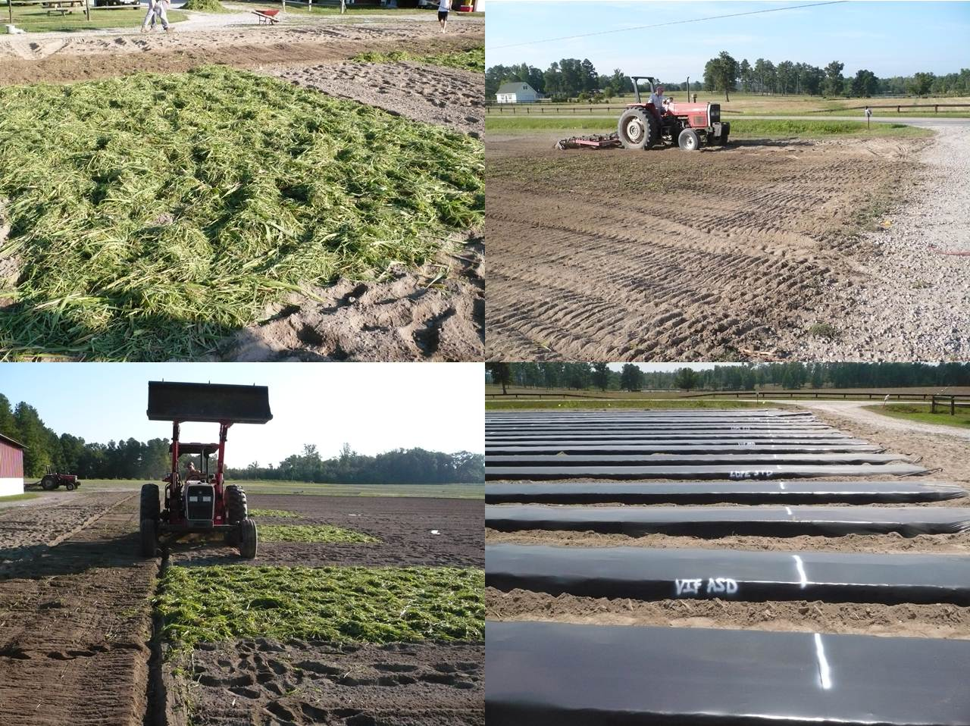
Figure 1: Field shots of a green manure applied to plots, rototilled into the soil followed by field cultivation to smoothen soils and formation of raised beds for strawberry production in the NC experiment.

