Figure 2 from OS09-050 Louws, Frank – SARE Final Report

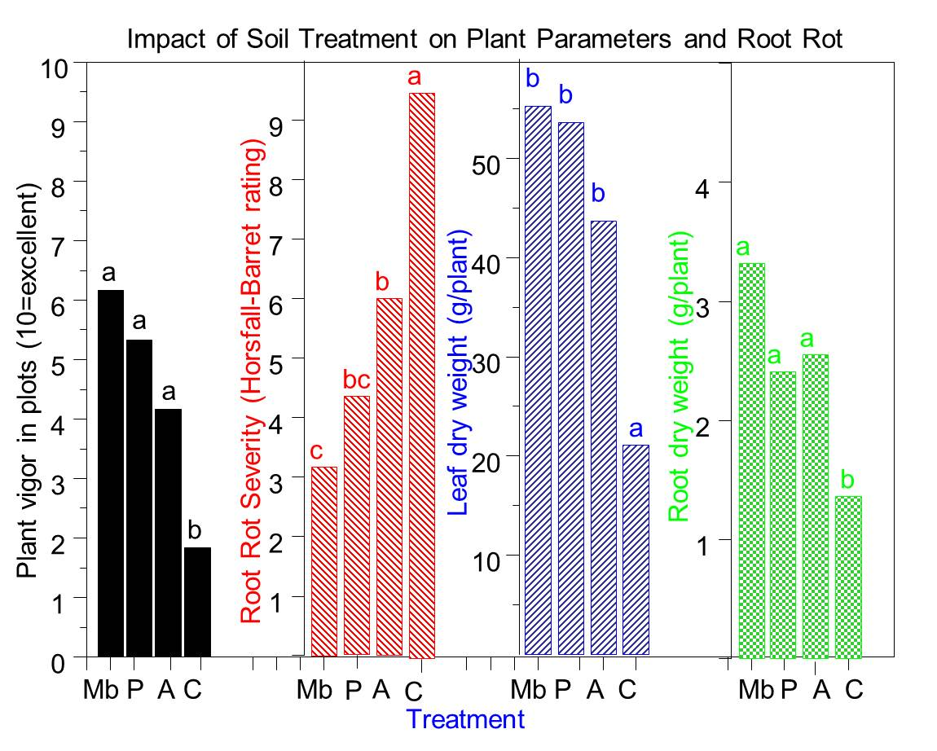
Figure 2: Impact of soil treatments on plant growth and root rot severity assessed near the end of the strawberry growth cycle and at peak harvest (May 2012) in TN. Bars with the same letter are not significantly different from each other (P=0.05).

