Figure 3 from OS09-050 Louws, Frank – SARE Final Report

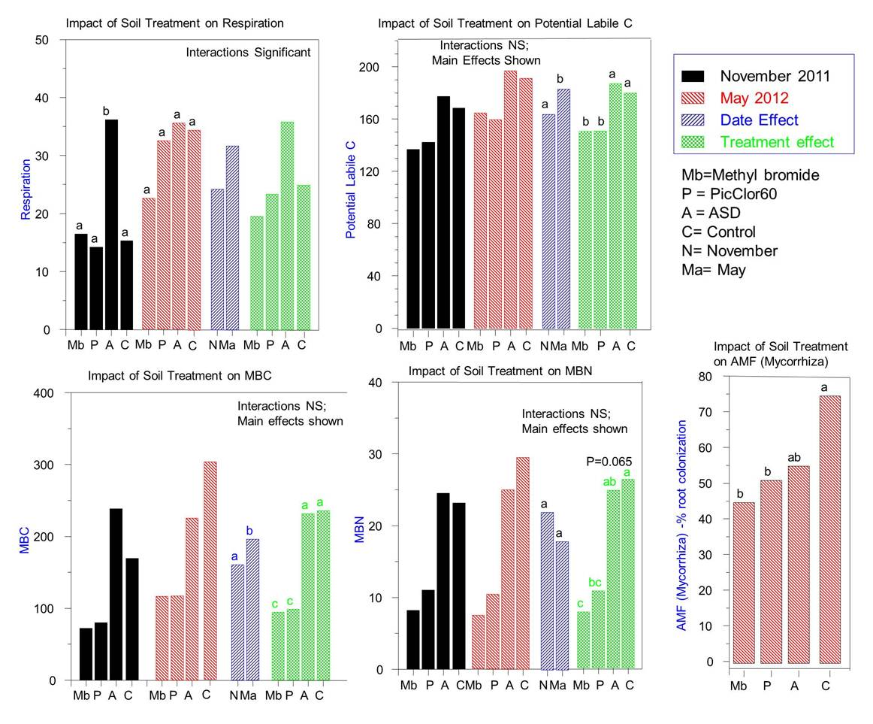
Figure 3: Selected microbial community analysis data sampled in November 2011 (approximately 1 month after planting) or May 2012 (peak harvest) in TN. Bars represent November data, May data and then main effects for date of sampling and main effects due to treatment averaged over sampling dates. Values with the same letter within similar bar patterns are not significantly different from one another (P=0.05).

