Figure 4 from OS09-050 Louws, Frank – SARE Final Report

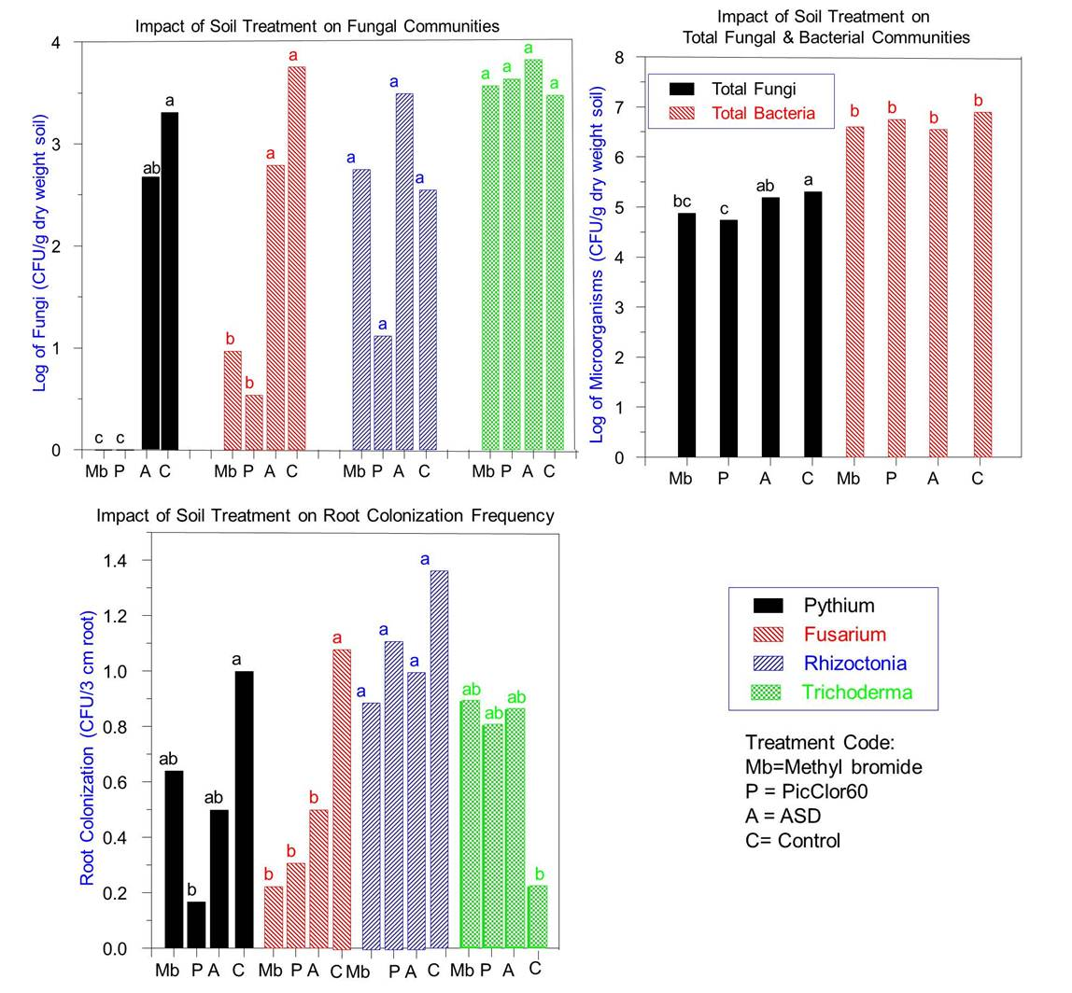
Figure 4: Prevalence of fungi commonly associated with black root rot of strawberry in soils on strawberry roots as well as total fungi and bacteria counts based on culture-based assays in TN. Values with the same letter within similar bar patterns are not significantly different from one another (P=0.05).

