Figure 5 from OS09-050 Louws, Frank – SARE Final Report

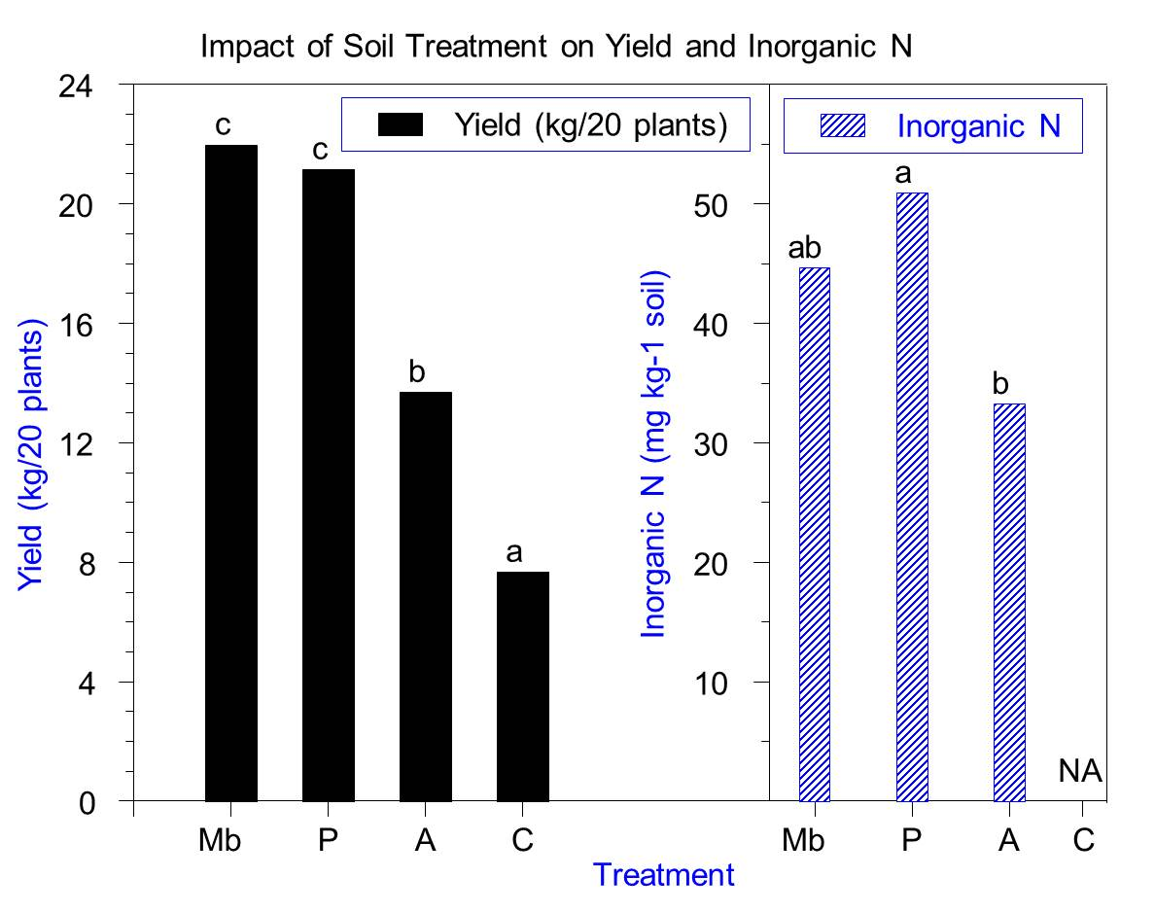
Figure 5: Yield and inorganic nitrogen as impacted by soil treatment in TN. Values with the same letter within similar bar patterns are not significantly different from one another (P=0.05).

