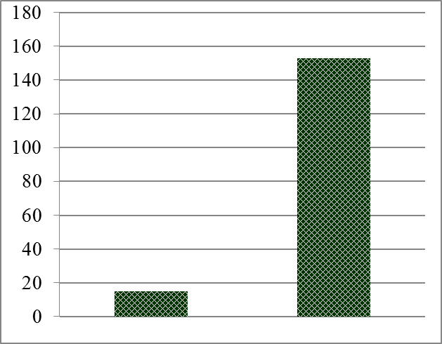

Figure 1. High tunnel construction in West Virginia from 2007-2012.
(Source: Extension Agent Survey and USDA-NRCS contracts)

