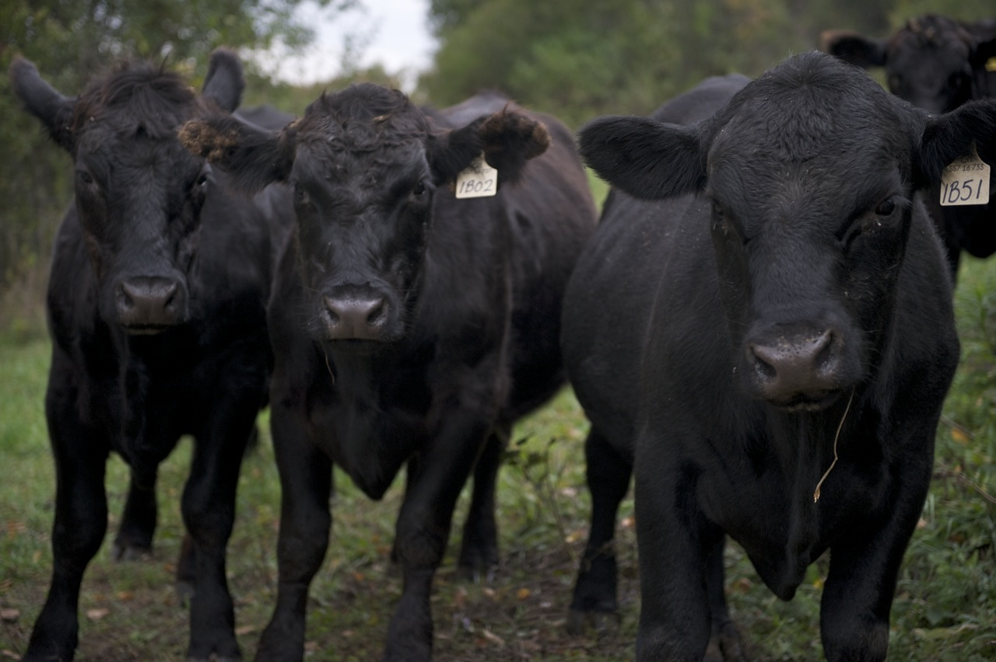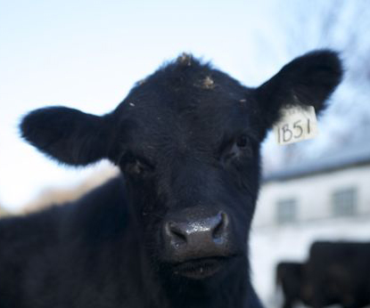

Adirondack Grazers Cooperative is a group of beef producers, from small to mid-size family-owned farms in New York and Vermont, who naturally raise and finish beef.

Our cattle are raised on the rich grasses of the Washington County Region without the use of hormones or feedlots. Our farmers care about their cattle and the earth, and you can taste it in the meat.

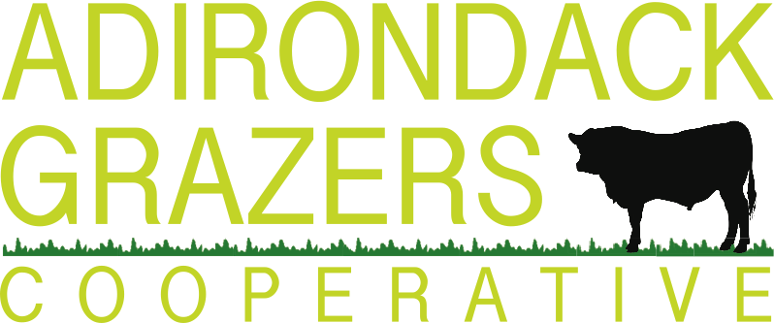

100% grass-fed or pasture-raised grain finished beef brought to you by a community of small, family farms

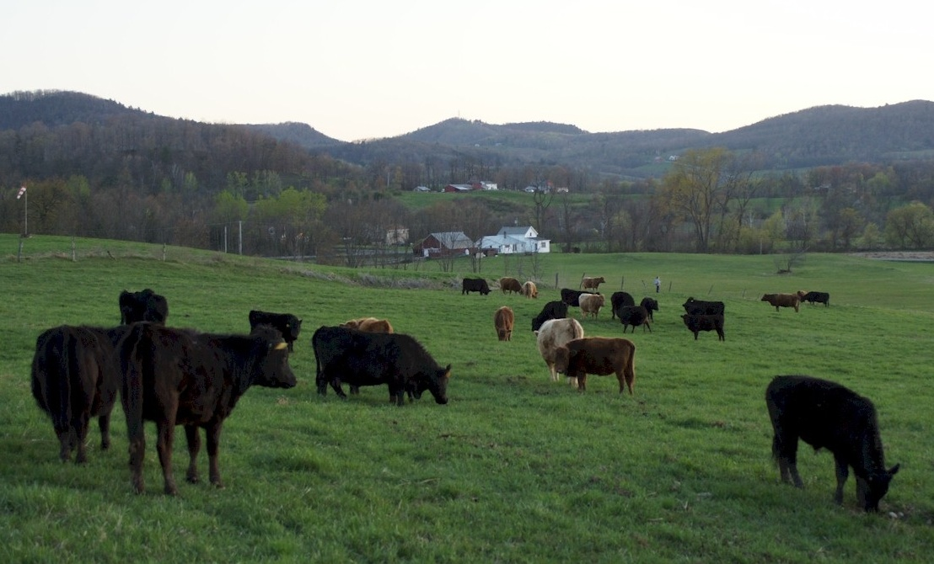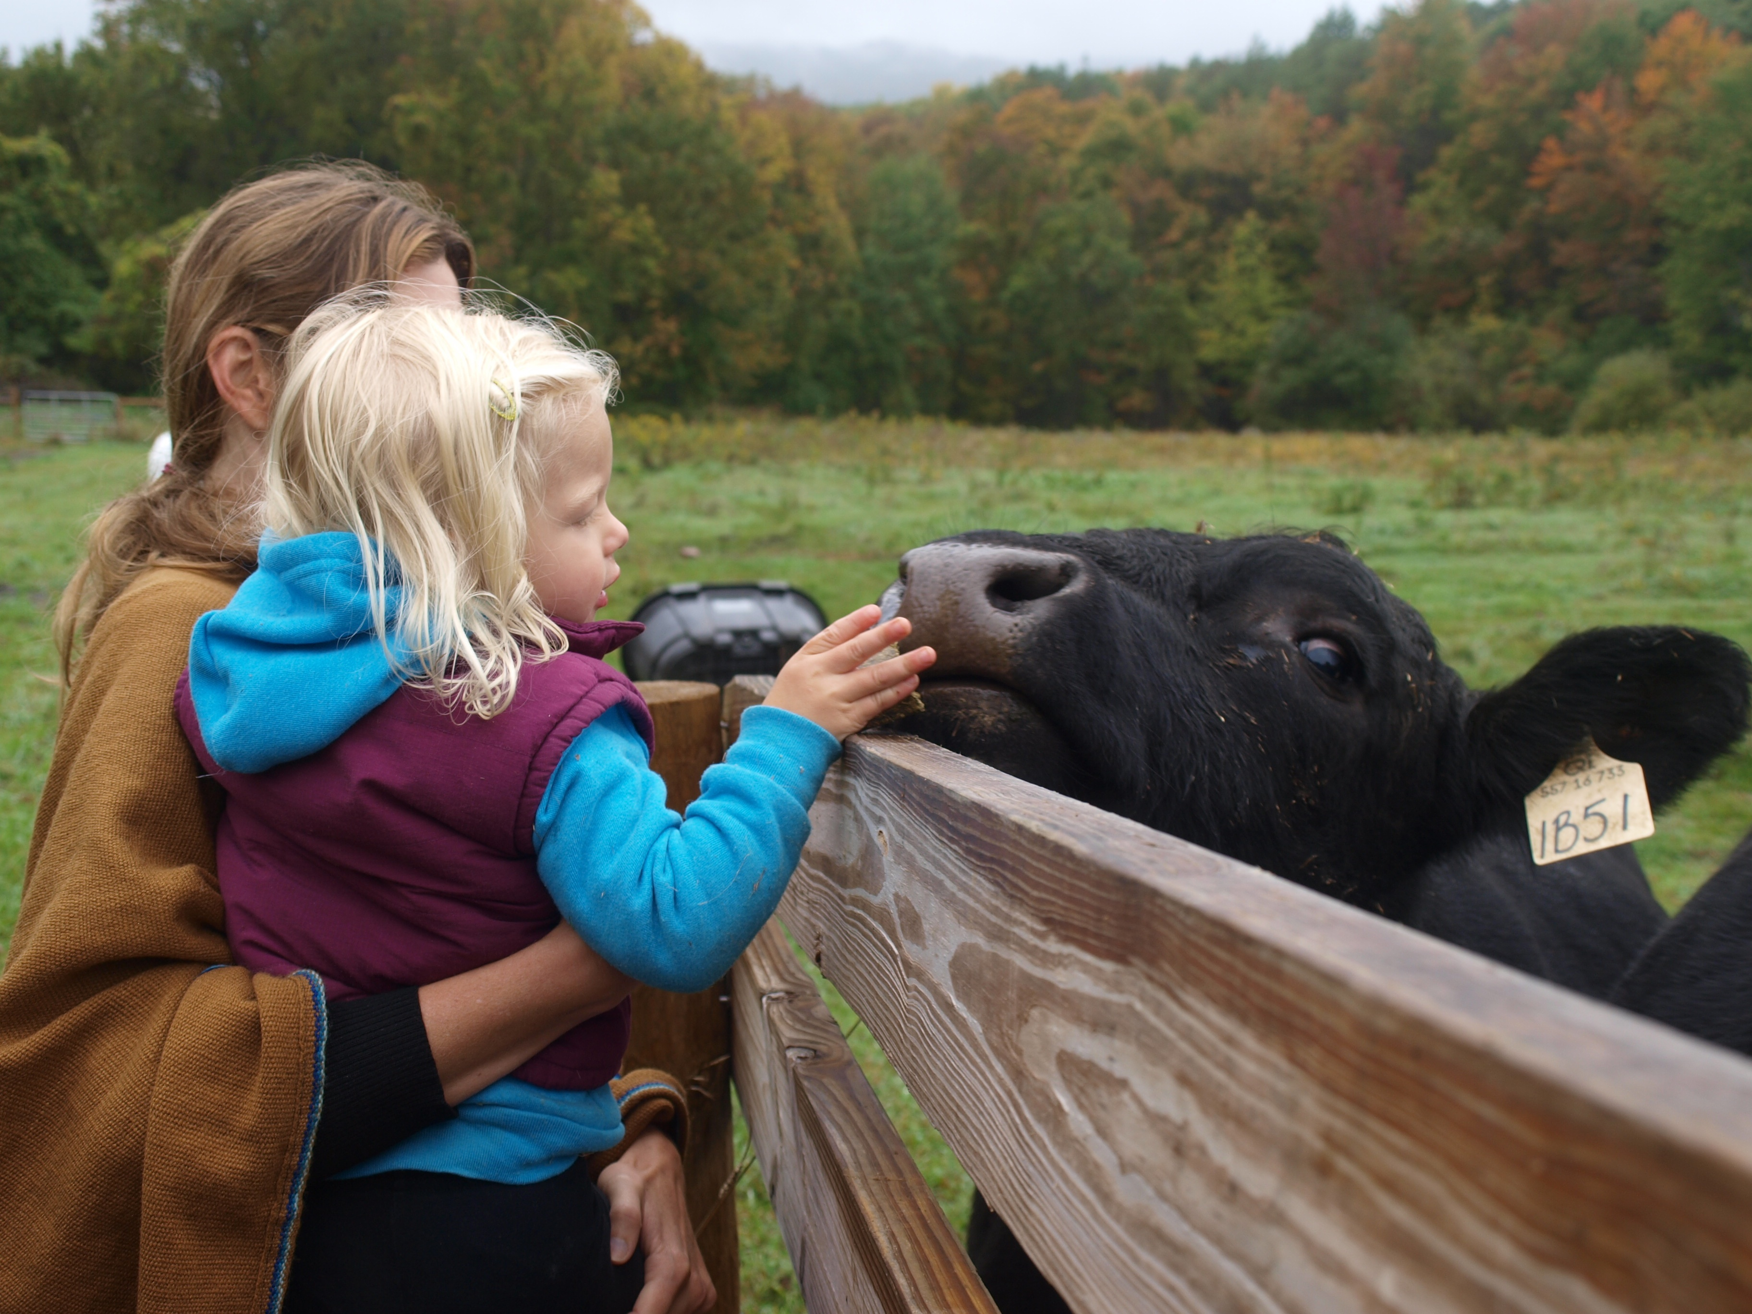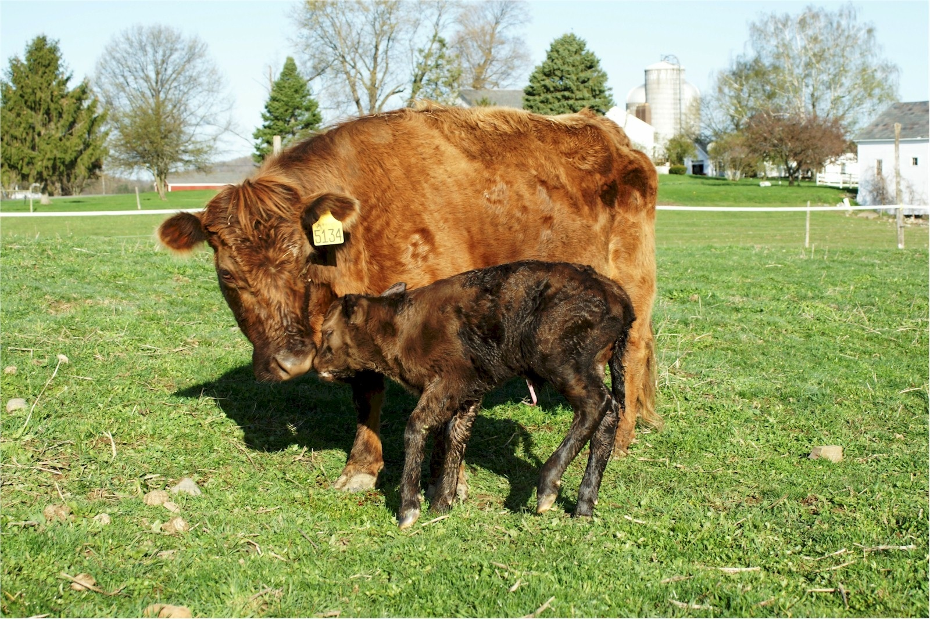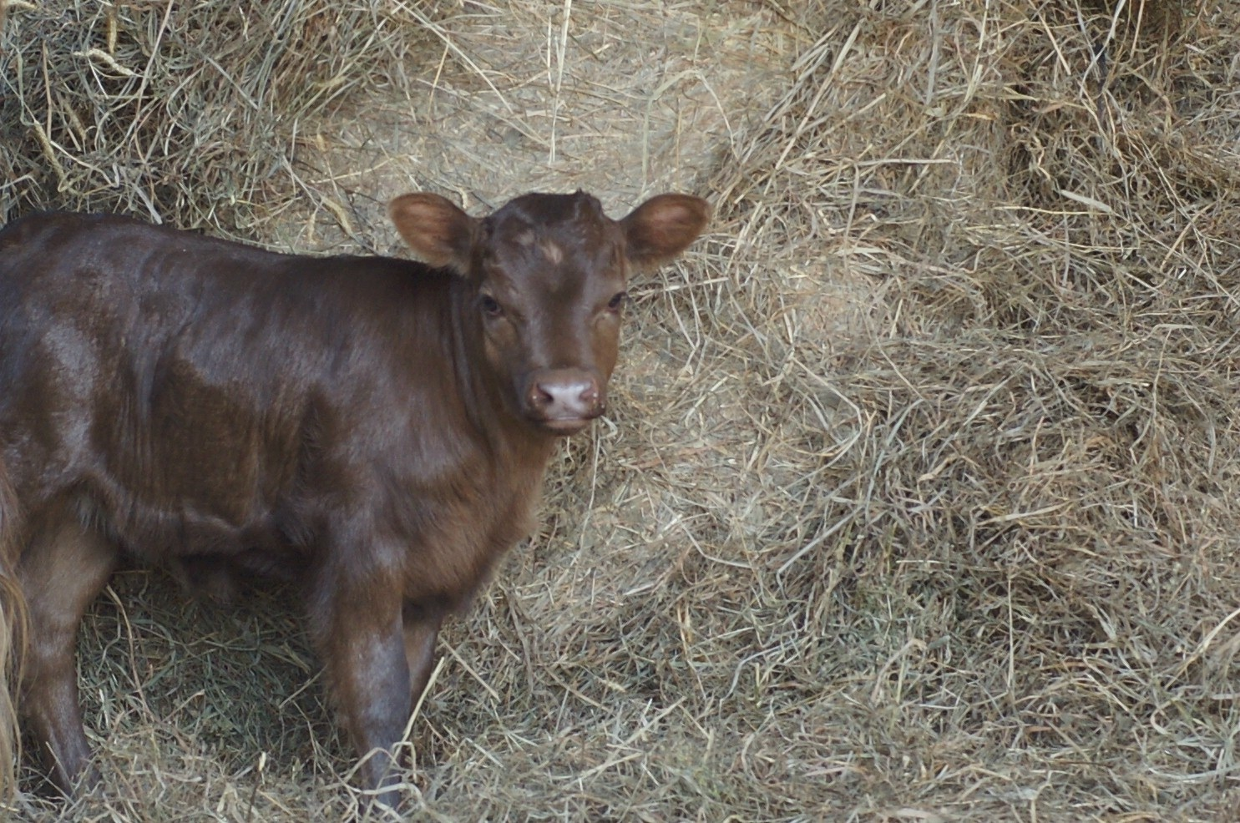

www.adkgrazers.com

Quality natural beef from pasture to plate

**ADK Grazers Cooperative**

**102 Emsig Lane**

**Granville, NY 12832**

**www.adkgrazers.com**

Everyone deserves healthy beef!

Partial funding for the work reported here was provided by the **USDA Sustainable Agriculture Research and Education Program**

**The Adirondack Choice**

To purchase ADK Grazers beef, please visit “Where To Buy” on: www.adkgrazers.com

Frozen beef can be purchased through Regional Access: http://regionalaccess.net

* We provide a reliable supply of quality meat produced by more than 20 member farms.
* Each farm maintains their individuality and identity. Customers know which farm produced their beef and how it was raised.
* All of our cattle are pasture-raised. We offer a choice of 100% grass-fed or pasture-raised grain finished beef.
* We slaughter and dry age our beef locally at small-scale, USDA facilities, which our farmers have known and worked with for years.
* We deliver whole, half or quarter carcasses, or the specific cuts of your choice.
* We sell convenient, family-sized packages of frozen, mixed cuts of beef.
* We maintain a New York City point of contact.

“We are what we eat” has become “we are what *they* eat.”

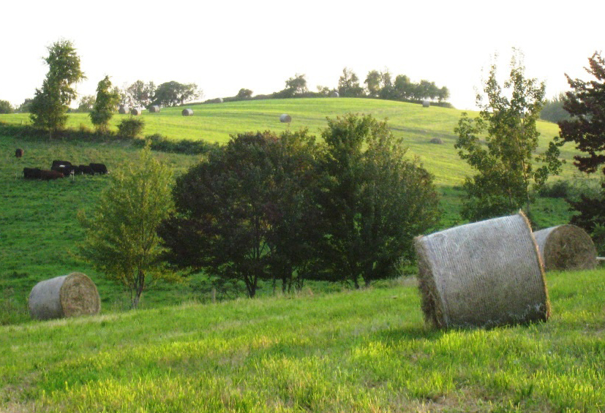

By purchasing our beef, you become part of a community of New York and Vermont farmers who sell humanely and sustainably-raised meat. Our customers know exactly where their beef is from and who raised it. We encourage customers to visit our farms in order to ensure transparency and to restore a vital link between what we eat and the communities we live in.

**Why ADK Grazers Beef?**

We, and the farms we work with, engage in sustainable practices:

* No high concentration of manure, which reduces air and water pollution
* No soil-depleting planting or harvesting practices
* Feed cattle rich, varied legumes and grasses
* Less land used for grain production for livestock consumption
* Pasture-grazing, which reduces CO2 emissions through plant absorption

Read more about our protocols and by-laws at: www.adkgrazers.com/Contact

**Sustainable Practices**

**Contact Us:**

Sarah Teale

sarah.teale@adkgrazers.com

917.941.0481

Cindy Casavant

cindy@adkgrazers.com

518.312.3843