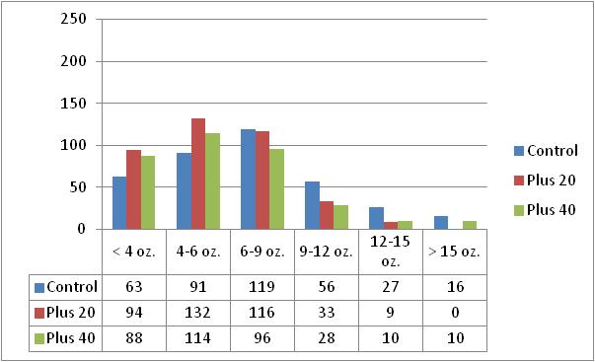
Figure 1. 2010 Yield of Russet Norkotah by Late Season Fertility Treatment (cwt./acre).

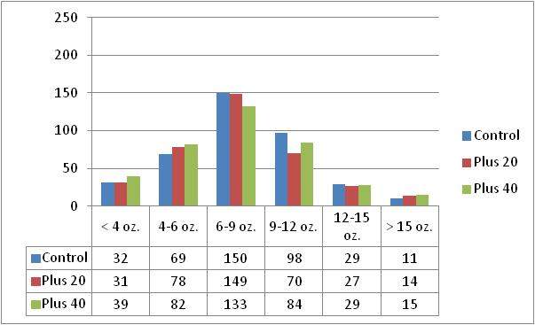
Figure 2. 2010 Yield of Russet Canela by Late Season Fertility Treatment (cwt./acre).

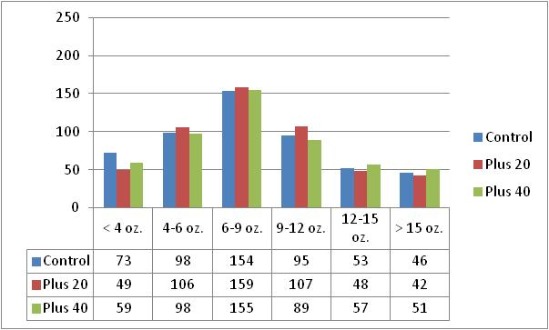
Figure 3. 2010 Yield of Rio Grande Russet by Late Season Fertility Treatment (cwt./acre).
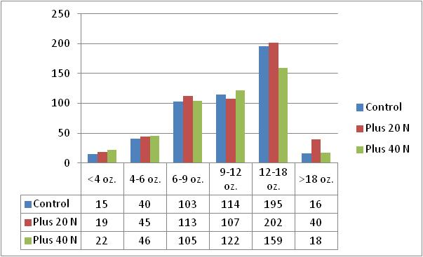
Figure 4. 2011 Yield of Russet Norkotah by Late Season Fertility Treatment (cwt./acre).

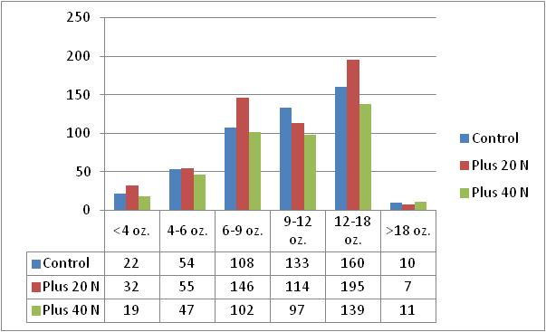
Figure 5. 2011 Yield of Canela Russet by Late Season Fertility Treatment (cwt./acre).
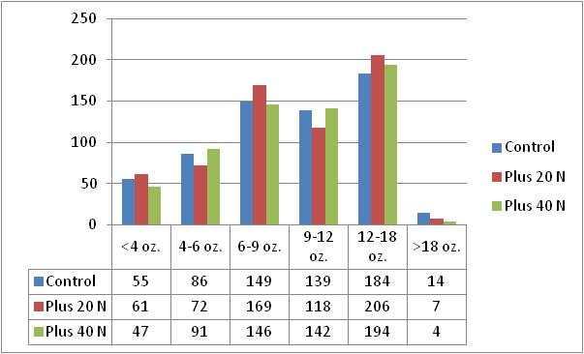
Figure 6. 2011 Yield of Rio Grande Russet by Late Season Fertility Treatment (cwt./acre).

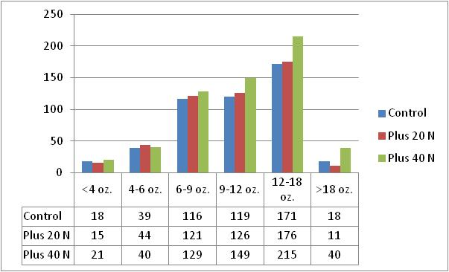
Figure 7. 2011 Yield of Mesa Russet by Late Season Fertility Treatment (cwt./acre).
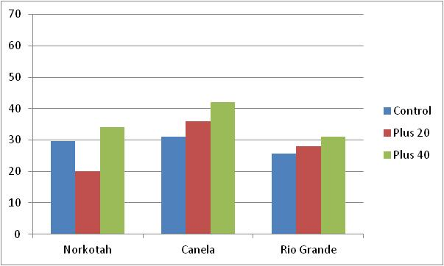
Figure 8. 2010 Percent of Tubers with At-harvest Skinning or Damage by Variety and Late Season Fertility Treatment.

Figure 9. Percent of Tubers with At-harvest Skinning or Damage by Variety and Late Season Fertility Treatment.
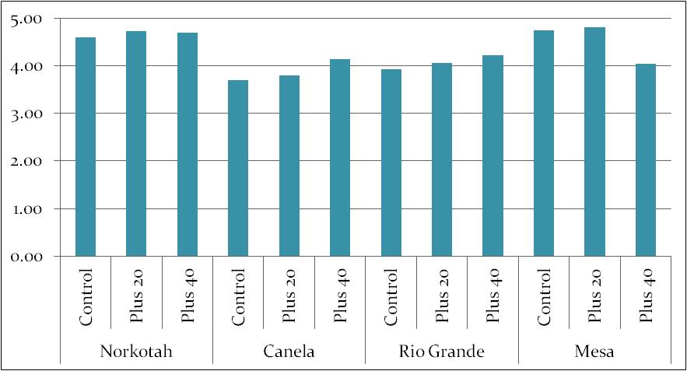
Figure 11. Resistance to Skin Shearing by Variety and Late Season Fertility Treatment for 2011.

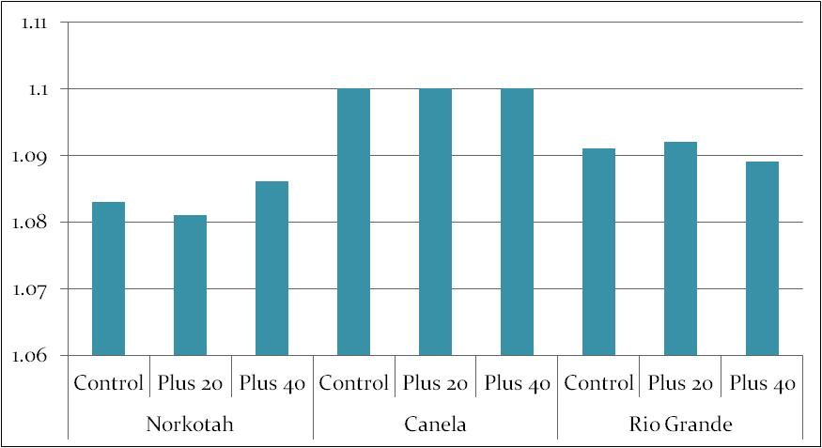
Figure 12. Tuber Specific Gravity with by Variety and Late Season Fertility Treatment 2010.
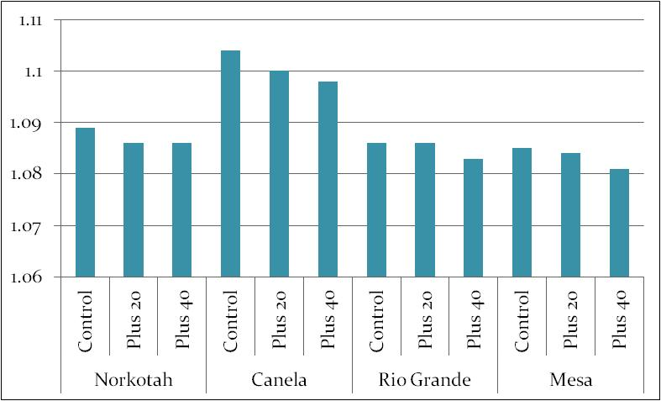
Figure 13. Tuber Specific Gravity with by Variety and Late Season Fertility Treatment for 2011.

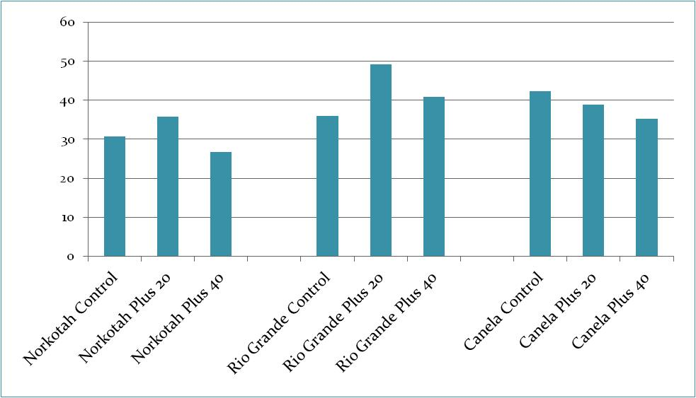
Figure 14. Average Pressure flattened Area (Sq. cm. pre tuber) by Variety and Late Season Fertility
Treatment for 2010.
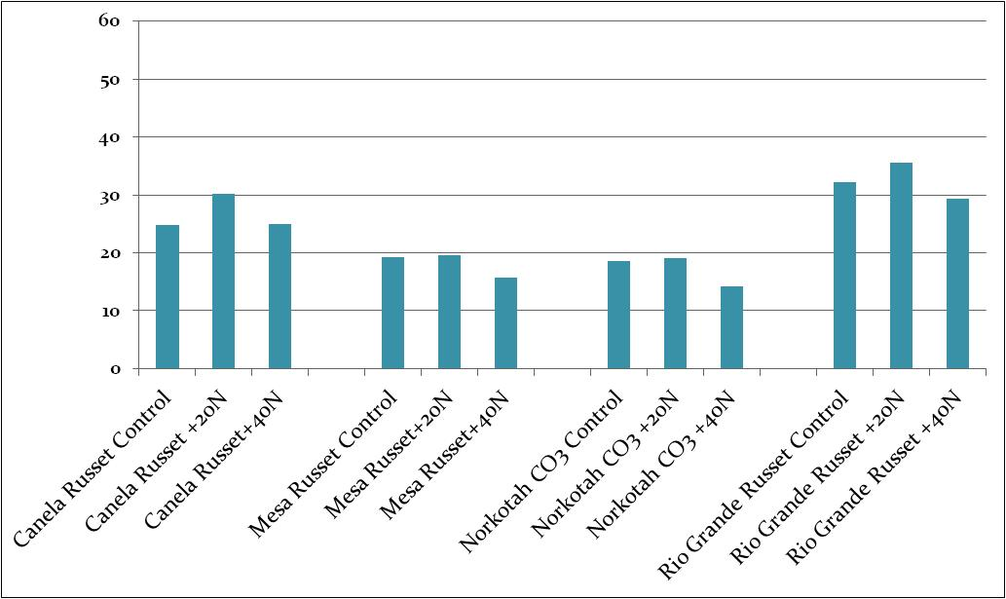

Figure 15. Average Pressure flattened Area (Sq. cm. pre tuber) by Variety and Late Season Fertility
Treatment for 2011.

